University of Cincinnati
BANA 2082
Answers are highlighted

Quiz 13A
1)The company identified in Chapter 13, Analytics in Action, is a. Intercontinental Hotels

- The Analytics in Action example in Chapter 13 concerned a. revenue management

- Chapter 13 focuses on
  - nonlinear optimization.

- In a nonlinear optimization problem
  - at least one term in the objective function or a constraint is nonlinear.

- The reduced gradient is analogous to the for linear models. a. reduced cost

- The Lagrangian multiplier is the for a constraint in a nonlinear problem. a. shadow price

Quiz 13B
- A feasible solution is a(n) if there are no other feasible solutions with a better

objective function value in the immediate neighborhood. a. local optimum

- A feasible solution is if there are no other feasible points with a better objective function value in the entire feasible region.
  - global optimum

- Solving nonlinear problems with local optimal solutions is performed using , in Excel Solver, which is based on more classical optimization techniques.
  - GRG Nonlinear
- The option in Excel Solver is helpful when the solution to a problem appears to depend on the starting values for the decision variables.
  - Multistart
- The measure of risk most often associated with the Markowitz portfolio model is the a. variance of the portfolio’s return.

Quiz 13C
- A portfolio optimization model used to construct a portfolio that minimizes risk subject to a constraint requiring a minimum level of return is known as
  - Markowitz mean-variance portfolio model.

- One of the ways to formulate the Markowitz model is to
  - minimize the variance of the portfolio subject to a constraint on the expected return of the portfolio.

- Which of the following is a second way of formulating the Markowitz model?
  - Maximizing the expected return of the portfolio subject to a constraint on variance

- A(n) is a set of points defining the minimum possible risk for a set of return values. a. efficient frontier

- The profit function for two types of iPod is
where x1 and x2 represent number of units of production of basic and advanced iPods, respectively.

Production time required for the basic iPod is 6 hours per unit, and production time required for the advanced iPod is 8 hours per unit. Currently, 50 hours are available. The cost of hours is already factored into the profit function. Formulate an optimization problem that can be used to find the optimal production quantity of basic and advanced iPods. Solve the optimization model you formulated, what is the optimal value of the objective function? Round your answer to one decimal place.
a. 685.8

- Let S represent the amount of steel produced (in tons). Steel production is related to the amount of labor used (L) and the amount of capital used (C) by the following function:

S = 15 L0.4 C 0.6

In this formula L represents the units of labor input and C the units of capital input. Each unit of labor costs $40, and each unit of capital costs $100.
Formulate an optimization problem that will determine how much labor and capital are needed in order to produce 55,000 tons of steel at minimum cost.
What is the minimum cost? Round your answer to two decimal places with no dollar sign a. 498173.57

- Consider Question 6, what is the optimal value of capital? Round your answer to two decimal places.
a. 2989.05

- Consider Question 6, what is the optimal value of labor? Round your answer to two decimal places.
a. 4981.72
- The distance between two cities in the United States can be approximated by the following formula, where lat1 and long1 are the latitude and longitude of city 1 and lat2 and long2 are the latitude and longitude of city 2:
Ted's daughter is getting married, and he is inviting relatives from 15 different locations in the United States. The DATA file Wedding gives the longitude, latitude, and number of relatives in each of the 15 locations. Ted would like to find the location to hold the wedding that minimizes the demand-weighted distance, where demand is the number of relatives at each location. Find the optimal location. Enter the latitude of the optimal location rounded to two decimal places.
a. 40.2

- Consider Question 9, enter the optimal value of the longitude rounded to two decimal places. a. -75.21

Quiz 13D
- The forecasting model uses nonlinear optimization to forecast the adoption of innovative and new technologies in the marketplace.
  - Bass

- In the Bass forecasting model, parameter m
  - refers to the number of people estimated to eventually adopt the new product.

- In the Bass forecasting model, the measures the likelihood of adoption due to a

potential adopter being influenced by someone who has already adopted the product. a. coefficient of imitation

- In the Bass forecasting model, the measures the likelihood of adoption, assuming no influence from someone who has already purchased (adopted) the product.
  - coefficient of innovation

- Which of the following conclusions can be drawn from the below figure using the Bass forecasting model?
(Note: Bass forecasting model is given by: F_{t} = (p + q[C_{t} – ₁ /m]) (m – C_{t} – ₁), where m = the number of people estimated to eventually adopt the new product, C_{t} – ₁ = the number of people who have adopted the product through time t – 1, q = the coefficient of imitation, and
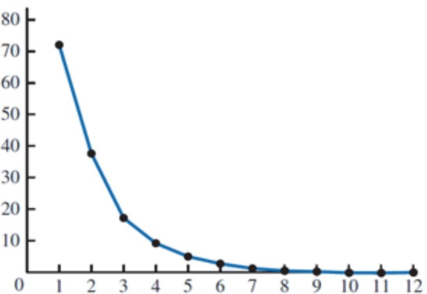
p = the coefficient of innovation.
  - q < p

