University of Cincinnati
BANA 2082
Answers are highlighted

Quiz 11A
1)The company identified in Chapter 11, Analytics in Action, is a. MeadWestvaco Corporation

- The Analytics in Action example in Chapter 11 concerned a. long-range management of timberland.

- Chapter 11 focuses on
  - linear optimization.

- or modeling, is the process of translating a verbal statement of a problem into a mathematical statement.
  - Problem formulation

- The term refers to the expression that defines the quantity to be maximized or minimized in a linear programming model
  - objective function

- Constraints are
  - restrictions that limit the settings of the decision variables

Quiz 11B
- A(n) solution satisfies all the constraint expressions simultaneously. a. Feasible
- The points where constraints intersect on the boundary of the feasible region are termed as the a. extreme points.
- The value for each less-than-or-equal-to constraint indicates the difference between the left-hand and right-hand values for a constraint.
  - Slack
- The slack value for binding constraints is a. Zero
- A scenario in which the optimal objective function contour line coincides with one of the binding constraint lines on the boundary of the feasible region leads to solutions.
  - alternative optimal
- Reconsider the Par Inc. problem. Suppose that the profit per bag for deluxe bags in $15. The rest of the problem remains the same. What is the optimal number of deluxe bags to produce?
a. 420
- Based on your results in Question 6, you would investigate getting additional time in the Cutting and Dyeing Department.
  - True
- Based on your results in Question 6, you would investigate getting additional time in the Finishing Department.
  - False

Quiz 11C
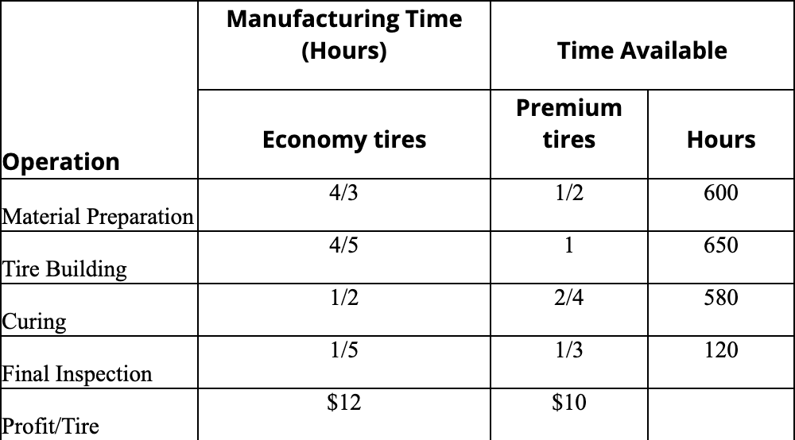
- Gatson manufacturing company produces 2 types of tires: Economy tire; Premium tire. The manufacturing time and the profit contribution per tire are given in the following table.
Answer the following assuming that the company is interested in maximizing the total profit contribution.

Develop a spreadsheet model and find the optimal solution using Excel Solver. What is the total profit contribution Gatson can earn with the optimal production quantities? Enter your answer without a dollar sign and rounded to two decimal places.
a. 6038.71

- Based on your answer to Question 1, how many Economy tires should Gatson manufacture to maximize profit contribution? Round your answer to one decimal place.
a. 406.5

- Based on your answer to Question 1, how many Premium tires should Gatson manufacture to maximize profit contribution? Round your answer to one decimal place.
a. 116.1

- The supervisor of a manufacturing plant is trying to determine how many of two parts, Part X and Part Y, are to be produced per day. Each part must be processed in three sections of the plant. The time required for the production along with the profit contribution for each part are given in the following table.
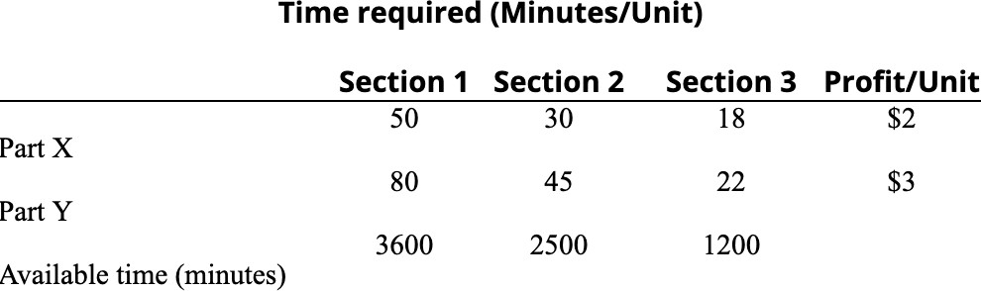

No more than 60 units of Part X and up to 70 units of Part Y can be produced per day. The company already has orders for 30 units of Part Y that must be satisfied.

Develop a spreadsheet model and find the solution that maximizes total profit contribution. What is the value of the objective function? Enter your answer without a dollar sign.
a. 138

- Based on your answer to Question 4, what quantity of Part X should be produced to maximize profit contribution?
  - 24

- Based on your answer to Question 4, what quantity of Part Y should be produced to maximize profit contribution?
  - 30

- The Pat-A-Cake Pastry Shop makes chocolate cake in three sizes – Small, Medium, and Large. The shop has the following amounts of the three main ingredients on hand – 400 ounces of cake flour, 550 ounces of caster sugar, and 150 ounces of cocoa powder. The table below provides details on the amount of each ingredient required for each cake size as well as the profit contributions.
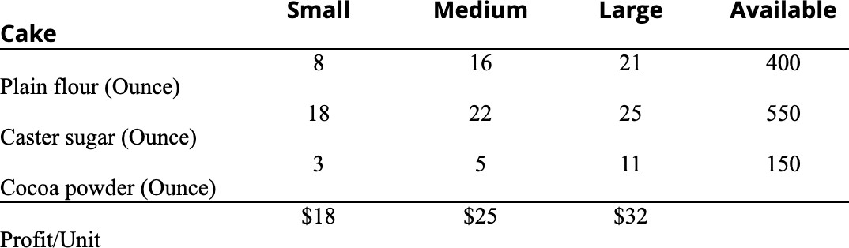

Develop a spreadsheet model and find the optimal solution using Excel Solver. What is the

optimal value of the objective function? Enter your answer without a dollar sign and round the answer to two decimal places.
a. 636.84

- Based on your answer to Question 7, what quantity of small cakes should be produced to maximize profit contribution? Round your answer to one decimal place.
a. 2.9

- Based on your answer to Question 7, what quantity of medium cakes should be produced to maximize profit contribution? Round your answer to one decimal place.
a. 16.6

- Based on your answer to Question 7, what quantity of large cakes should be produced to maximize profit contribution? Round your answer to one decimal place.
a. 5.3

Quiz 11D
- is the situation in which no solution to the linear programming problem satisfies all the constraints.
  - Infeasibility

- Problems with infeasible solutions arise in practice because
  - too many restrictions have been placed on the problem.

- The situation in which the value of the solution may be made infinitely large in a maximization linear programming problem or infinitely small in a minimization problem without violating any of the constraints is known as
  - Unbounded.
- In linear programming models of real problems, the occurrence of an unbounded solution means that the
  - problem formulation is improper.

- The shadow price of nonbinding constraints a. will always be zero.

- The study of how changes in the input parameters of a linear programming problem affect the optimal solution is known as
  - sensitivity analysis

Quiz 11E
- Rob is a financial manager with Sharez, an investment advisory company. He must select specific investments—for example, stocks and bonds—from a variety of investment alternatives . Which of the following statements is most likely to be the objective function in this scenario?
  - Maximization of expected return

- Rob is a financial manager with Sharez, an investment advisory company. He must select specific investments—for example, stocks and bonds—from a variety of investment alternatives . Restrictions on the type of permissible investments would be a in this case.
  - constraint

- A canned food manufacturer has its manufacturing plants in three locations across a state. Their product has to be transported to three central distribution centers, which in turn disperse the goods to seventy-two stores across the state. Which of the following is most likely to be the objective function in this scenario?
  - Minimizing the cost of shipping goods from the plant to the store

- A canned food manufacturer has its manufacturing plants in three locations across a state. Their product has to be transported to three central distribution centers, which in turn disperse the goods to seventy-two stores across the state. Which of the following visualization tools could help understand this problem better?
  - A network graph

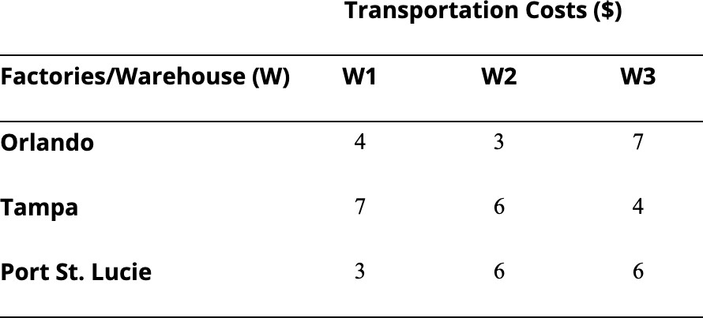
- A soft drink manufacturing company has 3 factories—one in Orlando, one in Tampa, and one in Port St. Lucie—which supply soft drink bottles to 3 warehouses located in the city of Miami. The associated per-unit transportation cost table is provided below.
The factory in Orlando has a capacity of 15,000 units. The factory in Tampa has a capacity of 18,000 units.
The factory in Port St. Lucie has a capacity of 8,000 units. The requirements of the warehouses are:

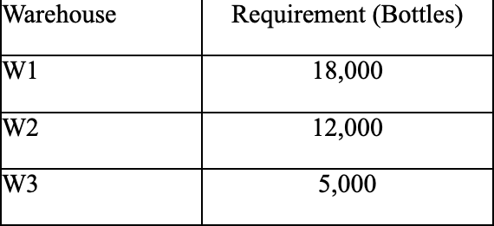
Determine how much of the company’s production should be shipped from each factory to each warehouse in order to minimize the total transportation cost. What is the optimal value of the objective function?
a. 141000

Quiz 11F
- Aggie Power Generation supplies electrical power to residential customers for many U.S. cities. Its main power generation plants are located in Los Angeles, Tulsa, and Seattle. The attached data table shows Aggie Power Generation’s major residential markets, the annual demand in each market (in Megawatts or MWs), and the cost to supply electricity to each market from each power generation plant (prices are in $/MW). AGGIE

If there are no restrictions on the amount of power that can be supplied by any of the power plants, what is the the total annual power distribution cost? Enter your answer rounded to two decimal places and without a dollar sign.
a. 2552382.81

- If at most 4,000 MWs of power can be supplied by any one of the power plants in Question 1, determine the new optimal solution. What is the annual increase in power distribution cost that results from adding these constraints to the original formulation? Enter your answer rounded to two decimal places and without a dollar sign.
a. 100566.41

- The Calhoun Textile Mill is in the process of deciding on a production schedule. It wishes to know how to weave the various fabrics it will produce during the coming quarter. The sales department has confirmed orders for each of the 15 fabrics produced by Calhoun. These demands are given in the attached data table. Calhoun Also given in this table is the variable cost for each fabric. The mill operates continuously during the quarter: 13 weeks, 7 days a week, and 24 hours a day.There are two types of looms: dobbie and regular. Dobbie looms can be used to make all fabrics and are the only looms that can weave certain fabrics, such as plaids. The rate of production for each fabric on each type of loom is also given in the table. Note that if the production rate is zero, the fabric cannot be woven on that type of loom. Also, if a fabric can be woven on each type of loom, then the production rates are equal. Calhoun has 90 regular looms and 15 dobbie looms. For this problem, assume that the time requirement to change over a loom from one fabric to another is negligible.Management would like to know how to allocate the looms to the fabrics and which fabrics to buy on the market so as to minimize the cost of meeting

demand. Enter your answer rounded to two decimal places without a dollar sign. a. 599108.16

- Refer to the Calhoun Textile Mill production problem described in the previous question. Use the procedure described in class to try to find an alternative optimal solution. Based on your answer, you can conclude that there are not alternative optimal solutions.
  - False

