Harran University - Yeniehir Campus

STAT 201

Chapter 12 Project Management
1)PERT and CPM are quantitative analysis tools designed to schedule and control large projects.
Answer: TRUE
- PERT is a deterministic analysis tool allowing for precise times of activities within a project.
Answer: FALSE
- PERT had its beginnings in a military department of the United States. Answer: TRUE
- CPM is a probabilistic analysis of managing a project. Answer: FALSE

- The first step in planning and scheduling a project is to develop the work breakdown structure.
Answer: TRUE
- A PERT/CPM network is a graphical display of a project that connects activities. Answer: TRUE
- The optimistic time is the greatest amount of time that could be required to complete an activity.

Answer: FALSE
- PERT is a network technique similar to CPM, but PERT allows for project crashing, whereas CPM does not.
Answer: FALSE
- In PERT, the most likely completion time of an activity is used to represent that activity's time within a project.
Answer: FALSE
- The expected completion time and variance of an activity is approximated by the normal distribution in a PERT analysis.
Answer: FALSE
- PERT was developed for a project for which activity or task times were uncertain. Answer: TRUE
- CPM was developed for use in managing projects about which we have good information about activity or task completion times.
Answer: TRUE
- With PERT, we are able to calculate the probability of finishing the project within a specified time.
Answer: TRUE
- With CPM, we are able to calculate the probability of finishing the project within a specified time.
Answer: FALSE
- Both PERT and CPM networks show activities and activity sequences. Answer: TRUE
- The identification of the project activities and their time, cost, resource requirements, predecessors, and person(s) responsible is called PERT planning.
Answer: FALSE
- Before drawing a PERT or CPM network, we must identify all activities and their predecessors.
Answer: TRUE
- The three time estimates employed in PERT are optimistic time, average time, and pessimistic time.
Answer: FALSE
- Given the variability of the activity completion times, the original critical path we identify in our PERT analysis may not always be the actual critical path as the project takes place. Answer: TRUE
- In PERT, the earliest start time for an activity is equal to the latest of the earliest finish times of all of its immediate predecessors.
Answer: TRUE
- PERT stands for Probabilistic Evaluation and Review Technique. Answer: FALSE
- One of the most significant benefits of PERT is that it forces the project manager to sit down and plan the project in great detail—and thus come to an understanding of relationships between the activities.
Answer: TRUE
- Slack is the time an activity can be delayed without impacting the completion time of the project.
Answer: TRUE
- The variance of the project completion time is equal to the sum of the variances of all the activities.
Answer: FALSE
- In PERT, we assume that the project completion time can be modeled by the normal distribution.
Answer: TRUE
- One PERT/COST assumption is that money is spent at a constant rate over the time taken to complete an activity.
Answer: TRUE
- CPM stands for Comprehensive Project Method. Answer: FALSE
- The longest time path through a PERT/CPM network is called the critical path. Answer: TRUE
- In CPM, crashing an activity that is not on the critical path increases the cost of the

project. Answer: TRUE
- Through the use of PERT/CPM, astute managers can derive flexibility by identifying noncritical activities and replanning, rescheduling, and reallocating resources such as personnel and finances.
Answer: TRUE
- In PERT, the variance in completion time is equal to the variance of the most time consuming activity on the critical path.
Answer: FALSE
- Given the assumptions in PERT, the probability that a project will be completed in less time than required by the activities on the critical path is approximately 50%.
Answer: TRUE
- Gantt charts and PERT diagrams provide the same information, just in different formats. Answer: FALSE
- Gantt charts contain information about the time taken by each activity, but not about the sequential dependencies of the activities.
Answer: TRUE

- The critical path of a network is the
- shortest time path through the network.
- path with the fewest activities.
- path with the most activities.
- longest time path through the network.
- None of the above

- In a PERT network, the earliest (activity) start time is the
- earliest time that an activity can be finished without delaying the entire project.
- latest time that an activity can be started without delaying the entire project.
- earliest time that an activity can start without violation of precedence requirements.
- latest time that an activity can be finished without delaying the entire project.
- None of the above

- Slack time in a network is the
- amount of time that an activity would take assuming very unfavorable conditions.
- shortest amount of time that could be required to complete the activity.
- amount of time that you would expect it would take to complete the activity.
- difference between the expected completion time of the project using pessimistic times and the expected completion time of the project using optimistic times.
- amount of time that an activity can be delayed without delaying the entire project.

- The first step in planning and scheduling a project is to develop the .
- employee scheduling plan
- PERT/CPM network diagram
- critical path
- work breakdown structure
- variance calculations for each activity

- Which of the following is not a concept associated with CPM?
- normal time
- probability
- normal cost
- crash cost
- deterministic network

- PERT
- assumes that we do not know ahead of time what activities must be completed.
- assumes that activity time estimates follow the normal probability distribution.
- is a network technique that uses three time estimates for each activity in a project.
- is a deterministic network technique that allows for project crashing.
- None of the above

- CPM
- assumes we do not know ahead of time what activities must be completed.
- assumes that activity time estimates follow the normal probability distribution.
- is a deterministic network technique that allows for project crashing.
- is a network technique that allows three time estimates for each activity in a project.
- None of the above

- Managers use the network analysis of PERT and CPM to help them
- derive flexibility by identifying noncritical activities.
- replan, reschedule, and reallocate resources such as manpower and finances.
- plan, schedule, monitor, and control large and complex projects.
- All of the above
- None of the above

- The expected time in PERT is
- a weighted average of the most optimistic time, most pessimistic time, and four times the most likely time.
- the modal time of a beta distribution.
- a simple average of the most optimistic, most likely, and most pessimistic times.
- the square root of the sum of the variances of the activities on the critical path.
- None of the above

- Given an activity's optimistic, most likely, and pessimistic time estimates of 4, 6, and 14 days respectively, compute the PERT expected activity time for this activity.
- 8
- 6
- 7
- 9
- None of the above

- Given an activity's optimistic, most likely, and pessimistic time estimates of 2, 5, and 14 days respectively, compute the PERT expected activity time for this activity.
- 6
- 7
- 9
- 5
- None of the above

- Given an activity's optimistic, most likely, and pessimistic time estimates of 4, 14, and 18 days respectively, compute the PERT expected activity time for this activity.
- 14
- 12
- 11
- 13
- None of the above

- Given an activity's optimistic, most likely, and pessimistic time estimates of 2, 10, and 20 days respectively, compute the PERT variance for this activity.
- 3
- 6
- 9
- 18
- None of the above

- Given an activity's optimistic, most likely, and pessimistic time estimates of 4, 12, and 18 days respectively, compute the PERT variance for this activity.
A) 2.33
B) 5.44
C) 8.00
D) 64.00
E) None of the above

- Given an activity's optimistic, most likely, and pessimistic time estimates of 3, 5, and 15 days, respectively, compute the PERT standard deviation for this activity.
- 2
- 4
- 5
- 15
- None of the above

- Given the following small project, the critical path is days.

Activity | Immediate  Predecessor | Time  (days)
A | - | 10
B | - | 4
C | A, B | 6
- 10
- 14
- 16
- 20
- None of the above

- Given the following small project, the critical path is days.

Activity | Immediate  Predecessor | Time  (days)
A | - | 8
B | A | 4
C | - | 10
- 4
- 10
- 12
- 22
- None of the above

Table 12-1
The following represents a project with know activity times. All times are in weeks.

Activity | Immediate Predecesso  r | Time
A | - | 4
B | - | 3
C | A | 2
D | B | 7
E | C, D | 4
F | B | 5

- Using the data in Table 12-1, what is the minimum possible time required for completing the project?
- 8
- 14
- 25
- 10
- None of the above

- Using the data in Table 12-1, what is the latest possible time that C may be started without delaying completion of the project?
- 0
- 4

- 8
- 10
- None of the above

- According to Table 12-1, compute the slack time for activity D.
- 0
- 5
- 3
- 6
- None of the above

- Using the data in Table 12-1, compute the latest finish time for activity E.
- 4
- 10
- 14
- 25
- None of the above

Table 12-2
The following represents a project with four activities. All times are in weeks.

Activity | Immediate Predecessor | Optimistic Time | Most Likely  Time | Pessimistic Time
A | - | 2 | 8 | 14
B | - | 8 | 8 | 8
C | A | 6 | 9 | 18
D | B | 5 | 11 | 17

- According to the data in Table 12-2, what is the critical path?
- A-B
- A-C
- B-D
- A-B-C-D
- None of the above

- According to the data in Table 12-2, what is the minimum expected completion time for the project?
- 18
- 19
- 37
- 11
- None of the above

- According to Table 12-2, there are four activities in the project. Assume the normal distribution is appropriate to use to determine the probability of finishing by a particular time. If you wished to find the probability of finishing the project in 20 weeks or fewer, it would be necessary to find the variance and then the standard deviation to be used with the normal distribution. What variance would be used?
- 2
- 4
- 8
- 12
- None of the above

- According to Table 12-2, there are four activities in the project. Assume the normal distribution is appropriate to use to determine the probability of finishing by a particular time. What is the probability that the project is finished in 16 weeks or fewer? (Round to two decimals.)
A) 0.07

B) 0.93
C) 0.43
D) 0.77
E) None of the above

- Consider a project that has an expected completion time of 60 weeks and a standard deviation of five weeks. What is the probability that the project is finished in 70 weeks or fewer? (Round to two decimals.)
A) 0.98
B) 0.48
C) 0.50
D) 0.02
E) 0.63

- Your company is considering submitting a bid on a major project. You determine that the expected completion time is 100 weeks and the standard deviation is 10 weeks. It is assumed that the normal distribution applies. You wish to set the due date for the project such that there is an 85 percent chance that the project will be finished by this time. What due date should be set?
A) 108.0
B) 110.4
C) 89.6
D) 85.0
E) 100

Table 12-3

Activity | Immediate  Predecessor | Optimistic | Most  Likely | Pessimistic | Standard  Deviation | Variance
A | -- | 4 | 5 | 6 | 0.333 | 0.111
B | -- | 12 | 16 | 18 | 1.000 | 1.000
C | A | 2 | 8 | 14 | 2.000 | 4.000
D | A | 5 | 5 | 5 | 0.000 | 0.000
E | B, C | 6 | 7 | 8 | 0.333 | 0.111

- According to Table 12-3, there are five activities in a PERT project. Which activities are on the critical path?
- A-B-C-D-E
- A-C-E
- B-D
- A-B-C-D
- B-E

- According to Table 12-3, there are five activities in a PERT project. What is the variance of the critical path?
A) 5.222
B) 4.222
C) 1.222
D) 0
E) 1.111

- According to Table 12-3, there are five activities in a PERT project. If the normal distribution were used to find the probability of finishing this project in 24 weeks or fewer, what mean and variance would be used?
A) 20 and 4.222
B) 30 and 5.222
C) 20 and 5.222
D) 30 and 4.222
E) 22.667 and 1.111

- The critical path of a network is the
- path with the least variance.
- path with zero slack.
- path with the most activities.
- path with the largest variance.
- None of the above

- In a PERT network, the latest (activity) start time is the
- earliest time that an activity can be finished without delaying the entire project.
- latest time that an activity can be started without delaying the entire project.
- earliest time that an activity can start without violation of precedence requirements.
- latest time that an activity can be finished without delaying the entire project.
- None of the above

- The work breakdown structure involves identifying the for each activity.
- time
- cost
- resource requirements
- predecessors
- All of the above

- PERT stands for .
- probabilistic evaluation and review technique
- program evaluation and review technique
- probability of expected run times
- program of expected run times
- project evaluation and review technique

- CPM stands for .
- critical path management
- critical project management
- critical project method
- critical path method
- centralized project management

- Which of the following questions can be answered by PERT?
- When will the entire project be completed?
- What is the probability that the project will be completed by a specific date?
- What are the critical activities?
- What are the noncritical activities?
- All of the above

- In PERT, we assume that
- the times to complete individual activities are known with certainty.
- all activities are carried out by staff from our own organization.
- the total cost of a project is independent of the time to complete the project.
- the total time to complete all activities on the critical path is described by a normal distribution.
- None of the above

- The two common techniques for drawing PERT networks are .
- NOA and NRA
- AON and AOA
- GANTT and NOA
- ONA and OAO
- CAN and CAA

- In PERT analysis, the probability of the optimistic time occurring should be on the order of .
A) 1/2
B) 1/3

C) 1/6
D) 1/10
E) 1/100

- The expected time in PERT is
- greater than the most likely time.
- equal to the most likely time.
- less than the most likely time.
- any of the above
- None of the above

- Given an activity's optimistic, most likely, and pessimistic time estimates of 3, 7, and 11 days respectively, compute the expected time for this activity.
- 5
- 6
- 7
- 12
- None of the above

- Given an activity's optimistic, most likely, and pessimistic time estimates of 3, 5, and 13 days respectively, compute the expected time for this activity.
- 3
- 4
- 5
- 6
- None of the above

- Given an activity's optimistic, most likely, and pessimistic time estimates of 1, 9, and 23 days respectively, compute the PERT expected activity time for this activity.
- 10
- 12
- 9
- 11
- None of the above

- Given an activity's optimistic, most likely, and pessimistic time estimates of 3, 6, and 9 days respectively, compute the PERT variance for this activity.
- 3
- 1
- 9
- 6
- None of the above

- The project described by:

Activity | Immediate  Predecessor | Time  (days)
A | -- | 10
B | A | 4
C | A | 6
D | B | 7
E | C | 5

is best represented by which of the following networks? A)

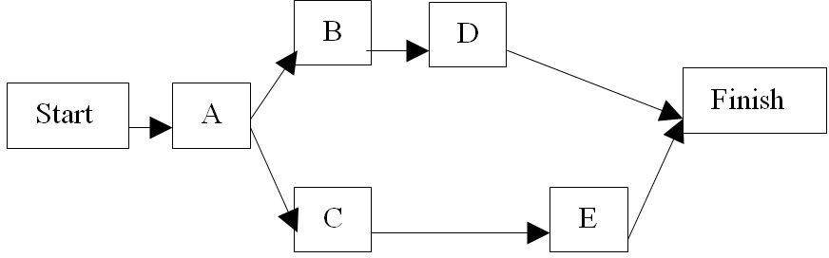
B)
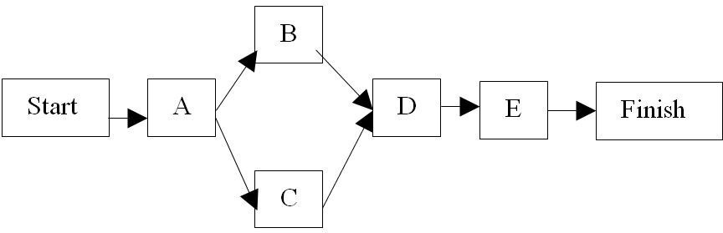
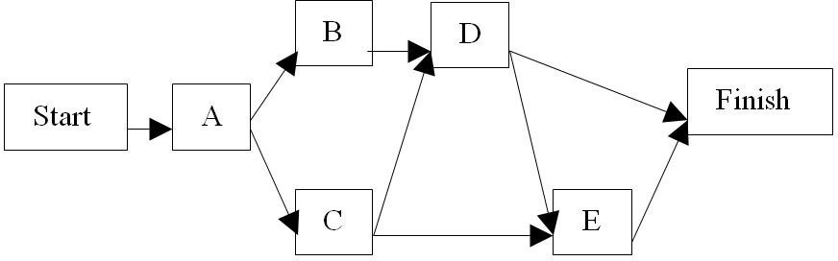
C)

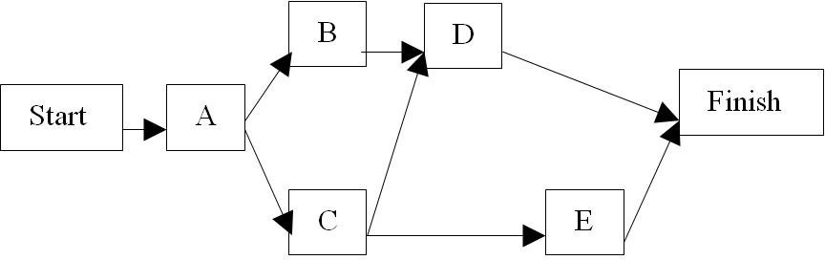
D)
E) None of the above
- The project described by:

Activity | Immediate  Predecessor | Time  (days)
A | -- | 10
B | A | 4
C | A | 6
D | B, C | 7
E | C | 5

has a critical path of length of .
- 21 days
- 14 days
- 23 days
- 32 days
- None of the above

- The project described by:

Activity | Immediate  Predecessor | Time  (days)
A | -- | 6
B | A | 2
C | -- | 8
D | B, C | 5
E | D | 7

has a critical path of length of .
- 15 days
- 20 days

- 17 days
- 18 days
- None of the above

Table 12-4
The following represents a project with known activity times. All times are in weeks.

Activity | Immediate  Predecessor | Time
A | -- | 4
B | -- | 3
C | A | 2
D | B | 7
E | C, D | 4
F | B | 5
G | E, F | 4

- Using the data in Table 12-4, what is the minimum possible time required for completing the project?
- 8
- 12
- 18
- 10
- None of the above

- Using the data in Table 12-4, what is the latest possible time that C may be started without delaying completion of the project?
- 0
- 4
- 8
- 10
- None of the above

- Using the data in Table 12-4, compute the slack time for activity D.
- 0
- 5
- 3
- 6
- None of the above

- Using the data in Table 12-4, compute the latest finish time for activity E.
- 4
- 10
- 14
- 25
- None of the above

- Using the data in Table 12-4, determine the latest time activity A can be started without delaying the project completion.
- 4
- 3
- 8
- 6
- None of the above

- Using the data in Table 12-4, determine the latest time activity A can be finished and not delay any activity?
- 4
- 0

- 8
- 5
- None of the above

- Consider a project that has an expected completion time of 50 weeks and a standard deviation of 9 weeks. What is the probability that the project is finished in 57 weeks or fewer? (Round to two decimals.)
A) 0.68
B) 0.78
C) 0.22
D) 0.32
E) None of the above

- Your company is considering submitting a bid on a major project. You determine that the expected completion time is 150 weeks and the standard deviation is 10 weeks. It is assumed that the normal distribution applies. You wish to set the due date for the project such that there is a 95 percent chance that the project will be finished by this time. What due date should be set?
A) 108.0
B) 160.4
C) 166.5
D) 135.0
E) None of the above

Table 12-5

Activity | Immediate  Predecessor | Time | ES | EF | LS | LF
A | -- | 4 | 0 | 4 | 6 | 10
B | -- | 5 | 0 | 5 | 0 | 5
C | A | 3 | 4 | 7 | 10 | 13
D | B | 8 | 5 | 13 | 5 | 13
E | B | 2 | 5 | 7 | 16 | 18
F | C, D | 3 | 13 | 16 | 15 | 18
G | C, D | 7 | 13 | 20 | 13 | 20
H | E, F | 2 | 16 | 18 | 18 | 20

- How long could Table 12-5's activity E be delayed without delaying the completion of the project?
- 7
- 16
- 11
- 18
- None of the above

- How long could Table 12-5's activity F be delayed without delaying the project?
- 2
- 3
- 14
- 16
- None of the above

- What is the minimum possible time required for completing the Table 12-5 project?
- 14
- 18
- 17
- 20
- None of the above

Table 12-6

Activity | Immediate  Predecessor | Optimistic | Most  Likely | Pessimistic | σ | σ2
A | -- | 2 | 3 | 4 | 0.333 | 0.111
B | -- | 2 | 5 | 8 | 1.000 | 1.000
C | A | 1 | 2 | 9 | 1.330 | 1.780
D | A | 5 | 5 | 5 | 0.000 | 0.000
E | B, C | 6 | 7 | 8 | 0.333 | 0.111
F | B | 14 | 14 | 14 | 0.000 | 0.000
G | D, E | 1 | 5 | 9 | 1.333 | 1.780
H | G, F | 1 | 4 | 8 | 1.167 | 1.362

- Which activities are part of Table 12-6's critical path?
- A-B-E-G-H
- A-C-E-G-H
- A-D-G-H
- B-F-H
- None of the above

- What is the variance of Table 12-6's critical path? A) 5.222
B) 4.364
C) 1.362
D) 5.144
E) 2.362

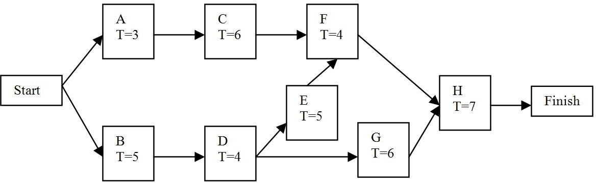
Figure 12-1

- Given the network in Figure 12-1, the critical path is
- A-C-F-H.
- B-D-E-F-H.
- A-C-E-G-H.
- B-D-G-E-F-H.
- None of the above

- Given the network in Figure 12-1, the time to complete those activities on the critical path is expected to be .
- 20
- 22
- 25
- 26
- None of the above

- Given the network shown in Figure 12-1, assume that completion of A is delayed by two days. What other activities are impacted?
- B

- D
- E
- C
- None of the above

- Given the network shown in Figure 12-1, assume that completion of B is delayed by two days. What happens to the project?
- The critical path is extended by two days.
- The start of activity F is delayed by two days.
- The start of activity E is delayed by two days.
- All of the above
- None of the above

- Given the network shown in Figure 12-1, assume that the completion of activity C is delayed by four days. What changes will take place?
- The critical path will change to: A-C-B-D-E-F-H.
- Activity F will be delayed by four days.
- Activity E will be delayed by four days.
- Activity G will be delayed by four days.
- None of the above

- Given the network shown in Figure 12-1 and the following information, what is the variance of the critical path?
Activity | Expected  time | Variance
A | 3 | 2
B | 5 | 3
C | 6 | 3
D | 4 | 1
E | 5 | 1
F | 4 | 2
G | 6 | 2
H | 7 | 2

- 16
- 7
- 9
- 8
- None of the above

- PERT often assumes that time estimates follow which of the following probability distributions?
- normal
- exponential
- binomial
- Poisson
- None of the above

- PERT assumes that the total completion time of a projects follows which of the following probability distributions?
- normal
- exponential
- binomial
- Poisson
- None of the above

- The crash time of an activity represents
- the normal time to complete an activity.
- the most pessimistic time to complete an activity.
- the incremental decrease in the time to complete an activity.
- the shortened activity time.
- None of the above

- Reducing the overall activity time is based on which of the following steps?
- crashing activities with the lowest overall crash cost
- crashing activities with the lowest overall normal cost
- crashing activities on the critical path based on lowest overall cost
- crashing activities on the critical path based on lowest cost/week
- crashing activities with the lowest cost/week.

- An alternative approach to project crashing is to use which of the following techniques?
- linear programming
- nonlinear programming
- Markov analysis
- queuing theory
- None of the above

- Which of the following is not a decision variable when formulating the project crashing problem as a linear program?
- the early finish times of critical activities
- the early finish times of non critical activities
- the start time of the project
- the finish time of the project
- the early start times of all activities

- Which of the following statement about project crashing is false?
- The crash cost is greater than or equal to the normal cost of an activity.
- The crash time is less than or equal to the normal time to complete an activity.
- Reducing the time of an activity on the critical path automatically reduces total project duration.
- It may not be possible to crash a particular activity.
- Crashing may not lead to an overall reduction in costs for the project.

- The process of smoothing out the utilization of resources in a project is called
- CPM.
- PERT.
- project crashing.
- work breakdown structure.
- resource leveling.

- Consider the following project schedule:

Activity | Immediate  Predecessor | Time | ES | EF | LS | LF
A | -- | 4 | 0 | 4 | 6 | 10
B | -- | 5 | 0 | 5 | 0 | 5
C | A | 3 | 4 | 7 | 10 | 13
D | B | 8 | 5 | 13 | 5 | 13
E | B | 2 | 5 | 7 | 16 | 18
F | C, D | 3 | 13 | 16 | 15 | 18
G | C, D | 7 | 13 | 20 | 13 | 20
H | E, F | 2 | 16 | 18 | 18 | 20

- Which activities are critical?
- Which activity has the most slack?
Answer: (a) B, D, G
(b) E

- Consider the project with the following estimates for activity times and precedence relationships:

Activity | Optimistic  Time | Most  Likely Time | Pessimistic  Time | Immediate  Predecessor(s)
A | 3 | 4 | 5 | ---
B | 5 | 7 | 9 | ---
C | 2 | 3 | 10 | A
D | 2 | 5 | 8 | B
E | 1 | 7 | 7 | B
F | 3 | 5 | 7 | C, D
G | 7 | 8 | 9 | D, E
H | 2 | 6 | 10 | F

- What is the expected duration of the project?
- What is the project variance?
- If the deadline of the project is 25 days, what is the probability of finishing the project on time?
Answer:
(a) 23
(b) 3.67
(c) 0.8508

- Consider the tasks, durations, and predecessor relationships in the following network. Draw the network and answer the questions that follow.

Activity | Immediate  Predecessors) | Optimistic  (Weeks) | Most Likely  (Weeks) | Pessimistic  (Weeks)
A | --- | 4 | 7 | 10
B | A | 2 | 8 | 20
C | A | 8 | 12 | 16
D | B | 1 | 2 | 3
E | D, C | 6 | 8 | 22
F | C | 2 | 3 | 4
G | F | 2 | 2 | 2
H | F | 6 | 8 | 10
I | E, G, H | 4 | 8 | 12
J | I | 1 | 2 | 3

- What is the expected duration of the project?
- What is the probability of completion of the project before week 42? Answer:
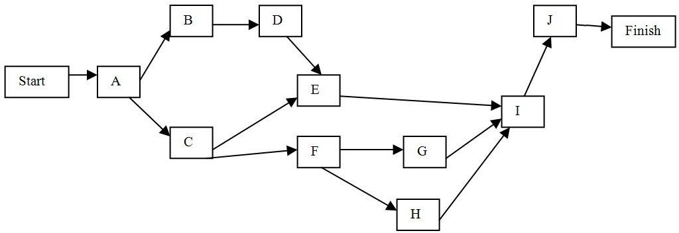

(a) 40 (b) 8079

- Given:

Activity | Optimistic | Most  Likely | Pessimistic
A | 3 | 4 | 5
B | 6 | 7 | 14
C | 6 | 9 | 12
D | 0.5 | 1 | 1.5
E | 2 | 3 | 10
F | 4 | 5 | 12
G | 1 | 3 | 11
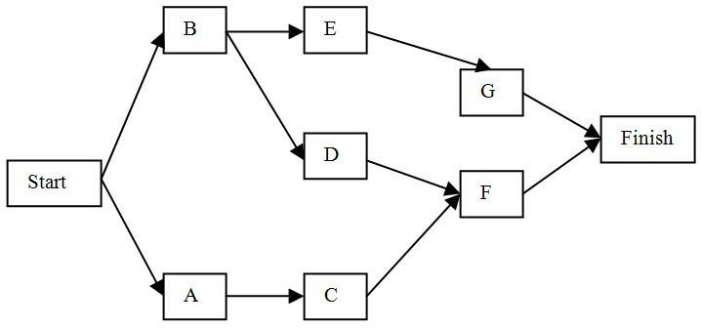
Determine:
- the critical path.
- the probability that the project will be completed in 22 weeks. Answer: (a) Critical path is A-C-F. Expected time is 19.
(b) Variance for critical path is 2.889, so standard deviation is 1.70. P(X ≤ 22) = 0.9608

- A small software development project has five major activities. The times are estimated and provided in the table below.

Activity | Immediate  Predecessor | a | m | b
A | -- | 2 | 5 | 8
B | -- | 10 | 10 | 10
C | A | 4 | 7 | 10
D | B | 2 | 5 | 14
E | C | 3 | 3 | 3

- What is the expected completion time for this project?
- What variance would be used in finding probabilities of finishing by a certain time? Answer:
- expected completion time = 16 (Activities B-D)
- variance = 0 + 4 = 4
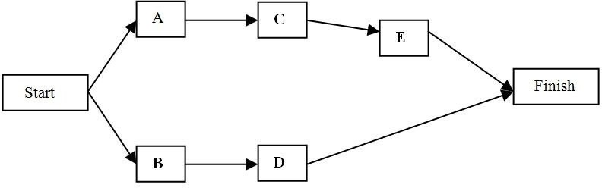

- Development of a new deluxe version of a particular software product is being considered. The activities necessary for the completion of this are listed in the table below (Time in weeks).

Activity | Normal  Time | Crash  Time | Normal  Cost | Crash  Cost | Immediate  Predecessor
A | 4 | 3 | 2200 | 2600 | --
B | 2 | 1 | 2200 | 2800 | --
C | 3 | 3 | 500 | 500 | --
D | 8 | 4 | 2300 | 2600 | A
E | 6 | 3 | 900 | 1200 | B
F | 3 | 2 | 3000 | 4200 | C
G | 4 | 2 | 1400 | 2000 | D, E

- What is the project completion date?
- What is the total cost required for completing this project on normal time?
- If you wish to reduce the time required to complete this project by one week, which activity should be crashed, and how much will this increase the total cost?
Answer:
- Project completion time = 16 weeks (Activities A-D-G)
- Total cost = $12,300
- Crash D, one week at an additional cost of $75
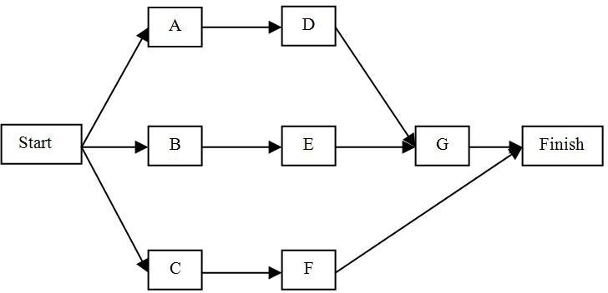

- Draw the PERT network associated with the following activities.

Activity | Immediate  Predecessor
A | --
B | A
C | A
D | B
E | B
F | C, E
G | A, D
H | F
I | F
J | G, H, I

Answer:

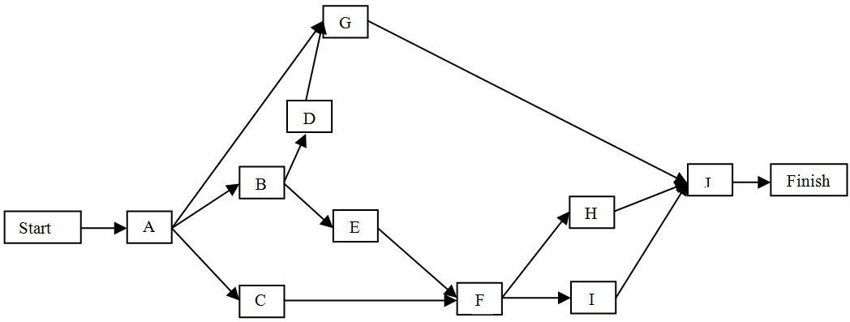

- Given (Time in weeks):

Activity | Optimistic | Most Likely | Pessimistic
A | 3 | 4 | 5
B | 6 | 7 | 14
C | 2 | 3 | 10
D | 6 | 9 | 12
E | 4 | 5 | 12
F | 1 | 3 | 11
G | 1 | 2 | 9
H | 2 | 5 | 8
I | 1 | 4 | 7
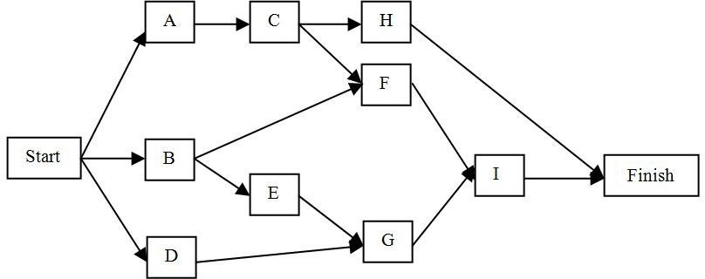

Determine:
- the critical path.
- the probability that the project will be completed in 22 weeks. Answer:
- Critical path is B-E-G-I.
- Variance for critical path is 6.33; standard deviation is 2.51. The probability that the project will be completed in 22 weeks = 0.65.

- A small software development project has four major activities. The times are estimated and provided in the table below.

Activity | Immediate Predecesso  r | a | m | b
A | -- | 2 | 5 | 8
B | A | 3 | 6 | 9
C | A | 4 | 7 | 10
D | B | 2 | 5 | 14
E | D | 3 | 3 | 3
F | C | 6 | 8 | 10
G | E, F | 1 | 1 | 1
H | C | 6 | 10 | 14
I | G, H | 3 | 4 | 5

- What is the expected completion time for this project?
- What variance would be used in finding probabilities of finishing by a certain time? Answer:
- expected completion time = 26 (Activities A-C-H-I)
- variance = 3.88
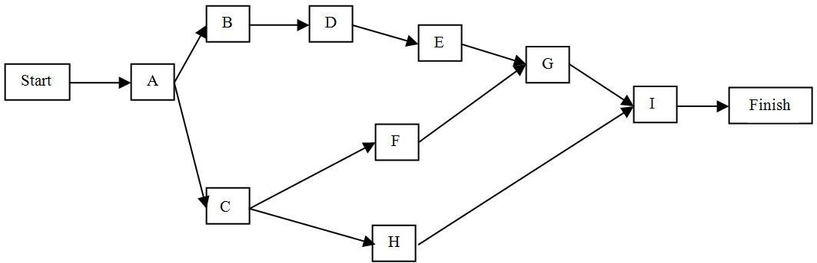

- Development of a new deluxe version of a particular software product is being considered. The activities necessary for the completion of this are listed in the table below (Time in weeks).

Activity | Immediate  Predecessor | a | m | b
A | -- | 2 | 5 | 8
B | A | 3 | 6 | 9
C | A | 4 | 7 | 10
D | B | 2 | 5 | 14
E | D | 3 | 3 | 3
F | C | 6 | 8 | 10
G | E, F | 1 | 1 | 1
H | C | 6 | 10 | 14
I | G, H | 3 | 4 | 5

- If you wish to reduce the time required to complete this project by two weeks, which activity(ies) should be crashed, and how much will this increase the total cost?
- What would be the added cost if you wanted to complete the project in the minimum time possible?
Answer:
- Crash D, two weeks at an additional cost of $100
- Crash D 4 weeks, G 2 weeks, E 3 weeks, A 1 week, and B 1 week, for a total additional cost of $1,700

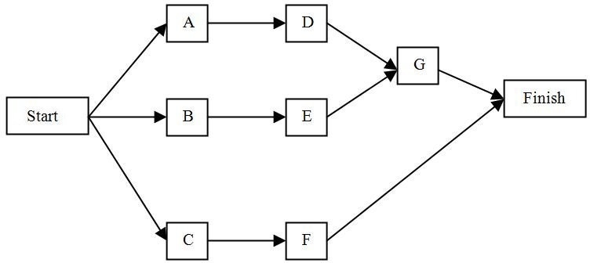

- PERT is the acronym for what?
Answer: Program Evaluation and Review Technique.

- In a PERT analysis, how is the optimistic time defined?
Answer: the estimated time for an activity, should circumstances go as well as possible (should have a low probability of actual occurrence)

- CPM is the acronym for what? Answer: Critical Path Method

- In PERT analysis, how is the pessimistic activity time defined?
Answer: the estimated time for an activity, based on unfavorable conditions (should have a low probability of actual occurrence)

- In PERT/CPM, what is meant by the critical path?
Answer: the series of activities in a network that has zero slack or the longest time path through a network

