Concordia University

PHYS 273

LESSON 4
1)Most countries depend on fossil fuels for more than 50% of their energy needs. T OR F
Answer:True
- What percentage of Canada’s energy consumption is in the form of fossil fuels

  - almost zero
  - about 25%
  - about 50%
  - about 75%
  - almost all Answer: D
- Using Sankey diagram: which of the following is not a main use of energy produced by nat- ural gas?

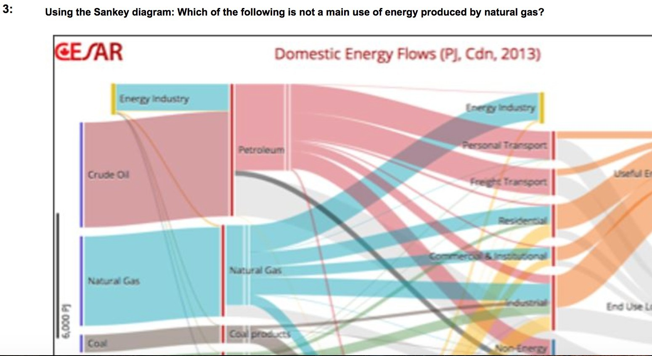

  - Residential
  - Commercial
  - industrial
  - transport

Answer: D

- Energy use per person is much higher

  - in high developed countries
  - in less
Answer: A

- Fossil fuels are not renewable resources because

  - they are bad for environment
  - take 100s millions years to produce
  - are hard to extract from Earth
  - cause too many emissions
Answer: B
- In North america, since 2005, natural gas consumption has:

  - increased b.plateaued
  - decreased
Answer: A

- how is the majority of electricity produced in Canada?

  - Hydro
  - Coal
  - Uranium
  - Solar Answer: A
- In the last 30 years South Asia has not seen a large increase in % of energy coming from fossil fuels. T OR F

Answer: False

