University of California, Davis

ARE 140

Answers are bold
ARE 140 -Quiz 2 January 16

1)Which one of the following conflicts with journalist Ben Swann's “Reality Check” report included in your assignment:
  - The recently created Interagency Center housed in the state department will coordinate and centralize domestic counter-propaganda efforts for the US Government.
  - Propaganda is information, ideas, or rumors deliberately spread widely to help or harm a person, a group, a movement, an institution, a nation, etc.
  - This legislation provides funding both for the new government agency and for private-sector think-tanks engaged in counter-propaganda related works.
  - Answer: Currently it is illegal for the US Government to disseminate propaganda materials to US citizens domestically because of the ban passed in 1948 to protect US citizens from their own government's misinformation campaigns.

2.Based on last Thursday's lecture that featured the accompanying graphic, identify the one incorrect statement below:

  - On average in the USA, the farmer's share of the retail value of the consumer's food expenditures has declined significantly over the past 60+ years.
  - Making cotton bolls into a more finished or usable product by ginning the cotton is an example of a farmer adding value to a raw farm product (if the farmer owns the cotton gin).
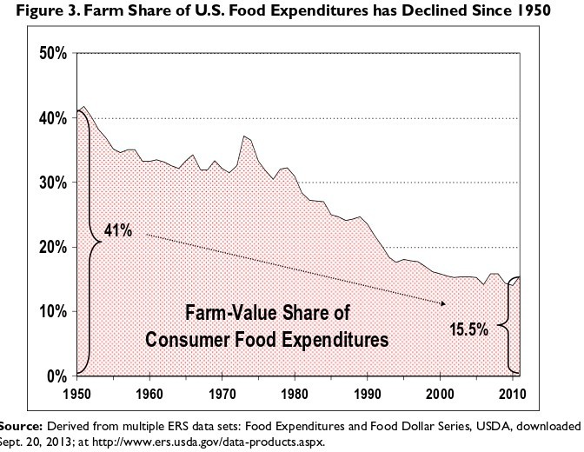
  - Consumers cooking and processing food at home adds value to the raw farm product for themselves, something that was a more common practice in the 1950s than today.

It is clear from the accompanying graphic that as a result of getting a lesser proportion of the retail value of

food since 1950, farm net income has dropped since the 1950s.

Regarding Case Study # 1, The Cannery urban farm, is the location of the farm easy to see from the road?
  - yes b) no

