Carleton University

ERTH 2415
answers are highlighted

Quiz 2:

1)you are in a helicopter following a tsunami. You measure the time between successive waves to be 100s. The frequency of the tsunami is 100s.
  - True b) False

- Tsunami waves can have a velocity similar to the cruising speed of a jumbo jet a) True
b) False

- The National Oceanic and Atmospheric Administration (NOAA) is the US agency responsible for monitoring the conditions of oceans, waterways, and the atmosphere. The following webpage is operated by NOAA and tracks tsunamis in the pacific ocean.The website lists Tsunami Messages for All Regions for the past 30 days. Select the HTML announcement for Kilauea Volcano on 14 July 2018 05:12.
An earthquake of a magnitude of 5.2 was observed. A tsunami warning was issued.
  - True b) False

- Go to the Pacific Tsunami warning centre website. Go to FAQ (left) webpage. The frequency of a major tsunami is 1 every 10 years.
  - True
  - False

- The department of Public safety operates the Get Prepared” website which provides useful tips to the public on how to prepare for a natural disaster. We wll explore this information. A tsunami can occur in large lakes but with a big warning,
  - True b) False

- Shield Volcanoes are smaller than lava plateaus
  - True b) False

- An increase in pressure is the most important mechanism to cause solid rock to melt into magma.
  - True b) False

- The Cascade Range of volcanoes of Northwestern North America is part of a chain of subduction zone volcanoes.
  - True

  - False

- Mt. Baker is considered a formant volcano since the ash explosions were in the 1840s.
  - True b) False

- In the textbook, go to Chapter 6 > (p190). Regarding volcanic causes of death, the top 3 direct causes of deaths are pyroclastic flows, tsunami, and lahar.
  - True
  - False

- In the textbook, go to Chapter 6 > Section Canada’s Sleeping Volcanoes > Garibaldi Volcano, Southern British Columbia (p181).
Garibaldi volcano is a stratovolcano that has been damaged and rebuilt several times in a succession of violent eruptions..
  - True
  - False

- The USGS is an agency responsible for providing science on natural hazards in the US. The USGS Volcanic hazards program website provides information on volcano monitoring, news and safety.
Go to the USGS website and navigate to “Prepare” (top right) and “During an Eruption” (left).
If you are near or downwind of a volcano during an eruption, you should not drive unless absolutely necessary.
  - True
  - False

- In the USGS Volcanic hazards program website, go to “Volcano Updates” “Alert-level system.
Notifications are issued through 10 regional US Volcano observatories.
  - True b) False

- In the textbook, review the in Greater depth > Volcanic ash: challenge to air traffic safety (p/186).
Ash can melt and later solidify on turbine blades, causing the engine to stall. a) True
b) False

- In Lake Nyos, Cameroon a successful solution to reduce the CO2 hazard has been installed vertical pipes to bring the CO2 to the surface.
  - True
  - False





- Go to the Pacific tsunami warning centre website. Go to FAQ and Identify the FALSE statement.
- The wave looks and acts like giant river of water on top of the ocean that floods the shore.
- Seismic waves travel about 100 times faster than tsunami waves. This means, we can detect and study the earthquake much more quickly than the tsunami itself.
- A tsunami advisory is issued when there is an earthquake of any kind
on the coast.
- A boat at sea should stay at sea until the harbor authority says it is safe to return.

- Regarding tsunamis and Canada, identify the FALSE statement.
  - The most frequent source of tsunami in BC is from Alaska.
  - The 1929 Grand Banks earthquake event, that triggered the tsunami, caused major damage before the tsunami reached land
  - The 1700 Cascadia earthquake and tsunami is known through oral history and is known to have destroyed a coastal village on Vancouver Island.
  - A tsunami generated from an earthquake in the Cascadia subduction zone would strike within minutes.

- In the textbook, go to Chapter 7 Tsunamis > Section Wind-caused Waves versus Tsunami Waves (p213). Identify the FALSE statement.
  - Tsunami waves have less momentum than wind-caused waves.
  - In the open ocean, wind-caused waves are generally taller than tsunami waves.
  - Wind-caused waves are different than tsunami waves in that each wave can be considered a solitary unit.
  - A knee high tsunami can kill you





- You decide you want to observe active volcanic activity. The safest volcano to observe would be located in
a) Kilimanjaro, Tanzania b) Iceland
- Tambora Indonesia.
- Mount St. Helens

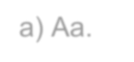
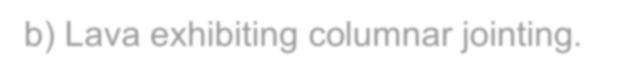
- The above figure was taken at the Kilauea volcano, Hawaii. What type of lava flow is shown in Figure?
- Aa.
- Lava exhibiting columnar jointing.

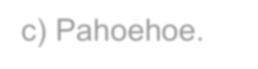
- Pahoehoe.
- Pillow lava.

- Regarding viscosity and volcanic eruptions. Identify the FALSE statement.
- High viscosity magma have explosive eruptions.
- Temperature is one of the factors that control viscosity.
- High viscosity magma traps volatiles.
- A high viscosity magma has lower Si02 content.


- Regarding volcanic materials, identify the FALSE statement:
a. A lava flow with low % of volatiles that cools quickly creates obsidian. b. A lava flow with low viscosity that cools quickly creates a pahoehoe
texture.
c. A lava flow with high viscosity that cools slowly creates an Aa texture.
d. Pillow lava is created when the cooling is underwater.

- In the textbook, go to Chapter 5 Volcanic Eruptions and Landforms, Section “The Three Vs of Volcanology” (p156).
Table 5.5 and 5.6 realate the magma characteristics and the 3 Vs. Review these tables and the associated text.

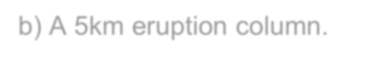
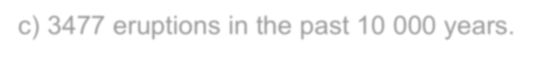
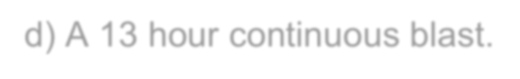
Strombolian eruption style is NOT characterized by:
- The presence of andesite.
- A 5km eruption column.
- 3477 eruptions in the past 10 000 years. d) A 13 hour continuous blast.

- In the textbook, go to Chapter 5 Volcanic Eruptions and Landforms, Section “The Three V’s of Volcanology” (p156). Tables 5.5, 5.6, 5.7, 5.8 relate the magma characteristics, 3 V’s, volcanic explosively index (VEI), and frequency/energy release of volcanic eruptions.
Review these tables and the associated text.
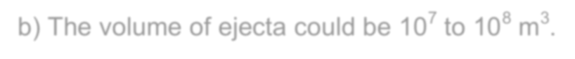


For an event with a medium volatile content, identify the FALSE statement.
- The volcanic landform could be a stratovolcano.
- The volume of ejecta could be 10⁷ to 10⁸ m³.
- The duration of the continuous blast can be in the range of 6 to 12 hours.
- For this volcano, the eruption frequency could be 39 eruptions every 10
000 years.

- The figure shows a a) Stratovolcnao

- Caldera
- shield volcano
- lava dome




- Go to the Get Prepared, Government of Canada, website and navigate to “Tsunami” and review the links “What to do”, “Before…” & “During…”. Identify the TRUE statement.
- A tsunami may be hit shorelines if the earthquake shaking lasts more than ten seconds.
- Leave your gas line ON, you may need to use the gas for heat or for cooking.
- If you hear a tsunami warning, you should move to lower ground.
- If you cannot get to higher ground, stay inside where you are protected from the water.
- Natural Resources Canada (NRC) provides information on volcanic hazards in Canada. Go to the “What are the hazards from volcanoes” link.


Identify the FALSE statement:
- Phreatic explosions are explosions caused by the interaction of water with hot rock or magma (lava).
- A volcanic landslide into large bodies of water can generate a tsunami.
- Jokulhlaups are large abrupt floods of water that may be triggered by volcano eruptions that are under a glacier.
- Volcanic ash is tephra smaller than 4 mm (and may be as small as thousandths of a millimetre).
- Go to the “What are the special hazards from volcanic ash?” link. Identify the FALSE statement




- Go to the “Where are Canada's volcanoes?” link. Identify the FALSE statement:
- Ash from the 1980 Mount St. Helens caused complete darkness in a city 400 km away from the volcano.
- During a large explosion, air travel disruptions would be likely, even in areas where no ash was deposited.
- Volcanic ash is similar to the ash produced by burning wood (hard,
abrasive, corrosive, electrically charged, and in water)
- The Interagency Volcanic Event Notification Plan (IVENP) ensures rapid and effective communication of information to the aviation community.


- Ash from Mount Meager of southwest British Columbia was found in
Saskatchewan
- Canada has 5 potential active volcanic areas.
- Even though a volcano has not erupted explosively for a millennia, there is still potential for future eruptions.
- The glass shards from an eruption at Mount Churchill were found in Newfoundland, Ireland and northern Europe.



- In the USGS Volcano hazards program website. Identify the FALSE statement
- In the “Hazards / Ash” section: Ash fallout can impact power supply and communications equipment.
- In the “Monitoring / Gas & Water” section: Volcanic gas and water are sampled and measured both when volcanoes are erupting and when they are quiet.
- In the “Education” section: the opportunity to observe and learn is rare
for the Hawaiian and Alaskan volcanoes.
- In the “Preparedness / During an Eruption” section: if you are near or downwind of a volcano during an eruption, you should not drive unless absolutely necessary.

