Dynamic Earth
Student
Institution
Class
Professor
Date

Dynamic Earth
Question 1
Continental drift refers to the movement of the earth’s continents towards or away from each other due to the drifting of the tectonic plates that make up the earth’s crust (Runcorn, 2013). Alfred Wegner proposed the continental drift theory in 1912 in an attempt to explain the shifting positions of the continents. Some of the evidence that was set forth to support the idea that the continents were once a joined body (Pangaea) but have ever drifted apart include: the jig-saw fit of the continents, fossil deposits, and truncated geologic features (Runcorn, 2013).
A closer look at the world map clearly shows that the continental margins form a complimentary pattern that resembles the jig-saw puzzle. Most continents form matching patterns along the coastlines, which seems to fit uniformly when brought together. For example, the western continental margin of Africa forms a complementary pattern with the eastern continental margin of South America (Runcorn, 2013). This suggests that South America and Africa were once joined together before they drifted away from each other more than 200 million years ago.
Similar fossils of plants and animals were discovered on different continents that were suggested to be together before the drift (Smith, 2020). Interestingly, the fossils were of similar animals, formed at the same time under similar conditions. This implies that the organisms must have been living in the same area, and after death, their remains were buried across the same area. Such fossils must have been separated by the drifting of the continents away from each other. For example, the fossils of an ancient shallow-water reptile, Mesosaurus, were discovered in South America and Africa (Runcorn, 2013). These reptiles lived in shallow waters and could not swim across the Atlantic Ocean. Additionally, the fossils of a family of seed-bearing ferns, Glossopteris, were discovered in Africa, South America, Asia, and Antarctica, implying that these plants must have grown under the same environmental conditions when the continents were joined together (Smith, 2020).
Some geologic features such as mountains seem to have been truncated by the drifting away of continents. The Acadian Orogeny in the northern Appalachians was formed at the same time as the Caledonide Orogeny in northern Great Britain and Scandinavia (Runcorn, 2013). If Europe and North America are perfectly reconstructed to form a single landmass, the Caledonides of northwestern Europe forms a perfect continuation of the Appalachians (Smith, 2020). Also, the sedimentary rocks forming the coastlines of western Africa and eastern South America have similar structures and ages but are cut off suddenly, implying that it was once a continuous rock stratum.
Question 2
Nepal is a landlocked country located in South Asia. On the other hand, Hawaii is an island state located on the western side of the United States and surrounded by the Pacific Ocean. Nepal lies on top of the boundary between the Indian and Eurasian plates, while Hawaii lies on top of the Pacific plate (Ding & Sun, 2020, p. 781-788). Nepal has dormant volcanoes that no longer erupt, unlike Hawaii that has very active volcanoes that have erupted at least ten times within the last 1000 years. Nepal is particularly prone to earthquakes because it lies on the boundary between two colliding plates (Kozhurin, 2004, p. 273-285). However, Hawaii is prone to tsunamis since it lies on the Pacific plate that keeps moving on top of the hot spots in the Pacific. Nepal lies on the convergent boundary between the Indian Plate and the Eurasian plate. Conversely, Hawaii lies in the middle of the Pacific plate above the Hawaiian hot spot. Nepal is located along the tectonic fault zone of the Himalayas. However, Hawaii is located far away from the tectonic fault zones. Nepal is dominated by fold mountains such as the Himalayas, with virtually no volcanoes (Kozhurin, 2004, p. 273-285). Hawaii, on the other hand, is dominated by volcanoes that are still active.
Question 3
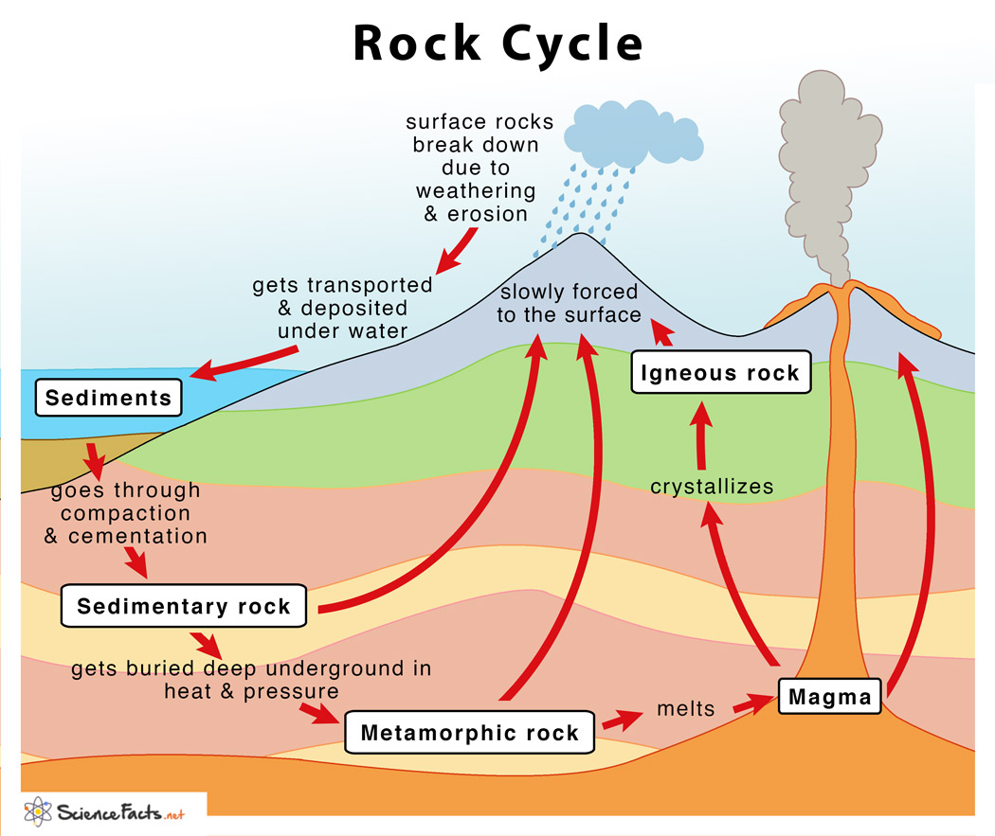
The rock cycle involves various steps that the crustal rocks undergo to change form from one type to another. There exists three main types of rocks that make up the earth’s crust: sedimentary, metamorphic and igneous rocks (Ostopowich, 2015). The rock type changes when the equilibrium conditions of the rock shift. The rock cycle occurs in six main steps: weathering and erosion, transportation, deposition, compaction and cementation, metamorphism, and rock melting (Ostopowich, 2015).
On the upper crust are igneous rocks, which break down into small pieces when acted upon by weathering agents and erosion like water and wind. Through transportation and deposition, the broken rock particles (sediments) accumulate over time. With the increased pressure exerted by newly deposited rock particles, the sediments undergo compaction and cementation to form sedimentary rocks (Ostopowich, 2015). Continuous sedimentation and compaction of the sediments resulting in the formation of numerous layers of sedimentary rocks. Over a long period, the weight of overlying rock strata increases the pressure exerted on the below rock layers. Due to intense pressure and high temperature deep down in the earth, the sedimentary rock melts to form metamorphic rocks (Ostopowich, 2015).
The molten metamorphic rock exists deep down in the earth as magma. Due to extremely high temperature and intense pressure exerted by the weight of the overlying crustal rocks, the molten magma escapes into the crust and above the ground through lines of weaknesses. As the magma moves out, it cools and solidifies within the crust (intrusive rock) or above the ground (extrusive rock) to form igneous rock (Ostopowich, 2015). Since the igneous rock is exposed to the surface, it’s vulnerable to weathering and erosion, which breaks down the large rock into smaller sediments. The sediments again accumulate the undergo compression and cementation to form the sedimentary rocks. The cycle goes on, resulting in the rock cycle.
Question 4
A rock is a naturally occurring substance made up of accumulated minerals. The three main types of rocks include igneous, sedimentary and metamorphic rocks (Pellant & Pellant, 2021). On the other hand, a mineral is a naturally occurring inorganic element or compound with definite chemical composition and physical properties. Examples of minerals include quartz, calcite, and feldspar (Pellant & Pellant, 2021).
The igneous rocks form when lava (molten rock) cools and solidifies within or above the ground surface. Sedimentary rocks form when sediments accumulate in layers then undergo compaction and cementation. Metamorphic rocks form when the existing rocks (igneous, sedimentary, or other metamorphic) undergo intense heating and pressure deep down in the earth and melt then change state (Pellant & Pellant, 2021). Igneous rocks form from solidification, whereas sedimentary rock forms from lithification (compaction and cementation) of sediments. Metamorphic rock, on the other hand, forms from melting. Igneous rocks are shallow and exist near or are exposed to the earth’s surface. Conversely, sedimentary rocks exist in layers some distance below the upper crust (intermediate). Metamorphic rocks lie deep down in the earth and may exist in a solid or molten state. Igneous rocks are acidic due to the high content of acidic minerals such as feldspar (Pellant & Pellant, 2021). Sedimentary rocks are, however, basic due to the presence of basic minerals like limestone. Metamorphic rocks are either basic or acidic, depending on whether the parent material was an igneous or sedimentary rock.
The igneous rocks are non-porous and hardly allow water to pass through, whereas the sedimentary rocks are porous and easily allow water to penetrate. Metamorphic rocks are hot and steam water. The igneous rocks have few fossil deposits because they form from magma that intrudes and solidifies on the ground surface, while the sedimentary rocks are the richest in fossil deposits that form during the accumulation of sediments (Pellant & Pellant, 2021). Metamorphic rocks are too hot for fossils to deposit and lack fossil deposits. Igneous rocks are moderately hard because they are made up of hard minerals such as hornblende and pyroxene. Sedimentary rocks are softer due to the presence of soft minerals like calcite and gypsum. Metamorphic rocks are the hardest because they are made up of various hard minerals. Igneous rocks may be light or dark in color, whereas sedimentary rock has a wide variety of colors due to the accumulation of various minerals (Pellant & Pellant, 2021). Metamorphic rock also exists in many colors depending on the available minerals.
Examples of igneous rock include obsidian, basalt, pumice, dacite, and andesite. Examples of sedimentary rocks are sandstone, shale, siltstone, conglomerate, and limestone (Pellant & Pellant, 2021). Common examples of metamorphic rocks are quartzite, marble, schist, phyllite, and gneiss.
Question 6
Hazards from natural processes such as earthquakes, tsunami, and the volcano cannot be prevented from occurring. Whenever they occur, many lives are lost, and unaccountable properties get damaged. These hazards can be accommodated by implementing early warning systems, sound engineering practices, and hazard analysis (PAToN, 2017, p. 3-17).
The early warning system (EWS) refers to the combination of tools and processes implemented within institutional structures and coordinated by national or international organs to help communities adequately prepare for natural hazards (PAToN, 2017, p. 3-17). The four elements of EWS include: “knowledge of the risk, technical monitoring and warning service, dissemination of meaningful warnings to at-risk people and public awareness and preparedness to the hazard” (PAToN, 2017, p. 3-17). Setting up onshore and offshore earthquake and tsunami detection centers makes it easier to detect these hazards and evacuate people to safer places before the disaster strikes. Authorities should integrate modern technologies such as remote sensing and geographic information systems, satellite communication, ICTs for crowdsourcing, and crisis mapping to inform people and prepare them for hazards (PAToN, 2017, p. 3-17). Public awareness is one of the greatest tools that can be used to mitigate the impact of natural hazards.
The engineering structures should be properly designed to accommodate the hazards. This helps save the structures from destruction and saves numerous lives that might have been lost when the structures collapse. For instance, buildings and roads should be designed and constructed in safer areas away from the natural hazard-prone areas (PAToN, 2017, p. 3-17). Also, the buildings, bridges, ships, coastal structures, and roads should be designed to withstand the destructive force of the hazards. Japan is a typical example of a nation along the ring of fire with flexible skyscrapers that can withstand high magnitude earthquakes.
Advanced data analysis tools should be used to analyze the trends of the hazards and establish their pattern of occurrence (PAToN, 2017, p. 3-17). This helps predict when the next disaster is likely to occur and allows early preparation through evacuation or other recommended solutions. Societies must implement effective risk management plans to prepare for the hazards and identify the mitigation procedures. Sufficient evacuation experts and equipment should be readily available, especially in vulnerable areas, to assist in evacuating the people as quickly as possible (PAToN, 2017, p. 3-17). Strict policies should also be imposed on individuals that fail to respond to disaster warnings. More importantly, false alarms must be minimized to maximize public trust and confidence in disaster alarms.
Question 7
The interior of the earth comprises the inner core, outer core, mantle, and crust. The core of the earth is unique and believed to be extremely hot and rich in iron minerals. Since it’s impossible to drill to the earth’s center, scientists rely on secondary techniques to acquire information regarding the earth’s interior. The methods used to study the earth’s interior include rocks and minerals laboratory experiments, measurement of seismic waves, magnetic and gravitational evidence (Gutenberg, 2016).
Scientists conduct physical and chemical experiments by subjecting rocks and minerals with similar characteristics inner core to extreme heat and pressure and see how they react. (Gutenberg, 2016) Also, the scientists analyze the materials collected from meteorites in the lab to get a clue of the earth’s interior since they are believed to be made up of materials that make up the earth. The scientists also use seismic waves’ knowledge to analyze how the waves travel during and after earthquakes (Gutenberg, 2016). By understanding the properties of these waves when they travel through various materials, the experts are able to deduce information to explain the unique features in the earth’s interior. The earth has a magnetic field which can be due to a permanent magnet or ionized molecules that move in a liquid medium within the earth’s interior. Typically, a permanent magnet cannot exist under high temperatures at the earth’s center, and scientists’ conclusion that the unique core is liquid can be considered valid (Gutenberg, 2016).

References
Ding, W., & Sun, Z. (2020). Marginal basins of the NW Pacific and Eastern Eurasia. International Geology Review, 62(7-8), 781-788.
Gutenberg, B. (2016). Physics of the Earth's Interior. Elsevier.
Kozhurin, A. I. (2004). Active faulting at the Eurasian, North American and Pacific plates junction. Tectonophysics, 380(3-4), 273-285.
Ostopowich, M. (2015). The Rock Cycle. Weigl Publishers.
PAToN, D. (2017). Co-existing with Natural Hazards and their Consequences. Disaster Resilience: An Integrated Approach, 2nd ed.; Paton, D., Johnston, DM, Eds, 3-17.
Pellant, C., & Pellant, H. (2021). Rocks and minerals. Dorling Kindersley Ltd.
Runcorn, S. K. (Ed.). (2013). Continental drift. Elsevier.
Smith, A. G. (2020). Continental drift. Encyclopedia of Solid Earth Geophysics, 1-2.

