Quincy College
BIO 151
Chapter 20. Antimicrobial Drugs
MULTIPLE CHOICE. Choose the one alternative that best completes the statement or answers the question.
1)Penicillin was considered a "miracle drug" for all of the following reasons EXCEPT A) It was the first antibiotic.
  - It doesn't affect eukaryotic cells.
  - It inhibits gram- positive cell wall synthesis.
  - It has selective toxicity.
  - It kills bacteria. Answer: A
- A drug that inhibits mitosis, such as griseofulvin, would be more effective against
- Gram- positive bacteria.
- Gram- negative bacteria.
- Fungi.
- Wall- less bacteria.
- Mycobacteria. Answer: C
- Most of the available antimicrobial agents are effective against A) Viruses.
- Bacteria.
- Fungi.
- Protozoa.
- All of the above. Answer: B
- Antimicrobial peptides work by
- Inhibiting protein synthesis.
- Disrupting the plasma membrane.
- Complementary base pairing with DNA.
- Inhibiting cell- wall synthesis.
- Hydrolyzing peptidoglycan. Answer: B
- In what way are semisynthetic penicillins and natural penicillins alike?
- Both are broad spectrum
- Both are resistant to penicillinase.
- Both are resistant to stomach acids.
- Both are bactericidal.
- Both are based on Ά- lactam. Answer: E

- Which of the following antibiotics is NOT bactericidal?
- Aminoglycosides
- Cephalosporins
- Polyenes

- Rifampins
- Penicillin Answer: C
- Which one of the following does NOT belong with the others?
- Bacitracin
- Cephalosporin
- Monobactam
- Penicillin
- Streptomycin Answer: E
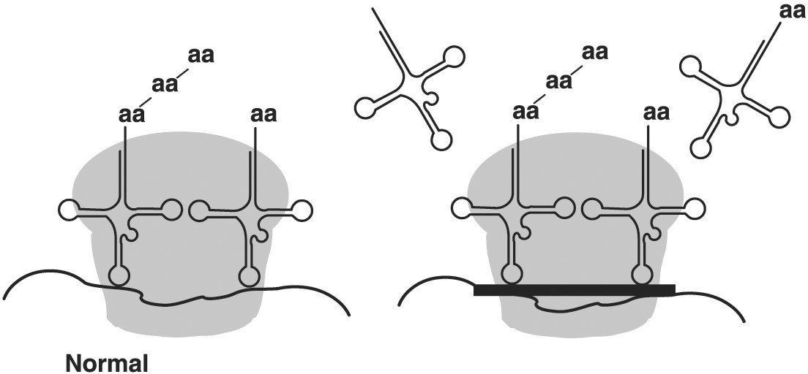
Figure 20.1
- The antibiotic tetracycline binds to the 30S subunit of the ribosome as shown in Figure 20.1. The effect is to A) Prevent attachment of tRNA.
- Prevent peptide bond formation.
- Prevent transcription.
- Stop the ribosome from moving along the mRNA.
- Prevent attachment of tRNA and mRNA. Answer: B
Figure 20.2
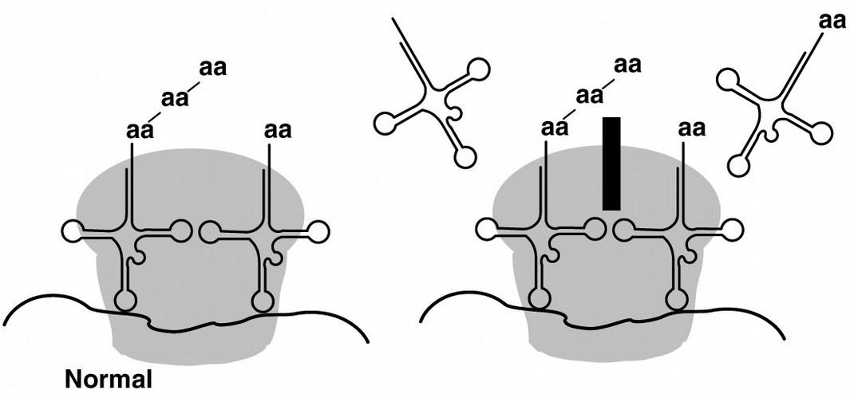
- The antibiotic cycloheximide binds to the 60S subunit of the ribosome as shown in Figure
20.2. The effect is to A) Prevent mRNANribosome binding in eukaryotes.
- Prevent peptide bond formation in prokaryotes.
- Prevent polypeptide elongation in eukaryotes.
- Prevent transcription in prokaryotes.
- Prevent ribosome formation in bacteria. Answer: C
- Which of these antimicrobial agents has the fewest side effects?
- Streptomycin
- Tetracycline
- Penicillin
- Erythromycin
- Chloramphenicol Answer: C

- Which of the following drugs does NOT act by competitive inhibition?
- Ethambutol
- Isoniazid
- Streptomycin
- Sulfonamide
- Tetracycline Answer: C
- Which of the following methods of action would be bacteriostatic?
- Competitive inhibition with folic acid synthesis
- Inhibition of RNA synthesis
- Injury to plasma membrane
- Inhibition of cell wall synthesis
- Competitive inhibition with DNA gyrase Answer: B
- Which of the following antibiotics is recommended for use against gram- negative bacteria?
- Polyenes
- Bacitracin
- Cephalosporin
- Penicillin
- Polymyxin Answer: E
- Which of the following antimicrobial agents is recommended for use against fungal infections?
- Amphotericin B
- Bacitracin
- Cephalosporin
- Penicillin
- Polymyxin Answer: A

Table 20.1
The following data were obtained from a broth dilution test.
Concentration of Antibiotic X Growth Growth in

Subculture
2 µg/ml + + 10 µg/ml - +
15 µg/ml - -
25 µg/ml - -
- In Table 20.1, the minimal bactericidal concentration of antibiotic X is A) 2 µg/ml.
- 10 µg/ml.
- 15 µg/ml.
- 25 µg/ml.
- Can't tell.

Answer: C
- In Table 20.1, the minimal inhibitory concentration of antibiotic X is A) 2 µg/ml.
- 10 µg/ml.
- 15 µg/ml.
- 25 µg/ml.
- Can't tell. Answer: B
- More than half of our antibiotics are A) Produced by fungi.
- Produced by bacteria.
- Synthesized in laboratories.
- Produced by Fleming.
- Produced by eukaryotic organisms. Answer: B
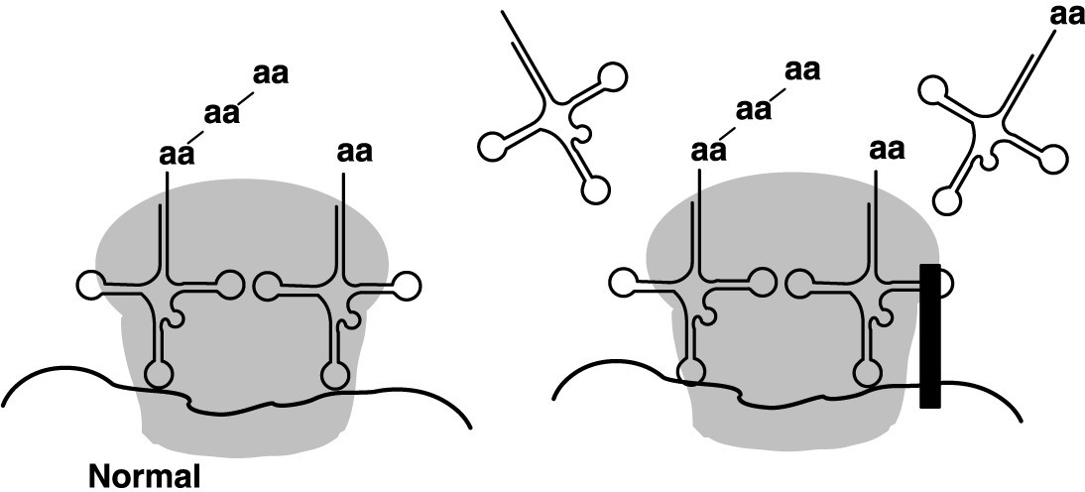
Figure 20.3
- The antibiotic chloramphenicol binds to the 50S subunit of the ribosome as shown in Figure 20.3. The effect is to A) Prevent attachment of tRNA.
- Prevent peptide bond formation.
- Prevent transcription.
- Stop the ribosome from moving along the mRNA.
- Prevent polypeptide formation in eukaryotes. Answer: A
Figure 20.4
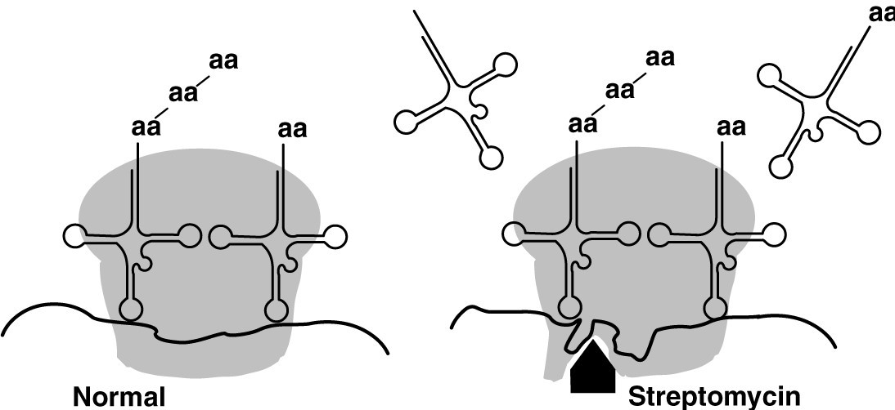
- The antibiotic streptomycin binds to the 30S subunit of the ribosome as shown in Figure
  - The effect is to A) Cause misreading of mRNA in 70S ribosomes.
  - Prevent binding of tRNA in eukaryotes.
  - Prevent polypeptide elongation in eukaryotes.
  - Prevent peptide bond formation in prokaryotes.
  - Prevent binding of tRNA in eukaryotes. Answer: A

- Which compound would be the most useful to treat candidiasis?
- Uracil
- Thymine
- Flucytosine
- Guanine
- Penicillin Answer: C
- Which of the following antibiotics are used to treat fungal infections?
- Aminoglycosides
- Cephalosporins
- Griseofulvin
- Polyenes
- Bacitracin
  - 1, 2, and 3 B) 3 and 4
- 3, 4, and 5
- 4 and 5
- All of the antibiotics Answer: B
- Which of the following antibiotics does NOT interfere with cell wall synthesis? A)
Cephalosporins
- Macrolides
- Natural penicillins
- Semisynthetic penicillins
- Vancomycin Answer: B
- The antimicrobial drugs with the broadest spectrum of activity are A) Aminoglycosides.
- Chloramphenicol
- Lincomycin.
- Macrolides.
- Tetracyclines. Answer: E
- Which of the following statements is false?
- Fluoroquinolone inhibits DNA synthesis.
- Acyclovir inhibits DNA synthesis.
- Amantadine inhibits release of viral nucleic acid.
- Interferon inhibits glycolysis.
- Azoles inhibit plasma membrane synthesis. Answer: D
- Protozoan and helminthic diseases are difficult to treat because
- Their cells are structurally and functionally similar to human cells.
- They replicate inside human cells.
- They don't have ribosomes.
- They don't reproduce.
- They have more genes than bacteria. Answer: A

- Which of the following organisms would most likely be sensitive to natural penicillin?
- L forms

- Streptococcus pyogenes
- Penicillinase- producing Neisseria gonorrhoeae
- Penicillium
- Mycoplasma
Answer: B
- Which of the following statements about drug resistance is false?
- It may be carried on a plasmid.
- It may be transferred from one bacterium to another during conjugation.
- It may be due to enzymes that degrade some antibiotics.
- It is found only in gram- negative bacteria.
- It may be due to increased uptake of a drug. Answer: D
- Which of the following does NOT constitute an advantage of using two antibiotics together?
- It can prevent drug resistance.
- It lessens the toxicity of individual drugs.
- Two are always twice as effective as one.
- It allows treatment to be provided prior to diagnosis.
- All of the above are advantages. Answer: C
- Drug resistance occurs
- Because bacteria are normal microbiota.
- When antibiotics are used indiscriminately.
- Against antibiotics and not against synthetic chemotherapeutic agents.
- When antibiotics are taken after the symptoms disappear.
- All of the above. Answer: B
Table 20.2
The following results were obtained from a diskNdiffusion test for microbial susceptibility to antibiotics. Staphylococcus aureus was the test organism.
Antibiotic Zone of
Inhibition
  - 3 mm
  - 7 mm
  - 0 mm
  - 10 mm
- In Table 20.2, the most effective antibiotic tested was
- A.
- B.
- C.
- D.
- Can't tell. Answer: D
- In Table 20.2, the antibiotic that exhibited bactericidal action was
- A.
- B.
- C.
- D.
- Can't tell. Answer: E
- In Table 20.2, which antibiotic would be most useful for treating a Salmonella infection?

- A
- B
- C
- D
- Can't tell. Answer: E
- Which of the following would be selective against the tubercle bacillus?
- Bacitracin N inhibits peptidoglycan synthesis
- Ethambutol N inhibits mycolic acid synthesis
- Streptogramin N inhibits protein synthesis
- Streptomycin N inhibits protein synthesis
- Vancomycin Ninhibits peptidoglycan synthesis Answer: B
- In the presence of penicillin, a cell dies because
- It lacks a cell wall.
- It plasmolyzes.
- It undergoes osmotic lysis.
- It lacks a cell membrane.
- Its contents leak out. Answer: C
- Lamisil is an allylamine used to treat dermatomycoses. Lamisil's method of action is similar to that of
- Polymyxin B.
- Azole antibiotics.
- Echinocandins.
- Griseofulvin.
- Bacitracin. Answer: B
- Niclosamide prevents ATP generation in mitochondria. You would expect this drug to be effective against
- Gram- negative bacteria.
- Gram- positive bacteria.
- Helminths.
- Mycobacterium tuberculosis.
- Viruses. Answer: C
Table 20.3
The following data were obtained from a broth dilution test:

Concentration of Antibiotic XGrowth
2.0 µg/ml -
1.0 µg/ml -
0.5 µg/ml 0.25 µg/ml +
0.125 µg/ml +
0 +
Bacteria from the 0.25 µg/ml tube were transferred to new growth media containing antibiotic X with the following results:

Concentration of Antibiotic XGrowth
2.0 µg/ml -
1.0 µg/ml +
0.5 µg/ml +
0.25 µg/ml +
- The data in Table 20.3 show that these bacteria
- Can be subcultured.
- Developed resistance to antibiotics.
- Were killed by 0.125 µg/ml of antibiotic X.
- Were killed by 0.5 µg/ml of antibiotic X.
- Were resistant to 1.0 µg/ml at the start of the experiment. Answer: B

- Which of the following statements about drugs that competitively inhibit DNA polymerase or RNA polymerase is false?
- They cause mutations.
- They are used against viral infections.
- They can affect host cell DNA.
- They are too dangerous to use.
- They interfere with protein synthesis. Answer: D
Figure 20.5
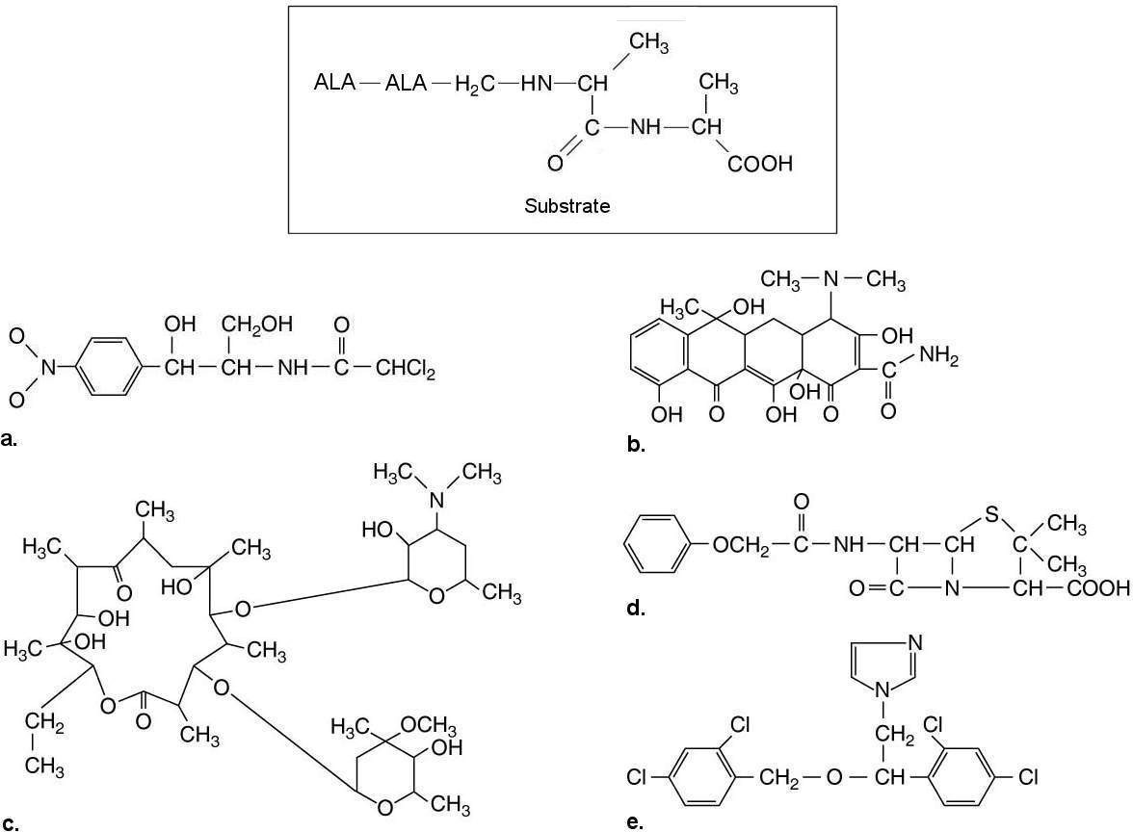
- The substrate for transpeptidase used to synthesize peptidoglycan is shown in Figure
  - Which of the drugs shown would inhibit peptidoglycan synthesis?
    - a
    - b
    - c
    - d
    - e Answer: D

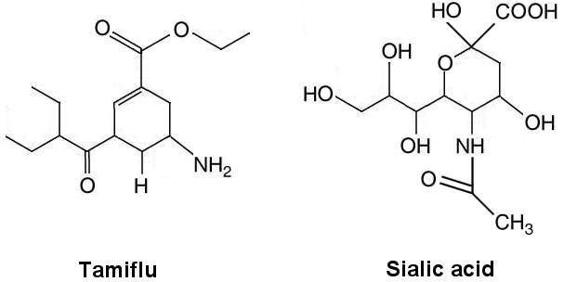
Figure 20.6
- The structures of the influenza drug Tamiflu and sialic acid, the substrate for influenza virus’s neuramidase, are shown in Figure 20.6. What is the method of action of Tamiflu?
- Inhibits cell wall synthesis
- Inhibits plasma membrane synthesis
- Inhibits synthesis of neuramidase
- Competitive inhibition
- Prevents synthesis of virus spikes Answer: D
- Which of the following does NOT affect eukaryotic cells?
- Antiprotozoan drugs
- Antihelminthic drugs
- Antifungal drugs
- Nucleotide analogs
- Semisynthetic penicillins Answer: E
- Mebendazole is used to treat cestode infections. It interferes with microtubule formation; therefore, it would NOT affect
- Bacteria.
- Fungi.
- Helminths.
- Human cells.
- Protozoa. Answer: A
- Which of the following antibiotics causes misreading of mRNA?
- Aminoglycoside N changes shape of 30S units
- Chloramphenicol N inhibits peptide bonds at 50S subunit
- Oxazolidinone N prevents formation of 70S ribosome
- Streptogamin N prevents release of peptide from 70S ribosome
- Tetracyclines N bind with 30S subunit Answer: A
- The antibiotic actinomycin D binds between adjacent G- C pairs, thus interfering with
- Transcription.
- Translation.
- Cellular respiration.
- Plasma membrane function.
- Peptide bond formation.

Answer: A
- Use of antibiotics in animal feed leads to antibiotic- resistant bacteria because
- Bacteria from other animals replace those killed by the antibiotics.
- The few surviving bacteria that are affected by the antibiotics develop immunity to the antibiotics, which they pass on to their progeny.
- The antibiotics cause new mutations to occur in the surviving bacteria, which results in resistance to antibiotics.
- The antibiotics kill susceptible bacteria, but the few that are naturally resistant live and reproduce, and their progeny repopulate the host animal.
- The antibiotics persist in soil and water. Answer: D

