University of Alabama
CH 231

CHAPTER 4—ACIDS AND BASES
MULTIPLE CHOICE
1)The pK_{a} of HCl is 7. What is the value of the equilibrium constant, K_{eq}, for the following equilibrium? [The concentration of water in a dilute aqueous solution is 55 M]

a. 1.8  10⁵
b. 385
c. 1.8  10^{5}
d. 1.8  10⁵ ANS: A
- The pK_{a} of acetic acid, CH₃COOH, is 4.76. What is the value of the equilibrium constant K_{eq}, for the following equilibrium? [The concentration of water in a dilute aqueous solution is 55 M]

a. 3.2  10⁷
b. 3.2  10^{7}
c. 3.2  10⁷
d. 3.2  10^{7} ANS: D
- Which of the following is the correct order of decreasing basicity (stronger base > weaker base)?
  - NH₃ > MeNH₂ > H₂O > HF
  - MeNH₂ > NH₃ > MeOH > CH₄
  - NH₃ > Me₃N > H₂O > MeOH
  - CH₃COONa > NaOH > NaOMe > NaNMe₂ ANS: B
- Which of the following is the strongest acid?
  - CH₃CH₃
  - CH₃NH₂
  - CH₃OH
  - CH₃F ANS: C
- Which of the following is the strongest acid?
  - HCl
  - HI
  - HF
  - HBr ANS: B

- Which of the following is easiest to deprotonate?
  - CH₄
  - CH₃CH₃
  - CH₂=CH₂
  - HC CH ANS: D
- Which of the following is the strongest acid?
  - CH₃OH
  - CH₃CHO
  - CH₃COCH₃
  - CH₃COOH ANS: D
- Which of the following is the strongest acid?
  - CH₃NH₂
  - CH₃PH₂
  - CH₃OH
  - CH₃SH ANS: D
- Which of the following compounds is the strongest acid?
  - HF
  - H₂O
  - NH₃
  - CH₄ ANS: A
- Which of the following compounds is the strongest acid?
  - CH₃OCH₃
  - CH₃CH₂OH
  - CH₃CHO
  - CH₃CO₂H ANS: D
- Which of the following compounds is the strongest acid?
  - CH₃COOH
  - ClCH₂COOH
  - CH₃CH₂OH
  - ClCH₂CH₂OH ANS: B
- Which of the following compounds is the strongest acid?
  - CH₃COOH
  - FCH₂COOH
  - ClCH₂COOH
  - BrCH₂COOH ANS: B

- Which of the following compounds is the strongest acid?
  - CH₄
  - CH₃CH₃
  - H₂C=CH₂
  - HC CH ANS: D
- Which of the following compounds is the strongest acid?
  - CF₃OH
  - CF₃CH₂ CH₂OH
  - CF₃CH₂ CH₂ CH₂OH
  - CF₃CH₂ CH₂ CH₂CH₂OH ANS: A
- Which of the following compounds is the strongest acid?
  - CH₃CH₂CH₂COOH
  - CH₃CH₂CHClCOOH
  - CH₃CHClCH₂COOH
  - ClCH₂CH₂CH₂COOH ANS: B
- Which of the following is the strongest base?
  - NaOH
  - NaCO₃
  - H₂O
  - CH₃OH ANS: A
- Which of the following is the strongest base?
  - iodide anion, I
  - fluoride anion, F
  - bromide anion, Br
  - chloride anion, Cl ANS: B
- Which of the following anions is the strongest base?
  - CH₃COO
  - HO
  - NH 
2
  - Cl ANS: C
- Which of the following anions is the strongest base?
  - NH 
2
  - NH₃
  - CH₃CH=N
  - CH₃C N ANS: A

- Which of the following compounds has the highest pK_{a}?
  - SiH₄
  - H₂S
  - PH₃
  - HCl ANS: A
- Which of the following compounds has the highest pK_{a}?
  - NH₃
  - H₂O
  - HCl
  - CH₄ ANS: D
- Which of the following compounds has the lowest pK_{a}?
  - H₂O
  - HBr
  - NH₃
  - CH₄ ANS: B
- Which of the following compounds has the lowest pK_{a}?
  - H₂O
  - H₂S
  - H₂Se
  - H₂Te ANS: D
- Which of the following is present in the highest concentration upon dissolution of H₂SO₄ in water?
  - H₂SO₄
  - H⁺
  - H₃O⁺
  - HO ANS: C
- Which of the following is present in the highest concentration upon dissolution of acetic acid in water?
  - OH
  - H₃O⁺
  - CH₃COOH
  - CH₃COOH⁺ ANS: C
- Which of the following terms describes the reactivity of boron tribromide, BBr₃?
  - Brønsted-Lowry acid and Lewis acid
  - Brønsted-Lowry base and Lewis base
  - Lewis acid and not a Brønsted-Lowry acid
  - Lewis base and not a Brønsted-Lowry base ANS: C

- Which of the following terms describes the reactivity of trimethylamine, (CH₃)₃N?
  - Brønsted-Lowry acid and Lewis acid
  - Brønsted-Lowry base and Lewis base
  - Lewis acid and not a Brønsted-Lowry acid
  - Lewis base and not a Brønsted-Lowry base ANS: B
- Which set of curved arrows accounts for the deprotonation of an acid (A-H) by a base (:B)?
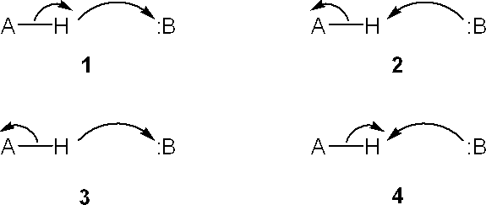

  - 1
  - 2
  - 3
  - 4
ANS: B

- Which sets of curved arrows accounts for the protonation of propene with HI?
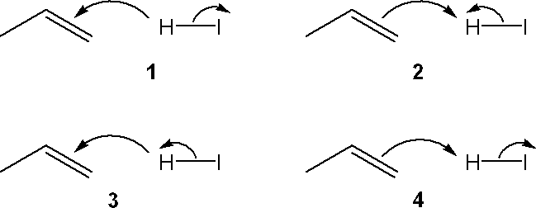

  - 1
  - 2
  - 3
  - 4
ANS: D

- Which of the following terms describes the role of ethene in the acid-base reaction shown?
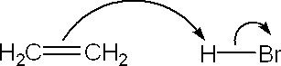

  - Brønsted-Lowry acid
  - Brønsted-Lowry base
  - Lewis acid
  - Lewis base ANS: B

- Which of the following terms describes the role of ethanol in the acid-base reaction shown?
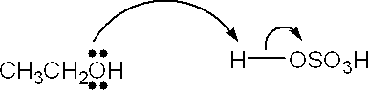

  - Brønsted-Lowry acid
  - Brønsted-Lowry base
  - Lewis acid
  - Lewis base ANS: B
- Which of the following terms describes the role of ethanol in the acid-base reaction shown?
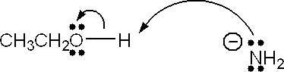

  - Brønsted-Lowry acid
  - Brønsted-Lowry base
  - Lewis acid
  - Lewis base ANS: A
- Which of the following terms describes the role of ethyne in the acid-base reaction shown?
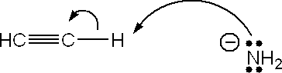

  - Brønsted-Lowry acid
  - Brønsted-Lowry base
  - Lewis acid
  - Lewis base ANS: A
- Which species is the conjugate acid in the following acid-base reaction?
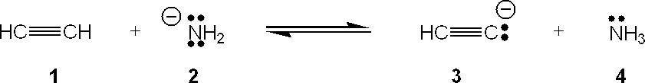

  - 1
  - 2
  - 3
  - 4
ANS: D

- Which species is the conjugate acid in the following acid-base reaction?
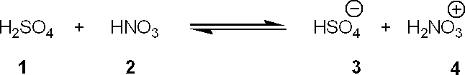

  - 1
  - 2
  - 3
  - 4
ANS: D

- What is the value of the equilibrium constant, K_{eq}, for the following reaction?
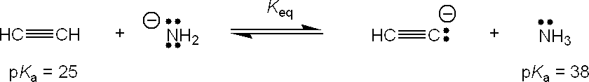

a. 10¹³
b. 1013
c. 13
d. ¹/₁₃
ANS: A

- What is the value of the equilibrium constant, K_{eq}, for the following reaction?
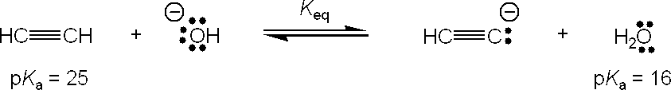

a. 10⁹
b. 109
c. 9
d. ¹/₉
ANS: B

- Which of the following is a Lewis acid but not a Brønsted-Lowry acid?
  - CH₃COOH
  - AlCl₃
  - H₂O
  - CH₃OH ANS: B
- Which of the following is a feature of a Lewis acid?
  - proton donor
  - proton acceptor
  - electron pair donor
  - electron pair acceptor ANS: D

- Which of the following is a feature of a Lewis base?
  - proton donor
  - proton acceptor
  - electron pair donor
  - electron pair acceptor ANS: C
- Which of the following is a feature of a Brønsted-Lowry acid?
  - proton donor
  - proton acceptor
  - electron pair donor
  - electron pair acceptor ANS: A
- Which of the following is a feature of a Brønsted-Lowry base?
  - proton donor
  - proton acceptor
  - electron pair donor
  - electron pair acceptor ANS: B
- Which of the following has the highest bond dissociation energy?
  - HF
  - HCl
  - HBr
  - HI ANS: A
- Which of the following concepts can be used to rationalize the observation that acetic acid is a stronger acid than methanol?
  - electronegativity
  - resonance
  - valence shell electron pair repulsion theory
  - Pauli exclusion principle ANS: B
- Which atom in the following structure is preferentially protonated by a strong acid?
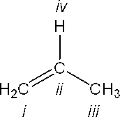

  - i
  - ii
  - iii
  - iv
ANS: A

- What is the approximate pK_{a} value of HCl?
  - 7
  - 5
  - 16
  - 51 ANS: A
- What is the approximate pK_{a} value of acetic acid?
  - 7
  - 5
  - 16
  - 51 ANS: B
- Which of the following has a pK_{a} value of approximately 16?
  - HBr
  - CH₃COOH
  - CH₃CH₂OH
  - HC CH ANS: C
- Which of the following has a pK_{a} value of approximately 25?
  - CH₃CH₃
  - CH₂=CH₂
  - HC CH
  - CH₃CH₂OH ANS: C
- Which of the following statements is not true?
  - The position of the equilibrium for an exergonic reaction favors products
  - The products of an exergonic reaction have a higher Gibbs free energy than the reactants.
  - The equilibrium constant of a reaction for which  G = 0 is 1.
d.  G =  H  T S
ANS: B

- Which of the following equations is correct?
a.  G =  H  T S
b.  H =  G  T S
c.  G =  H   S
d.  G =  H   S/T
ANS: A

- Which of the following energy diagrams represents the fastest reaction?
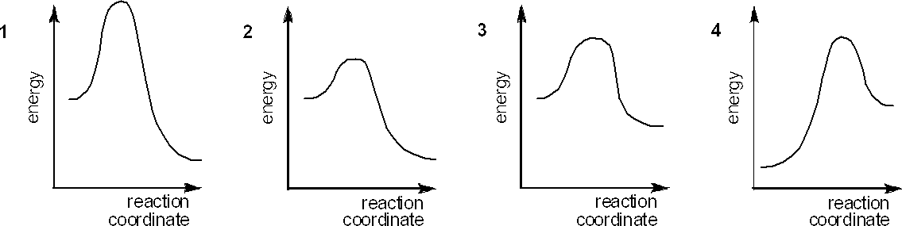

  - 1
  - 2
  - 3
  - 4
ANS: B

- Which of the following energy diagrams represents the slowest reaction?

  - 1
  - 2
  - 3
  - 4
ANS: D

- Which of the following is a definition of the rate-determining step of a reaction mechanism?
  - the first step
  - the last step
  - the step that crosses the highest energy barrier
  - the most exothermic step ANS: C
- Which of the following is a definition of the activation energy of a reaction?
  - the difference in Gibbs free energy between the reactants and the transition state
  - the difference in Gibbs free energy between the reactants and the intermediate
  - the difference in Gibbs free energy between the reactants and the product
  - the difference in Gibbs free energy between the transition state and the product ANS: A

- Under which of the following conditions will a reaction be spontaneous when  H > 0?
  - T S = 0
b. T S >  H
c. T S < 0
d.  G = 0 ANS: B
- Which of the following energy diagrams best represents the changes in energy during addition of HBr to an alkene?
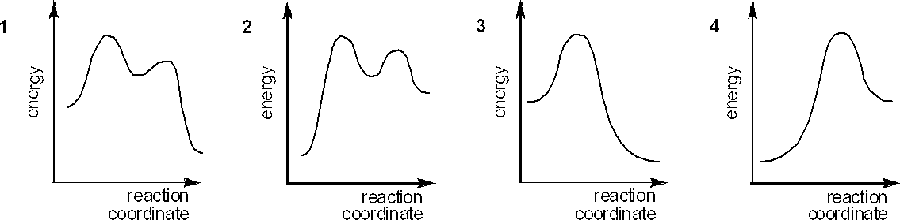

  - 1
  - 2
  - 3
  - 4
ANS: A

PROBLEM

- Use curved arrows to show the movement of pairs of electrons in the following acid-base reaction and show the structures of the conjugate acid and conjugate base.
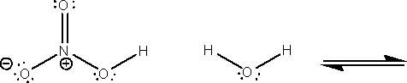

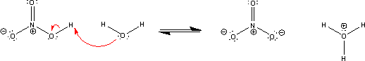
ANS:

- Use curved arrows to show the movement of pairs of electrons in the following acid-base reaction and show the structures of the conjugate acid and conjugate base.
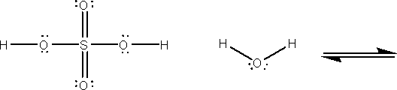

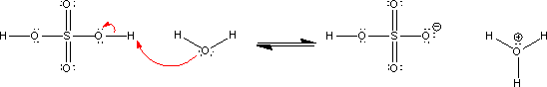
ANS:

- Complete the equation below for the protonation of 2-butene with HBr. Show the movement of pairs of electrons with curved arrows and provide the structures of the conjugate acid and conjugate base.

ANS:

- Complete the equation below for the protonation of cyclohexene with HCl. Show the movement of pairs of electrons with curved arrows and provide the structures of the conjugate acid and conjugate base.
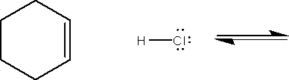

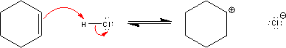
ANS:

- Provide the equation for the equilibrium constant, K_{eq}, for the following equilibrium.

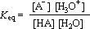
ANS:

- Provide the equation for the acid dissociate constant, K_{a},for the following equilibrium.

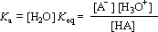
ANS:

- Provide the equation that relates the equilibrium contant, K_{eq}, to the acid dissociation constant, K_{a}, for the following equilibrium.

ANS:
K_{a} = [H₂O] K_{eq}

- Provide the equation that relates the acid dissociation constant, K_{a}, to the pK_{a} of an acid.

ANS:
pK_{a} = –log₁₀K_{a}

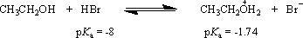
- What is the value of the equilibrium constant for the following equilibrium?

ANS:
log₁₀K_{eq} = pK_{a}(acid) – pK_{a}(conjugate acid) = -8 – (-1.74) = -6.26

K_{eq} = 10^{-6.26} = 5.5 x 10⁻⁷

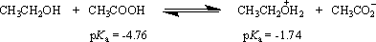
- What is the value of the equilibrium constant for the following equilibrium?

ANS:
log₁₀K_{eq} = pK_{a}(acid) – pK_{a}(conjugate acid) = -4.76 – (-1.74) = -3.02

K_{eq} = 10^{-3.02} = 9.5 x 10⁻⁴

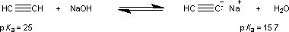
- What is the value of the equilibrium constant for the following equilibrium?

ANS:
log₁₀K_{eq} = pK_{a}(acid) – pK_{a}(conjugate acid) = 25 – 15.7 = 9.3

K_{eq} = 10^{9.3} = 2.0 x 10⁹

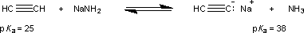
- What is the value of the equilibrium constant for the following equilibrium?

ANS:
log₁₀K_{eq} = pK_{a}(acid) – pK_{a}(conjugate acid) = 25 – 38 = 13

K_{eq} = 10¹³

- Provide a brief explanation, based on features of the molecules, for the following trend in pK_{a} values?
CH₃OH > CH₃NH₂ > CH₃CH₃ 16 38 51

ANS:
This trend is best understood in terms of the stability of the conjugate base that would be formed upon deprotonation of each of these acids. The methoxide anion (CH₃O⁻), the conjguate base of methanol, has a negative charge on a highly electronegative oxygen atom. The oxygen atom accomodates the negative charge better than the nitrogen atom or carbon carbon in the conjugate bases of methylamine and ethane (CH₃NH⁻ and CH₃CH ⁻, respectively).
2

- Provide a brief explanation, based on features of the molecules, for the following trend in pK_{a} values?

CH₃CH₂OH > CH₃COOH 15.9 4.76

ANS:
This trend is best understood in terms of the stability of the conjugate base that would be formed upon deprotonation of each of these acids. One explanation is that the negative charge of the acetate anion (CH₃CO ⁻), the conjugate base of acetic acid, is delocalized over the two oxygen atoms by resonance. In contrast, in the ethoxide anion (CH₃CH₂O⁻), the conjguate base of ethanol, the negative charge is localized on a single oxygen atom.
2

- Provide a brief explanation, based on features of the molecules, for the following trend in pK_{a} values?

CH₃CH₂OH > CF₃CH₂OH
ethanol 2,2,2-trifluoromethanol 15.9 12.4

ANS:
This trend is best understood in terms of the stability of the conjugate base that would be formed upon deprotonation of each of these acids. The highly electronegative fluorine atoms of the 2,2,2- trifluoroethoxide anion (CF₃CH₂O⁻), the conjugate base of 2,2,2-trifluoroethanol, withdraw electron density from the oxygen atom and thereby stabilize the anion relative to the ethoxide anion (CH₃CH₂O⁻), the conjguate base of ethanol.

- Provide a brief explanation, based on features of the molecules, for the following trend in pK_{a} values?

CH₃CH₃ | > CH₂=CH₂ | > HCCH
ethane | ethene | ethyne
 | (ethylene) | (acetylene)
51 | 44 | 25

ANS:
This trend is best understood in terms of the stability of the conjugate base that would be formed upon deprotonation of each of these acids. The lone pair of electrons of the acetylide anion (HCC⁻) are in a lower-energy atomic orbital (an sp orbital), and more tightly held, than the lone pair of electrons in the conugate bases of ethylene (H₂C=CH⁻, sp² hybridized) and ethane (CH₃CH ⁻, sp³ hybridized), respectively.
2

- Use curved arrows to show the movement of pairs of electrons in the following reaction between a Lewis acid and a Lewis base, and show the structure of the product.
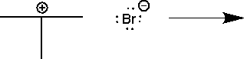

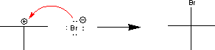
ANS:

- Use curved arrows to show the movement of pairs of electrons in the following reaction between a Lewis acid and a Lewis base, and show the structure of the product.

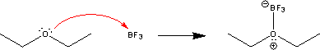
ANS:

