Table of Contents
1 Introduction 3
1.3 Project Objective 5
Chapter 2 5
2 Methodologies and Implementation 5
2.1 Basic Construction and Working of BLDC Motor 5
2.2 Operation of Brushless DC motor 6
Methodology 7
Chapter 3 8
3.1 Software Simulation 8
3.2 Limitations 11
Chapter 4 12

Chapter 1

1 Introduction
1.1 Overview:
Latest development and researches are being made on brushless DC (BLDC) motor instead of simple DC motors or three phase induction motors. These researches are due to the advantages of brushless DC motor over other motors. Till now the BLDC motors have achieved more than 100000+ rpm speed. But achieving high power is still under consideration. Due to BLDC motor's advantages over all other motors, it has overcome these motors in many technologies where very high speed is very essential like in defense system. Another main advantage of BLDC motor is that in spite of having very high speed it can also achieve that high speed in no time.
The purpose of our project was to design a Brushless motor drive that is an efficient and has low cost than other drives of BLDC motor that costs a lot. Efficient drive is made by controlling the speed of BLDC. This drive not only controls the speed of BLDC motor but also has an option of reversing the direction of rotation of the motor. This availability is done to show the advantage of BLDC motor in real time that it can achieve its maximum speed in one direction and can also achieve its maximum speed in reverse direction in very less time. This phenomenon is used in the process like printing or dying where high speed as well as forward and reverse direction is required to achieve the desired results.
In 3D printing technology where the layers are made up of the prototype. This can only be done in a very high speed and a constant speed otherwise the prototype cannot give the desired results. In defence purposes where the rotational speed is required at very high rate like in tankers and most important is accuracy. The BLDC motor has very significant application there. Achieving precise rotation for targeting and localization of target can only be done by using BLDC motor because it gives precise rotational speed and precise positioning.
1.2 Why Brushless DC Motor?
Brushless DC (micro-BLDC, small, medium and Large) motor is commonly mandatory for utilizations of devices of motion control and systems of all types. In electric traction, like in other applications, widespread range in torque and speed control for electric motor is preferred. Although DC motor satisfies these necessities but these motors need periodic repairs and maintenance. The AC machines similar to induction motors and brushless DC motor does not have brushes, and their rotors are strong because commutator and rings do not exist. In below Figure 1.4 BLDC motor is shown.
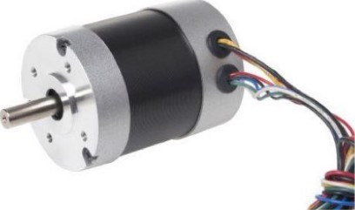
Figure 1-1 (Typical BLDC motor)

In below Figure 5 BLDC (internal structure/inside view) motor is shown.
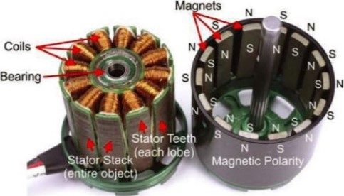
Figure 1-2 (Inside view of BLDC motor)
BLDC have several benefits over induction motors and brushed DC motors. Some of them are given below o Improved torque vs speed characteristics o Delivers constant speed o Response is Highly dynamic o less heat losses (High efficiency) o Very higher speed ranges o Longer operating life o Noiseless operation
Due to these dynamic advantages BLDC motors have replaced simple brushed DC motor in many technologies.

1.3 Project Objective
The main objectives of this project are:
o To make an efficient Brushless DC motor drive o control of the speed of Brushless DC motor manually
1.4 Project Applications of Constant, smooth and high-speed applications o Closed loop applications like in Refrigerators, Air conditioning systems,
Washing machines, Vacuum cleaners o Positioning applications

Chapter 2

2 Implementation

2.1 Basic Construction and Working of BLDC Motor
BLDC motors are usually categorized as a type of synchronous motor due to their similarity in speed. So it can also be named as permanent magnet synchronous motor. This shows that the speed of the magnetic field produced by the stator of BLDC motor is equal to the speed of rotation of permanent magnet rotor of BLDC motor. Another advantage of Brushless DC motor over simple DC motor is that there is no term as "slip regulation" present in the rotation phenomena of BLDC motors.
Construction and electrically phase wise BLDC motors are present in the market in three main categories as single-phase BLDC motors, two phase BLDC motors and three phase BLDC motors. Out of these three types the most commonly and widely used BLDC motors are three phase BLDC motors in industry as well as in domestic purposes.

2.2 Operation of Brushless DC motor
Each commutation segments arrangement has one of the windings supplied electrically to positive cycle (current enters into the winding), the second winding is supplied the negative (current exits the winding) and the third is in a not supplied at that time. The torque in BLDC motor is produced in such a way that the magnetic field produced due to the stator of the motor and the magnetic field of the permanent magnet of the rotor each. Ideally, the maximum value of the torque occurs when the stator magnetic field and rotor magnetic field are both at 90⁰ to each other and falls off as the fields move together forward.
For the motor to be in smooth running operation, the magnetic field of the stator should be in motion constantly, means it should shift its position whenever the rotor magnetic field rotates to chase the stator magnetic. The coils' energizing scheme of Brushless DC motor is shown below in Figure 10.
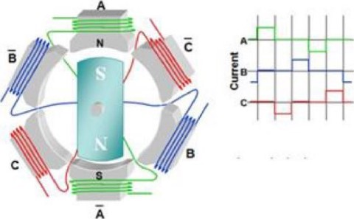
Figure 10 (Energizing scheme of coils o BLDC motor)
From above figure it shows that whenever one coil is energized the other two are deenergized and in next cycle the second coil is energized and other two remains deenergized and this process continues itself. These pulses are generated from a Hybridge MOSFET driver circuit and is called PWM technique, which is explained in next portion.
- For controlling the brightness of LEDs
- Will provide variable voltage from 0% to 100% of input voltage
- To create variable sound signs
- One can have variable speed from motors
0% duty cycle

10% duty cycle
25% duty cycle 100%.
50% duty cycle
80% duty cycle
100% duty cycle

Methodology
A six-step voltage inverter powers a three-phase motor rated at 1 kW, 500 Vdc, and 3000 rpm. The inverter is a Specialized Power Systems library MOSFET bridge. The DC bus voltage is regulated by a speed regulator. The inverter gates signals are produced by decoding the motor's Hall effect signals. The inverter's three-phase output is added to the stator windings of the PMSM block.
The load torque applied to the machine's shaft is initially set to zero and gradually increases to its nominal value (3 N.m) at t = 0.1 s.
There are two control loops in operation. The inner loop synchronizes the inputs of the inverter gates with the electromotive powers. The outer loop regulates the speed of the motor by varying the DC bus voltage.

Chapter 3

3 Results and Analysis

3.1 Software Simulation

Parameters:
- Value of Integral gain = 16.61, Proportional Gain = 0.013
- Voltage Source emf = 500V
- subnet resistance = 5000ohms & capacitance = 10^-6 F
- Sampling time Ts= 5*10^-6

Steps of Simulation:
- Reference speed with a constant value of 3000.
- So the Simulink implementation is based on basically 8 blocks,
- Further this is passed to input voltage block with 0 phase in V value.
- The constant reference voltage is passed through speed regulator with PI negative feedback control.
- Further passing this voltage from Snubb's resistance & capacitance for regulating outputs.
- Output is plotted for Stator current, Back EMF, Speed & Torque.
- And finally, this signal is passed through Motor block of Simulink with 3 phases initiated.

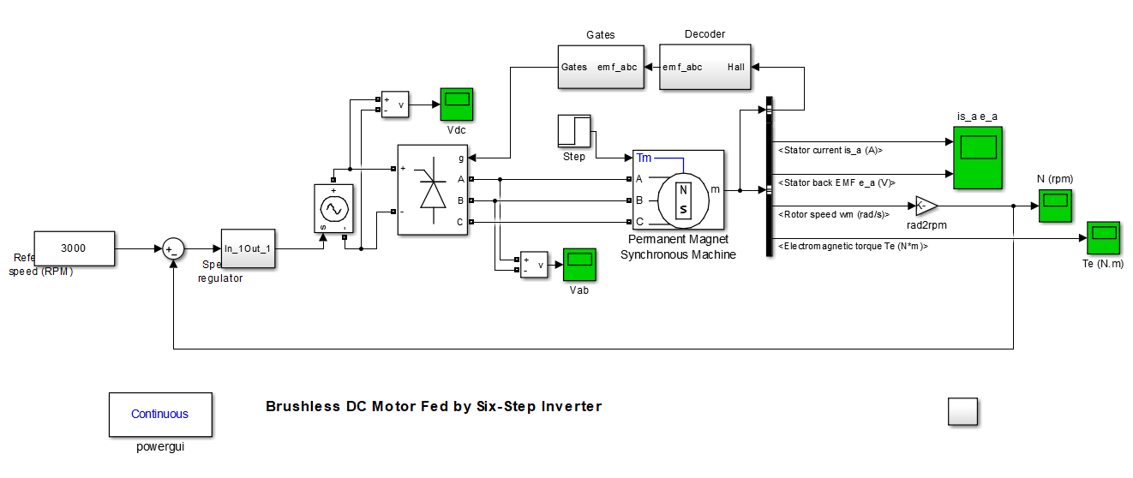

The graphs are given below,

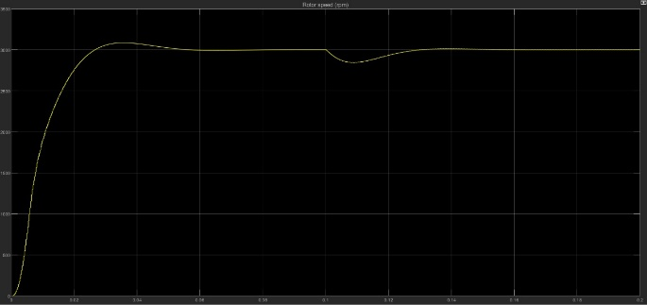
Graph-1

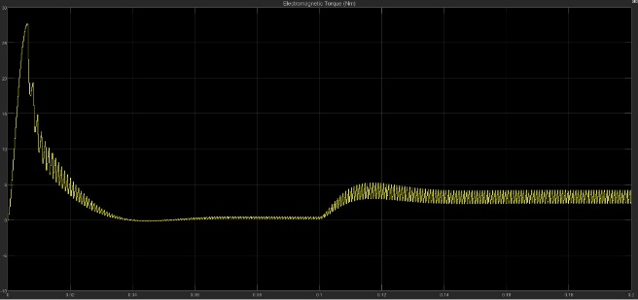
Graph-2

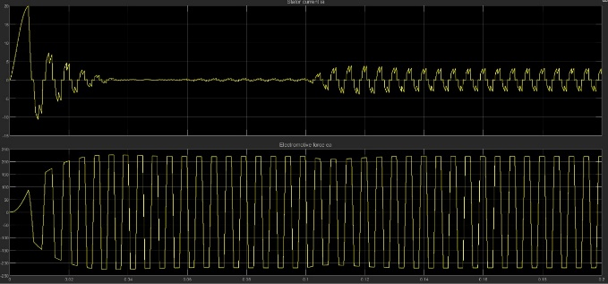
Graph-3

3.2 Limitations
Limitation of the project are:
- Due to very high speed of the used BLDC motor (>23000 rpm) the tools that can be attached to the shaft of the motor should be capable of bearing that high speed otherwise serious damages may be happen.
- Current BLDC motors have not yet achieved very high power like in MW, so where this value of high power is required the limitations are followed.

Chapter 4

Conclusion

Take note of the motor currents' sawtooth shape. This is due to the DC bus, which applies a constant voltage to the motor inductances for 120 electrical degrees. The original current is strong and reduces as the speed is increased to the nominal speed. To retain the nominal rpm, the stator current increases as the nominal torque is applied.

