University of Missouri - NUTR 1300
multiple-choice questions.
1)The components of the scientific methods are as follows .
  - observing something in nature
  - designing and executing experiments
  - analyzing the data and formulating a conclusion
  - formulating a hypothesis
  - all of the above

- Which of the following statements is correct?
  - Scientific ideas are subjected to repeated testing.
  - Science can be used to prove or disprove the idea of deities or spirits.
  - Science does not require observations that other people can confirm.
  - Only philosophy can lead to important conclusions about nature.
  - Scientific ideas are subjected to laws of theology.

- Which elements make up the majority of living matter in the human body?
  - Oxygen, Carbon, Hydrogen and Phosphate.
  - Oxygen, Carbon, Hydrogen and Nitrogen.
  - Oxygen, Carbon, Hydrogen and Potassium.
  - Oxygen, Carbon, Phosphate and Sulfur
  - Oxygen, Carbon, Calcium and Hydrogen

- You try to start your car, but it does not start. Which of these is a prediction?
  - If I recharge the battery, then my car will start.
  - My car's battery is dead.
  - A new car would function properly.
  - What is wrong with my car?
  - My car ran out of gas.

- In the term trace element, the adjective trace means that .
- The element is very rare on Earth.
- The element passes rapidly through the organism
- The element enhances health but only at high concentrations
- The element is required in very small amounts.
- The element can be used as a label to trace atoms through an organism’s metabolism.

- The development of Goiter occurs when is missing from an individual’s diet?
- Phosphorus
- Fluorine
- Iodine
- Calcium
- Oxygen

  - What name is given to bonds that share pairs of electrons?
    - Covalent
    - Hydrogen
    - Ionic
    - Van der Waals
    - All of the above
  - In the following reaction, what type of bond is holding the two atoms together? K+ + Cl⁻ → KCl

    - Hydrophilic
    - Ionic
    - Hydrophobic
    - Hydrogen
    - Van der Waals

  - Which of the following statements concerning unsaturated fats is false?
    - They have double bonds in their fatty acid chains
    - They are generally liquid at room temperature
    - Lack a kink in their fatty acid tails
    - They contain less hydrogen compared to saturated fats having the same number of carbon atoms.
    - High levels of unsaturated (trans) fat and cholesterol can lead to development of Atherosclerosis.

  - The following molecule will tend to participate in what type of bond?
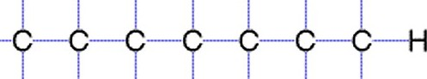
    - Hydrophilic
    - Ionic
    - Hydrophobic
    - Hydrogen
    - Van der Waals

  - If the pH of a solution is increased from a pH 11 to pH 5, it means that the .
    - Hydrogen ion (H⁺) concentration has decreased
    - Hydrogen ion (H⁺) concentration has increased
    - Hydrogen ion (H⁺) concentration remained the same
    - Hydroxyl ion (OH⁺) concentration has increased
    - Carbon ion (C) concentration has increased

  - In the figure below, the black arrow indicates bonds have formed.
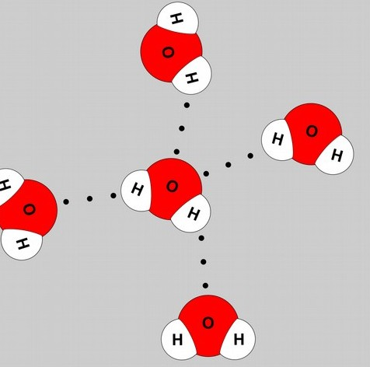
    - Hydrophilic
    - Ionic
    - Hydrophobic
    - Hydrogen
    - Van der Waals
  - Which of the following is not the function of a lipid?
    - Long-term energy storage
    - Component of the cell
    - Hormones in the body
    - Immediate available energy
    - None of the above
  - Which is not the function of a protein?
    - Hormone receptor
    - Carries genetic information from the cytoplasm to the nucleus
    - Act as enzymes to speed up rate of reactions in the body
    - Serves a structural support in the cell
    - Acts as defense molecules
  - Which polysaccharide has the greatest number of branches?
    - Cellulose
    - Sucrose
    - Fructose
    - Amylose (starch)
    - Glycogen
  - How will brief heating (to 95°C) affect macromolecular structures in aqueous solution?
    - DNA duplexes alone will unwind and separate.
    - Proteins will unfold (denature).
    - Starch will become single sugar subunits (building blocks).
    - DNA duplexes will unwind and separate, and proteins will unfold (denature).
    - Proteins will hydrolyze into amino acids.
  - Why does ice float in liquid water?
    - Covalent disulfide bonds stabilize and keep the molecules of ice farther apart than the water molecules of liquid water.
    - The ionic bonds between the molecules in ice prevent the ice from sinking.
    - Ice always has air bubbles that keep it afloat.
    - Hydrogen bonds stabilize and keep the molecules of ice farther apart than the water molecules of liquid water.
    - The crystalline lattice of ice causes it to be denser than liquid water.

(A) Triacylglycerol (B) DNA (C) Cholesterol
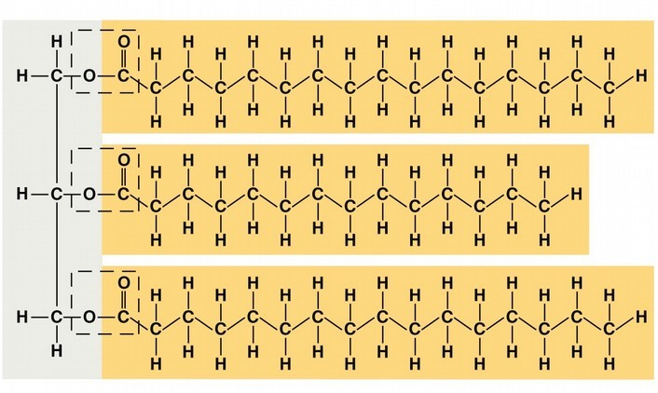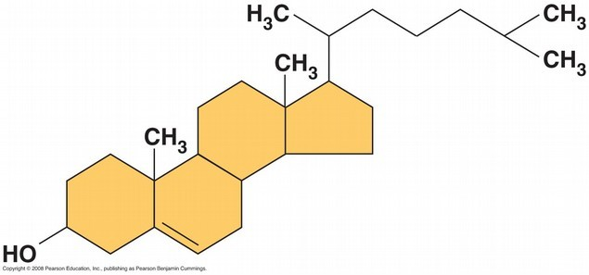

(D) Starch (E) Alanine (F) Nucleotide
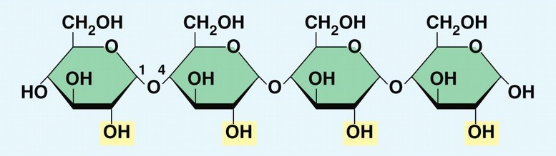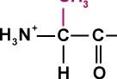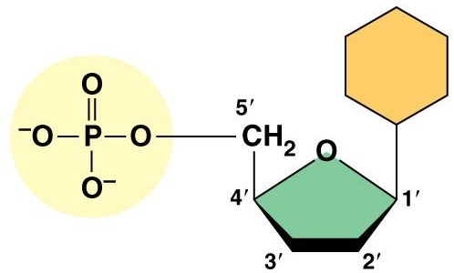

The figure above contains examples of molecules found in the cell. Based upon figure, answer the following questions. Identify the molecules indicated by the letters (A-F).
  - The molecule identified by the letter ‘A’ is a/ an
    - Amino acid
    - Saturated fatty acid chain
    - Unsaturated fatty acid chain
    - Polysaccharide
    - Nucleotide

  - The molecule identified by the letter ‘F’ is a/ an
    - Amino acid
    - Estrogen
    - Monosaccharide
    - Polysaccharide
    - Nucleotide

  - The molecule identified by the letter ‘C’ is a/ an
    - Amino acid
    - Phospholipid
    - Steroid
    - Polysaccharide
    - Nucleotide

  - The molecule identified by the letter ‘E’ is a/ an
    - Amino acid
    - Phospholipid
    - Saturated fatty acid chain
    - Monosaccharide

    - Nucleotide
  - Which of the following is not a monomer/polymer pairing?
    - Triacylglycerol/phospholipid
    - Ribonucleotide/RNA
    - Deoxyribonucleotide/DNA
    - Monosaccharide/polysaccharide
    - Amino acid/protein
  - Polysaccharides and proteins are similar in that they
    - are decomposed into their subunits by dehydration reactions.
    - all contain nitrogen and oxygen in their single subunits (building blocks).
    - are synthesized from monomers by the process of hydrolysis.
    - are synthesized from subunits by dehydration reactions.
    - are synthesized as a result of peptide bond formation between single subunits.
  - The tertiary structure of a protein is the
    - bonding together of several polypeptide chains by weak bonds.
    - unique three-dimensional shape of the fully folded protein.
    - order in which amino acids are joined in a protein chain.
    - organization of a polypeptide chain into an α helix or β pleated sheet.
    - overall protein structure resulting from the aggregation of two or more protein subunits.
  - The R group or side chain of the amino acid serine is -CH2-OH. The R group or side chain of the amino acid leucine is -CH2-CH-(CH3)2. Where would you expect to find these amino acids in a globular (round) protein in aqueous solution?
    - Serine would be in the interior, and leucine would be on the exterior of the globular protein.
    - Leucine would be in the interior, and serine would be on the exterior of the globular protein.
    - Both serine and leucine would be in the interior of the globular protein.
    - Both serine and leucine would be on the exterior of the globular protein.
    - Both serine and leucine would be in the interior and on the exterior of the globular protein.
  - Changing two amino acids in a protein consisting of 350 amino acids would .
    - alter the primary structure of the protein but not its tertiary structure or function.
    - cause the quaternary structure of the protein to unfold.
    - never alter the biological activity or function of the protein.
    - always exclusively alter the primary structure of the protein and disrupt its biological activity.
    - always alter the primary structure of the protein, sometimes alter the tertiary structure of the protein, and sometimes affect its biological activity.
  - If carbon in uracil is marked by fluorescence so it glows. Then the marked uracil is added to the growth medium of cells, what macromolecules will glow?
    - Phospholipids
    - DNA
    - RNA
    - Both DNA and RNA
    - Proteins
  - Which of the following pairs of base sequences could form a short stretch of a normal double helix of DNA?
- 5’-ACCT-3’ with 5’-TGGA-3’
- 5’-ACTC-3’ with 5’-GAGT-3’
- 5’-GCGC-3’ with 5’-ATAT-3’

- 5’-TCAG-3’ with 5’-TCAG-3’
Please read the following scenario to answer the following questions.

While radioactive isotopes are used in medicine to identify tumors and other diseases, they can also be used to treat diseases such as cancer. One method to treat cancerous tumors is to expose them to radiation, which can kill the cancerous cells and the tumor. In 2013, the U.S. Food and Drug Administration approved a new cancer treatment based on the radioactive isotope radium-223; this isotope has a half-life of 11.4 days. The radioactive drug, known as Xofigo®, is injected into the patient's bloodstream and travels to certain regions of the body. Because it emits high-energy radiation over short distances, it can kill cancerous cells in the sites where it localizes.
After the drug was injected into a person, the following data were collected regarding the amount of radiation measured in different organs in the person's body.

Levels of Radiation
250
200
150
100
50
Measured Radiation
0

  - Which of the following would be the best experiment to determine whether this drug is an effective treatment option for cancer patients?
- Give the drug to a single cancer patient and ask him how he feels several months later.
- Give the drug to a group of cancer patients and measure whether their tumors are destroyed.
- Give the drug to a single cancer patient and measure whether her tumor is destroyed.
- Give the drug to a group of mice that have artificially induced tumors and measure whether their tumors are destroyed.

  - A cancer patient receives an injection of the drug on January 1. Suppose that the patient must receive a second injection once the amount of the drug decreases to less than 6% in his or her body. On approximately what day should the cancer patient schedule an appointment to receive another injection?
- January 13
- January 23
- February 3
- February 13
- February 25

  - Using the table above, what kind of cancer do you think Xofigo® is best used to treat?
- Bone cancer
- Brain cancer
- Liver cancer
- Lung cancer

- Urinary Bladder cancer
Shown below is ribbon four subunit model of hemoglobin
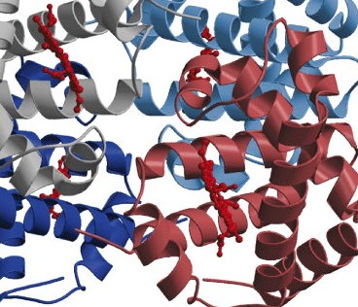
  - Based upon the hemoglobin structure, the levels of protein structure seen are .
    - Primary, Secondary, Tertiary and Quaternary
    - Primary, Secondary and Tertiary
    - Secondary, Tertiary and Quaternary
    - Primary and Secondary

  - Based upon the hemoglobin structure, the bonds most likely involved in hemoglobin pictured is/are .
    - Hydrogen bonds only
    - Peptide bonds only
    - Phosphodiester bonds only
    - Hydrogen and phosphodiester bonds
    - Hydrogen and peptide bonds

  - A group of biologists is trying to synthesize a new artificial compound to mimic the effects of a known hormone that influences sexual behavior. The biologists have turned to you for advice. Which of the following compounds is most likely to mimic the effects of the hormone?
    - a compound with the same number of carbon atoms as the hormone
    - a compound with the same molecular mass (measured in daltons) as the hormone
    - a compound with the same three-dimensional shape as part of the hormone
    - a compound with the same number of orbital electrons as the hormone
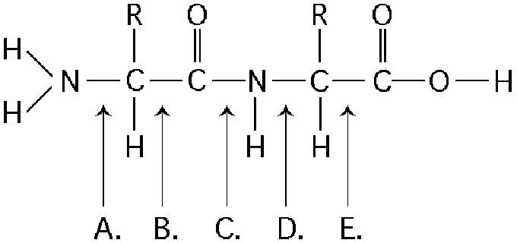
    - a compound with the same number of hydrogen and nitrogen atoms as the hormone Refer to figure below to answer the following question.

  - At which bond would water need to be added to achieve hydrolysis of the protein, back to its component amino acids?
    - A
    - B
    - C
    - D
    - E

End of multiple-choice questions. Continue exam the exam
Answer the following short answer questions
Suppose you are a research assistant in a lab studying DNA-binding proteins. You have been given the amino acid sequences of all the proteins encoded by the genome of a certain species and have asked to find candidate proteins that could bind DNA. 6 points

  - On the line provided, write the name of the group or groups of amino acids you would expect to see in the DNA-binding regions of such proteins? 3 points

Polar charged group – (specifically - the positively charged amino acids)

(B) Briefly explain your reasoning. 3 points

DNA has many phosphate groups along the backbone of each strand, so the molecule has many negative charges.
Therefore, you might expect a DNA-binding protein to have many amino acids with positively charged side chains.

  - A new planet, called Tigers, has been discovered. The cells on the plant are composed of phospholipids with non-polar heads and polar tails. The water on the planet is exactly like Earth’s. In the box below, draw a representation of three molecules of phospholipids floating on the surface of water. Be certain to label everything. 6 points
3 molecules drawn

Polar tails interacting with water
Non-polar heads sticking out of the water water labeled

Answer the following short answer questions. Beef Stew recipe by Paula Dean
- Brown 1 lbs. of beef meat in hot oil.
- Add water, Worcestershire sauce, garlic, bay leaves, onion, salt, sugar, pepper, paprika, and allspice.
- Cover and simmer 1 1/2 hours.
- Remove bay leaves and garlic clove.
- Add carrots and celery.
- Cover and cook 30 to 40 minutes longer.

  - You store the beef stew overnight in the refrigerator at 4˚C. The next evening, you remove the stew from the refrigerator and see a harden layer on top of the beef stew. In the box below, provide a reason why a harden layer formed. Provide detailed reasoning in your response. 6 points

The beef stew contains oil (see step #1). Therefore it has fat in it.
The fat has tails that are hydrophobic (OR NON-POLAR) and tend to aggregate together…. To keep water out.
The fat takes on a harden state at cooler temperatures. Therefore, there is a layer of fat at the top that ardens at 4 degrees Celsius. +

h

  - Heart burn is a painful burning feeling in your chest or throat due to stomach acid backing up into your esophagus (throat). Physicians sometimes prescribe Milk of Magnesia to patients with heartburn. In the box below, explain why this is done. Provide detailed reasoning in your response. 6 points
Milk of magnesia is a basic solution.
A person’s stomach is a pH of 2 due to the gastric juices.
When a person drinks Milk of Magnesia it neutralizes the stomach

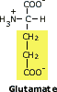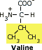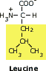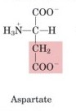
Shown above are four amino acids. The R-group for each amino acid is shaded.
  - Sickle cell anemia properties and structure is the result of the amino acid glutamate being replaced by a valine in the hemoglobin protein sequence. An ambitious Mizzou student decides to perform an experiment, which involves exchanging amino acids in the hemoglobin protein. The student makes the follow changes:
Mutant A: Glutamate #6 is changed to Aspartate
Mutant B: Glutamate #6 is changed to Leucine

    - Which mutant above will most likely display a normal red blood cell shape?

Circle the answer. 3 points

    - Explain your reasoning. 3 points

Mutant A or Mutant B

MUTANT A has similar R GROUP properties as glutamate (+1.5).
Therefore this mutant can be predicted to NOT have a sickle shape as found in sickle cell disease. (+1.5)

VERSION A

