QUESTION 1: FREQUENCY TABLES
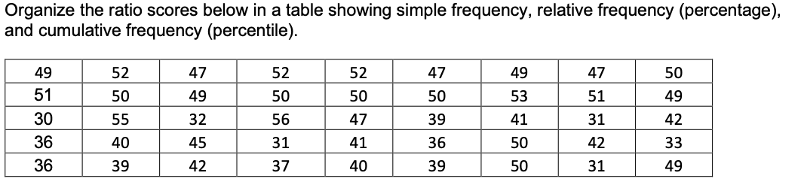
Observation | Absolute frequency | Relative frequency | Cumulative frequency
30 | 1 | 2.22% | 2.22%
31 | 3 | 6.67% | 8.89%
32 | 1 | 2.22% | 11.11%
33 | 1 | 2.22% | 13.33%
36 | 3 | 6.67% | 20.00%
37 | 1 | 2.22% | 22.22%
39 | 3 | 6.67% | 28.89%
40 | 2 | 4.44% | 33.33%
41 | 2 | 4.44% | 37.78%
42 | 3 | 6.67% | 44.44%
45 | 1 | 2.22% | 46.67%
47 | 4 | 8.89% | 55.56%
49 | 5 | 11.11% | 66.67%
50 | 7 | 15.56% | 82.22%
51 | 2 | 4.44% | 86.67%
52 | 3 | 6.67% | 93.33%
53 | 1 | 2.22% | 95.56%
55 | 1 | 2.22% | 97.78%
56 | 1 | 2.22% | 100.00%

QUESTION 2: FREQUENCY TABLES
Organize the data in a table with absolute frequency, relative frequency (percentage) and cumulative frequency (percentile).
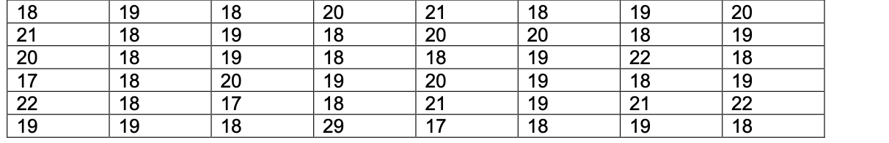
Observation | Absolute frequency | Relative frequency | Cumulative frequency
17 | 3 | 6.25% | 6.25%
18 | 17 | 35.42% | 41.67%
19 | 13 | 27.08% | 68.75%
20 | 7 | 14.58% | 83.33%
21 | 4 | 8.33% | 91.67%
22 | 3 | 6.25% | 97.92%
29 | 1 | 2.08% | 100.00%
QUESTION 3: MEAN, MEDIAN AND MODE
For the below data asset, calculate the:
a.) Mean b.) Mode c.) Median
a) Mean = ∑x_{i} /n
Mean = 334/20
Mean = 16.70
b) Mode = 11
c) median = (16 + 16)/2
Median = 16
QUESTION 4: PERCENTILE & QUARTILES
For the given data set below, calculate the 25th 50th and 75th percentile. Also provide the Five Number
Percentiles:
25th percentile = (12 + 12)/2
25th percentile = 12
50th percentile (median) = 16
75th percentile = (19 + 19)/2
75th percentile = 19
Five number summary:
Minimum = 10
1st quartile (25th percentile) = 12
Median (50th percentile) = 16
3rd quartile (75th percentile) = 19
Maximum = 25
QUESTION 5: MEAN, MEDIAN AND MODE
A frozen food company has a contract with Farm A, to provide peas for their processing plant. The daily supply of peas (in tons) over the past two weeks from Farm A has been as follows:
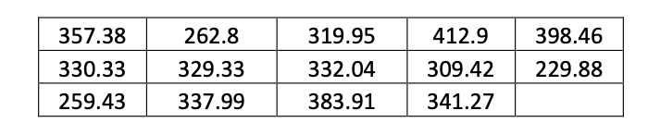
The frozen food company also contracts with Farm B. The daily supply of peas (in tons) over the past two weeks from Farm B has been as follows:
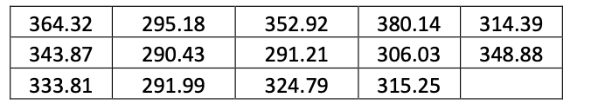
Calculate the respective mean, median and mode for each of the Farms and comment on the answers.
Farm A, mean = 328.935 (4,605.09/14)
Farm A, median = 331.185
Farm A, mode = NA
Farm B, mean = 325.229
Farm B, median = 320.02
Farm B, mode = NA
On average, firm A supplied more peas to the frozen food company than firm A on a daily basis. The mean daily peas supply from firm A was 328.94 tons while firm B’s mean daily supply was equal to 325.23 tons. Firm A’s median peas supply of 331.185 tons was also higher than firm B’s median supply of 320.02 tons. None of the samples had a modal value which was to be expected given the ratio scale and small sample sizes.

QUESTION 6: THEORY
6.1. Explain the difference between a POPULATION and a SAMPLE
A population refers to all the individuals or items of interest to the analyst while a sample refers to a portion of one or more but not all of the individuals or items from the population.
6.2. Explain the difference between a parameter and a statistic
A parameter is a value that describes the distribution of the variable in the population while a statistic is a value that summarizes the distribution of the variable in the sample. Statistics are usually used to estimate the population parameter either as point estimates or confidence intervals.
6.3. discuss the reasons for why we make use of sampling data
Sampling data is used for convenience since it is impractical, time consuming, and costly to conduct a census of all population items to gain information about the population. Usually, the cost of conducting a census outweigh the benefits of the information collected for use at an organizational level. Since a sample of adequate size can be reliably used to estimate the population parameter, researchers prefer to randomly sample from the population at a lower cost.
6.4. discuss two characteristics of the normal distribution
It is bell shaped; the frequency of observations close to the center is higher with a decrease in frequency as you move towards the tails. It is centered at the mean, which is equal to the median and mode of the distribution

QUESTION 7: SCATTERPLOTS & CORRELATION
Discuss and comment on each of the below graphs in terms of its correlation and relationship.

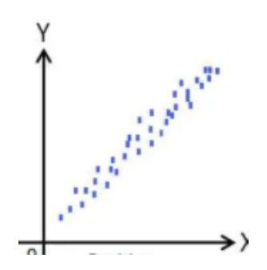a) There is a distinct linear trend in the scatter with Y values increasing with X values, which is an indication of strong positive correlation between the two variables. The two variables have a direct relationship where an increase in X associated with an increase in Y.

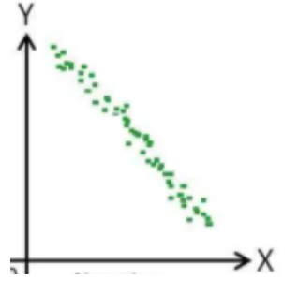b) There is a distinct linear trend in the scatter with Y values decreasing with X values indicating a strong negative correlation between the two variables. X and Y have an inverse relationship where an increase in X is associated with a decrease in Y.

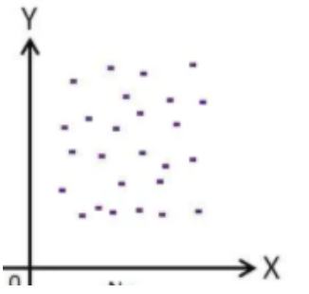c) The observations are randomly scattered across the plot with no discernible trend indicating the absence of a relationship between the variables.

QUESTION 8: CORRELATION
8.1. Discuss the definition of correlation and what information the correlation calculation provides
Pearson’s correlation coefficient measures the direction and strength of the linear relationship between two continuous variables. Pearson’s correlation coefficient ranges between -1 to 1 with 1 and -1 indicating perfect positive correlation and negative correlation, respectively, while zero indicates absence of a relationship between the variables.
8.2. Discuss the limits of correlation
Correlation analysis cannot be used to draw inference on causal relationships between variables. For example, in the correlation analysis of the relationship between class attendance and academic performance, a significant correlation coefficient cannot be used to conclude that class attendance causes better academic performance as the absence of independent variable manipulation prevents us from drawing meaningful inference about the direction of causality. It is possible that students with better class performance are more motivated to attend classes making academic performance the predictor and class attendance the response variable. Correlation analysis is also strictly bivariate, which prevents analysts from controlling for the effect of extraneous variables. In the foregoing example, students class performance could be influenced by other factors such as IQ. The researcher can determine the extent of correlation between IQ and academic performance using correlation analysis but cannot determine the effect of class attendance on academic performance after controlling for IQ.

QUESTION 9: CORRELATION
The number of visitors to a cycle track and the number of drinks sold by a café at the location are recorded in the table below.
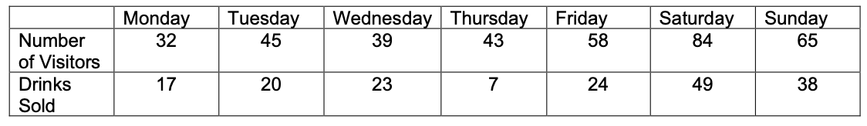

9.1. Draw a scatterplot diagram and interpret the graph

There is a marked linear trend in the observations with a majority of the datapoints falling on a fairly straight line indicating the presence of a strong positive and approximately linear correlation between the number of drinks sold and the number of visitors.
9.2. Describe the relationship between the number of visitors and the number of drinks sold.
The number of drinks sold increases with the number of visitors. This relationship is as expected given that each new visitor represents a drink sales opportunity.
9.3. Which particular day does not fit the relationship?
The number of drinks sold in Thursday deviates from the observed relationship between drinks sold and number of visitors. The drink sales are lower than expected.
9.4. Calculate the correlation coefficient.
Mean of X, number of visitors = 52.29 (366/ 7)
Mean of Y, number of drinks sold = 25.43 (178/ 7)
Standard deviation of X = 17.92
Standard deviation of Y = 13.91
Correlation coefficient, r = $\frac{1}{n-1}\left[\sum{\left(x-x\right) \left(y-y\right)/ s_{x} s_{y}}\right]$
x | y | (x - x) | (y-y) | (x-x)(y-y)
32 | 17 | - 20.29 | - 8.43 | 170.9796
45 | 20 | - 7.29 | - 5.43 | 39.55102
39 | 23 | - 13.29 | - 2.43 | 32.26531
43 | 7 | - 9.29 | - 18.43 | 171.1224
58 | 24 | 5.71 | - 1.43 | -8.16327
84 | 49 | 31.71 | 23.57 | 747.551
65 | 38 | 12.71 | 12.57 | 159.8367
 |  |  | Sum | 1313.14
$\sum{\left(x-x\right) \left(y-y\right)}$= 1,313.14
STDEV, X * STDEV, Y = 52.2857 (17.92 * 13.91)
Correlation coefficient, r = 1/6 * (1,313.14/ 249.2672)
Correlation coefficient, r = 0.878
QUESTION 10: NORMAL DISTRIBUTION
The heights of adult females are normally distributed with mean 160cm and Standard Deviation 8cm.
10.1. Explain the Normal Distribution and Standard Normal Distribution in your own words
Normal distributions are a family of unimodal symmetric bell-shaped distributions centered at the mean whose height and width are described by the distribution’s standard deviation. There are an infinite number of normal distributions with different mean and standard deviations. The standard normal distribution is a special type of normal distribution with a mean of zero and standard deviation of one. Converting all the scores from a normal distribution into Z scores transforms the distribution into the standard normal.
10.2. Find the probability that a randomly selected adult female has a height greater than 170cm
Z = (X – μ)/ SD
Z = (170 – 160)/ 8
Z = 1.25
P (X ≥ 170) = 1 – P(X ≤ 170)
P (X ≥ 170) = 1 – 0.8944
P (X ≥ 170) = 0.1057
Any adult female whose height is greater than 170cm is defined as tall. An adult female is chosen at random. Given that she is tall,
10.3. find the probability that she has a height greater than 180cm
Using the Bayesian conditional probability formula,
P (height greater than 180cm | tall) = P(B|A) * P (A)
P(B|A) * P(A) + P(B|A’)*P(A’)
A = height greater than 180 cm
B = tall
P (A) = 0.1057
P (B) = 0.0062
P (tall | height greater than 180 cm) = 1
P (tall | height less than 180 cm) = P (170 ≤ X ≤ 180) = 0.9938 – 0.8944
P (tall | height less than 180 cm) = 0.0994
P (not tall) = 0.8943
P (height greater than 180 cm | tall) = (1 * 0.1057)/ (1 * 0.1057 + 0.0994*0.8943)
P (height greater than 180 cm | tall) = 0.1057/ 0.1946
P (height greater than 180 cm | tall) = 0.54
Half of tall adult females have a height greater than h cm. 10.5. Find the value of h.
H is the mean of the tall adult women’s distribution. Using the probability from 10.3,
P (X ≤ 180) = 0.46 (1 – 0.54)
Z score corresponding to 0.46 = -0.1004
Z = (180 – h)/ 8
-0.1004 = (180 – h)/8
-0.8032 = 180 – h
h = 180.8032

