1)What determines the position of the FE line? Give two examples of changes in the economy that would shift the FE line to the right.
Answer: The position of the FE line is determined by the labor market and the production function. Labor supply and demand determine equilibrium employment. Using equilibrium employment in the production function gives the full-employment level of output. The FE line is vertical at that point. The FE line shifts to the right if there is an increase in labor supply or the capital stock or if there is a beneficial supply shock.

- What relationship does the IS curve capture? Derive the IS curve graphically and show why it slopes as it does. Give two examples of changes in the economy that would cause the IS curve to shift down and to the left.
Answer: The IS curve shows combinations of the real interest rate (r) and output (Y) that leave the goods marketin equilibrium. Equilibrium in the goods market occurs when the aggregate supply of goods (Y) equals the aggregate demand for goods (Cd + I d + G). Since desired national saving (Sd) is Y – Cd – G, an equivalent condition is Sd = I d. Equilibrium is achieved by the adjustment of the real interest rate to make the desired level of saving equal to the desired level of investment. For different levels of output, there are different desired saving curves, with different equilibrium interest rates. When plotted on a figure showing output and the real interest rate, this forms the IS curve, as shown in Figure 9.15. The curve slopes downward because as output rises, the saving curve shifts along the investment curve and the real interest rate declines.

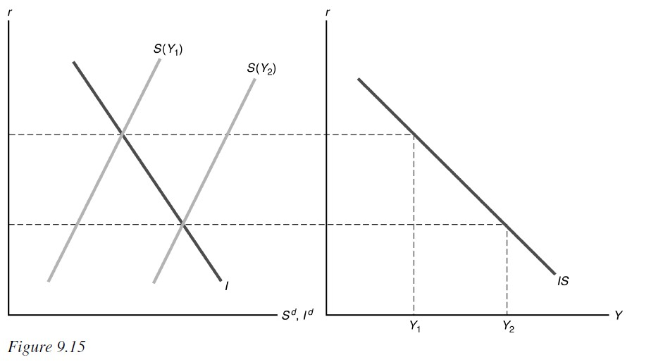
The IS curve could shift down and to the left if: (1) expected future output falls, because this increases desired saving; (2) government purchases fall, because this increases desired saving; (3) the expected future marginal product of capital falls, because this decreases desired investment; or (4) corporate taxes increase, because this decreases desired investment.

- What relationship does the LM curve capture? Derive the LM curve graphically and show why it slopes as it does. Give two examples of changes in the economy that would cause the LM curve to shift down and to the right.
Answer: The LM curve shows the combinations of output and the real interest rate that maintain equilibrium in the asset market. Equilibrium in the asset market occurs when real money demand equals the real money supply. Figure 9.16 shows the derivation of the LM curve and why it slopes upward. An increase in output from Y1 to Y2 raises money demand, shifting the money demand curve from MD(Y1) to MD(Y2). With money supply fixed at MS, there must be a higher real interest rate to get equilibrium in the asset market. This gives two points of the LM curve, plotted on the right half of the figure. The result is that higher output increases the real interest rate along the LM curve, so the LM curve slopes upward.

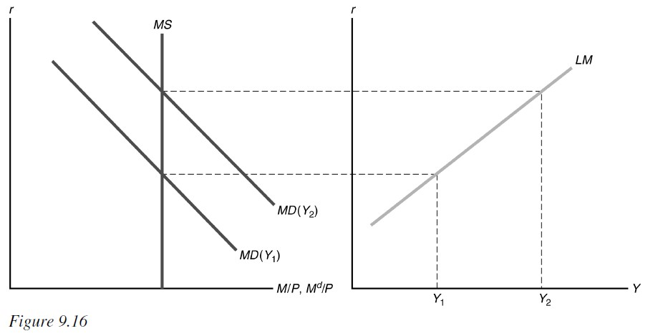
The LM curve would shift down and to the right if the nominal money supply or expected inflation increased or if the price level or nominal interest rate on money decreased. In addition, the curve would shift down and to the right if there were a decrease in wealth, a decrease in the risk of alternative assets relative to the risk of holding money, an increase in the liquidity of alternative assets, or an increase in the efficiency of payment technologies.

- For constant output, if the real money supply exceeds the real quantity of money demanded, what will happen to the real interest rate that clears the asset market? In describing the adjustment of the real interest rate, use the relationship that exists between the price of a nonmonetary asset and the interest rate that it pays.
Answer: For constant output, if real money supply exceeds the real quantity of money demanded, the real interest rate will decline to increase the real quantity of money demanded until equilibrium is reached. This process occurs because people who find themselves with excess money balances purchase nonmonetary assets, thus increasing the market price of the nonmonetary assets and reducing the real interest rate.

- Define general equilibrium and show the general equilibrium point in the IS-LM diagram. If the economy isn't in general equilibrium, what determines output and the real interest rate? What economic forces act to bring the economy back to general equilibrium?
Answer: General equilibrium is a situation in which all markets in an economy are simultaneously in equilibrium. This is shown in Figure 9.17 as the point at which the FE line and the IS and LM curves intersect. If the economy is not initially in general equilibrium, output and the real interest rate are determined by the intersection of the IS and LM curves. Then adjustment of the price level moves the LM curve until it intersects the FE line and IS curve.

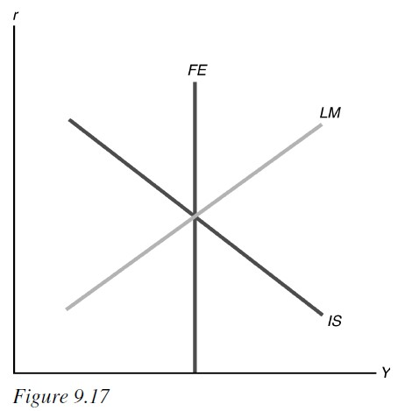

- Define monetary neutrality. Show that, after prices adjust completely, money is neutral in the IS-LM model. What are the classical and Keynesian views about whether money is neutral in the short run? In the long run?
Answer: There is monetary neutrality if a change in the nominal money supply changes the price level but has no effect on real variables. Once prices adjust, money is neutral in the IS– LM model, because a change in the money supply that shifts the LM curve is matched by a proportional change in the price level that returns the real money supply back to its original level and moves the LM curve back to its original location. Classical economists believe that money is neutral in the short run, but Keynesians believe that there may be sluggish adjustment of the price level, so that changes in the money supply affect output and the real interest rate in the short run. Both classicals and Keynesians believe money is neutral in the long run.

