Appearance and Reality
Student’s Name
University Affiliation
Professor’s name
Course title
Date

Appearance and reality
As humans, we are surrounded by material objects, and our understanding of the world is based on what we perceive to be true. Reality to people is defined by what they perceive to be true based on their appearance. People rarely question what appears to them in life as appearance is a reality to most of us. The ability to critically examine what we perceive and determine the underlying value of everything that we are viewing or hearing is what enables one to distinguish between perception and reality. Determining if there is any knowledge whose uncertainty cannot be doubted sets the platform for critical thought and analyses of our environment.
According to Bertrand, sight and hearing as well as other senses that help us to better distinguish something as sense data (Russell, 2012). Bertrand used the example of a table to explain the concept that appearance is defined not by abstract truth that is universal to all but one that is influenced by three major factors that are the environment, the observer and the object. To better explain Bertrand philosophical perceptive of reality and appearance it is important to use a modern example that one can relate to and that is “the dress” (Appendix). On February 26, 2015, a viral internet picture caused controversy across the world with no one able to accurately determine if the color of the dress was black, blue or gold (Rogers, 2015). Bertrand identified that the differences in perception define appearances, and thus it is impossible to accurately determine an object as simply being one color or being of a given texture. The dress embodies the concepts of Bertrand when it comes to the belief that sense data does not define reality. The dress provided an argument that further highlights his ideology of appearance and reality based on the differences in human color perception across the world.

References
Rogers, A. (2015). The science of why no one agrees on the color of this dress. Retrieved from
https://www.wired.com/2015/02/science-one-agrees-color-dress/
Russell, B. (2012). The problems of philosophy. OUP Oxford.

Appendix: The dress
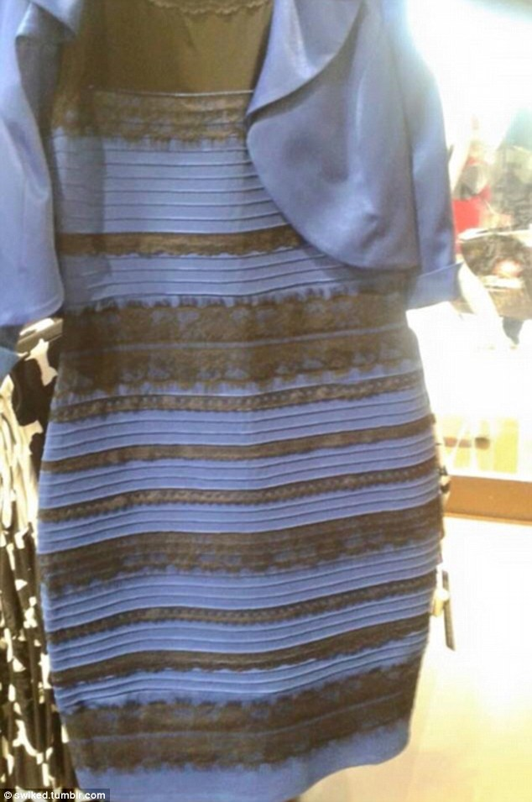
Retrieved from http://www.dailymail.co.uk/femail/article-3466064/Do-blue-white-green-gold-One-year-Dress-left-internet-baffled-furious-debate-breaks-color-jacket.html

