Theories and Techniques
A. Explain the five steps of the theory of constraints (TOC) process. To what processes might the company in the case study apply TOC? Why would applying TOC to these processes be advantageous?
The Theory of Constraints (TOC) process is a five-step guideline that can be used to overcome physical and non-physical constraints that limit an organization’s ability to meet its objective (Heizer, Render & Munson, 2016). The five steps of the TOC process are: identification of constraints; creation of a plan to resolve the constraints; redirection of resources to implement the constraint resolution plan; mitigation of the effects of the constraints by expanding organizational capabilities or offloading work; and repetition of the process once one set of constraints is overcome (Heizer et al., 2016).
The company can apply the TOC process at an organizational level and at a process level. At the organizational level, TOC can be used to identify the broad constraints that limit BYD’s ability to be a market leader in the manufacture of electric vehicles. The physical constraints that might be identified at this level are battery-related: cost of battery, short-term and long-term durability of the battery, affordability and proximity of consumers to charging stations. The subsequent TOC steps are best implemented at a process level. BYD can identify the costliest processes in the manufacture of car batteries and create a plan to reduce the process cost. The company will then commit resources to the implementation of the plan and improve organizational capabilities in the area.
While BYD currently uses environmentally friendly batteries, the solution of one of the aforementioned constraints such as battery cost could jeopardize the battery’s environmental friendliness; thus, the company should cycle through the five processes until all constraints are resolved. The TOC method allows the company to be familiar with all relevant constraints in its process and focus on the most pressing limitations. Further, using the TOC method, management can note the side effects of certain solutions and use a cost-benefit approach to determine whether the outcome justifies the costs. If the cost arising from the side effect is deemed to high, management will halt the implementation of the solution and engineer a better solution to the constrain; thus, eliminating the cost of fixing the adversarial side effect.
B. Describe how total quality management (TQM) principles and tools can be used to improve quality in the latest line of products in the context of the case study.
Total Quality Management (TQM) refers to a perpetual process of product improvement that encompasses the entire organization. BYD can use the plan-do-check-act principle that is central to the TQM philosophy to ensure perpetual improvement of its ferrous lithium battery. A TQM tool that could be implemented to resolve the company’s cost problem is internal benchmarking of cost-effective departments and implementation of the cost-cutting strategies to other departments. BYD would also benefit from external benchmarking of companies that surpass it in some critical aspect of electric vehicle manufacture such as Tesla’s provision of sufficient and conveniently placed superchargers for the users of its hybrid and electric vehicles. TQM principles and tools should be used by all department managers in BYD. At the departmental level, managers and supervisors can use TQM tools such as cause-effect diagrams, flow charts, and statistical process control charts within Six-Sigma’s DMAIC paradigm to identify problem areas in the manufacturing process and areas that can be improved for higher quality and cost-effective products.
Data Analysis
A. Draw a cause-and-effect diagram that assesses why some of the company’s supply chain partners might have struggled to implement some of the company’s newly developed materials. Summarize your findings from the diagram.
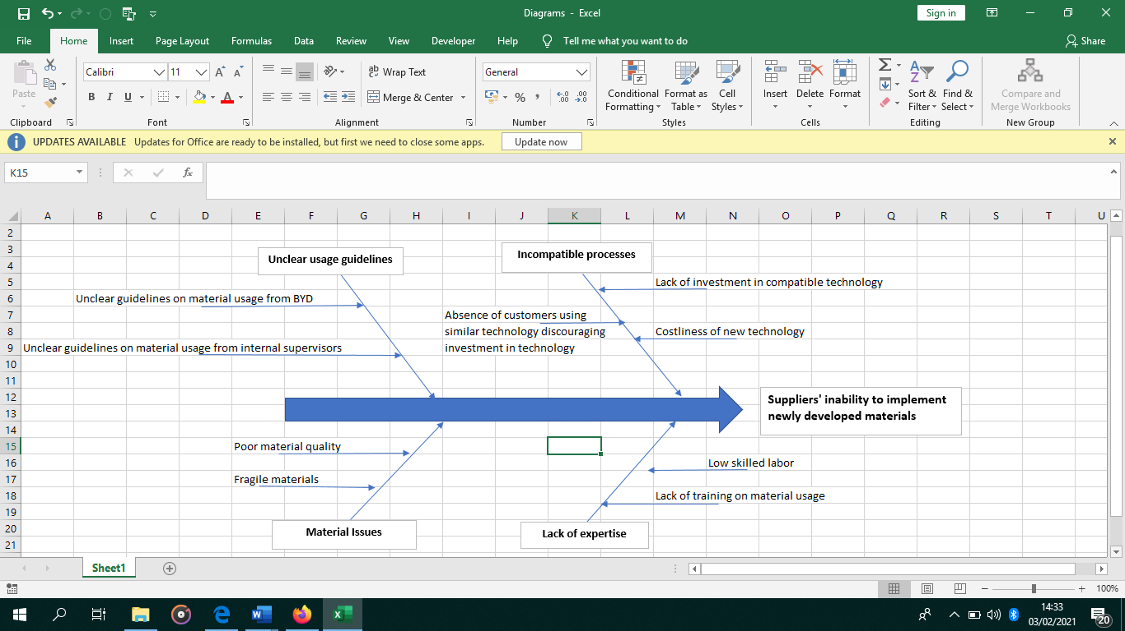
The four reasons for supply chain partners’ struggle in the implementation of BYD’s newly developed materials are incompatible processes, low skilled labor, material issues, and unclear usage guidelines. BYD is leading the industry in the development of new technology for Lithium ion batteries. Its supply chain partners might be struggling to implement BYD’s materials due to incompatible processes and technology. This could be due to the unavailability of capital to invest in costly technology. For capital rich supply chain partners, the absence of other customers using similar technology will discourage them from acquiring the technological advancements as they would be beholden to BYD for revenue to recoup the investment amount.
BYD is able to keep its costs low by employing unskilled labor. Its supply chain partners are also likely to rely on unskilled labor; hence, the lack of expertise to implement the new materials. In the same vein, supply chain partners could be keeping their training costs low to remain competitive making it difficult for workers to gain the technical know-how to implement the materials. The materials could be of low quality and fragile requiring supply chain partners to go through a steep learning curve prior to material implementation to prevent wastage. Supply chain partners could also be struggling due to the absence of clear usage guidelines from BYD and from internal supervisors.
B. Draw a hypothetical process (time-function) map for producing a recently released (within the past two years) product manufactured by the company. As an operations manager, how will you use the value map? Be sure to include your process map within your case study analysis.
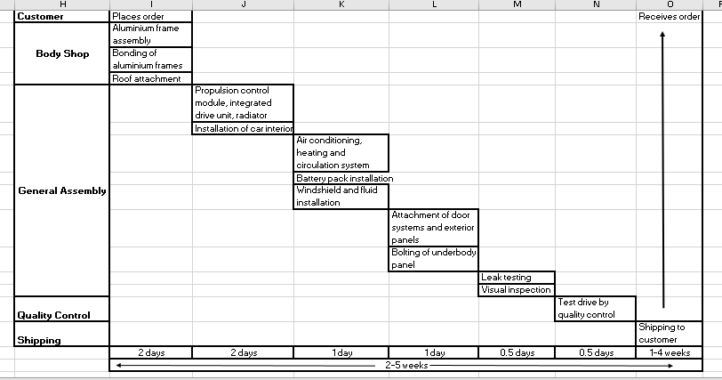
Source: Electric Automobile, madehow.com
I would use the value map to identify the core value-addition areas in the manufacturing process.
C. Considering the data and options below, determine where the company should locate its new manufacturing plant. Explain why this would be the favorable location.
Factor | Weight | Mexico City | Columbia, SC
Political Risk | .25 | 70 | 80
Transportation Costs | .20 | 40 | 90
Labor Productivity | .20 | 85 | 75
Rental Costs | .15 | 90 | 55
Labor Costs | .10 | 80 | 50
Taxes | .10 | 90 | 50

From the sum of the product of the assigned weights and scores, Mexico City has a higher weighted aggregate score (73) than Columbia (71.25). While Mexico City offers lesser benefits in two of the qualitative areas the company assigned the greatest weight (political risk and transportation costs), it offers much higher benefits in the labor productivity, rental costs, labor costs, and taxes compared to Columbia making it the better choice.

References
Heizer, J., Render, B., & Munson, C. (2016). Operations management: Sustainability and supply
chain management. Boston, MA: Pearson Learning
How Products are Made (n.d). Electric Automobiles. Retrieved from:
http://www.madehow.com/Volume-5/Electric-Automobile.html

