Question 2 (1 point)
GDP = C + I + G + GX - IM. Explain why we subtract imports rather than just ignore them.
Imports are part of consumption, investment, and government expenditure and are subtracted to prevent double counting.

Question 3 (1 point)
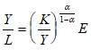
Starting from the standard Cobb-Douglas form of the production function, derive
$Y=EK^{a }L^{1-a}$
$L^{1-a}=\frac{Y}{EK^{a}}$
$L ={\frac{Y}{EK^{a}}}^{1/(1-a)}$
$\frac{Y}{L}=Y*Y^{-\frac{1}{1-a} }*{(EK^{a})}^{\frac{1}{1-a}}$
$\frac{Y}{L}=Y^{-\frac{a}{1-a} }*{K^{\frac{a}{1-a}}}^{}*E ;$
$\frac{Y}{L}= E*{\frac{K}{Y}}^{\frac{a}{1-a}}$

Question 4 (2 points)
- From the equation expressing the balanced growth equilibrium condition, g(Y/L) = g(K/L), derive the implication: K/Y is constant in BGE.
Let k and y be derivatives with of per capita capital and output with respect to time. We know that:
$\frac{K}{Y}=\frac{k}{K}*\frac{K}{y}$
$\frac{Y}{y}*\frac{k}{Y}=\frac{1}{\frac{y}{Y}}*\frac{k}{Y}$
$\frac{k}{y}=\frac{gK}{L}*\frac{K}{y}$
$\frac{k}{Y}*\frac{1}{g}\left(\frac{Y}{L}\right)=g\left(\frac{K}{L}\right)*g\left(\frac{Y}{L}\right)=\frac{k*y}{K*Y}$
Now, sy = $\left(n+d+g\right)→\frac{s}{n+d+g}=\frac{k}{y}=\frac{K}{Y}………\left(1\right)$
Increasing K/Y causes an increase in the right-hand side of equation (1). Y must increase to restore the balanced growth condition.
- From the equation expressing the balanced growth equilibrium condition and using a Cobb-Douglas production function, derive the implication: in BGE, the growth rate of the standard of living, Y/L, equals the growth rate of efficiency, E.
Y/L = (K/Y) ^ (a/(1-a)) * E
(K/L * L/Y) ^ (a/ (1-a)) * E = y = (k/y) ^ (a/(1-a)) * E
ln (y) = (a/(1-a)) * ln (k) – (a/(1-a)) * ln(y) + ln(E)
Differentiating with respect to time, and letting ∆ denote the derivative with respect to time, we have:
∆y/y = (a/(1-a)) * ∆k/k— (a/(1-a)) * ∆y/y + ∆E/E (1+a/(1-a)) * ∆y/y=(a/(1-a)) * ∆k/k + ∆E/E. But along balanced growth path, g(Y/L) = g(K/L) ∆y/y=∆k/k.
Thus, 1/(1-a) * ∆y/y = a/(1-a) * ∆y/y+∆E/E (1/(1-a) – a/(1-a)) * ∆y/y = ∆E/E ∆y/y= ∆E/E which completes the derivation.

Question 5 (2 points)
Suppose the economy can be defined by the following
s = 36 % n = ½ % | g = 2 % δ = 1 ½ % | α = 1/3  E₀ (initial value of E) = $20,000/yr
- In BGE, what are the values of K/Y, Y/L, and K/L when E = E₀? You’ll enter your answers in boxes in gradescope (no units or you’ll mess up the auto-grading). You’ll upload a copy of your work. Your work should clearly show the units.
n + d + g = 0.005+ 0.02+ 0.015= 0.04
K/Y = k*L/(y*L)
k/y = s/ (n+ d+ g)
K/Y = 0.36/ 0.04 = 9.
Y/L= E* (k*L/(y*L))^ (a/(1-a))
Y/L =20000*9^ ((1/3)/ (1-1/3)) = 60000.
K/L= (K/Y) * (Y/L) = 9*60000 = 540,000
- Provide expressions that show the BGE values of Y/L and K/L after 10 years. Use your expressions to compute the BGE values of Y/L and K/L after 10 years. You’ll enter your answers in a box in gradescope (no units or you’ll mess up the autograding). You’ll upload a copy of your work. Your work should clearly show the units.
Y/L = (K/Y) ^ (a/(1-a)) *E* exp(n*t)
(K/Y) ^ (1/3÷2/3) * E* exp(10n) = (K/Y)^ (0.5) *E *exp(10n)
Y/L = 9^ 0.5* 20000* exp(10*0.005) = 63076.27
K/Y= 9
K/L = 540000* exp(10n)
K/L = 540000*exp(10*0.005)
K/L = 567,686.392

Question 6
- (1 point) After the war ends, is Economy A in BGE? Is Economy B in BGE? Defend your answers.
While there was a shift in the economies’ steady state position, both economies remained in the balanced growth path since ∆k = sf(k) – (n+ d+ g)* k. Changes in n and k result in capital widening changes, which in turn causes capital deepening changes without moving the economies away from their balanced growth paths.
- (½ point) Draw a graph that shows the determination of the pre-war and post-war K/L and Y/L for Economy A and Economy B. Label everything clearly, using subscript “0" to denote the common pre-war position, subscript “A” to denote postwar economy A and subscript “B” to denote postwar economy B.
Reduction of population led to an increase in capital per worker in both economies. Destruction of capital stock in economy A, however, led to a reduction in capital per worker. The capital widening in economy A shifted upwards with a steady state position at A after the war while in economy B, capital widening curve shifted downwards with a steady state position at B. The relation is given in:
y-A < y-0 < y-B and k-A < k-0< k-B

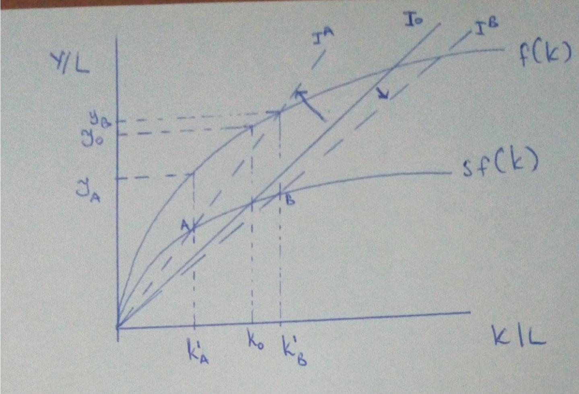
- (1 point) Suppose that natural population growth is endogenous: in both economies, natural population growth is inversely related to output per worker. Explain why the war will therefore cause the economies of these two countries to diverge.
Capital per worker in economy B (whose capital was not destroyed) is higher than capital per worker in economy A. Higher capital per worker implies higher output per worker in economy B than in A at steady state. Consequently, the higher investment per worker in B as compared to A results in higher productive capacity in B compared to A. With higher productive capacity, firms in B are motivated to increase output due to more capacity. As output increases, more capacity increases in B hence the two economies will diverge instead of converging.
Lower capital per worker in A speaks to lower output per worker, which in turn implies lower investments and lower productive capacity. Firms in economy A reduce output; thus, lowering the savings and the investments thereby resulting into further reduction in capacity. Ultimately, A and B never converge.
- (½ point) Redraw the graph from part B. Illustrate your answers from part C by adding to the redrawn graph. Continue using subscripts "A" and "B" to distinguish the two economies. Use superscript "*" to denote the new BGE positions.
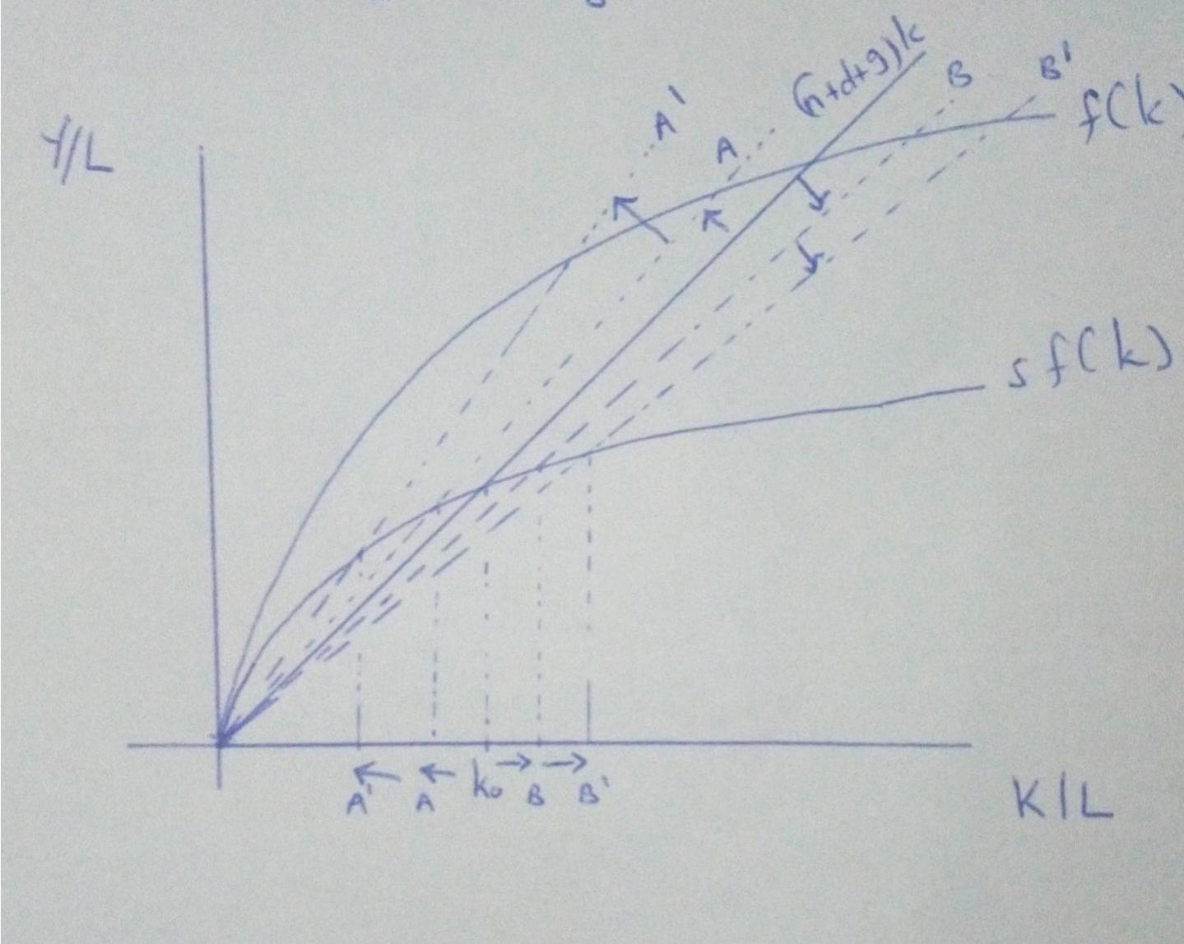

Question 7: The Essay (3 points total)
Consider this argument: “I don’t care whether government spending is to build and maintain new and efficient transportation and communication networks, to hire more teachers, or to increase payments to unemployed people. Increased government spending lowers the standard of living in the long run.”
Follow This 5-step method and write a 1-page essay in which you critique the argument above.

Given an initial level of government savings, S-G, an increase in government spending is synonymous with a decrease in S-G (Delong & Olney, 2018). With further increments in government spending, government savings will decrease to a point where subsequent government spending is only be feasible if financed by private savings, S-P. Continued government spending will result in the shrinkage of both government and private sector spending and an increase in budget deficits. As the savings reduce, capital accumulation will reduce, which will in turn cause a reduction in output. Consequently, the standard of living Y/L in the economy drops.
This is assuming that the total savings in the economy equals the sum of government savings and private savings; government spending is solely funded by savings in the domestic economy; there is no capital flight, and no capital inflow; and taxes are non-existent such that government spending is not funded by tax revenue (Delong & Olney, 2018). Changing the assumption regarding sources of government spending to the new assumption that government spending is funded by both domestic savings and foreign capital outflows results in a different outcome.
With an increase in foreign capital inflow, government spending rises without a reduction in domestic savings. Additional foreign capital to domestic savings increases the savings domestically. As a result, the savings rate will increase as will the amount of capital accumulated in the economy. This will result in an increase in output leading to an increase in output per worker hence an improvement in the standard of living (Delong & Olney, 2018). The alternative assumption is based on the knowledge that governments do borrow externally in the event of government budget deficits and rely upon capital inflow to boost their own resources in the process of increased government spending (Delong & Olney, 2018).
Reference
Delong & Olney. (2018). Macroeconomics. 3rd Edition. New York, NY: McGraw Hill

