QUESTION 1
- All of the following are characteristics of long-run equilibrium for firms in a monopolistically competitive market except:
 |  | price equals marginal cost.
 |  | price equals average total cost.
 |  | price exceeds the minimum of average total cost.
 |  | marginal cost equals marginal revenue.
1 points
QUESTION 2
- All of the following are strategies a firm with market power can adopt to increase it profits over time except:
erecting barriers to entry.
setting price equal to the marginal costs of production.
mergers with, and acquisitions of, competing firms.
influencing the regulatory process.
1 points
QUESTION 3
- Assume that for a particular firm's output price = $80, marginal cost = $30, average total cost = $25. Based on this information, the firm's Lerner Index is equal to:
0.313.
0.625.
0.6.
0.375.
1 points
QUESTION 4
- Assume that when price is $20, quantity demanded is 9 units, and when price is $19, quantity demanded is 10 units. Based on this information, what is the marginal revenue resulting from an increase in output from 9 units to 10 units?
$10
$1
$19
$20
1 points
QUESTION 5
- Because firms produce a differentiated product, each of the firms in a monopolistically competitive market faces a demand curve that is:
perfectly elastic.
downward sloping.
perfectly inelastic.
perfectly elastic or perfectly inelastic depending on whether the firm's output is a luxury or a necessity.
1 points
QUESTION 6
- Suppose a monopolist is producing a level of output such that MR > MC. What should the firm do to maximize its profits?
The firm should increase output.
The firm should increase price.
The firm should do nothing — it wants to maximize the difference between MR and MC in order to maximize its profits.
The firm should hire less labor.
1 points
QUESTION 7
- Suppose the firms in a monopolistically competitive market are earning positive economic profits. What will happen to move the market to its long-run equilibrium?
The demand curves faced by firms in the market will shift to the right.
The firms' demand curves will become less elastic.
More close substitutes will appear in the market.
1 points
QUESTION 8
- The Lerner Index is a measure of market power that focuses on:
the difference between a firm's product price and its marginal costs of production.
the share of the market controlled by the X largest firms in the market.
the ratio of the price of a firm's product to the price elasticity of demand for the product.
the sum of the squares of the market share of each firm in an industry.
1 points
QUESTION 9
- The measure of market power that focuses on the share of the market controlled by the X largest firms in the market is known as:
the Lerner Index.
the Herfindahl-Hirschman Index.
the Minimum-Efficient Scale Index.
a concentration ratio.
1 points
QUESTION 10
- The monopoly characteristic of monopolistically competitive firms ensures that such firms will earn positive zero economic profits over the long run.
True
False
1 points
QUESTION 11
- Use Figure 8.1, which represents the situation faced by a monopolist, to answer the following questions.
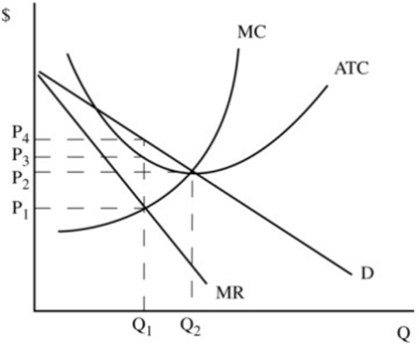
Figure 8.1
For the firm in Figure 8.1, the profit-maximizing (loss-minimizing) price and level of output are:
P₄ and Q₁.
P₃ and Q₁.
P₂ and Q₂.
1 points
QUESTION 12
- Use Figure 8.1, which represents the situation faced by a monopolist, to answer the following questions.
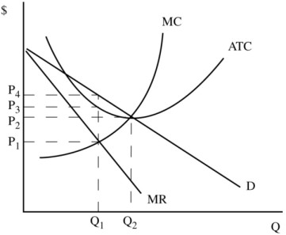
Figure 8.1
The firm depicted in Figure 8.1 is:
incurring an economic loss but it should continue to operate in the short run so long as price exceeds average variable costs.
earning a zero economic profit.
earning a positive economic profit.
incurring an economic loss and should shut down.
1 points
QUESTION 13
- Use Figure 8.1, which represents the situation faced by a monopolist, to answer the following questions.
Figure 8.1
Assuming instead that the market depicted in Figure 8.1 is perfectly competitive, the equilibrium price and output would be:
P₂ and Q₂.
P₁ and Q₁.
P₃ and Q₁.
P₄ and Q₁.
1 points
QUESTION 14
- Which of the following barriers to entry into a market is most beneficial from society's perspective?
Ownership of an essential productive resource.
Brand loyalties.
Economies of scale.
1 points
QUESTION 15
- Which of the following is characteristics is common to both monopoly and monopolistic competition?
Ease of entry into the industry.
Long-run economic profit equals 0.
Firms are price setters.
A relatively large number of sellers.
1 points
QUESTION 16
- Which of the following is the best example of a monopolistically competitive market?
The wheat market.
The electricity market.
The restaurant market.
The market for automobiles.
1 points
QUESTION 17
- Which of the following is not a type of "lock-in" that acts as a barrier to entry into a particular market?
Pricing at or below the average cost of production.
Specialized suppliers.
Loyalty programs.
1 points
QUESTION 18
Which of the following statements regarding a monopolist is false?
The marginal revenue curve lies below the demand curve for the monopolist's output.
The monopolist may or may not earn positive economic profits.
Unlike a perfectly competitive firm, a monopolist faces little or no competition.
The monopolist sets price equal to marginal cost to maximize profits.
1 points
QUESTION 19
- Which of the following statements regarding patents is false?
Patents can help firms gain market power through innovation and then act as a barrier to entry.
Patents encourage the production of information, which might otherwise be under supplied.
Patents can last for an indefinite time period.
A firm that has market power as a result of a patent may be more likely to innovate than a perfectly competitive firm.
1 points
QUESTION 20
- Which of the following values of the Lerner Index indicates the greatest amount of market power?
0.313.
0.625.
0.375.
0.6.

