Principles of Microeconomics Spring2018
Homework 5

Name Pratik Kacha

MULTIPLE CHOICE. Choose the one alternative that best completes the statement or answers the question.
- Conceptually, the efficient level of carbon emissions is the level for which 1) C
  - the marginal cost of reducing carbon emissions is minimized.
  - the marginal benefit of reducing carbon emissions is minimized and the marginal cost of reducing carbon emissions is maximized.
  - the marginal benefit of reducing carbon emissions is equal to the marginal cost of reducing carbon emissions.
  - the marginal benefit of reducing carbon emissions is maximized.
- Which of the following is a source of market failure? 2) A
  - incomplete property rights or inability to enforce property rights
  - unforeseen circumstances which leads to the bankruptcy of many firms
  - a lack of government intervention in a market
  - an inequitable income distribution
- Which of the following activities create a negative externality? 3) C
  - cleaning up the sidewalk on your block
  - graduating from college
  - keeping a junked car parked on your front lawn
  - repainting the house you live in to improve its appearance
- What is a "social cost" of production? 4) D
  - the cost of the environmental damage created by production
  - the cost of the natural resources used up in production
  - the sum of all costs to individuals in society, regardless of whether the costs are borne by those who produce the products or consume the product
  - the total costs of producing a product, both implicit and explicit costs
- A positive externality causes 5) A
  - the marginal social benefit to exceed the marginal private cost of the last unit produced.
  - the marginal private benefit to exceed the marginal social cost of the last unit produced.
  - the marginal social benefit to be equal to the marginal private cost of the last unit produced.
  - the marginal social benefit to be less than the marginal private cost of the last unit produced.

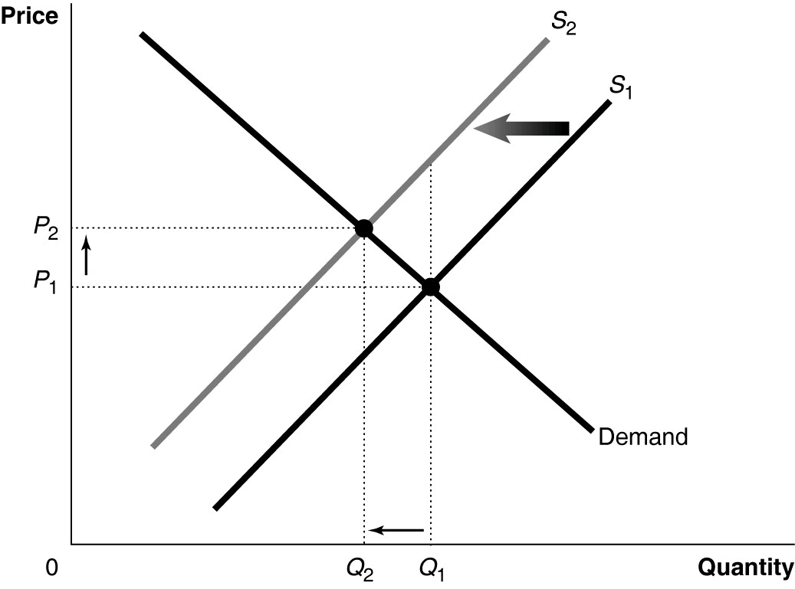
Figure 5-1
Figure 5-1 shows a market with an externality. The current market equilibrium output of Q1 is not the economically efficient output. The economically efficient output is Q2.

- Refer to Figure 5-1. Suppose the current market equilibrium output of Q1 is not the economically efficient output because of an externality. The economically efficient output is Q2. In that case, the diagram shows
  - the effect of an external benefit such as a subsidy granted to consumers of a good.
  - the effect of a positive externality in the production of a good.
  - the effect of an external cost imposed on a producer.
  - the effect of a negative externality in the production of a good.

- Refer to Figure 5-1. If, because of an externality, the economically efficient output is Q2 and not the current equilibrium output of Q1, what does S1 represent?
  - the market supply curve reflecting external cost
  - the market supply curve reflecting marginal social cost
  - the market supply curve reflecting implicit cost
  - the market supply curve reflecting marginal private cost

- Refer to Figure 5-1. If, because of an externality, the economically efficient output is Q2 and not the current equilibrium output of Q1, what does S2 represent?
  - the market supply curve reflecting implicit cost
  - the market supply curve reflecting marginal private cost
  - the market supply curve reflecting external cost
  - the market supply curve reflecting marginal social cost
6) D

7) D

8) D

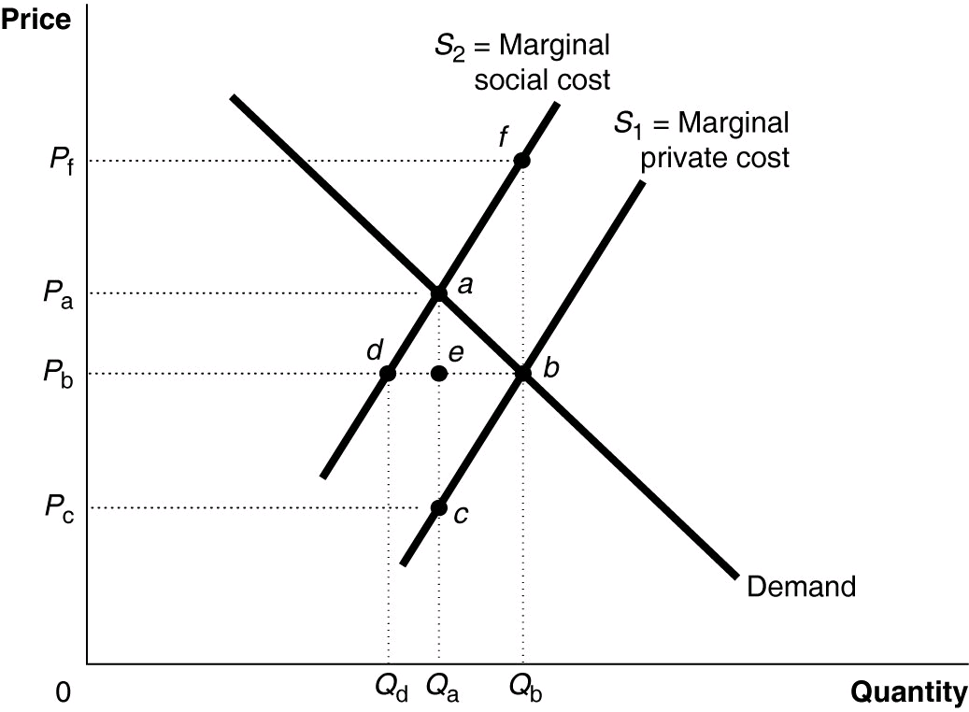
Figure 5-2

Figure 5-2 shows a market with a negative externality.

- Refer to Figure 5-2. The efficient output level is 9) B
  - Qb - Qd. B) Qa. C) Qd. D) Qb.
- Refer to Figure 5-2. The deadweight loss due to the externality is represented by the area 10) C
  - abc. B) ade. C) abf. D) abd.
- Refer to Figure 5-2. The marginal benefit of the last unit produced is represented by the price 11) B
  - Pa. B) Pb. C) Pc. D) Pf.
- Refer to Figure 5-2. The true marginal cost of the last unit produced is represented by the price 12) D
  - Pa. B) Pb. C) Pc. D) Pf.
- A market supply curve reflects the 13) D
  - social costs of producing a good or service.
  - external benefits of producing a good or service.
  - external costs of producing a good or service.
  - private costs of producing a good or service.
- A positive externality results when 14) C
  - someone pays for a good or service even though she is not directly affected by the production or consumption of it.
  - people who are not directly involved in producing or paying for a good or service benefit from it.
  - people who live in one country benefit from the production of a good or service that occurs in another country.
  - economists are sure that a good or service provides benefits to consumers.

- Medical research that results in a cure for a serious disease produces positive externalities. What is the impact of this positive externality on economic efficiency?
  - A deadweight loss occurs because at equilibrium the marginal social cost of medical research is greater than the marginal social benefit.
  - A deadweight loss occurs because at equilibrium the marginal social cost equals the marginal social benefit.
  - At equilibrium, less than the economically efficient quantity of medical research is produced.
  - At equilibrium, more than the economically efficient quantity of medical research is produced.

Figure 5-5
15) C

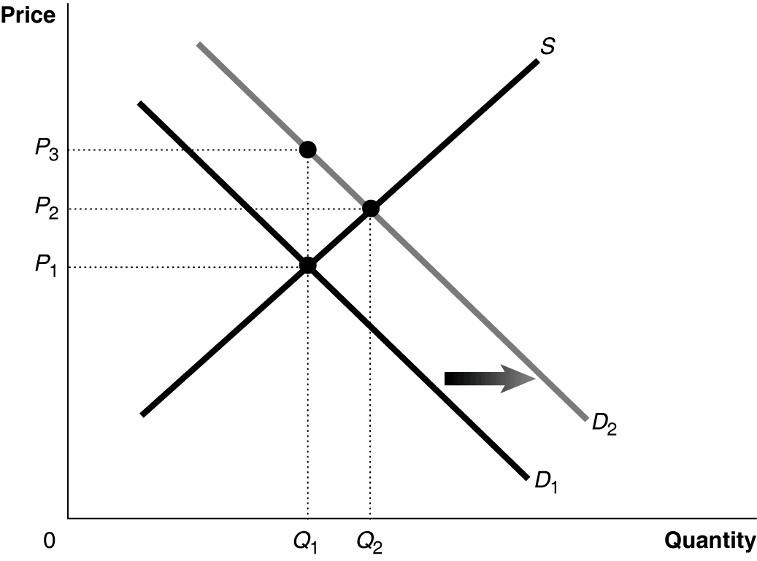

Figure 5-5 shows a market with an externality. The current market equilibrium output of Q1 is not the economically efficient output. The economically efficient output is Q2.

- Refer to Figure 5-5. Suppose the current market equilibrium output of Q1 is not the economically efficient output because of an externality. The economically efficient output is Q2. In that case, diagram shows
  - the effect of a subsidy granted to producers of a good.
  - the effect of a negative externality in the consumption of a good.
  - the effect of an excess demand in a market.
  - the effect of a positive externality in the consumption of a good.
16) C

- In economics, the optimal level of pollution is 17) A
  - the level for which the net benefit from reducing the pollution is the greatest.
  - the level for which the marginal benefit from reducing the pollution is the greatest.
  - zero.
  - the level for which the total benefit from reducing the pollution is the greatest.

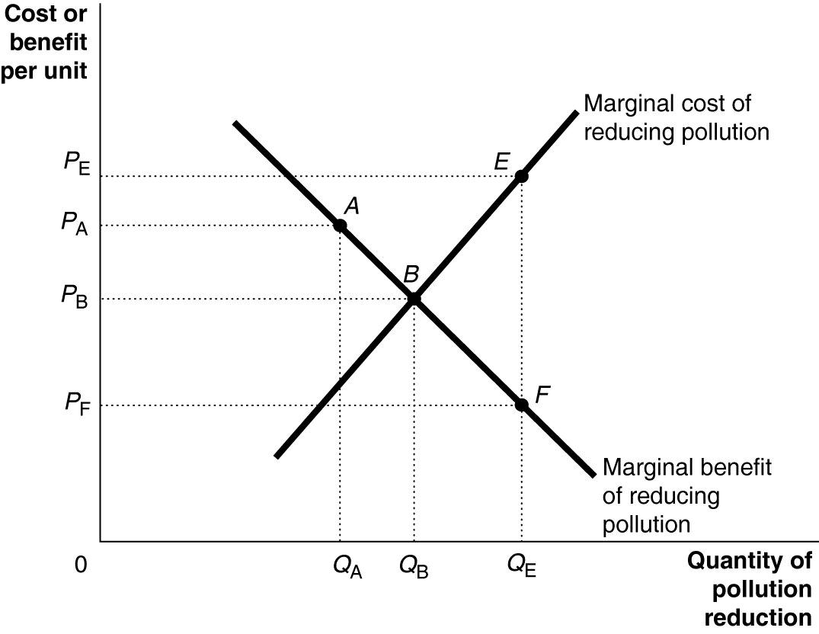
Figure 5-7

- Refer to Figure 5-7. The marginal benefit of reducing pollution curve is the same curve as 18) C
  - the positive externality curve.
  - the external benefit curve.
  - the demand for pollution reduction curve.
  - the supply of pollution reduction curve.
- The Coase theorem states that 19) C
  - assigning property rights is the only thing the government should do in a market economy.
  - a free-market equilibrium is the best solution to address externalities.
  - if transactions costs are low, private bargaining will result in an efficient solution to the problem of externalities.
  - government intervention is always needed if externalities are present.

- Consider the following characteristics:
- low transactions costs
- small levels of pollution
- high levels of pollution
- clear assignment of property rights

Which of the above are assumptions behind the Coase Theorem?
  - a, b, and d B) a, c, and d C) a and d D) a only
21) C

- Governments can increase the consumption of a product that creates positive externalities by 21) D
  - convincing everyone to consume the product.
  - assigning property rights to the producers of the product.
  - taxing the production and consumption of the product.
  - subsidizing the production of the product so that the supply is increased and market price is reduced.

- Suppose a tax equal to the value of the marginal external cost at the optimal output is imposed on a pollution generating good. All of the following will result from the tax except
  - a decrease in the equilibrium quantity produced and consumed.
  - an increase in the equilibrium market price.
  - a decrease in market supply of the good.
  - an increase in demand for the good.

Figure 5-12
22) D

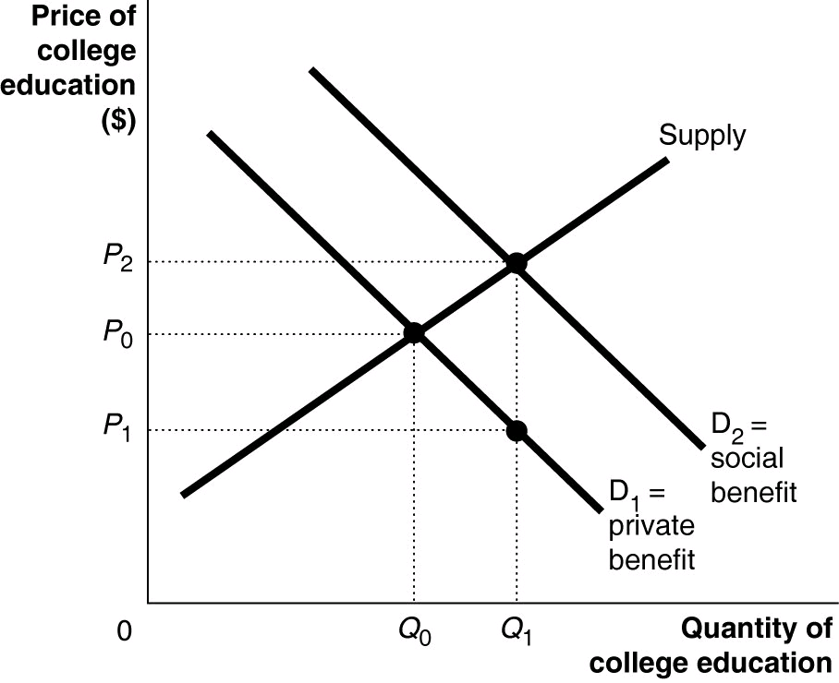

College education benefits society by producing a more employable workforce, reducing crime, and creating a better informed citizenry. Thus, the marginal social benefits of college education exceed the marginal private benefits for any level of college education. This is illustrated in Figure 5-12.

- Refer to Figure 5-12. One way to obtain the economically efficient amount of college education is for governments to subsidize college education. What is the size of the per-student subsidy that the government must provide to internalize the external benefits? (Note that the subsidy can be granted to the education institutions or to the students directly or indirectly; for example, through low-interest student loans.)
A) P0 - P1 B) P1 C) P2 - P0 D) P2 - P1
23) D

