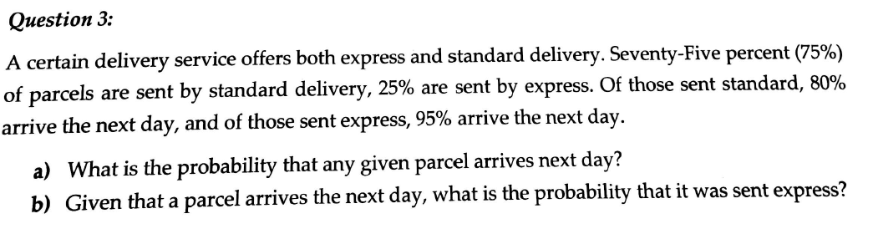
Answer
Consider the total parcel to be 100.
Drawing a flowchart model
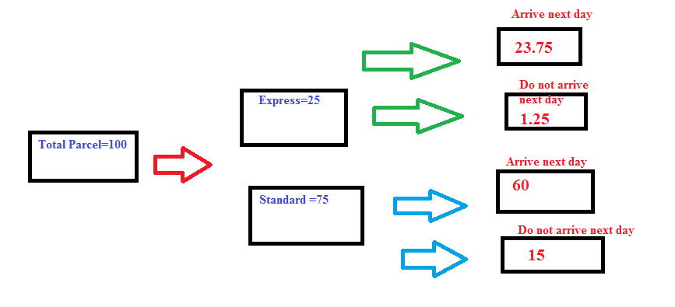
a)Total number of parcel =100
Number of parcel arriving next day using both Express and Standard =23.75+60 = 83.75
Probability = 83.75/100 =0.8375

b)We have the find the probability of conditional statement
P(X=sent by expresss|Y=arrives next day) =P(X and Y)/P(Y)
Now, from the above flow chart the total parcel sent by express and arrived next day =23.75
Probability of being sent by express and arrive on next day=P(X and Y) =23.75/100
P(Y) =Probability that the parcel arrives next day =(60+23.75)/100= 83.75/100
Required probability =$\frac{\frac{23.75}{100}}{\frac{83.75}{100}}=0.2836$

