Determination of Vitamin C in Supplementary tablets.

Virtual lab experiment
November 24, 2020

Table of Contents
Abstract 2
Theoretical Background of the Experimental Titration 2
Procedure [1] 2
Part A: Preparation of Vitamin C Stock Samples 2
Part B: Titration of Vitamin C samples 3
Results 4
Experimental data: 4
Calculated data: 5
Sample calculations: 6
Questions 6
Discussion 8
Conclusion 10
References 10

Table 1: Burette Readings 5
Table 2: Class compiled results 5
Table 3: Calculation of Vitamin C per tablet 5
Table 4: Results - mg Vitamin C per tablet 7
Table 5:Class statistics 7

Abstract

A titration experiment was performed to measure the amount of vitamin C in supplement tablets from 3 different manufacturers. The results showed systematic errors in the order of 5% too low of expected value with very large variances. The mean results were 471 +/- 52, 476 +/- 52 and 476 +/- 29 mg/tablet.

Theoretical Background of the Experimental Titration

Vitamin C is titrated against Iodine in the following reaction
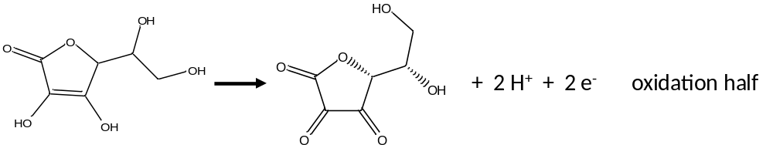
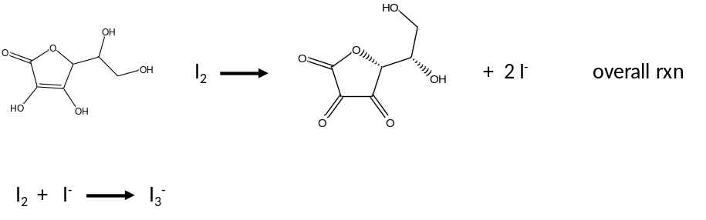
And finally, the I₃- (triiodide ion) reacts with starch to form a blue color.
The key here is the stoichiometry: 1 Vitamin C reacts with 1 I₂ molecule.

Procedure [1]

Part A: Preparation of Vitamin C Stock Samples
- Record a minimum of 3 observations of the supplement before and after preparation
- Using a mortar and pestle, crush a 500mg Vitamin C tablet and analytically transfer it to a clean dry 250mL volumetric flask using a dry solids funnel. Rinse the mortar and pestle with DI water and add the rinse to the volumetric flask.
- Add deionized water to the flask to fill the flask halfway full.
- Cover the flask with Parafilm® (or a glass stopper – but note if you use a stopper, occasional venting will be required). Swirl until completely dissolved. Fill the flask to the line with DI water (bottom of meniscus on line) with a disposable pipette.
- Cover (Parafilm or stopper) and invert 17 times to mix venting as needed

Part B: Titration of Vitamin C samples
- Clean the burette with tap water and a fraction of a drop of soap. Remove all traces of soap with tap water then rinse with deionized water. Obtain about 5 mL of the 0.0037M iodine solution and rinse the burette with it. Place the 5mL rinse in a small waste beaker for disposal. Setup the burette on a stand/clamp at benchtop.
- Carefully fill the burette with the 0.0037M iodine solution to approximately the 0.00 mL mark.
- Remove all air bubbles/air pockets from the tip of the burette by draining out the solution quickly (Stopcock fully opened.
- Ensure the funnel is out of the burette.
- Record the actual initial volume in the burette to two decimal places in your data sheet. To that point, the burette has major markings in the 1’s column and minor markings in the 0.1’s column. Those two numbers can be read precisely. All lab measurements should be read to the precise digits + 1 extra that has uncertainty. Burette readings should be estimated to the 0.01’s column. Most people, with practice, can read burettes to +/- 0.02 mL so that this image
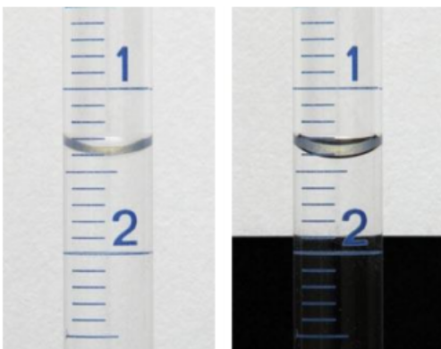
Can be read as 1.42mL. Note the effect adding a piece of black paper behind the burette has on ease of reading. The surface of the liquid appears darker and is therefore easier to read.
- Have lab manager or TA verify your reading
- For this next part, we will be transferring a very precise volume of diluent to an Erlenmeyer flask. This is accomplished with a pipette (see lab manual [1]). Practice pipetting with DI water in a beaker first rather than wasting the sample. Once you can repeatedly pipette, transfer 10.0mL of the Vitamin C stock solution into a clean 250mL Erlenmeyer flask.
- Fill the Erlenmeyer flask to approximately 100mL with DI water (the precise amount of DI water is not important – the moles of acid is)
- Add 10 drops of starch indicator and swirl the flask
- Place the Erlenmeyer flask under the burette on a white piece of paper to better see the endpoint.
- Titrate by adding the iodine solution from the burette. You should observe localized color changes from colorless to purple as the iodine reacts with the starch. As the flashes of purple become larger and persist longer, slow down the addition to dropwise rate. The end point is reached when the faint bluish color persists.
- Record the endpoint burette volume to 2 decimal points
- Repeat steps 7-12 for a total of 3 titrations.
- Dispose of solutions in hazardous waste containers in the lab
- Clean all glassware and put away
- Calculate mass of Vitamin C for each of the 3 trials.
- Calculate the average mass of vitamin C in milligrams
- Obtain class set of results from MyLS

Results

Experimental data:
Last 6 digits of student ID = 994920
Table 1: Burette Readings
 | Trial 1 | Trial 2 | Trial 3
Final burette reading (mL) | 26.20 | 25.49 | 25.99
Initial burette reading (mL) | 0.00 | 0.00 | 0.00
Volume dispensed (mL) | 26.20 | 25.49 | 25.99

Table 2: Class compiled results
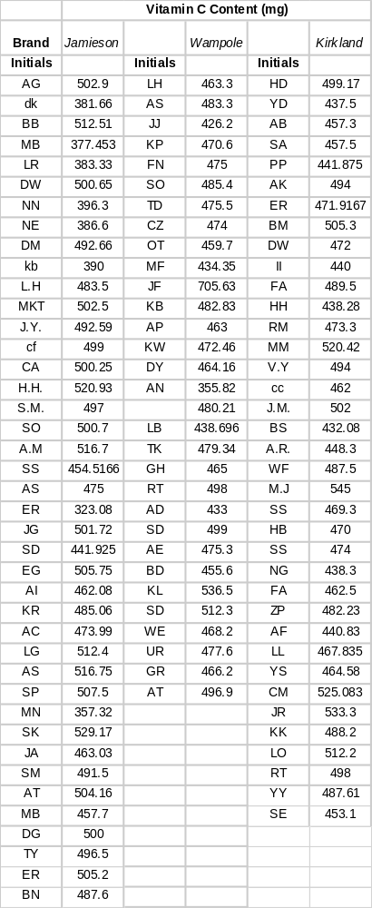

Calculated data:
Table 3: Calculation of Vitamin C per tablet
Type of supplement | Wampole®
Concentration of standardized Iodine (M) | 0.0037
Trial # | 1 | 2 | 3
Volume of titrant (L) | 0.02620 | 0.02549 | 0.02599
Mole of titrant | 9.69x10⁻⁵ | 9.43x10⁻⁵ | 9.62x10⁻⁵
Mole of ascorbic acid | 9.69x10⁻⁵ | 9.43x10⁻⁵ | 9.62x10⁻⁵
Mass ascorbic acid (g) | 0.0171 | 0.0166 | 0.0169
Mass ascorbic acid in stock solution (mg) | 427 | 415 | 423
Average mass of ascorbic acid (mg) in 1 tablet | 420 (2 sig figs)

Sample calculations:
From volume and molarity of titrant trial 1
$$Volume I_{2} Titrant \left(L\right)=\frac{\left(final -initial \right)}{1}*\frac{1 L}{1000mL}= \frac{\left(26.20-0.00\right)mL}{1}*\frac{1 L}{1000mL}=0.02620L$$
$$mol I_{2} titrant=volume*molarity= \frac{0.02620 L}{1}*\frac{0.0037 mol I_{2}}{1 L}=9.69x{10}^{-5} mol$$
From the stoichiometry (showing calculations for trial 1)
$$mol ascorbic acid=\frac{9.694x{10}^{-5} mol I_{2}}{1}* \frac{1 mol acid}{1 mol I_{2}}=9.69x{10}^{-5} mol ascorbic acid$$
From the dilution scheme for the stock solution (showing calculations for trial 1)
$$mass ascorbic acid=\frac{9.69x{10}^{-5} mol acid}{1}* \frac{176.1g acid}{1 mol acid}=0.0171g ascorbic acid$$
$$mass acid in stock solution=\frac{250mL stock}{1}* \frac{0.0171g acid}{10.0 mL stock}*\frac{1000 mg}{1g}=427mg acid$$

Questions
- Calculate mg vitamin C in the stock solution and in the supplement.
From the molarity and volume dispense of titrant (Trial 1)
$$mol I_{2} \left(L\right)=\frac{\left(26.20-0.00\right)mL}{1}*\frac{1 L}{1000mL}*\frac{0.0037 mol I_{2}}{1 L}=9.69x{10}^{-5} mol$$

From the reaction stoiochiometry (trial 1)

$$mol ascorbic acid=\frac{9.69x{10}^{-5}mol I_{2}}{1}*\frac{1 mol acid}{1 mol I_{2}}=9.69x{10}^{-5}mol ascorbic acid$$

From the molar mass of ascorbic acid for trial 1

$$mass ascorbic acid=\frac{9.69x{10}^{-5}mol}{1}*\frac{176.1g}{mol}=0.0171g$$

From the dilution factor for trial 1

$$mass acid in stock solution=\frac{250mL stock}{1}*\frac{0.0171g acid}{10.0mL stock}*\frac{1000 mg}{1 g}=427mg$$

From the sample preparation (1 tablet 250mL stock solution), for trial 1

$$mass acid in 1 tablet=mass of acid in stock solution=427mg$$

Combining all those steps gives this overall conversion for trial 1

$$\frac{0.02620L I_{2}}{10.0mL AA}*\frac{0.0037mol I_{2}}{1 L I_{2}}*\frac{1 mol AA}{1 mol I_{2}}*\frac{176.1g AA}{1 mol AA}*\frac{1000mg}{g}*\frac{250mL AA}{1 tablet}=427 \frac{mg AA}{tablet}$$

So that for trials 2 and 3, we can simplify the process to

$$___vol I_{2}\left(L\right)* 3.7*176.1*25=___ \frac{mg AA}{tablet}$$
Table 4: Results - mg Vitamin C per tablet
 | Trial 1 | Trial 2 | Trial 3 | Average
mg ascorbic acid / tablet | 427 | 415 | 423 | 420 (2sf)*

*NOTE: The value 0.0037 has 2 sig figs. Since the operations are all multiplication and division, the 2 sig figs in 0.0037 limits the final result to 2 sig figs. To avoid rounding errors 1 extra sig fig was carried through intermediate calculations.

- Calculate percent error
I the manufacturers claim is true [2], then each tablet has 500mg of vitamin C in it. If that is assumed to be the “true accepted value”, then for this experiment

$$\%error\frac{=|experimental-accepted|}{|accepted|}*100\%=\frac{=\left|420-500\right|}{\left|500\right|}*100\%=16\%$$

- (a) Calculate the class average and standard deviation and comment on what the standard deviation means, (b) calculate the percent error for the average values compared to manufacturers specifications, (3) create a data table of the results.

- The mean +/- 1 standard deviation represents the range of values that 67% of the experiment result values lie within.
- The class average for the Wampole supplements was 476.6 mg / tablet. Assuming the tablets true value was 500.0mg, the error is then

$$\%error\frac{=|experimental-accepted|}{|accepted|}*100\%=\frac{=\left|476.6-500.0\right|}{\left|500.0\right|}*100\%=4.69\%$$

- The following table is a summary of the class statistics
Table 5:Class statistics
 | Jamieson | Wampole | Kirkland
average | 470.5 | 476.6 | 476.6
std | 52.1 | 52.5 | 29.0
n | 41 | 31 | 37
true value | 500.0 | 500.0 | 500.0
% error | 5.91% | 4.69% | 4.67%

- Determine which of the chemical species in this lab was oxidized and which was reduced.
From the theoretical section, the ascorbic acid lost 2 electrons while the I2 gained 2 electrons. Since gaining of electrons is “REDUCTION” and loss of electrons is “OXIDATION”, the I2 was reduced and the ascorbic acid was oxidized

Integrity statement.
- This submission is my own original work.
- No reproductions were produced nor shared with any other online websites or any other students.
- I understand and agree to WLU’s policies regarding academic integrity.

- In the attached image, identify the carbon that underwent REDOX, determine its original and final oxidation state and determine whether it was oxidized or reduced

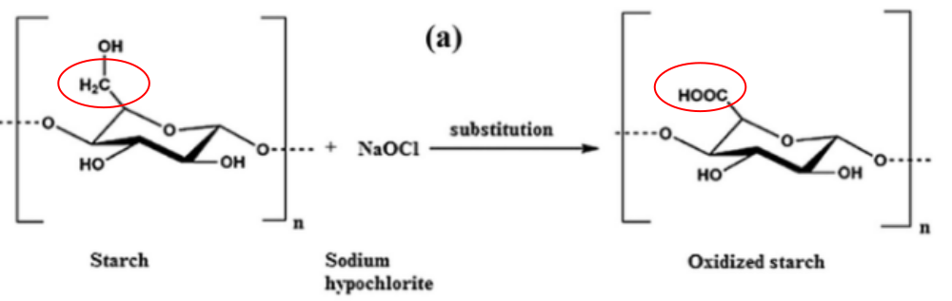
On the left, the circled carbon is attached to 2 H’s, an OH and another C. If we assume the other C has a 0 charge, the 2 H+’s are +1 and the OH is -1, then we can write
$$0+2\left(+1\right)+1\left(-1\right)+C=0→C= -1$$
On the right, the C is bonded to another C (the same other C as on the left) an O and an OH. So we can write
$$0+\left(-2\right)+\left(-1\right)+C=0→C= +3$$
Since Reduction is defined as “reduction in oxidation state” and oxidation is the opposite, we can easily see that circled C was oxidized.

Discussion

There are two very different types of errors present in this experiment. The first one is random errors and the second is systematic. Random errors are errors that occur during due events such as measuring mass. Random errors occur on either side of a true value. They add noise by not an offset. Systematic errors occur on only side of a true value and result in an offset from true value
In this experiment, systematic errors included
- Preparation of the I2 titrant standard. Since the same standard was used for all three titrations, any variations in that standard would drive the values to one side or the other of true values. To eliminate this error, we could have run repeats with different standards
- Overshooting endpoints. The idea here is we will never undershoot endpoints. If we don’t add enough titrant, the solution will remain colorless so we add more. But it’s easy to overshoot an endpoint. The result is a 1 sided error or a systematic error. The best we can do to eliminate this particular error is to run 1 time then use that information to reduce titration to dropwise addition and future trials.
The effect on this particular lab can be determined by the equation
$$___vol I_{2}\left(L\right)* 3.7*176.1*25=___ \frac{mg AA}{tablet}$$
Derived in question 1.
If we accidently add more I2 than needed, the predicted mg ascorbic acid per tablet would be too high. Given the numbers in the lab, a 0.1 mL difference would result in a difference 1.6 mg Vitamin C per table. Since there are about 20drops / mL, 0.1mL is only 2 drops of titrant. That is 2 drops is about 0.4% error.
- We’re assuming the starch indicator endpoint equals the equivalence endpoint of the titration. In reality, that’s probably not the case. This will lead to a systematic error (same side of true) for all titrations. If the solution turns blue before equivalence, then the amount of titrant added will be too low and the mg AA / tablet will be too low.
- Transfer of tablet sample to volumetric flask. If any mass of tablet was left in the mortal and pestle, that would be a systematic error since it would be on one side of true value. (we would never transfer too much tablet to the volumetric flask only less than what we started with). T

In addition to systematic errors, this experiment also included some random errors
- Dilution of the stock solution. The idea is we dilute to the line. However, this is a dilution and errors can be not enough or too much DI water.
- Transferring 10.00mL of stock solution to the Erlenmeyer flask. This can be too much or too little stock solution so this is a random error as well.
- Reading of the burette. As in all measurements, there is noise in the burette reading which can be too high or too low.
There are 3 other errors not mentioned here yet. They are (1) the generation of volume of titrant values. In this virtual lab, we assume the student’s ID numbers are random and therefore generate random errors in titrant volumes. However, that might not be the case, (2) the error associated with overshooting the endpoint might have propagated as a systematic error through the entire class. And (3) other blunders (calculates for example). As a result it might be wise to run a Q test on the data and discard outliers.
Overall, the mean values of the results we all too low. This implies that we have a systematic error giving us too low of values. The most likely candidate for this is the endpoint detection. Since overshooting the endpoints will result in too high a result.
If we could believe the results, all three manufacturers were within 1 standard deviation of the true value while Kirkland’s was the most consistent with the lowest standard deviation.

Conclusion

The purpose of this lab was to use titration to calculate the concentration of ascorbic acid in a vitamin C tablet. In this case, the tablets were titrated with Iodine with an iodine/starch indicator. The errors in the results we quite large for titration experiments and were probably caused by systematic errors that need to be evaluated. Overall the results were 471 +/- 52 mg/tablet, 476 +/ -52 mg/tablet and 476 +/- 29 mg/tablet for Jamieson’s, Wampole’s and Kirkland’s tablets respectively.

References

[1] | Staff, Laboratory manual: Virtual Experiment 1 - Determination of Vitamin C in Supplements, Laurier Department of Chemistry and Biochemistry, 2020.
[2] | "Wampole Vitamin C tablet, 500mg," [Online]. Available: https://www.wampole.ca/produit/vitamin-c/.

