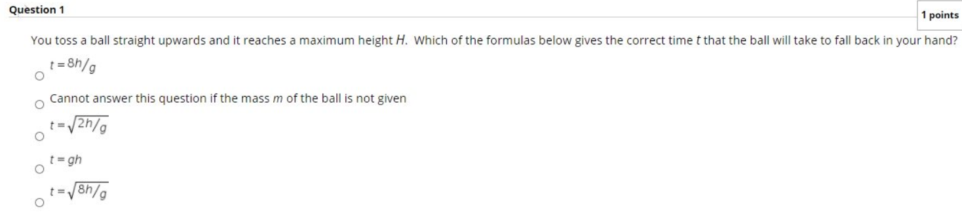
Time of flight for maximum height is given by $t=\frac{u\sin{θ}}{g}→u\sin{θ}=tg$
And maximum height formula is given by
$$h =\frac{u^{2}\sin^{2}{θ}}{2g}→h=\frac{t^{2}g^{2}}{2g}→h=\frac{t^{2}g}{2}$$
$$→t=\sqrt{\frac{2h}{g} }$$
Hence Option C

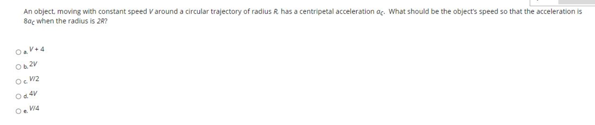
We know that $a_{c}=\frac{V^{2}}{R} ⋯(1)$
New Acceleration is $8a_{c}$, $r=2R$
Putting $8a_{c}=\frac{v^{2}}{2R} ⋯(2)$
Dividing both (2) & (1)
$$8=\frac{\frac{v^{2}}{2R}}{\frac{V^{2}}{R}}→v^{2}=16V^{2}→v=4V$$
Hence option D

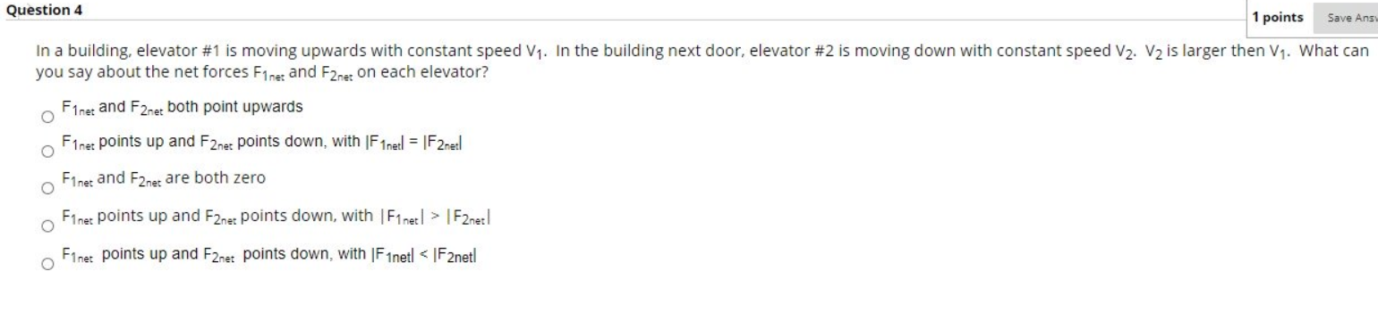
Option C, because the net force on the elevator is zero as both the elevator are moving with constant velocity.
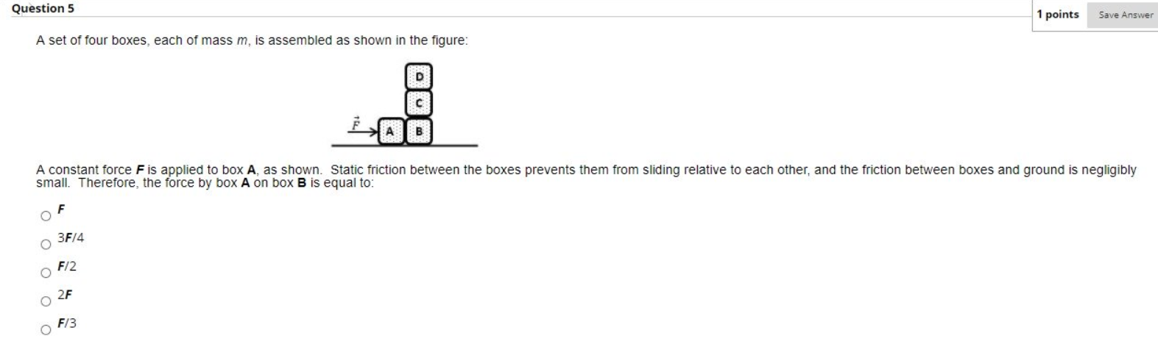
Making FBD diagram of A & B
R2
B
N
$$F_{net}$$
A
F
N
R
R1
Writing force balancing equations for A
F = N
For B
N = $F_{net}→F_{net}=F$
Hence option A
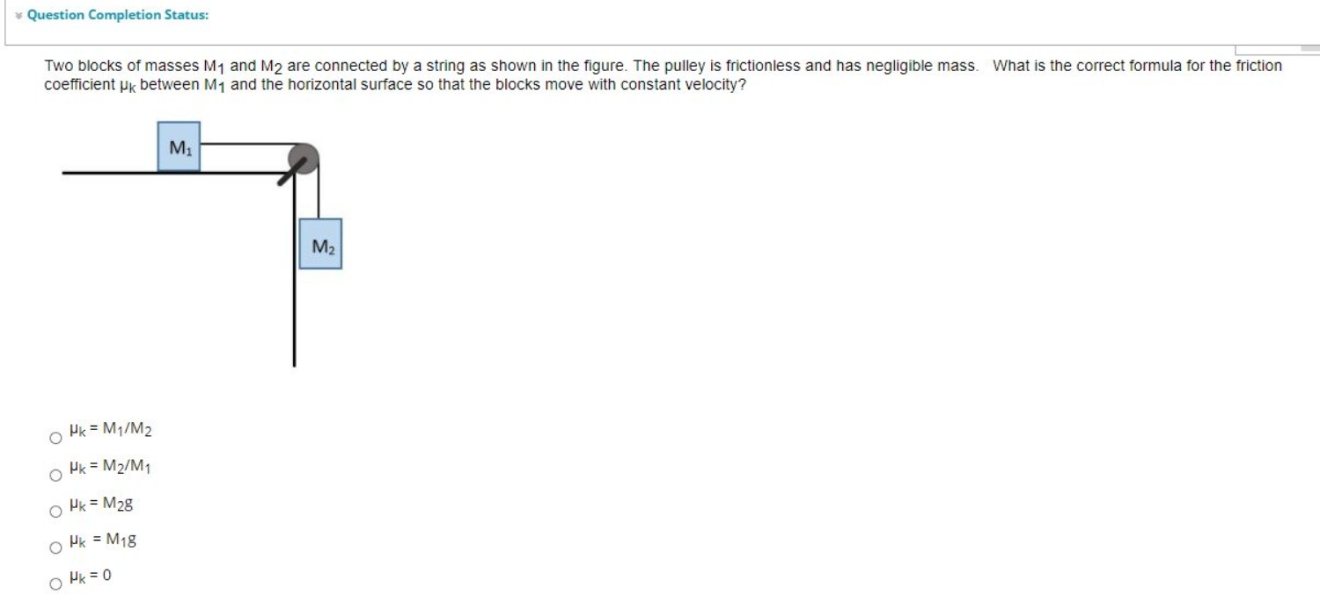
Making FBD of the system
$$M_{1}$$
$$T$$
$$μN$$
N
$$M_{1}g$$
$$M_{2}$$
$$T$$
$$M_{2}g$$

Now Balancing force
$$T=M_{2}g ⋯\left(1\right)$$
In M_1
$$N=M_{1}g$$
$$T=μN=μM_{1}g ⋯\left(2\right)$$
Equating (1) & (2)
$$μM_{1}g=M_{2}g→μ=\frac{M_{2}}{M_{1}}$$
Hence Option B
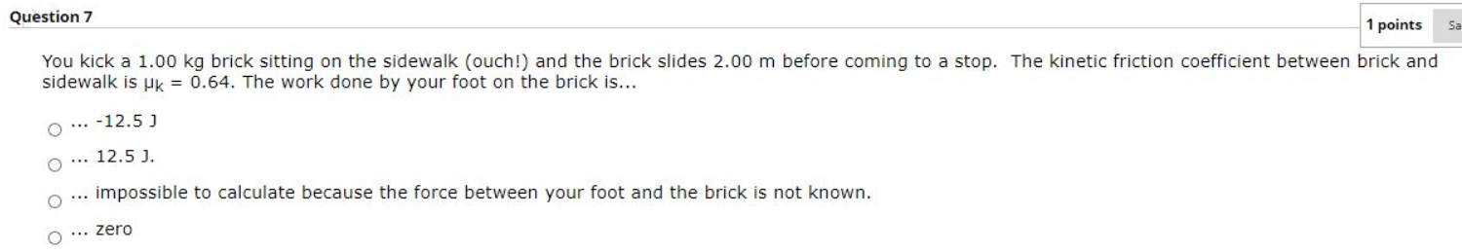
Work done by friction is given by
$$W = μmgd$$
Putting values
$$W= 0.64×1×9.81×2= 12.55 \sim 12.5J$$
Hence Option B
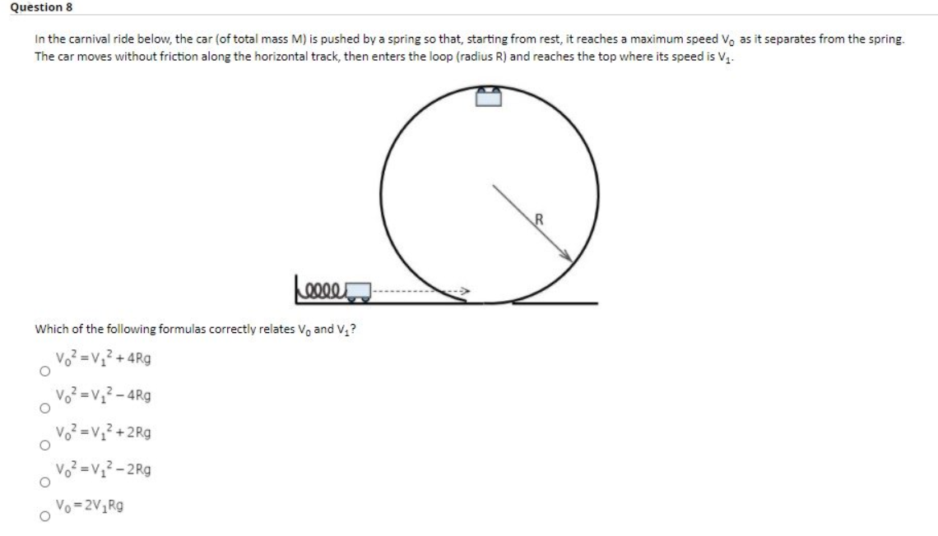
By conservation of energy
$$KE_{f}-KE_{i}=ΔPE$$
$$\frac{1}{2}mV_{1}^{2}-\frac{1}{2}mV_{0}^{2}=0-mg\left(2R\right)$$
Solving $V_{1}^{2}-V_{0}^{2}=-4Rg→V_{0}^{2}=V_{1}^{2}+4Rg$
Hence Option A
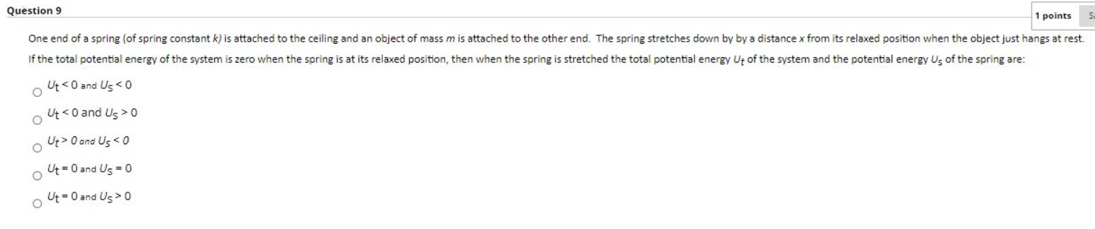
Total energy of the system is conserved, Hence $U_{t}+U_{s}=0$
Spring energy will be $\frac{1}{2}kx^{2} which will be>0 , →U_{s}>0$
$$→U_{s}=U_{t}→ U_{t}<0$$
Hence Option B
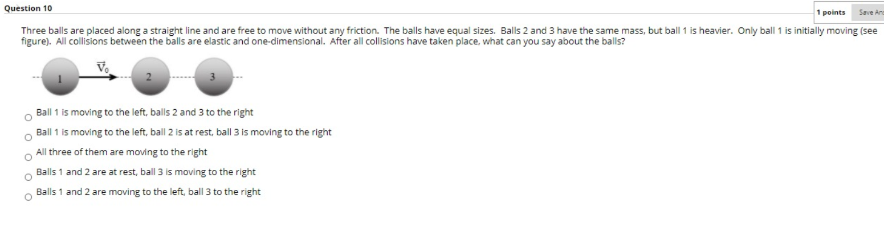
Ass all the collisions are elastic that means when the ball 1 will hit ball 2, ball1 will stop and ball2 will start moving and when ball 2 will hit ball 3, Ball 2 will stop and ball 3 will start moving
Hence Option D Ball1 and Ball2 are at rest and ball 3 is moving to the right
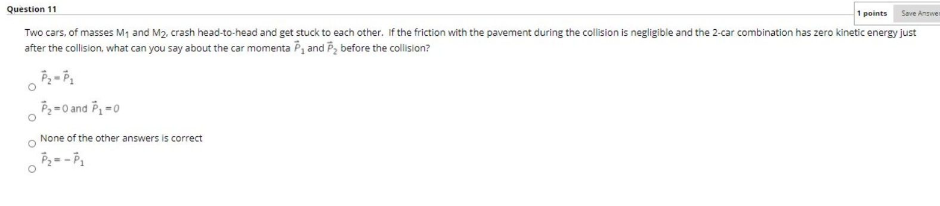
If the two cars are stuck to each other and stopped that means
$$m_{1}v_{1}+m_{2}v_{2}=\left(m_{1}+m_{2}\right)×0→ m_{1}v_{1}= -m_{2}v_{2}$$
$$→P_{2}= -P_{1}$$
Hence option D
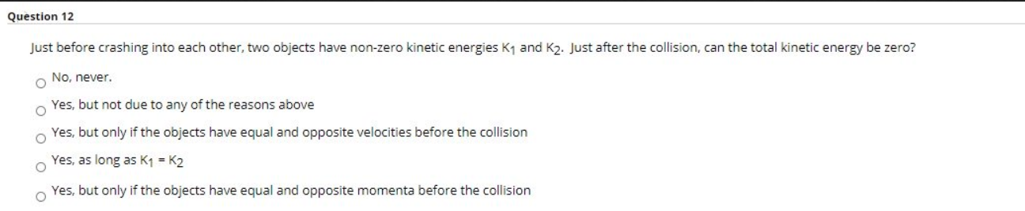
In perfectly elastic collision Final kinetic energy is zero
Bu conservation of momentum
$$m_{1}v_{1}+m_{2}v_{2}=m_{1}v_{1}^{'}+m_{2}v_{2}^{'}$$
Final velocity is zero, so
$$m_{1}v_{1}+m_{2}v_{2}=0→P_{1}= -P_{2}$$
Hence option E
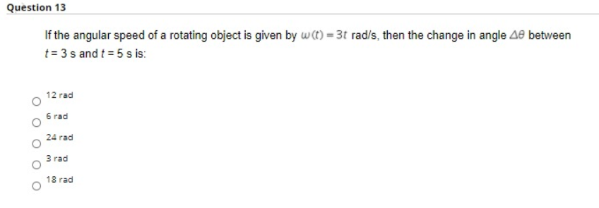
$$ω=\frac{Δθ}{dt}→Δθ=ωdt→3tdt$$
From t = 3 to t = 5 $Δθ= \int_{3}^{5}{3tdt}→{\left[\frac{3t^{2}}{2}\right]}_{3}^{5}=24$
Hence option C
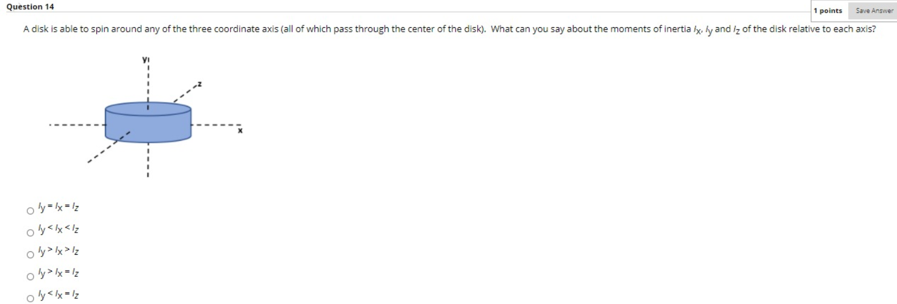
Since the disk is symmetric in X & Z direction $→ I_{x}=I_{z}$
And $I_{y}=I_{x}+I_{z}→I_{y}>I_{x}=I_{z}$
Hence option D
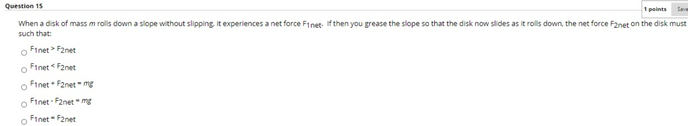
When the grease is used the friction will be less hence it will experience more net force.
Hence Option B
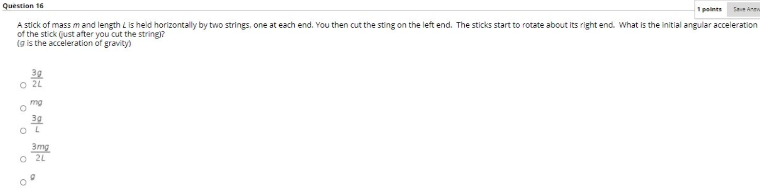
Conserving angular moment
$$τ=Iα$$
$$mg×\frac{L}{2}=\frac{1}{3}ML^{2}α$$
$$α=\frac{3g}{2L}$$
Hence option A
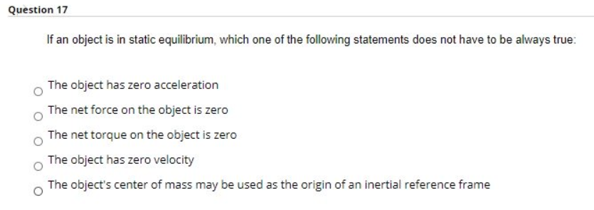
An object is in static equilibrium if and only if
- The sum of the forces on it in each direction is zero.
- The sum of the torques on it in each direction is zero.
- Its linear momentum is zero (i.e. it's not moving).

These conditions are not satisfied by option A because zero velocity will automatically mean zero acceleration
Hence option A

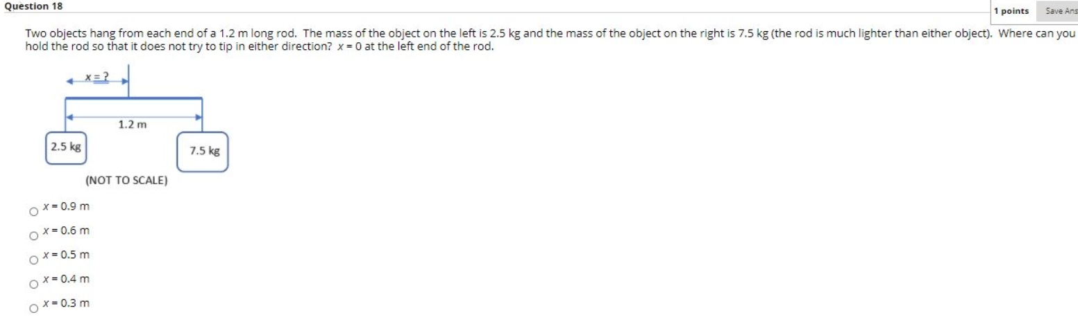
Balancing moment at distance x, we get
$$2.5×g×x =7.5×g×(1.2-x)$$
$$→x=0.9m$$
Hence option A

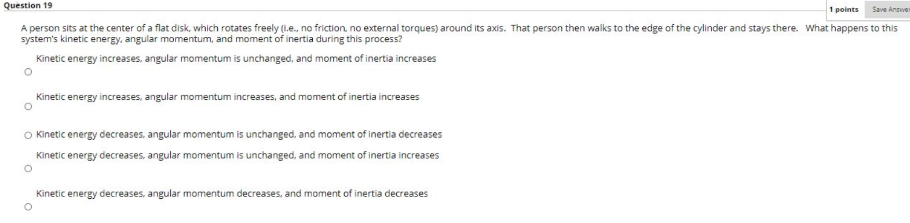
For a system angular moment is conserved Hence angular momentum is unchanged
As the person moves toward edge $ω decrease$
$$Iω=constant→I increase$$
So, moment of inertia increase
Kinetic energy is given by $KE=\frac{1}{2}Iω^{2}=\frac{1}{2}\left(Iω\right)ω$
As $ω decrease→KE decreases$
Hence option D
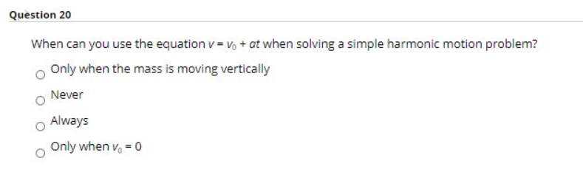
Kinematical equations can be used in motion where acceleration is constant.
In simple harmonic motion, acceleration is not constant. At extreme position it is maximum whereas at mean position it is minimum.
But S. H. M is neither linear nor one dimensional. Its acceleration is also continually changing.
That's why we can't use these equations in S. H. M.
Hence option B, Never

