Question 1
Answer any two (2) of the following questions. Provide enough detail to earn 6 marks for each. If you answer more than 2, only the first 2 will be marked. Use proper sentences, grammar and spelling. Each question is worth 6 marks.
- Name and discuss any five of the proactive actions given by OWASP to deal with web/mobile applications vulnerabilities.
- What are the collision avoidance strategies used in wireless ethernet?
Avoiding collision in a wireless Ethernet is done through a protocol called CSMA/CA(Carrier sense multiple access with collision avoidance). This protocol essentially works the same way CSMA/CD does where the transmitting device must first have access to the transmission channel to check whether it is free, if it is then it will wait for interframe space before it sends the frame, but with additional steps.
This algorithm works by checking for any collision when each bit is sent. In the event a collision is detected the transmission is stopped by the device, it then waits for the noise to fall then now retransmits the bit. This is meant to avoid adverse effect on performance on the shared medium in wireless ethernet.
- Discuss the criteria followed by all the router for selecting a best path to forward a received packet regardless of the routing protocols.
- The router first finds the destination IP address by ANDing the IP address and the network mask.
- It then does a comparison of the network address with all individual the rows in its routing table. From those that match the network address, the best-match must be identified, this is done by selecting the route with the longest match with the destination address. This places the packets as close to its destination as possible.
- In the case whether there is more than one row with the same longest match, a metric will be used to determine a tie breaker which will be the shortest path, the metric will be dependent upon the routing protocol.
- Discuss briefly the automated security testing tools used during the development of the mobile application.

Question 2
Plan Protect and Respond is the management’s security responsibility. What is management’s main function under Planning?
 |  | Comprehensive Policies
 |  | Defence in Depth
 |  | None of the above
 |  | Risk Analysis

Question 3
How collision can be detected in CSMA/CD?
Detecting power level on the wire
Detecting frequancy on the wire
Detecting phases on the wire
None of them

Question 4
A technique used by hackers which does not use any technology is which of the following?
Cross Site Scripting
SQL injection
Social Engineering
Denial of Service

Question 5
A modern technology that makes routers work like switches to make very fast routing decisions is which of the following?
IEEE 802.3ae
IPv4/v6
MPLS
IPv6

Question 6
"The router received a packet, and it decapsulated to layer 3. After finding the destination host IPv4 address, the router needed to find the network address of the host address and the best path to the destination. What is the process? "
Anding the IPv4 address with network mask to find network address then check the routing table for the best path to the network address of the destination.
Anding the IPv4 address with a default gateway to find network address then check the routing table for the best path to the network address of the destination.
Anding the IPv4 address with Network mask to find network address then check mac address table for the best path to the network address of the destination.
Anding the IPv4 address with Network mask to find network address then use switch for forwarding the packet to the destination.

Question 7
What is the biggest danger of the smart home?
hacking IoT devices to get personal information
misconfigured devices that cause household fires
robots that kill the homeowners
None of the above

Question 8
Which of the following is a programming language for building IoT applications?
C/C++
Java
C#
All of the above

Question 9
How collision can be detected in CSMA/CD?
Detecting voltage level on the wire
Detecting frequancy on the wire
Detecting phases on the wire
None of them

Question 10
Which of the following is NOT a programming language for building IoT applications?
JavaScript
B#
Swift
Azure

Question 11
A popular tool which uses the same techniques a hacker uses to find vulnerabilities and design weaknesses in an application software is:
Codebrag
VeraCode
Checkmarx
Metasploit

Question 12
Answer any five (5) of the following acronyms, in the space provided. Write the full words of the acronym. For full marks, the words must be spelled correctly (0.25 mark). Then, in one sentence, describe the function\ purpose or description of the acronym. (0.75 mark)
VPN | EAP | RADIUS | WEP | MITM | VoIP | IFS
VPN – Virtual Private Network
VPN is used to privately and securely connect to the internet and surf.
EAP -Extensible Authentication Protocol –
-It is a protocol used for networks to extend authentication methods for point-to-point protocols.
RADIUS -Remote Access Dial In User Service
-This stores user authentication information (user accounts and passwords)
WEP – Wire Equivalent Privacy
– this is the original wireless networks security algorithm for IEEE 802.11
IFS -Interframe space
-is a period of time a station waits after deferring transmission.

Question 13
Review the diagram below and answer the following questions. Computer T is sending a message to server Z. Write your answer in the table below.
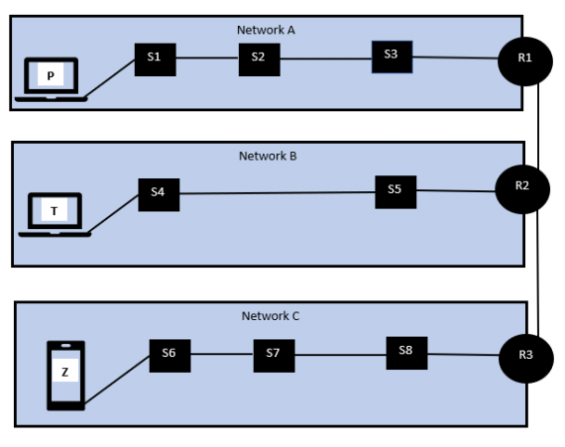
How many physical links does the message travel? | Blank 1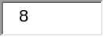
How many data links does the diagram have? | Blank 2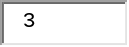
How many routes does the message travel? | Blank 3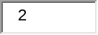

Question 14
In the secure database access, secure communication must be enough to have secure access.
True
False

Question 15
A robot must protect its own existence as long as such protection conflict with the First or Second Laws
True
False

Question 16
In SDLC, the management never releases the application “as is” to control costs.
True
False

Question 17
The AllSeen standard for interconnecting IoT devices is_________ interoperability _______.
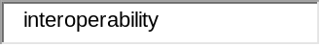

Question 18
A tool designed to take the advantage of a known weakness is called an ____automated hacking tool_________.
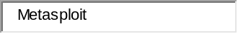

Question 19
Multiplying the value of an asset by the probability of loss is used to calculate ______________Risk Analysis_____ .
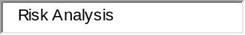

Question 20
The _____Firewall____protocol is designed to prevent unauthorized access to a data port.
