FINAL EXAMINATION 

TERM | COURSE NAME | COURSE CODE | VERSION
Summer | Introduction to Database Systems | DBS211 | V1

Name | (write your full name here)
Student Number | (write your student number here)
Section | (write your section number here)

DATE: Tuesday, August 11th 2020

TIME ALLOWED: 2 hours
PERCENTAGE: 10%
TOTAL MARKS: 20
PROFESSOR(S): Asem Omari, Ayesha Manzer, Parul Kantaria, Ron Tarr

SPECIAL INSTRUCTIONS:

- This is take-home test, open book, and a 12 hour window for completion
- Write your answers in this document and submit on black board submission folder
- Once you start you have 2 hours to submit.

This exam includes a cover page, plus 2 pages of questions.

SENECA’S ACADEMIC INTEGRITY POLICY
As a Seneca student, you must conduct yourself in an honest and trustworthy manner in all aspects of your academic career. A dishonest attempt to obtain an academic advantage is considered an offense, and will not be tolerated by the College.

APPROVED BY:

Sue Abraham, Chair, School of ITAS

GTA Landscaping is a landscaping company that has been in business for over a decade.

GTA Landscaping's business is to offer several services to customers. Services include "Lawn Cutting", "Garden Planting", fall "Leaf Clearing", and winter "Snow Shoveling". Each customer may require one or more of these services at a time; and the customer may require the same service repeated several times each year.

Teams of employees deliver the services offered by GTA Landscaping. Each team can carry out all types of service, and more than one team can carry out each service. All of GTA Landscaping maintenance employees are organized into a team. Each employee can belong to only one team. We will also store each employee's OHIP (health card) number in case an employee is injured on the job.

GTA Landscaping: User View 1
Below are shown sample invoices for the services our business sells. (An invoice is the same as a receipt). We write a customer invoice once all services are completed for a customer visit. This invoice will itemize many details including the services provided, the time it took to complete those services, the charge for those services, the total of all service charges.

Invoice Statement
INVOICE #: | 1355
INVOICE DATE: | 5-Jul-19 |  | CUSTOMER: | 56 - John Adams
WORK TEAM: | 3 |  | ADDRESS: | 234 Bloor W
EQUIP. USED: | 20 hp John Deer tractor/ mower |  |  | M2S 4S3
SERVICES:
SERVICE CODE | DESCRIPTION | HOURLY CHARGE | WORK DURATION (hours) | TOTAL CHARGE
LC | Lawn Cutting | $25.00 | 0.75 | $18.75
LW | Lawn Weeding | $35.00 | 1.15 | $40.25
LF | Lawn Fertilizing | $15.00 | 0.25 | $3.75
TG | Tree Pruning | $45.00 | 0.50 | $22.50
 |  |  |  | SUBTOTAL: $85.25

GTA Landscaping: User View 2
Below is a listing of GTA Landscaping teams of lawn care specialists that do the services for our customers. The Operations Manager uses this report to schedule which teams will be sent to which customers on any given work day. Team members work together when visiting a customer site.

Team - Employee Reports

TEAM | DESCRIPTION
1 | General Contracting
 | NAME | EMP ID: | OHIP | HOME PHONE | START DATE | SKILLS
 | Cindy Lee | 120 | 219032002 | 905-338-1234 | 1-Jan-98 | General Contractor
 | Amy Smith | 122 | 34111991 | 905-338-1234 | 30-Jun-99 | Plumbing
TEAM | DESCRIPTION
2 | Pruning and Planting
 | NAME | EMP ID: | OHIP | HOME PHONE | START DATE | SKILLS
 | Paula Corelli | 121 | 325443001 | 416-458-4562 | 30-Jun-98 | Pruning
 | Paul Huang | 123 | 54222991 | 416-932-4533 | 30-Jun-05 | Fertilizing
TEAM | DESCRIPTION
3 | General Maintenance
 | NAME | EMP ID: | OHIP | HOME PHONE | START DATE | SKILLS
 | Maria Wong | 124 | 43524532 | 905-345-5366 | 23-Aug-98 | Electrical
 | Phil Ramirez | 126 | 32543555 | 416-435-6599 | 3-Mar-17 | Lawn
 |  |  |  |  |  | Maintenance

What do they want from you?

a) Final Entity/Attribute list that has been normalized to 3rd NF

CUSTOMER (customer id, first_name, last_name, phone_no, email_id, customer_house_no, area_id)
SERVICE_ORDERS (order_id,invoice_date,equip_used,order_status,customer_id)
ORDER_DETAILS (order_id, services_code, work_duration)
SERVICES (service_code, description, hourly_charge)
ORDER_TEAM (order_id, team_id)
TEAM (team_id, team_name)
EMPLOYEE (employee_id, first_name,last_name, OHIP,home_phone, start_date, skills,team_id)
AREA (area_id, area_name, zip_code)

b) Entity/Relationship diagram that reflects your Entity/Attribute list
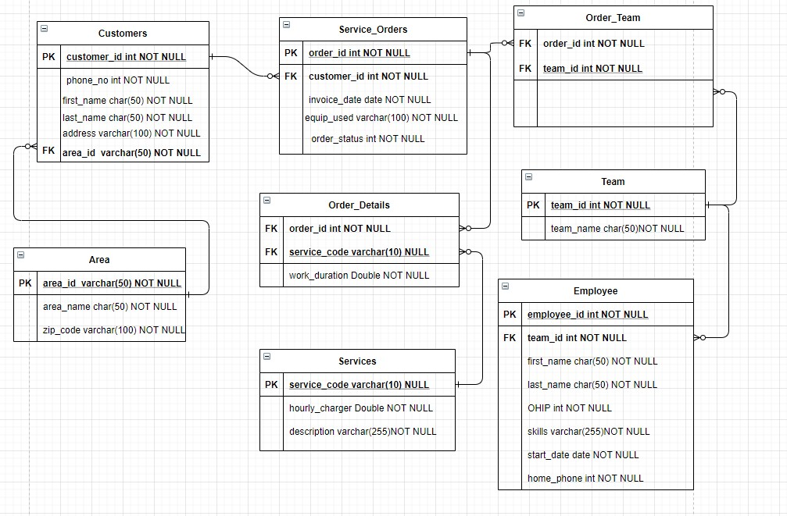

ANY ASSUMPTIONS MADE MUST BE STATED

If an assumption is reasonable for this case, then it will be given some consideration. Generally, if it is not stated anywhere it is not needed.

