Analysis 3
Student Name
Name of Institution
Analysis 3
The objective of the current analysis is to evaluate the nature and strength of the relationship between two response variables, suicide ideation and smoking status, and two predictor variables, future aspirations and gender. Three research hypotheses were tested using data collected from 62 participants across six variables. The findings of the statistical analyses are presented in the subsequent sections.
Hypothesis 1
The researcher hypothesized that suicide indication scores and aspirations for the future were negatively correlated: higher future aspirations are expected to be associated with lower suicidal ideation. To determine the validity of the contention, the null hypothesis: suicide indications scores and aspiration scores are uncorrelated, ρ = 0 was tested using Pearson’s product moment correlation coefficient. Pearson’s correlation statistic was selected as both variables are measured on an interval scale and the data was collected using a random sampling technique. Prior to conducting the correlation analysis, the homoskedasticity, linearity, no outliers, and normality assumptions – which must hold for the results of the analysis to be used in inferential testing – were tested.
The variables’ adherence to the four assumptions was inferred from the scatterplot presented in Figure 1 below. Even though the relationship between suicidal ideation and future aspiration is not perfectly linear, there is no observable curvature in the scatter. From the scatter of datapoints around the regression line, the variables appear to have a moderate linear correlation. The variation in the scatter of the points across the suicide scores is also insignificant, suggesting homoskedasticity. There are no outlier observations in the scatterplot. Given that both variables are non-count data measured on an interval scale and that the sample is sufficient (N >30), then, the variables’ distribution be assumed to be normal on the basis of the Central Limit Theorem.
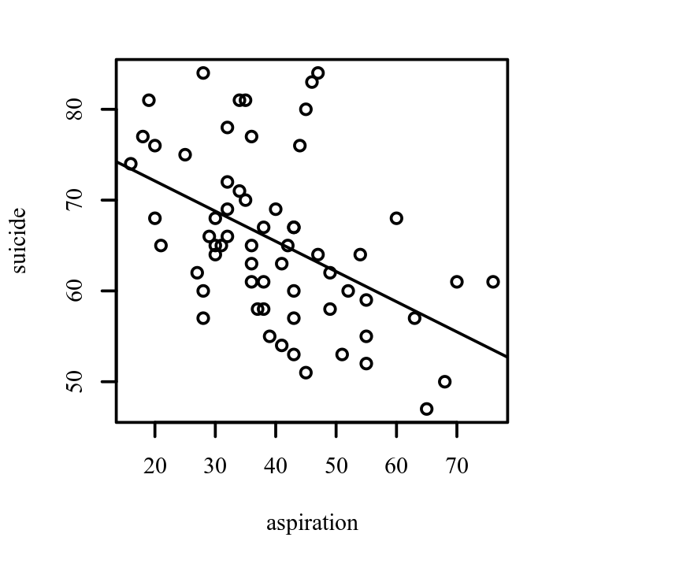
Figure 1: Scatterplot of the relationship between suicidal ideation and future aspiration
Correlation Analysis Results
The correlation analysis results are summarized in Table 1 below. Aspiration and suicidal ideation were negatively and significantly correlated (r_{p} = -0.48, p < .001, 95% CI [-0.65, -0.26]). Thus, the null hypothesis is rejected and the conclusion that an increase in aspiration scores is associated with a decrease in suicidal ideation is drawn. The correlation coefficient between aspiration and suicide was -0.48, indicating a moderate effect size. This correlation indicates that as aspiration increases, suicide tends to decrease. Table 1 presents the results of the correlation. Cohen (1988) proposed effect size ranges based on the correlation coefficient: coefficients between .10 and .29 represent a small effect size, coefficients between .30 and .49 represent a moderate effect size, and coefficients above .50 indicate a large effect size. Based on Cohen’s effect sizes, the test detected a moderate effect size.
Table 1
Pearson Correlation Results Between aspiration and suicide
Combination | r_{p} | 95% CI | p
Aspiration-Suicide | -0.48 | [-0.65, -0.26] | < .001
Note. n = 62.
Hypothesis 1b)
Having established the presence of a significant relationship between suicidal ideation and future aspirations, the predictive relationship between the two variables was assessed using simple linear regression. The model’s F statistic or beta coefficient’s t-statistic will be used to evaluate the null hypothesis: the slope of the regression model, β₁ = 0. The model’s adherence to the four assumptions – normal residual distribution, presence of a linear relationship between predictor and response, homoscedasticity of residuals, and no outlier observations will be assessed using residual plots.
The normality assumption was assessed using a normal Q-Q scatterplot, which shows the quantiles of the model residuals against the quantiles of a Chi-square distribution (DeCarlo, 1997). The residual distribution is exactly normal when the datapoints are flush on the straight theoretical quantiles and approximately normal when the deviation of residual values from the straight line is minimal. For the assumption of normality to be met, the quantiles of the residuals must not strongly deviate from the theoretical quantiles. Strong deviations could indicate that the parameter estimates are unreliable. The normal Q-Q scatterplot of the model residuals is presented in Figure 2 below. The residuals curve upwards and away from the theoretical quantiles line speaking to a right-skewed distribution. Despite the right skew, the normality assumption is not majorly violated as a majority of the values fall on the straight line and the upward curvature is not highly pronounced.
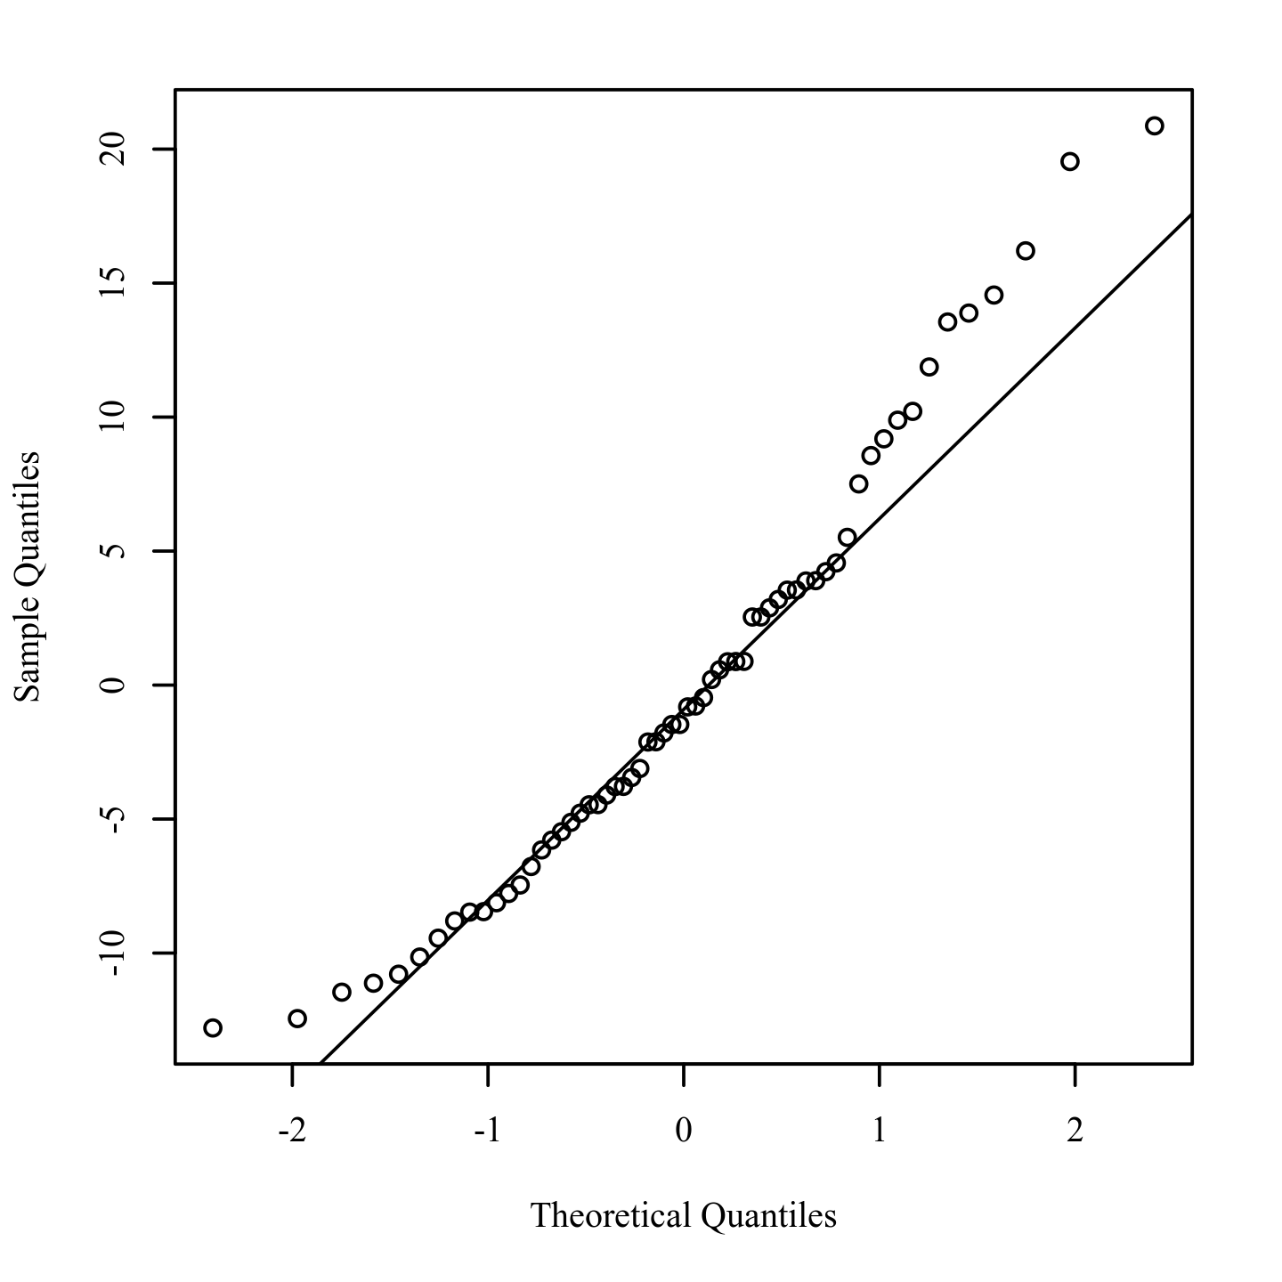
Figure 2. Q-Q scatterplot for normality of the residuals for the regression model.
The homoscedasticity and linearity assumptions were tested using a residuals vs. predicted values plot, which is presented in Figure 3 below. From Figure 3, the variance in residual values is relatively low at the separate ends of the plot and highest in the middle. The difference in scatter is, however, minimal and the residual values are approximately homoscedastic. The linear model is a good fit for the data given the random scatter of residuals across the plot. The expected value of the residuals is equal to zero, as is expected of an adequate linear model.
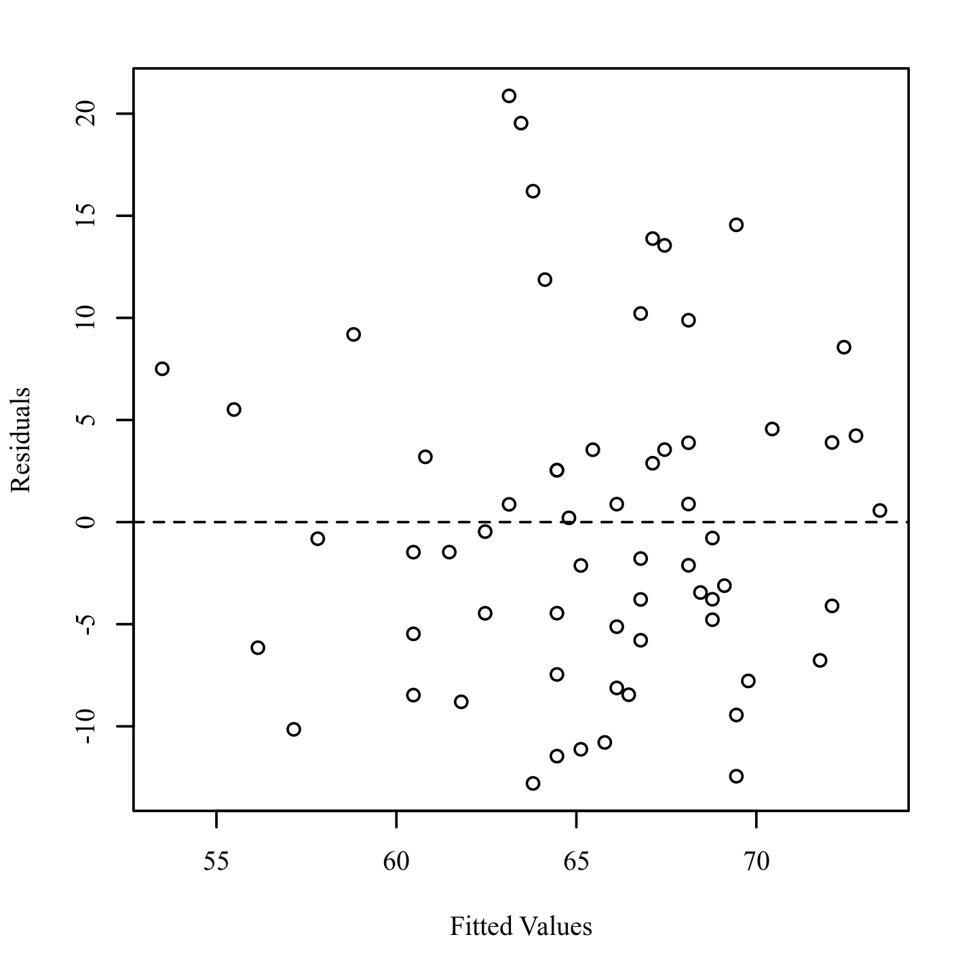
Figure 3. Residuals scatterplot testing homoscedasticity and linearity
To identify influential points, Studentized residuals were calculated and the absolute values were plotted against the observation numbers (Field, 2017; Pituch & Stevens, 2015). Studentized residuals are calculated by dividing the model residuals by the estimated residual standard deviation. An observation with a studentized residual greater than 3.23 in absolute value, which corresponds to the 0.999 quartile of a t distribution with 61 degrees of freedom, is considered to have significant influence on the results of the model. From the studentized residuals plot presented in Figure 4 below, the highest studentized residual was less than 3.0. The model does not have any outlier datapoints that could exert undue influence on the regression statistics.
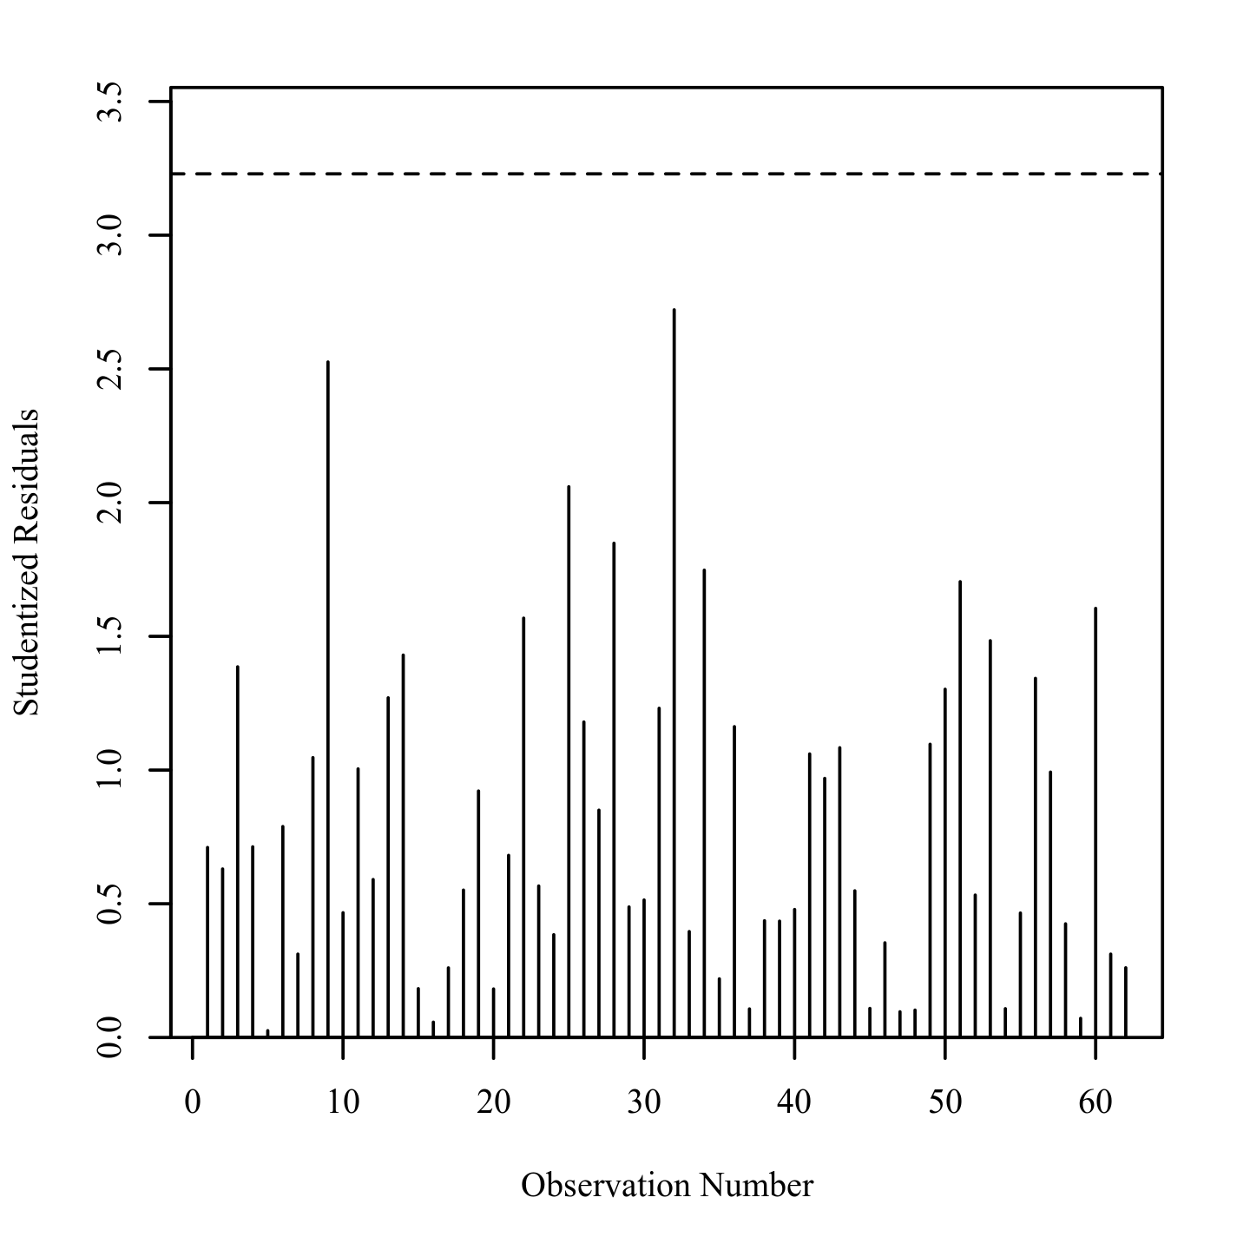
Figure 4: Studentized residuals plot for outlier detection
Regression Analysis Results
The simple linear regression model coefficients are presented in Table 2 below. The model was statistically significant at an alpha level of 0.05 (F (1,60) = 17.50, p < .001). From the R² value of 0.23, approximately 23% of the variance in suicide could be explainable by aspiration. Most of the variation in the model (77%) is unexplained; as such, suicidal ideation can be more accurately predicted with the addition of relevant variables to the model. The slope coefficient (-0.33) was statistically significant (t(60) = -4.18, p < .001). On average, a one-unit increase of aspiration score is associated with a 0.33 decrease in the suicidal ideation score.
Table 2
Results for Linear Regression with aspiration predicting suicide
Variable | B | SE | 95% CI | β | t | p
(Intercept) | 78.75 | 3.34 | [72.08, 85.42] | 0.00 | 23.61 | < .001
Aspiration | -0.33 | 0.08 | [-0.49, -0.17] | -0.48 | -4.18 | < .001
Note. Results: F(1,60) = 17.50, p < .001, R² = 0.23
Unstandardized Regression Equation: suicide = 78.75 - 0.33*aspiration
Hypothesis 2
The researcher hypothesized that gender and smoking were related, with male participants expected to smoke more frequently compared to their female counterparts. A Chi-square test of independence was conducted to determine the validity of the null hypothesis: gender and smoking are unrelated. The chi-square test was deemed most appropriate for this analysis as the predictor variable, gender, is an ordinal variable and the response variable, smoking is measured on a nominal scale using counts. The assumption of adequate cell size, which requires all cells to have expected values greater than zero and 80% of cells to have expected values of at least five, was assessed (McHugh, 2013). Both conditions were met as the expected values of all the cells was greater than zero and 83.33% of the cells had expected frequencies of at least five.
Descriptive analysis of the data was conducted prior to the chi-square analysis and the results are summarized in Table 3 below. The sample was predominantly female (58.06%). Overall, most of the participants reported never having smoked (63%). The proportion of individuals who had never smoked was higher among female participants (75%) compared to male participants (46%). A similar percentage of female and male participants (19%) had experimented with smoking while more male (35%) than female (6%) participants were active smokers.
Table 4
Frequency Table for Nominal Variables
Variable | Male | Female | Total
Smoking
Never smoked | 12 (46%) | 27 (75%) | 39 (63%)
Experimented | 5 (19%) | 7 (19%) | 12 (19%)
Smoker | 9 (35%) | 2 (6%) | 11 (18%)
Missing | 0 (0%) | 0 (0%) | 0 (0%)
Note. Due to rounding errors, column wise percentages may not equal 100%.
Chi-Square Results
The chi-square test results are summarized in Table 4 below. The Chi statistic attained significance at an alpha value of 0.05, (χ²(2) = 9.18, p = .010), suggesting that gender and smoke are related. The level combinations whose observed values were substantially larger than their expected values were: female lifetime non-smokers and male smokers. On the other hand, the observed values of female smokers and male non-smokers were considerably greater than their expected values. The descriptive statistics and difference between observed and expected values by levels validate the research hypothesis that the proportion of smokers in the male subset is higher than in the female subset.
Table 4
Chi-Square Test Results
 | Gender
Smoke | Male | Female | χ² | df | p
Never smoked | 12[16.35] 36 | 27[22.65] 16 | 9.18 | 2 | .010
Experimented | 5[5.03] | 7[6.97]
Smoker | 9[4.61] 49 | 2[6.39] 219
Note. Values formatted as Observed [Expected].

