Gene Analysis Tool
Student’s Name
Institution Affiliations

Ontology description
Gene ontology is the analysis of genetic traits that have been expressed after differential studies have been done. This kind of method tries to identify the categories and classes of hereditary proteins and genes that have been overexpressed in duplicates representing the phenotypic characteristics of an organism. The ontology gene analysis uses statistical approaches that are specialized to single out the enriched classes of genes, and also it identifies the deleted groups of chromosomes in a gene. The enrichment gene analysis deals with many genetic traits identified and classified according to their phenotypic or genotypic characteristics (Martin et al. 2018). The analysis procedure tries to replicate and express genes in different conditions, that the expressed genes are identified, and the functional segment is located so that ontological analysis is started. The input genes identified and placed in bins are tested using the statistical analysis to identify gene enrichment in each particular container.
The ontological tool that identifies gene pool is programmed to identity gene enrichment through inbuilt commands. The tool interface is organized into a couple of four-step instructions that are critical for the gene analysis. The first step is set to allow the user to choose an organism supported by the GOrilla program that has the provision of the applicable organism to conduct gene ontology analysis. Step two allows the user to select on the running or execution mode with a single ranked and double unranked list of genes. The third step requires the targeted gene proteins to be pasted together with a background set of protein if two list genes need to be identified (Pomaznoy & Peters, 2018). The fourth step requires the user to select on the ontology that comprises a biological process portrayed by the genetic proteins, the molecular function of the functional units of the genes, and finally, the cellular component that the expressed gene occurs in an organism.
Other instructions include parameters with a p-value threshold that tries to identify gene protein that fall under the gene expression classes. The proteins that fall above that threshold are not expressed and calculated after the instruction command is run to output. The output reads the p-value enrichment, genetically associated to GO terms hence describing the organism's gene analysis.
Explanation
Gene ontology comprises of three categories where. The first one is classified into a molecular function that indicates the operations and activities conducted by the products of genetic material. Subsequently, cellular components are associated with different organelles and structures where the genetic proteins influence and control function in a cell (Pomaznoy & Peters, 2018). Finally, Biological processes are a result of collective activities that are initiated by the genes. Moreover, gene enrichment contains classifiers with a myriad of genes found in the public domain (Martin et al. 2018). The other enrichment sets include curations that perform specific activities according to context, and the last portion is gene models that provide groups of the gene for a particular species. The null hypothesis formulated by the tool during interpretation is that it can adjust and alter multiple theories since it can test a large number of a genetic set at a single moment.
Drosophila ontological genes results
Biological process
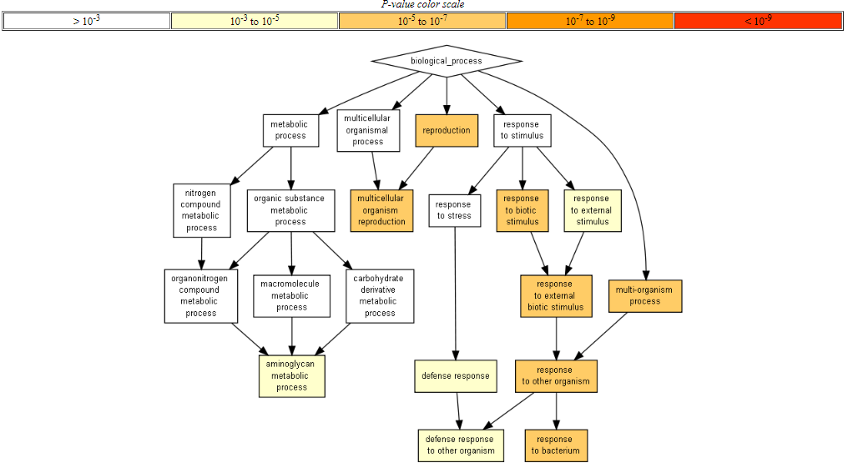
The drosophila biological activities comprise reproduction as the core process leading to multi-cellular perpetuations of genetic material. The drosophila responds to biotic stimuli that are triggered by the external environment.
Molecular function
The activities that are done by the products of genetic material include serine hydrolyses activity. It is responsible for synthesizing serine amino acids. Peptidase regulator activity, on the other hand, is involved in the regulation of amino acid production.
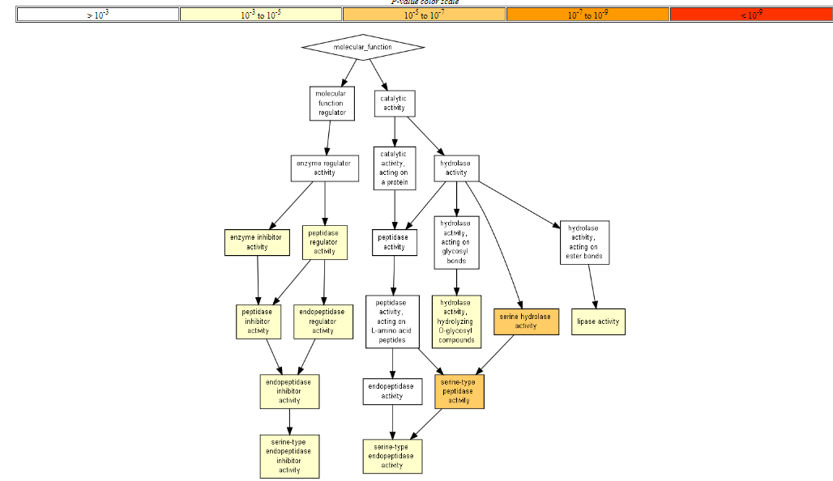

Cellular component
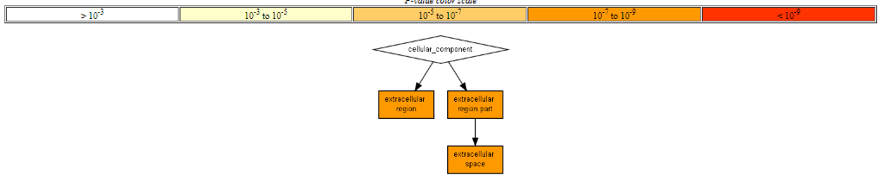
The cellular component of drosophila comprises an extracellular region, part, and space filled by different kinds of organelles and structures that collectively work together to bring about organism functions like locomotion and covering of the external compartment.

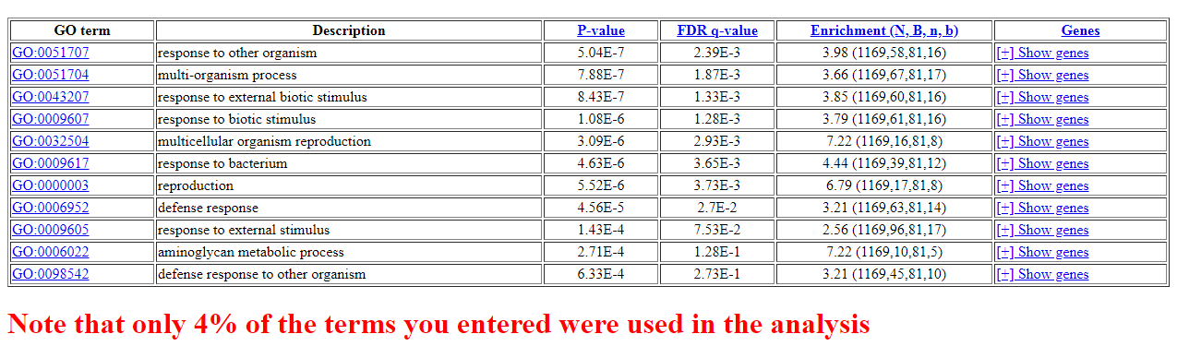

Reference
Martin, M., Hiroyasu, A., Guzman, R. M., Roberts, S. A., & Goodman, A. G. (2018). Analysis of Drosophila STING reveals an evolutionarily conserved antimicrobial function. Cell reports, 23(12), 3537-3550.
Pomaznoy, M., Ha, B., & Peters, B. (2018). GOnet: a tool for interactive Gene Ontology analysis. Bmc Bioinformatics, 19(1), 470.

