Assignment 3
Student Name
Name of Institution

Assignment 3
Question 1.
#a) Fitting the regression model with an indicator variable
magdata<- read.csv("magnes.csv", header = TRUE)
Magnesium<-c(magdata$Magnesium..y.,magdata$Magnesium..y..1)
Time<-c(magdata$Time..x.,magdata$Time..x..1)
Treatment<-c(magdata$Treatment,magdata$Treatment.1)
magdata1<-data.frame(Magnesium, Time, Treatment)
magdata1$Timesq=magdata1$Time^2
Model<- lm(Magnesium ~ Time + Timesq + Treatment, data = magdata1)
summary(Model)
##
## Call:
## lm(formula = Magnesium ~ Time + Timesq + Treatment, data = magdata1)
##
## Residuals:
## Min 1Q Median 3Q Max
## -0.20821 -0.06062 0.01984 0.04540 0.49503
##
## Coefficients:
## Estimate Std. Error t value Pr(>|t|)
## (Intercept) 2.370774 0.052381 45.261 < 2e-16 ***
## Time -0.086652 0.024942 -3.474 0.00104 **
## Timesq -0.000997 0.003994 -0.250 0.80386
## Treatment -0.165000 0.027671 -5.963 2.2e-07 ***
## ---
## Signif. codes: 0 '***' 0.001 '**' 0.01 '*' 0.05 '.' 0.1 ' ' 1
##
## Residual standard error: 0.1035 on 52 degrees of freedom
## Multiple R-squared: 0.8052, Adjusted R-squared: 0.794
## F-statistic: 71.64 on 3 and 52 DF, p-value: < 2.2e-16
#The regression equation when Treatment = 0 #Magnesium = 2.37 - 0.086Time - 0.001Timesq #When Treatment = 1 #Magnesium = 2.205 - 0.086Time - 0.001Timesq
#From the statistically significant F ratio and adjusted R-square value of 0.794, the model adequately explains the variation in Magnesium scores. Looking at the individual predictor variables, the time and treatment coefficients are statistically significant but the Timesq coefficient is insignificant. A unit increase in time is associated with a 0.087 decrease in magnesium uptake. Varying the treatment level from 0 to 1 shifts the regression line downwards by 0.165 units. The magnesium uptake for treatment 0 is expected to be 0.165 higher than the uptake for treatment 1 for all values of Time.
plot(Model)
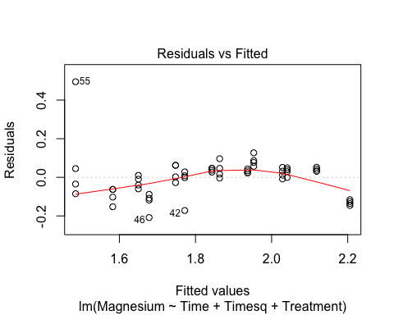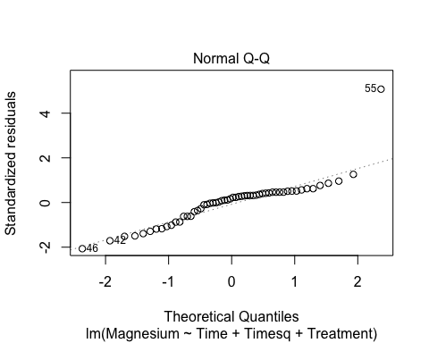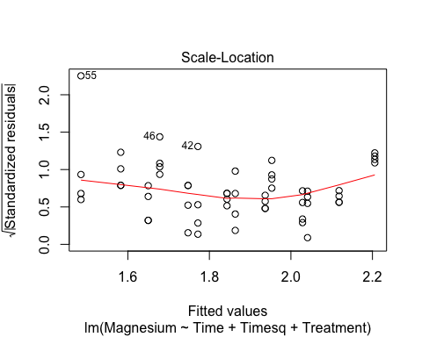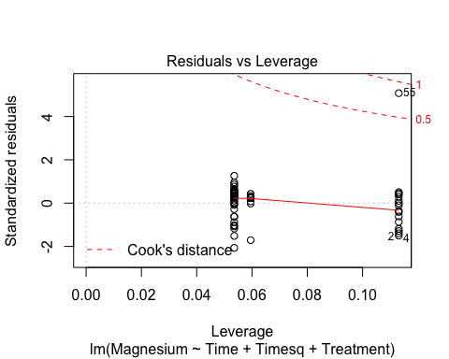
#The residuals are scattered randomly across the residuals versus fitted values plot, indicative of the absence of autocorrelation. Other than the 55th residual with a standardized value larger than 4, the residual observations do not deviate sigificantly from the theoretical quantiles line in the Q-Q plot. The dataset is approximately normal. The outlier observation (55) is evident in the standardized residuals versus fitted values and residuals versus leverage plots. Observation 55 falls outside Cook’s distance boundary making it an influential data point with the potential to reduce the reliability of the model and coefficient estimates.
#b) 1. Creating matrix X for the combined model
time1<-c(magdata$Time..x.,rep(0,28))
treatment1<-c(magdata$Treatment,rep(0,28))
time2<-c(rep(0,28),magdata$Time..x..1)
treatment2<-c(rep(0,28),magdata$Treatment.1)
time1sq=time1^2
time2sq=time2^2
magnesiumT<-c(magdata$Magnesium..y.,magdata$Magnesium..y..1)
magdata2<-data.frame(magnesiumT,time1,treatment1,time1sq,time2,treatment2,time2sq)
head(magdata2)
## magnesiumT time1 treatment1 time1sq time2 treatment2 time2sq
## 1 2.08 0 1 0 0 0 0
## 2 2.07 0 1 0 0 0 0
## 3 2.09 0 1 0 0 0 0
## 4 2.06 0 1 0 0 0 0
## 5 2.17 1 1 1 0 0 0
## 6 2.15 1 1 1 0 0 0
#b) 1. Fitting the regression line for the combined model and determining the beta coefficient vector
model2<- lm(magnesiumT~0+time1+treatment1+time1sq+time2+treatment2+time2sq,data = magdata2)
summary(model2)
##
## Call:
## lm(formula = magnesiumT ~ 0 + time1 + treatment1 + time1sq +
## time2 + treatment2 + time2sq, data = magdata2)
##
## Residuals:
## Min 1Q Median 3Q Max
## -0.15857 -0.04256 -0.01455 0.04237 0.46333
##
## Coefficients:
## Estimate Std. Error t value Pr(>|t|)
## time1 0.001696 0.031179 0.054 0.95683
## treatment1 2.108452 0.039941 52.789 < 2e-16 ***
## time1sq -0.013899 0.004993 -2.784 0.00756 **
## time2 -0.175000 0.031179 -5.613 8.69e-07 ***
## treatment2 1.069048 0.019971 53.531 < 2e-16 ***
## time2sq 0.011905 0.004993 2.384 0.02094 *
## ---
## Signif. codes: 0 '***' 0.001 '**' 0.01 '*' 0.05 '.' 0.1 ' ' 1
##
## Residual standard error: 0.09152 on 50 degrees of freedom
## Multiple R-squared: 0.9978, Adjusted R-squared: 0.9976
## F-statistic: 3864 on 6 and 50 DF, p-value: < 2.2e-16
#b) 1. Specifying X and B matrices
B<-model2$coefficients
B
## time1 treatment1 time1sq time2 treatment2
## 0.001696429 2.108452381 -0.013898810 -0.175000000 1.069047619
## time2sq
## 0.011904762
X<- as.matrix(magdata2[,2:7])
head(X)
## time1 treatment1 time1sq time2 treatment2 time2sq
## [1,] 0 1 0 0 0 0
## [2,] 0 1 0 0 0 0
## [3,] 0 1 0 0 0 0
## [4,] 0 1 0 0 0 0
## [5,] 1 1 1 0 0 0
## [6,] 1 1 1 0 0 0
tail(X)
## time1 treatment1 time1sq time2 treatment2 time2sq
## [51,] 0 0 0 5 2 25
## [52,] 0 0 0 5 2 25
## [53,] 0 0 0 6 2 36
## [54,] 0 0 0 6 2 36
## [55,] 0 0 0 6 2 36
## [56,] 0 0 0 6 2 36
#b) 2. C matrix to calculate difference in beta coefficients
C<- rbind(c(1,0,0,-1,0,0),c(0,0,1,0,0,-1))
C
## [,1] [,2] [,3] [,4] [,5] [,6]
## [1,] 1 0 0 -1 0 0
## [2,] 0 0 1 0 0 -1
#c) Testing the hypothesis using the T^2 test
p = 6
m = 2
n = dim(magdata2)[1]
B0<- c(0,0,0,0,0,0)
sig2<-sum(model2$residuals^2/(n-p))
V <- sig2*C%*%solve(t(X)%*%X)%*%t(C)
Tsq<-t(C%*%B)%*%solve(V)%*%C%*%B
Tsq #T square statistic
## [,1]
## [1,] 16.55525
critval<-2*qf(0.95,m,n)
critval #critical value
## [1] 6.323722
#Conclusion of simple indicator variable appropriateness. The test statistics falls in the rejection region; thus, we reject the null hypothesis that treatment 1 and treatment 2 time and time square coefficients are equal. A simple indicator variable, which shifts the intercept while leaving the slope unchanged is not appropriate for this model.
#d) Testing the appropriateness of the simple indicator variable using full and reduced models #Fitting the full model
full<-lm(Magnesium ~ Time + Timesq + Treatment, data = magdata1)
summary(full)
##
## Call:
## lm(formula = Magnesium ~ Time + Timesq + Treatment, data = magdata1)
##
## Residuals:
## Min 1Q Median 3Q Max
## -0.20821 -0.06062 0.01984 0.04540 0.49503
##
## Coefficients:
## Estimate Std. Error t value Pr(>|t|)
## (Intercept) 2.370774 0.052381 45.261 < 2e-16 ***
## Time -0.086652 0.024942 -3.474 0.00104 **
## Timesq -0.000997 0.003994 -0.250 0.80386
## Treatment -0.165000 0.027671 -5.963 2.2e-07 ***
## ---
## Signif. codes: 0 '***' 0.001 '**' 0.01 '*' 0.05 '.' 0.1 ' ' 1
##
## Residual standard error: 0.1035 on 52 degrees of freedom
## Multiple R-squared: 0.8052, Adjusted R-squared: 0.794
## F-statistic: 71.64 on 3 and 52 DF, p-value: < 2.2e-16
#Fitting the reduced model
reduced<-lm(Magnesium ~ Time + Timesq, data = magdata1)
summary(reduced)
##
## Call:
## lm(formula = Magnesium ~ Time + Timesq, data = magdata1)
##
## Residuals:
## Min 1Q Median 3Q Max
## -0.29071 -0.07658 -0.00063 0.11047 0.41253
##
## Coefficients:
## Estimate Std. Error t value Pr(>|t|)
## (Intercept) 2.123274 0.041068 51.702 < 2e-16 ***
## Time -0.086652 0.032058 -2.703 0.00922 **
## Timesq -0.000997 0.005134 -0.194 0.84675
## ---
## Signif. codes: 0 '***' 0.001 '**' 0.01 '*' 0.05 '.' 0.1 ' ' 1
##
## Residual standard error: 0.1331 on 53 degrees of freedom
## Multiple R-squared: 0.672, Adjusted R-squared: 0.6596
## F-statistic: 54.29 on 2 and 53 DF, p-value: 1.483e-13
#Calculating the F statistic
RSSf<-sum(full$residuals^2)
RSSf
## [1] 0.5574208
RSSr<-sum(reduced$residuals^2)
RSSr
## [1] 0.9385708
den<-reduced$df.residual
den
## [1] 53
num<-den-full$df.residual
num
## [1] 1
Fstat<-((RSSr-RSSf)/num)/(RSSf/den)
Fstat
## [1] 36.24003
pvalf<-1-pf(Fstat,1,53)
pvalf
## [1] 1.682781e-07
#The F-ratio attained significance; hence, we reject the null hypothesis and conclude that the slopes of the two treatment models differ making the simple indicator variable a poor fit for the model.
Question 2
#a) Correlation matrix
airdata<- read.csv("air.csv", header = TRUE)
R<- cor(airdata)
R
## Wind..x1. Solar.radiation..x2. CO..x3.
## Wind..x1. 1.0000000 -0.10144191 -0.1938032
## Solar.radiation..x2. -0.1014419 1.00000000 0.1827934
## CO..x3. -0.1938032 0.18279338 1.0000000
## NO..x4. -0.2695426 -0.07356907 0.5021525
## NO2..x5. -0.1098249 0.11573199 0.5565838
## O3..x6. -0.2535928 0.31912373 0.4109288
## HC..x7. 0.1560979 0.05201044 0.1660323
## NO..x4. NO2..x5. O3..x6. HC..x7.
## Wind..x1. -0.26954261 -0.1098249 -0.2535928 0.15609793
## Solar.radiation..x2. -0.07356907 0.1157320 0.3191237 0.05201044
## CO..x3. 0.50215246 0.5565838 0.4109288 0.16603235
## NO..x4. 1.00000000 0.2968981 -0.1339521 0.23470432
## NO2..x5. 0.29689814 1.0000000 0.1666422 0.44776780
## O3..x6. -0.13395214 0.1666422 1.0000000 0.15445056
## HC..x7. 0.23470432 0.4477678 0.1544506 1.00000000
#b) Find eigenvalues and eigenvectors of R
aireigen<- eigen(R)
correigen<-aireigen$values
correigen
## [1] 2.3367826 1.3860007 1.2040659 0.7270865 0.6534765 0.5366888 0.1558989
#b) Determine how many factors are needed for the FA model. The optimal set of factors is based on the eigenvalues of the correlation matrix. The first thee factors with eigenvalues larger than one were selected. From below, the three factors explained 70% of the total variance. From the accompanying scree plot, the largest drop in explained variance occurs after the first factor, which is to be expected. The decrease in eigen values between the second and third factors is minimal while the variance explained drops significantly after the third factor. Hence, the three-factor solution is the best fit for the FA model
cumulative=(correigen[c(1)]+correigen[c(2)]+correigen[c(3)])/sum(correigen)
cumulative
## [1] 0.7038356
#Scree Plot
plot(aireigen$values, type = "lines", main = "Scree Plot")
## Warning in plot.xy(xy, type, ...): plot type 'lines' will be truncated to
## first character
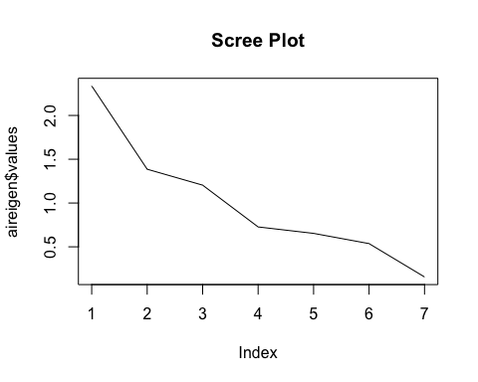
#c) Assuming common factor number, m=2, estimate the factor loading values and specific variances using the principal components approach.
#covariance matrix
aircovar<-var(airdata)
#eigenvalues and vectors
aireigen2<-eigen(aircovar)
eigval<-aireigen2$values
eigval
## [1] 304.2578640 28.2761046 11.4644830 2.5243296 1.2795247 0.5287288
## [7] 0.2096157
eigvec<-aireigen2$vector
eigvec
## [,1] [,2] [,3] [,4] [,5]
## [1,] 0.010039244 0.07622439 0.03087761 0.9203045748 0.3423859285
## [2,] -0.993199405 0.11615518 0.00659069 -0.0002118679 0.0022391022
## [3,] -0.014062314 -0.09956775 -0.18282641 -0.1382922410 0.6500776063
## [4,] 0.004710175 0.01320423 -0.13021553 -0.3277842624 0.6431560485
## [5,] -0.024255644 -0.15038113 -0.95526318 0.1023719020 -0.2065840405
## [6,] -0.112429558 -0.97335904 0.16981025 0.0632480276 -0.0002935726
## [7,] -0.002340785 -0.02382046 -0.08519558 0.1095073458 0.0619613872
## [,6] [,7]
## [1,] 0.011779079 -0.169729925
## [2,] 0.003353218 -0.001781987
## [3,] -0.563893916 0.443577538
## [4,] 0.497513370 -0.462855916
## [5,] -0.009009299 -0.105029951
## [6,] 0.051067254 -0.066992404
## [7,] 0.657012233 0.738019426
#Factor loadings of two factors on the seven variables
FLmat=eigvec[,1:2]%*%diag(sqrt(eigval[c(1,2)]))
FLmat
## [,1] [,2]
## [1,] 0.17511443 0.40532535
## [2,] -17.32436626 0.61765845
## [3,] -0.24528879 -0.52945432
## [4,] 0.08215953 0.07021387
## [5,] -0.42309094 -0.79965586
## [6,] -1.96110754 -5.17586403
## [7,] -0.04083029 -0.12666596
#Specific variances
SpecVar<-diag(aircovar-FLmat%*%t(FLmat))
SpecVar
## Wind..x1. Solar.radiation..x2. CO..x3.
## 2.305046298 0.000511124 1.181578894
## NO..x4. NO2..x5. O3..x6.
## 1.170665935 10.545075347 0.343002153
## HC..x7.
## 0.460801978
#d) Estimate the quantities above again using maximum likelihood
air.fa<-factanal(airdata, factors = 2, rotation = "none")
air.fa$loadings
##
## Loadings:
## Factor1 Factor2
## Wind..x1. -0.168 -0.255
## Solar.radiation..x2. 0.321
## CO..x3. 0.783 0.418
## NO..x4. 0.697 -0.128
## NO2..x5. 0.597 0.173
## O3..x6. 0.997
## HC..x7. 0.246 0.156
##
## Factor1 Factor2
## SS loadings 1.544 1.408
## Proportion Var 0.221 0.201
## Cumulative Var 0.221 0.422
air.fa$converged
## [1] TRUE
#d) What is the difference between solutions of ML and principal components
#The maximum likelihood factor loadings range between 0 and 1, as the MLE factor loadings measure the extent to which the item scores are explained by the underlying factor. A number of the principal components factor loadings are larger than one as the loading is equal to a regression coefficient in a linear equation to predict the variables using standardized components #The cumulative proportion of variance explained by the two factors in the MLE factor analysis is equal to 0.422 while the two factors in the PC model cumuatively explain 53.18 of the model’s variation
cumulative2=(correigen[c(1)]+correigen[c(2)])/sum(correigen)
cumulative2
## [1] 0.5318262
#e) Perform a varimax rotation of both solutions in (c) and (d). Interpret the results #Varimax rotation of Principal Component factor loadings #After rotation, the second item, solar radiation, loaded significantly on the first factor while all other items loaded more substantially on the second factor compared to the first factor. The rotation did not uncover meaningful structure of the factors.
FLmat.rotated=varimax(FLmat, normalize = TRUE)
FLmat.rotated
## $loadings
##
## Loadings:
## [,1] [,2]
## [1,] 0.430
## [2,] -17.153 -2.510
## [3,] -0.146 -0.565
## [4,]
## [5,] -0.272 -0.863
## [6,] -0.998 -5.444
## [7,] -0.132
##
## [,1] [,2]
## SS loadings 295.322 37.212
## Proportion Var 42.189 5.316
## Cumulative Var 42.189 47.505
##
## $rotmat
## [,1] [,2]
## [1,] 0.9836770 0.1799431
## [2,] -0.1799431 0.9836770
#varimax rotation of maximum likelihood factor loadings #After rotation, the items, CO, NO, and NO2 loaded significantly on the first factor with factor loadings larger than 0.4. The items, O3 and solar radiation had strong and fair loadings on the second factor while wind and HC had weak loadings on the selected factors.
air.fa.rotated=factanal(airdata, factors = 2, rotation = "varimax")
air.fa.rotated$loadings
##
## Loadings:
## Factor1 Factor2
## Wind..x1. -0.176 -0.249
## Solar.radiation..x2. 0.319
## CO..x3. 0.797 0.391
## NO..x4. 0.692 -0.152
## NO2..x5. 0.602 0.152
## O3..x6. 0.997
## HC..x7. 0.251 0.147
##
## Factor1 Factor2
## SS loadings 1.573 1.379
## Proportion Var 0.225 0.197
## Cumulative Var 0.225 0.422

#f) Calculate the factor scores from the ML estimates by: 1. Weighted Least Squares
set.seed(22)
new1<-sim.item()[1:42,1:7]
predict(air.fa.rotated,new1,airdata,type="weighted.ls")
##
## MR1
## [1,] -2.201244
## [2,] -3.997722
## [3,] -3.574611
## [4,] -3.549106
## [5,] -2.958017
## [6,] -3.889169
## [7,] -2.797065
## [8,] -4.542448
## [9,] -4.359797
## [10,] -3.180829
## [11,] -3.264446
## [12,] -4.097399
## [13,] -4.134565
## [14,] -4.081333
## [15,] -4.940201
## [16,] -2.205613
## [17,] -3.307421
## [18,] -3.624088
## [19,] -4.169204
## [20,] -3.114123
## [21,] -3.278461
## [22,] -3.665355
## [23,] -4.062352
## [24,] -3.875371
## [25,] -3.625456
## [26,] -3.242870
## [27,] -2.954677
## [28,] -3.496551
## [29,] -3.206449
## [30,] -3.079206
## [31,] -5.169542
## [32,] -2.761066
## [33,] -3.258576
## [34,] -3.383674
## [35,] -3.862490
## [36,] -3.908778
## [37,] -5.940530
## [38,] -3.795604
## [39,] -4.098915
## [40,] -4.283063
## [41,] -2.806929
## [42,] -2.452833
#2. Regression approach
predict(air.fa.rotated,new1,airdata,type="regression")
## Error in UseMethod("predict") : no applicable method for 'predict' applied to an object of class "factanal"

Question 3
#a) Sample covariance matrix S
stockdata<- read.csv("stock.csv", header = TRUE)
stockmatrix<- stockdata[1:100, 1:5]
covarmatrix<- cov(stockmatrix)
covarmatrix
## Allied.Chemical Du.Pont Union.Carbide Exxon
## Allied.Chemical 0.0016299269 0.0008166676 0.0008100713 0.0004422405
## Du.Pont 0.0008166676 0.0012293759 0.0008276330 0.0003868550
## Union.Carbide 0.0008100713 0.0008276330 0.0015560763 0.0004872816
## Exxon 0.0004422405 0.0003868550 0.0004872816 0.0008023323
## Texaco 0.0005139715 0.0003109431 0.0004624767 0.0004084734
## Texaco
## Allied.Chemical 0.0005139715
## Du.Pont 0.0003109431
## Union.Carbide 0.0004624767
## Exxon 0.0004084734
## Texaco 0.0007587370
#Sample principal components
stockeigen<- eigen(covarmatrix)
stockeigen$values
## [1] 0.0035953867 0.0007921798 0.0007364426 0.0005086686 0.0003437707
sqrt(stockeigen$values)
## [1] 0.05996154 0.02814569 0.02713748 0.02255368 0.01854106
stockeigen$vectors
## [,1] [,2] [,3] [,4] [,5]
## [1,] -0.5605914 0.73884565 -0.1260222 0.28373183 -0.20846832
## [2,] -0.4698673 -0.09286987 -0.4675066 -0.68793190 0.28069055
## [3,] -0.5473322 -0.65401929 -0.1140581 0.50045312 -0.09603973
## [4,] -0.2908932 -0.11267353 0.6099196 -0.43808002 -0.58203935
## [5,] -0.2842017 0.07103332 0.6168831 0.06227778 0.72784638
#b) Proportion and Cumulative proportion of total variance explained by each principal component
VarEx=stockeigen$values/sum(stockeigen$values)
VarEx
## [1] 0.60159252 0.13255027 0.12322412 0.08511218 0.05752091
CumVarEx=cumsum(stockeigen$values)/sum(stockeigen$values)
CumVarEx
## [1] 0.6015925 0.7341428 0.8573669 0.9424791 1.0000000
#c) Construct a Scree Plot of the eigen values
stock.pca<- prcomp(stockdata)
plot(stock.pca, type="lines", main = "Scree Plot")
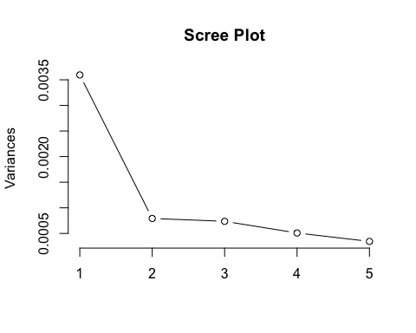
#Can we summarize the five stock variables in less than five dimensions? #Yes. The second greatest reduction in variance occurs between component three and four. The stock variables can be summarized using three dimensions. Cumulatively, the three dimensions would explain 85.74% of the variation in the dataset.

