Part 1: Cancer Epidemiology

Name

Instructor

Course

Date

Abstract
Overall cancer incidence rates have declined due to advances in diagnosis and treatment techniques. However, an increasing number of people continue to die each year as a result of cancer-related causes. The deaths are attributed to some specific types of cancers including breast, prostate, lung, and colorectal cancers. There are evident cancer incident and mortality rate disparities across different ethnic groups in the United States. Minority ethnic groups have showcased increased mortality rates when compared to the general population. The disparities are associated with poverty, lack of healthcare access, and low quality of care. Nonetheless, lifestyle changes have been shown to lower cancer incidence and mortality rates. As a result, the proposed social justice program recommends increasing awareness on lifestyle changes and screening to lower cancer incidence and mortality rates respectively.
Part One: Cancer Epidemiology
Advancements in the detection and treatment of cancer have led to the decline of the disease. The Healthy People (2020) indicates that cancer is the second leading cause of death in the United States. Although there has been a decline in the progression of the disease, the decline has been disproportionate as statistics report that a large number of individuals from minority ethnic communities have high cancer morbidity and mortality rates.
Overview of the Problem
According to Arem and Loftfield (2018), there were 1.7 million individuals diagnosed with cancer in the United States in 2016 and it is estimated that 1630 people die from cancer each day. The World Health Organization (2020) indicates that the number of new cancer cases is expected to increase by 70% over the next 20 years. There are complex and interrelated factors that contribute to the risk of developing cancer. Cancer is more prevalent in individuals from low socioeconomic backgrounds. The risk of cancer is associated with a person’s income level, occupation, education level, social status, and geographic location. Cancer is related to environmental factors. Cancer incidence rates are lower among individuals living in safe and healthy living and working conditions (Healthy People, 2020). Unsafe environments with high levels of toxins in water, air, and soil may expose people to the risk of cancer.
Socioeconomic factors affect an individual’s access to healthcare services, education, and safe and healthy living and working conditions, which are associated with the risk of developing and surviving cancer. Access to healthcare services involves access to healthcare insurance and the availability of healthcare hospitals. Access to healthcare services affects an individual’s risk of surviving cancer as it affects the stage at which cancer is diagnosed. Lack of healthcare insurance makes it expensive for individuals to make out of pocket payments for healthcare services. Lack of access to healthcare services makes it challenging for the individuals to get screened for various forms of cancer (Healthy People, 2020). For this reason, they only get medical attention when they start presenting symptoms, which occurs when cancer has already grown into advanced stages.
Education is an indicator of socioeconomic status that has been shown to be inversely correlated to cancer incidence rates. Education is a major component of cancer control as it influences lifestyle behavior. Studies have found correlations between high education levels and low cancer incidence rates. Education provides individuals with increased awareness on healthy lifestyles that result in health outcomes. More educated people are more likely to adopt healthy lifestyles choices including good diets, exercising, and avoiding alcohol and tobacco (Franceschi et al., 2015). Also, education is associated with income levels such that high income is correlated with high education levels. Socioeconomic factors are important when cancer development and survival.
Being overweight and obesity are emerging issues in cancer. Cancers such as breast, colorectal, kidney, uterine, and pancreas cancers are more prevalent in overweight individuals. As a result, strategies to address cancer have shifted to preventing weight gain. Another remerging issue in cancer prevention is the risks faced by cancer survivors. One of the risks is the immediate and longterm impacts of cancer and its treatment. There are economic, social, and emotional factors associated with cancer treatment. Going forward, public health efforts have shifted to preventing lifestyle behaviors that increase the incidence and mortality rates of cancer. In future, the number of cancer survivors is expected to increase by 30% (Healthy People, 2020). Therefore, it is important to understand the health status and behaviors of survivors.
The Healthy People indicates that despite the fact that cancer has a high mortality rate, it is preventable by reducing risk factors. The Healthy People has identified the need for public health objectives to promote the reduction of the number of cancer cases, as well as the number of illnesses, disability, and death caused by the disease. Arem and Loftfield (2018) indicate that factors that cause cancer including genetic, environmental, occupation, radiation, and lifestyle factors. Up to one third to one half of all cancer cases may be preventable by healthy lifestyle choices including maintaining healthy body mass index, maintaining an active lifestyle, limiting alcohol consumption, and eliminating tobacco use. Therefore, public health efforts should boost awareness among minority ethnic communities and individuals from low socioeconomic backgrounds on the need to adopt healthy lifestyles and undergo screening as ways of reducing cancer incidence and mortality rates.
Cancer incidence rates are different for men and women. The most common cancers for men are prostate, lung, and colorectal. They are associated with 43% of all colorectal cancers diagnosed in men in 2020. For women, the three most prevalent cancers include breast, lung, and colorectal cancer. They are associated with 50% of all cancer diagnoses in 2020. Nonetheless, cancer mortality rates are higher among men compared to women. Up to 189.5 per 100,000 men are diagnosed with cancer compared to 135.7 women per 100,000. As of January 2019, there were approximately 16.9 cancer survivors in the United States, and the number is expected to increase to 22.2 million by 2030. Statistics indicate that approximately 39.5% of men and women will be diagnosed with cancer at one point in their lives. In 2020, it is forecasted that up to 16,850 children will be diagnosed with cancer and 1,730 will die of the disease (National Cancer Institute, 2020).
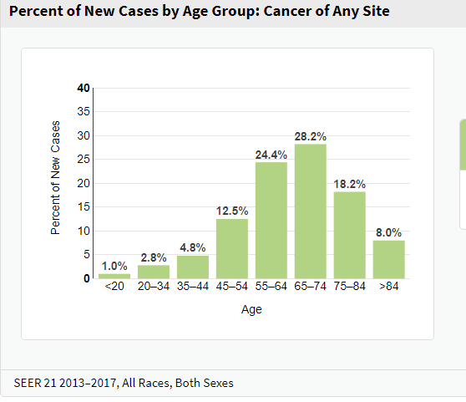
Figure 1: Percentage of new cases by age group (National Cancer Institute, 2020).
As determined by the graph above, cancer is more prevalent among individuals between the ages of 65 and 74. High incidence rates are also prevalent among the age group of 55-64 years and 75 to 84 years (National Cancer Institute, 2020).
Statistics indicate that at least 40% of individuals in the United States will be diagnosed with cancer at some point in their lives (Arem & Loftfield, 2018). In 2020, approximately 1.8 million people will be diagnosed with cancer in the United States and about 606,520 people will die of cancer. In the state of California, there will be 172,040 new cancer cases and 6060 deaths associated with cancer in 2020. Cancer incidence rates from 2012-2016 is 404.8 per 100,000 people while the death rates in the same time period is 142.4 per 100,000 people. In Los Angeles, approximately 600,000 people die due to cancer each year, about 185 deaths per 100,000 people (The National Cancer Institute, 2020).
Mortality rates provide the best indicators of progress against cancer. When determining the effectiveness of efforts that have been implemented to address the burden of cancer, it is important to address factors other than incidence rates. The incidence rates may not always provide an accurate picture of cancer prevention progress. An increase in incidence rates may indicate a real increase in disease occurrence. On the other hand, an increase in incidence rates may also indicate an increase in the use of screening tests that detect cancer cases. Mortality rates provide a more accurate effect of managing cancer as they provide evidence of improved treatments (National Cancer Institute, 2020). The reduction of death rates while incidence rates continue going upwards indicates the availability of better treatment.
Trends in mortality rates indicate that the overall cancer mortality rates have reduced since the early 1990s. In men, mortality rates have declined by 1.8% from 2001 to 2017. In women, mortality rates have declined by 1.4% per year from 2001 to 2017. In children between the ages of 0-14, mortality rates have reduced by 1.4% each year. Despite the fact that overall death rates associated with cancer have declined, mortality rates in some of the cancers have increased (National Cancer Institute, 2020).
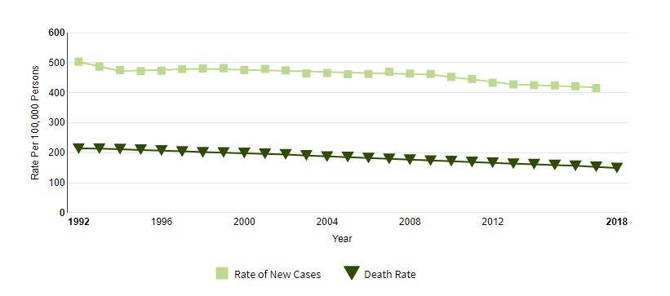
Figure 2: Comparison between rate of new cases and death rates (National Cancer Institute, 2020).
As determined by the graph, the incidence cases are higher than the death rates. The statistics show that more people are surviving cancer. For instance, in 1992, the number of new cancer cases was 50 million while the death rate was 20 million. Compared to the incidence rate, the mortality rate was 40%. In contrast, in 2018, the death rate reduced to 15 million people while the incidence rate reduced to 40 million people. The mortality rate in 2018 compared to the incidence rate is 37.5% (National Cancer Institute, 2020). The reduction in the incidence and mortality rates is as a result of advanced in screening and treatment technology, and increased awareness among the population on the benefit of screening and the need to adopt healthy behaviors to prevent cancer.
It is important to address cancer incidence and mortality rates in the United States due to the economic implications of the disease. Statistics indicate that cancer expenditures in the United States have increased. Care for cancer survivors cost $137.4 billion as a result of medical care expenditures. The cost was associated with Medicare and individual patient payments for outpatient consultations, hospitalizations, medical equipment, hospice care, home health care, and pharmacological treatment. As the population ages, it is expected that healthcare expenditures due to cancer will continue increasing. National expenditures are highest for colorectal, female breast, lung, prostate, and lymphoma cancers (National Cancer Institute, 2020). The high costs of the disease reflect the prevalence of disease, costs, and treatment patterns.
Review of Epidemiological and Demographic Data
Cancer epidemiology refers to the study of the determinants, distribution, and frequency of cancer in specific populations. The main aim of epidemiological studies is to determine causative factors with the aim of implementing preventive strategies to control the disease (Thun et al., 2017). Cancer occurs when normal cells are transformed into tumor cells. The cells transform from pre-cancerous lesions to malignant tumors.
Mortality/morbidity
The National Cancer Institute (2020) indicates that the three most prevalent cancers include breast, lung, colorectal, and prostate cancers. The four types of cancers account for approximately 50% of all new cancer cases in the United States, and they are responsible for nearly 50% of all cancer deaths. The rates and types of cancer differ significantly depending on race and ethnicity.
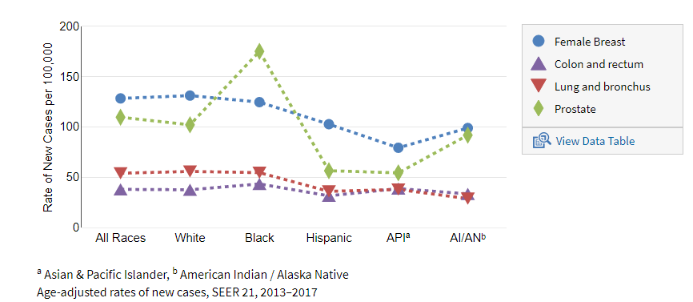
Figure 3: Most common cancers based on race/ ethnicity (National Cancer Institute, 2020)
As showcased by the figure above, the most prevalent form of cancer among all races is female breast cancer, followed closely by prostate cancer. The figure shows differences in cancer incidence types between males and females as the latter are more prone to breast cancer while males are prone to prostate cancer. Whites have the highest rates of breast cancer and lung and bronchus cancer. On the other hand, Blacks have the highest rates of prostate cancer as well as colon and rectum cancer. The Hispanic rate of the four cancers is lower than the national average. Asian and Pacific Islanders have the lowest rates of female breast and prostate cancers. American Indians and Alaska Natives have the lowest rates of lung and bronchus cancer (National Cancer Institute, 2020).
Health disparities
There are prevalent health disparities in cancer mortality rates. As depicted by the figure below, Blacks have the highest rates of cancer mortality for the five types of cancer. Trends in the mortality rates are similar to the incidence rates as Blacks have the highest mortality rates of prostate and colon and rectum cancers. Blacks’ rates of female breast and lung and bronchus cancers are comparable to national average rates. Health disparities are evident in the differences between incidence and mortality rates. While Whites have the highest incidence rates of female breast cancer, Blacks have the highest rates of mortality in female breast cancer (National Cancer Institute, 2020).
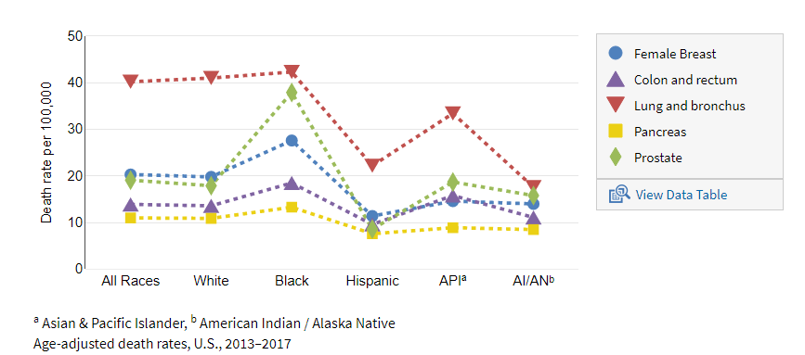
Figure 4: Cancer mortality based on race/ethnicity
Cancer is the leading cause of death for Hispanics, contributing to approximately 21% of all deaths. However, Hispanics have lower incidence rates for all types of cancer compared to Whites. However, they have higher incidence rates for various types of cancers including cervix, stomach, and liver cancers. Hispanic women have the highest rates of cervical cancer. African Americans are also less likely to survive five years after a cancer diagnosis, regardless of the type or stage of cancer. African American males have higher prostate cancer incidence and mortality rates. African American women are more likely to die after a breast cancer diagnosis compared to women from the general population. With regards to American Indians, the death rates for cervical cancer are the highest when compared to any other population. In Asian American women, breast and lung cancer rates have increased while the overall cancer rates in the general population have reduced.
Risk factors
There are significant health disparities associated with cancer. According to Howlader (2015), there are evident disparities in healthcare related to cancer. Factors contributing to differences in healthcare include lack of access to healthcare, lack of health insurance, poverty, language and literacy barriers, and poor expectations of the results of cancer treatment. Minorities are more likely to be impacted by the factors that contribute to the differences in healthcare. They are also at a greater risk of receiving poor healthcare compared to the rest of the population.
One third to one half of all cancer cases are preventable. When detected early, cancer results in a higher probability of survival, lower rates of morbidity, and less expensive treatment. Early diagnosis is effective in enhancing awareness of the disease and how to get care, providing clinical evaluation and diagnosis, and facilitating access to treatment. Some of the most common types of cancer such as oral, breast, colorectal, and cervical cancer have high rates of cure when detected early. Cancer progression depends on a person’s genetic factors and three other determinants including physical, chemical, and biological carcinogens. Aging is also said to be a significant factor in the development of cancer because a person’s cellular repair mechanisms become less effective as a person grows older (World Health Organization, 2018). Cancer risk is more prominent among older individuals as approximately 78% of all cancers are diagnosed in individuals over the age of 55 years (National Cancer Institute, 2016). The World Health Organization indicates that approximately 66% of all deaths due to cancer occur as a result of lifestyle-related factors.
Social Justice Rationale for the Program
WHO, IARC, and the Task Force on the Prevention and Control of Noncommunicable diseases have identified a number of strategies to reduce the premature mortality for cancer. One of the strategies involves the development of standards and tools to guide the planning and implementation of interventions for the prevention, screening, early detection, treatment, and palliative care for cancer (World Health Organization, 2018). Similarly, the program recommends screening as the best way to reduce incidence and mortality rates of cancer. Screening has also been identified as an effective strategy to reduce cancer prevalence. Arem and Loftfield (2018) indicate that the early detection of cancer could improve survival rates. Efforts to address cancer rates should not only focus on the prevention of new cases, but also on the prevention of recurrence as well as the adverse outcomes associated with long-term treatment and preventing comorbidities associated with psychosocial factors.

References
Arem, H., & Loftfield, E. (2018). Cancer epidemiology: A survey of modifiable risk factors for prevention and survivorship. American journal of lifestyle medicine, 12(3), 200-210.
Franceschi, S., Plummer, M., Clifford, G., De Sanjose, S., Bosch, X., Herrero, R., ... & Vaccarella, S. (2015). Differences in the risk of cervical cancer and human papillomavirus infection by education level. British journal of cancer, 101(5), 865-870.
Howlader, N. (2015). Cancer health disparities in the United States: Facts & figures. ASCO. Retrieved from https://www.cancer.net/sites/cancer.net/files/health_disparities_fact_sheet.pdf
Healthy People (2020). Cancer. Retrieved from https://www.healthypeople.gov/2020/topics-objectives/topic/cancer?topicid=5
National Cancer Institute (2016). Cancer statistics. Available at: http://www.cancer.gov/statistics.
National Cancer Institute (2020). Cancer statistics. Retrieved from https://www.cancer.gov/about-cancer/understanding/statistics
Thun, M., Linet, M. S., Cerhan, J. R., Haiman, C. A., & Schottenfeld, D. (Eds.). (2017). Cancer epidemiology and prevention. Oxford University Press.
World Health Organization (2018). Cancer. Retrieved from https://www.who.int/news-room/fact-sheets/detail/cancer

