Statistical Graphics
Student Name
Name of Institution

Statistical Graphics
Graph One
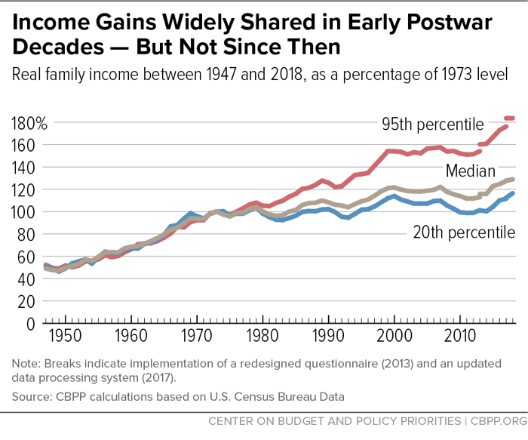
Article Title: A guide to statistics on historical trends in income inequality
URL: https://www.cbpp.org/research/poverty-and-inequality/a-guide-to-statistics-on-historical-trends-in-income-inequality
Authors: Chad Stone, Danilo Trisi, Arloc Sherman, and Jennifer Beltran
Publication Date: 13 January, 2020
Type of Graph: Time series plot
Context: I selected this graph as it illustrates the widening income disparity between the upper 5th percentile and other income classes in the US in a concise manner. The graph shows the trend in the 20th percentile, median, and 95th percentile real family income as a percentage of 1973 real household income value from 1947 to 2018. Between 1947 and 1973, the growth in real family income for households in the bottom, middle, and upper levels of the US income distribution was more or less constant; hence, the inequality gap did not widen considerably in this period. However, from 1974 and 1963, the growth in real income for households in the upper level of the distribution far outstripped the real income growth for households in the middle and bottom level of the income distribution.
Strengths of the Graph: The graph has a caption that accurately describes the data being displayed, aiding the reader’s understanding.
The source of the data is provided and can be corroborated by the reader from the calculations given in the article lending credence to the trends shown in the graph
The x and y axes are clearly and correctly labelled and a consistent scale is used minimizing data distortion.
The authors’ muted the grid by using horizontal grid lines to assist the reader in accurately quantifying the difference in household income level across the three income classes while eliminating vertical grid lines which are unimportant to the display and would distract from the data. They also coloured the horizontal gridline grey, which is visible without being distracting to the reader.
Weaknesses of the Graph: The authors failed to title the x-axis and the y-axis. While the reader will understand that the values in the x-axis correspond to calendar years, the absence of the y-axis title inhibits the interpretability of the graph. The y-axis scale ranges from 0% to 180%, which is even more confusing for a reader who expects a percentage scale to stop at 100%. The reader must infer the x and y axes measure from the caption
The legends are also presented within the graph, which might distract the reader from interpreting the data.
The title of the graph, “Income gains widely shared in early post-war decades – but not since then”, does not accurately describe the contents of the graph. The graph shows the 20th percentile, median, and 95th percentile household income as a percentage of the 1973 income level. It does not, however, show the income levels as a percentage of overall national income nor does it include trend in national income in the period. In some cases, e.g. in the mid-2000s, the median and 25th income levels fell while the 95th percentile household income. It is possible that the national income in this period was falling while the income of the upper 5% was increasing, which is incongruent with the graph title. The title is appropriate for the evidence presented in the article but not for the data plotted in the graph.
Graph Two
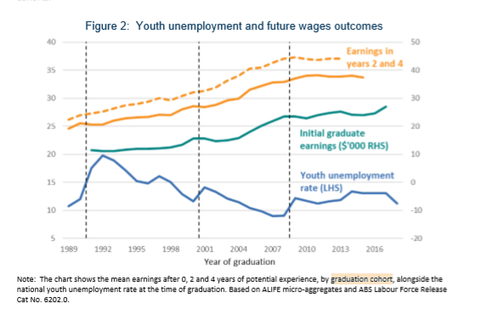
Article Title: The career effects of labour market conditions at entry
URL: https://treasury.gov.au/sites/default/files/2020-06/p2020-85098-202006.pdf
Authors: Dan Andrews, Nathan Deutscher, Jonathan Hambur and David Hansell
Publication Date: June 2020
Type of Graph: Time Series Plot
Context: The graph was published in a Treasury working paper looking into the persistent effect of labour market conditions at entry on an individual’s work trajectory. I selected the graph as it is highly relevant to me, a student yet to join the labour market. The graph shows the trend in average earnings after 0, 2, and 4 years of experience for different graduation cohorts alongside the youth unemployment rate. The chart suggests that the 10-year earnings prospects of individuals employed when the unemployment rate was high is worse compared to individuals
Strengths: The chart includes a caption/note that describes the data under displayed.
The source of the data is given in the caption.
The x and y-axis are clearly and correctly labelled and the intervals are spaced regularly.
The x-axis is correctly titled.
The grid is muted with horizontal grid lines which aid data interpretation but excludes superfluous vertical grid lines.
The chart’s title concisely presents the trends illustrated in the plot.
Weaknesses: The choice of plot seems ill-advised. From the note, the authors aimed at comparing the average earnings after 0,2, and 4 years of experience by graduation cohort. This would have been better accomplished by using a clustered bar graph with years of experience on the x-axis and bars for the graduation cohort. The current chart links the average earnings after 0/2/4 years in an irrational manner considering that the authors did not have data for all the graduation cohorts in the period of observation. A bar chart would have been better suited to non-continuous data such as this.
The legends are presented within the graph which distracts from the data.
The legends for earnings after 2 and 4 years of experience are presented in a single line and the reader is expected to guess that the dotted line represents average earnings after four years of experience.
The y-axis title is missing, it is unclear whether earnings are measured in hundreds or thousands of dollars.
Graph Three.
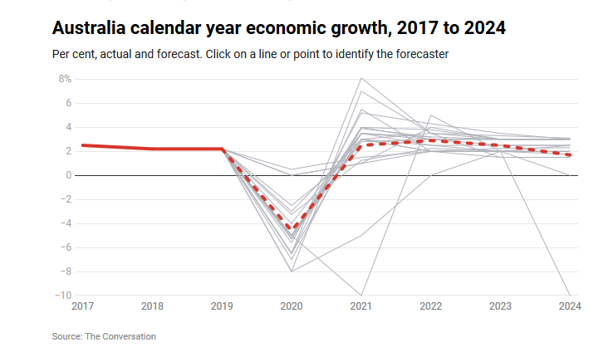
Article Title: Economic survey for 2020-21 points to a weak recovery getting weaker, amid declining living standards.
URL: https://www.abc.net.au/news/2020-06-29/economic-survey-australia-weak-recovery-getting-weaker/12398728
Author: Peter Martin
Publication Date: June 28, 2020
Type of Graph: Time Series Plot
Rationale: Given the lack of consensus on the impact of COVID-19 on the economy, I was interested in economists outlook of the post-COVID economic recovery rate. The graph shows the forecasts of the Australian economy between 2020 and 2024 made by 22 renown economists from 16 universities and the average prediction computed from the 22 projections.
Strengths: The chart includes a caption/note that describes the data and the procedure to display the legend.
The chart has a title describing the subject and period of the analysis.
The data source is provided.
The x and y-axis are clearly and correctly labelled and the intervals are spaced regularly.
The choice of line colour is well-suited for the data represented. All of the 22 forecasts are presented in grey as no individual forecast is particularly important compared to other forecasts and the use of different colours could overwhelm the reader. The average forecast, which is of key importance, is presented in a bright red colour that draws the reader’s attention.
The grid is muted with horizontal grid lines which aid data interpretation but no superfluous vertical grid lines.
Weaknesses: The legends are only visible upon hovering above the line plot. This inhibits the ability to republish the graph and the interpretability of the graph to persons viewing the graph on mobile browsers.
The x-axis title is missing while the y-axis title is ambiguous due to the presentation of the y-axis measure and procedure to display the legend in a single line that appears to be a caption
Graph Four
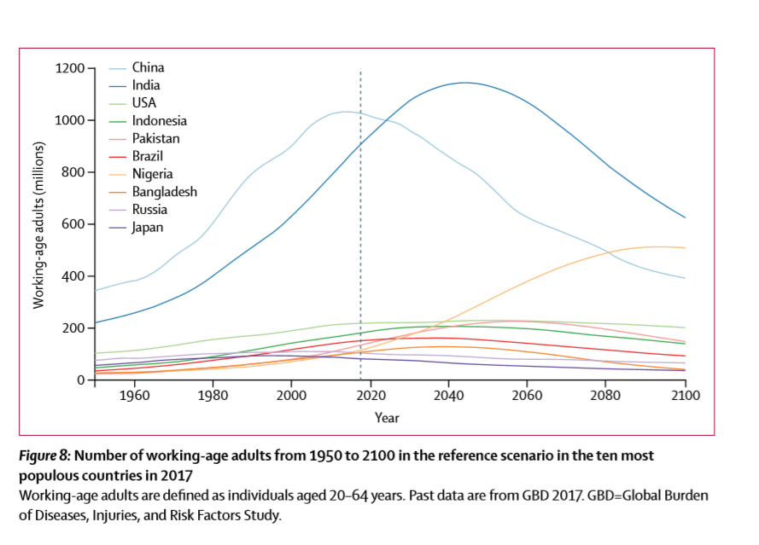
Article Title: Fertility, mortality, migration, and population scenarios for 195 countries and territories from 2017 to 2100: a forecasting analysis for the Global Burden of Disease Study
URL: https://www.thelancet.com/article/S0140-6736(20)30677-2/fulltext
Authors: Stein Emil Vollset, et al.
Publication Date: July 14, 2020
Type of Graph: Time Series Plot
Rationale: Of the graphs appearing in articles published in the Lancet in 2020, the projection of working age adults across 10 countries was of the highest interest to me.
Strengths: The chart includes a caption below the graph that describes the data. The caption also serves as a title as a title cannot be placed above the graph in journal articles using APA formatting.
The source of the data is provided.
The x and y-axis are clearly and correctly labelled and the intervals are spaced regularly.
The x and y-axis and clearly and correctly titled.
The grid is completely eliminated and does not overshadow the data.
Weaknesses: The legend is presented within the graph distracting from the data.
The colours of the Pakistan, Nigeria, and Bangladesh trend lines are virtually indistinguishable.
Graph Five
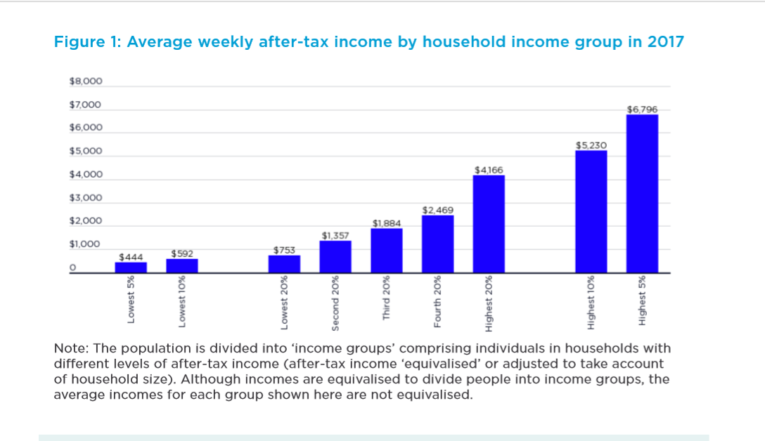
Article Title: Inequality in Australia 2020
URL: http://povertyandinequality.acoss.org.au/wp-content/uploads/2020/09/Inequality-in-Australia-2020-Part-1_FINAL.pdf
Authors: Davidson P., Bradbury B., Wong M., and Hill T.
Publication Date: 2020 (unspecified day and month)
Type of Graph: Bar Plot
Rationale: I selected this graph to gain more insight into the extent of inequality in Australia following the exploration of inequality in the US in the first graph.
Strengths: The chart is title is appropriate and succinct. The graph title, “Average weekly after-tax income by household income group in 2017”, correctly summarizes the contents of the graph.
The note presented below the title clarifies the plotting process and lends to the interpretability of the data.
The x and y-axis are clearly and correctly labelled and the intervals are spaced regularly in spite of the absence of weekly earnings data for the lowest and highest 15th percentile.
Weaknesses: The display of weekly income is unnecessary and introduces clutter to the graph considering the use of horizontal grid lines.
The authors failed to indicate the source of the data.
The x and y-axis titles are missing.

