Method

Name

Instructor

Course

Date

Method
This section describes the participants, materials/ apparatus, and procedure used to undertake the research study to determine the risks of social isolation for male and female participants, cognitively, physically, and psychologically.
Participants
The research study includes 400 volunteers; 200 males and 200 female. Participants will be recruited from social media outlets such as Facebook, Instagram, Twitter, radio, and digital newspaper advertisements. The recruitment strategy involves advertising publicly on all social media outlets, such as Facebook, Twitter, and Instagram. Additional advertisements will run on the local radio stations, and advertisements will also appear in local newspapers, digitally version only. Interested participants will click on a link that will direct them to a quick questionnaire containing more information on the recruitment process. Individuals who hear the advertisement on local radio stations will be directed to a website containing the link.
Once participants have been directed to the link, they will be required to provide answers to six questions as follows:
1. What is your city and state? ___________
2. Gender:
- Male:
- Female:
- Other (Specify):
3. Age (Participant will click on a drop-down menu which includes ages 18-100).
- Younger than 18
- 18-23
- 24-29
- 30-34
- 35-40
- 41 and above
4. Email address and phone number.
5. First name only.
6. Hours spent socializing daily?
After the participants have submitted the first questionnaire, the results will be sent to a panel of informants who will review all results. The aim of the first questionnaire is to establish whether the participants meet the minimum criteria for research. The criteria include:
- Must be within a 50-mile radius of the laboratory.
- No gender will be excluded
- Between 18-40 years
- Must have a valid email address and a valid phone number.
Anyone who does not meet the above criteria will be excluded from the first round and will no longer be considered for the study. Contact information will be used to facilitate communication with the participants. Participants are only required to fill out the first name at this stage of the study, which will be used to assign a random number to the participant for purposes of identification.
Participants who pass the first round of the selection process will be notified through the provided contact information. They will be provided with a second questionnaire and they will be given a maximum of 14 days to fill out the second questionnaire. On the 15th day, participants that will not have responded to the second questionnaire will not be considered for the study. The second questionnaire will ask for more in-depth information including:
- What is your city and state?_____________
- Gender:
- Male
- Female
- Other (Specify)
If other:
Biological Gender:
- Male
- Female
- Age:
Year ___Month _____Day
- First and Last Name _____________________
- Physical Health History ________________________
- Mental Health History _____________________
- Family Medical History ______________________
- How many hours do you spend socializing daily?
Less than one hour
- 1-3 hours
- 3-5 hours
- 6-8 hours
- More than 5 hours
- Describe what socializing means to you_______________
- How many hours do you spend exercising?
Daily______________________________
Weekly_____________________________
Monthly____________________________
Yearly______________________________
- Which techniques do you use for daily mind stimulation?____________________
Before responding to the second questionnaire, participants will be required to read through a brief description about the research study. They will be required to provide consent to being isolated from all social interactions/stimulation for 60 days in a completely controlled facility. In addition, participants must be willing to arrive during their appointed time for a full mental/health/and cognitive evaluation. Informants will review the second questionnaire and select participants that have met the required criteria. 200 males and 200 females will be selected from the group of qualified participants. Individuals who chose “Other” as their gender will still be included in the study but will be assigned by their biological gender. The simple random method will be used to select participants.
Inclusion criteria for selected participants include:
- Participants may not have any current or past medical or mental issues.
- Participants must be within the age range of 18 and 40.
- Participants must still reside within 50 miles of the laboratory.
- Participants must read and agree to give up all privacy during the observation period.
- Participants must be willing to give up all forms of social media, electronics, or other mental stimulation.
- Participants must be willing to complete an observation period of 60 days, unless researchers, informants, or medical staff feels they are unable to continue due to physical or mental harm.
- Participants must be willing to cooperate throughout their observation time; this includes participating in weekly check-ins with medical staff and or researchers.
- Participants must be willing to stay in a controlled environment.
- Participants must be aware that if they do not complete the full 60-day observation or if they break any of their agreement to properly participate in the study, there will be no compensation. (This includes if the participant is released due to medical condition).
- Participants will receive their first compensation after completing their final evaluation with the research team, medical staff, and psychologists on the last day of observation.
- Participants agree and have a complete understanding there will only be one-time compensation that will be given for their 60-day observation period. Participants will not receive any more compensation should research become public or if there are any financial gains from the research study.
- Participants will be signing over all freedoms during their stay.
- Participants will not hold researchers, physicians, informants, licensed psychologists, or any others involved in the study accountable for any lifelong complications they may develop. This includes all medical, physical, mental, and cognitive complications.
- If at any time professional staff feels the participant may be in harm's way, they are required to release the participant from the study.
- Participants must not be claustrophobic and must be willing to withstand small enclosed spaces.
- Compensation given is not tax-free. Participants will be provided a yearly tax form by mail or printable version sent via email, in which they must claim and pay taxes on. This form will be provided to the participant via mail/email no later than February 15th, 2022.
Materials
Participants’ cognitive levels will be evaluated using the Mini Mental State Examination (MMSE) (See Appendix A). The tool measures an individual’s cognitive level and is ideal for measuring cognitive impairment. The tool was developed by Folsten et al in 1975 to measure cognitive impairment. The administration of the tool takes between 5 and 10 minutes and tests for cognitive function including calculation, recall, language, attention, repeating named prompts, orientation, and the ability to follow simple prompts. A score of 24-30 indicates no cognitive impairment; a score of 18-23 suggests mild cognitive impairment; while a score of 0-17 suggests severe cognitive impairment. The test is valid and reliable as it has a test-retest reliability of 0.8 to 0.95 and a specificity of 0.70 (Mitchell, 2017).
The Mental State Examination (MSE) will be applied by qualified, registered mental health experts to evaluate participants’ mental health status. The tool was developed by Karl Jaspers in The diagnostic tool evaluated factors that contribute to mental health including perception, speech, mood, appearance, thought content, behavior, attitude, judgment, insight, cognition, affect, and thought process. Studies have shown MSE to have high scores on validity and reliability. Mental health experts categorize the participants’ mental health status as normal or abnormal (Stockmann et al., 2019). Normal scores will receive a rating of 1 while abnormal scores will receive a rating of 0.
A physical exam will; be carried out by a registered physician to determine the participants’ general health status (See Appendix C). The examination will start by the physician inspecting the participants’ bodies for unusual marks or growth. After that, the physician will have the patients lie down and they will inspect parts of the body to evaluate the functioning of individual organs. Physicians will provide scores based on the participant’s health status on each of the identified body organ and will provide scores of normal or abnormal. The tool has been standardized for validity and reliability by the National Health Institute (Ko et al., 2020). Normal scores will receive a rating of 1 while abnormal scores will receive a rating of 0.

Procedure
After the required number of participants has been selected and informed consent is signed, participants will be assessed using the provided cognitive, mental, and physical assessment tools. Each participant’s scores will be recorded. Each participant will be given a clean solid color jumper daily that will have their randomly assigned number displayed on the back. Names will not be used in this study. The only personally identifiable information that will be provided includes age, race, biological gender, and the assigned identification number. Participants will be prohibited from bringing any personal items such as clothing, shoes, hair products, or any other essential items. All participants will be assigned toiletries and other needed survival items. Lighting in the rooms will not be natural lighting. It will be controlled by an automatic timer, which will shut off at 9 p.m. and turn on at 5 a.m. daily. A healthy, nutritious meal will be provided three times a day. Meals will be delivered via a slot in the door and will be consumed in individual isolation rooms. Breakfast will be served at 6 a.m., lunch at 12 p.m., and dinner at 6 p.m., an additional dessert will be served on weekends at 7 p.m. No desserts will be served on weekdays.
Cameras will also be placed in all isolation rooms including privacy areas such as restrooms and sleep areas. All areas will be monitored for the entire duration of the participant’s stay. Participants will not be able to leave their isolation rooms during the duration of their stay, unless Researchers, Psychologists, and/or Physicians on-site feel it is deemed necessary due to mental and/or physical health that could potentially be life-threatening to the participant. If at any time this is deemed necessary, the participant will be permanently removed from the study, and no compensation will be given.
Participants will be provided with a sleeping area that will include two pillows, two bed sheets, and a light blanket. Room temperature will be maintained at 72-degree F daily, with no change in temperature. Sleep areas will all be white. The living area will include a couch, a small table and two chairs for eating daily meals. The restroom will include one toilet, one sink, and a small shower without a door. All walls will be white and will include one famous art piece. The couch in the living area will be a navy blue and the art piece will be the famous “Starry Night” by Vincent Van Gogh.
After the completion of the 60 days, the participants will undergo the second process of the cognitive, mental, and physical examinations using MMSE, MSE, and the provided physical examination assessment test respectively. Each individual’s score on the second administration of the tests will be recorded and the scores will be compared with the scores of the initial administration. The overall participants’ scores will be compared for both tests to determine any changes in the participants’ cognitive, mental, and physical abilities.

References
Cahn-Hidalgo, D., Estes, P. W., & Benabou, R. (2020). Validity, reliability, and psychometric properties of a computerized, cognitive assessment test (Cognivue®). World Journal of Psychiatry, 10(1), 1.
Ko, Y. A., Hu, Y., Quyyumi, A. A., Waller, L. A., Voit, E. O., Ziegler, T. R., ... & Martin, G. S. (2020). Comparison of physical examination and laboratory data between a clinical study and electronic health records. Plos one, 15(7), e0236189.
Mitchell, A. J. (2017). The Mini-Mental State Examination (MMSE): update on its diagnostic accuracy and clinical utility for cognitive disorders. In Cognitive screening instruments (pp. 37-48). Springer, Cham.
Stockmann, C., Diaz, D. A., Murphy, D., Dever, K., Marchini, M., Huffman-Frazee, J., & Anderson, M. (2019). Development of a mental health Objective Structured Clinical Examination (OSCE): A pilot study. Simulation & Gaming, 50(4), 448-460.

Appendix A: Mini Mental State Exam
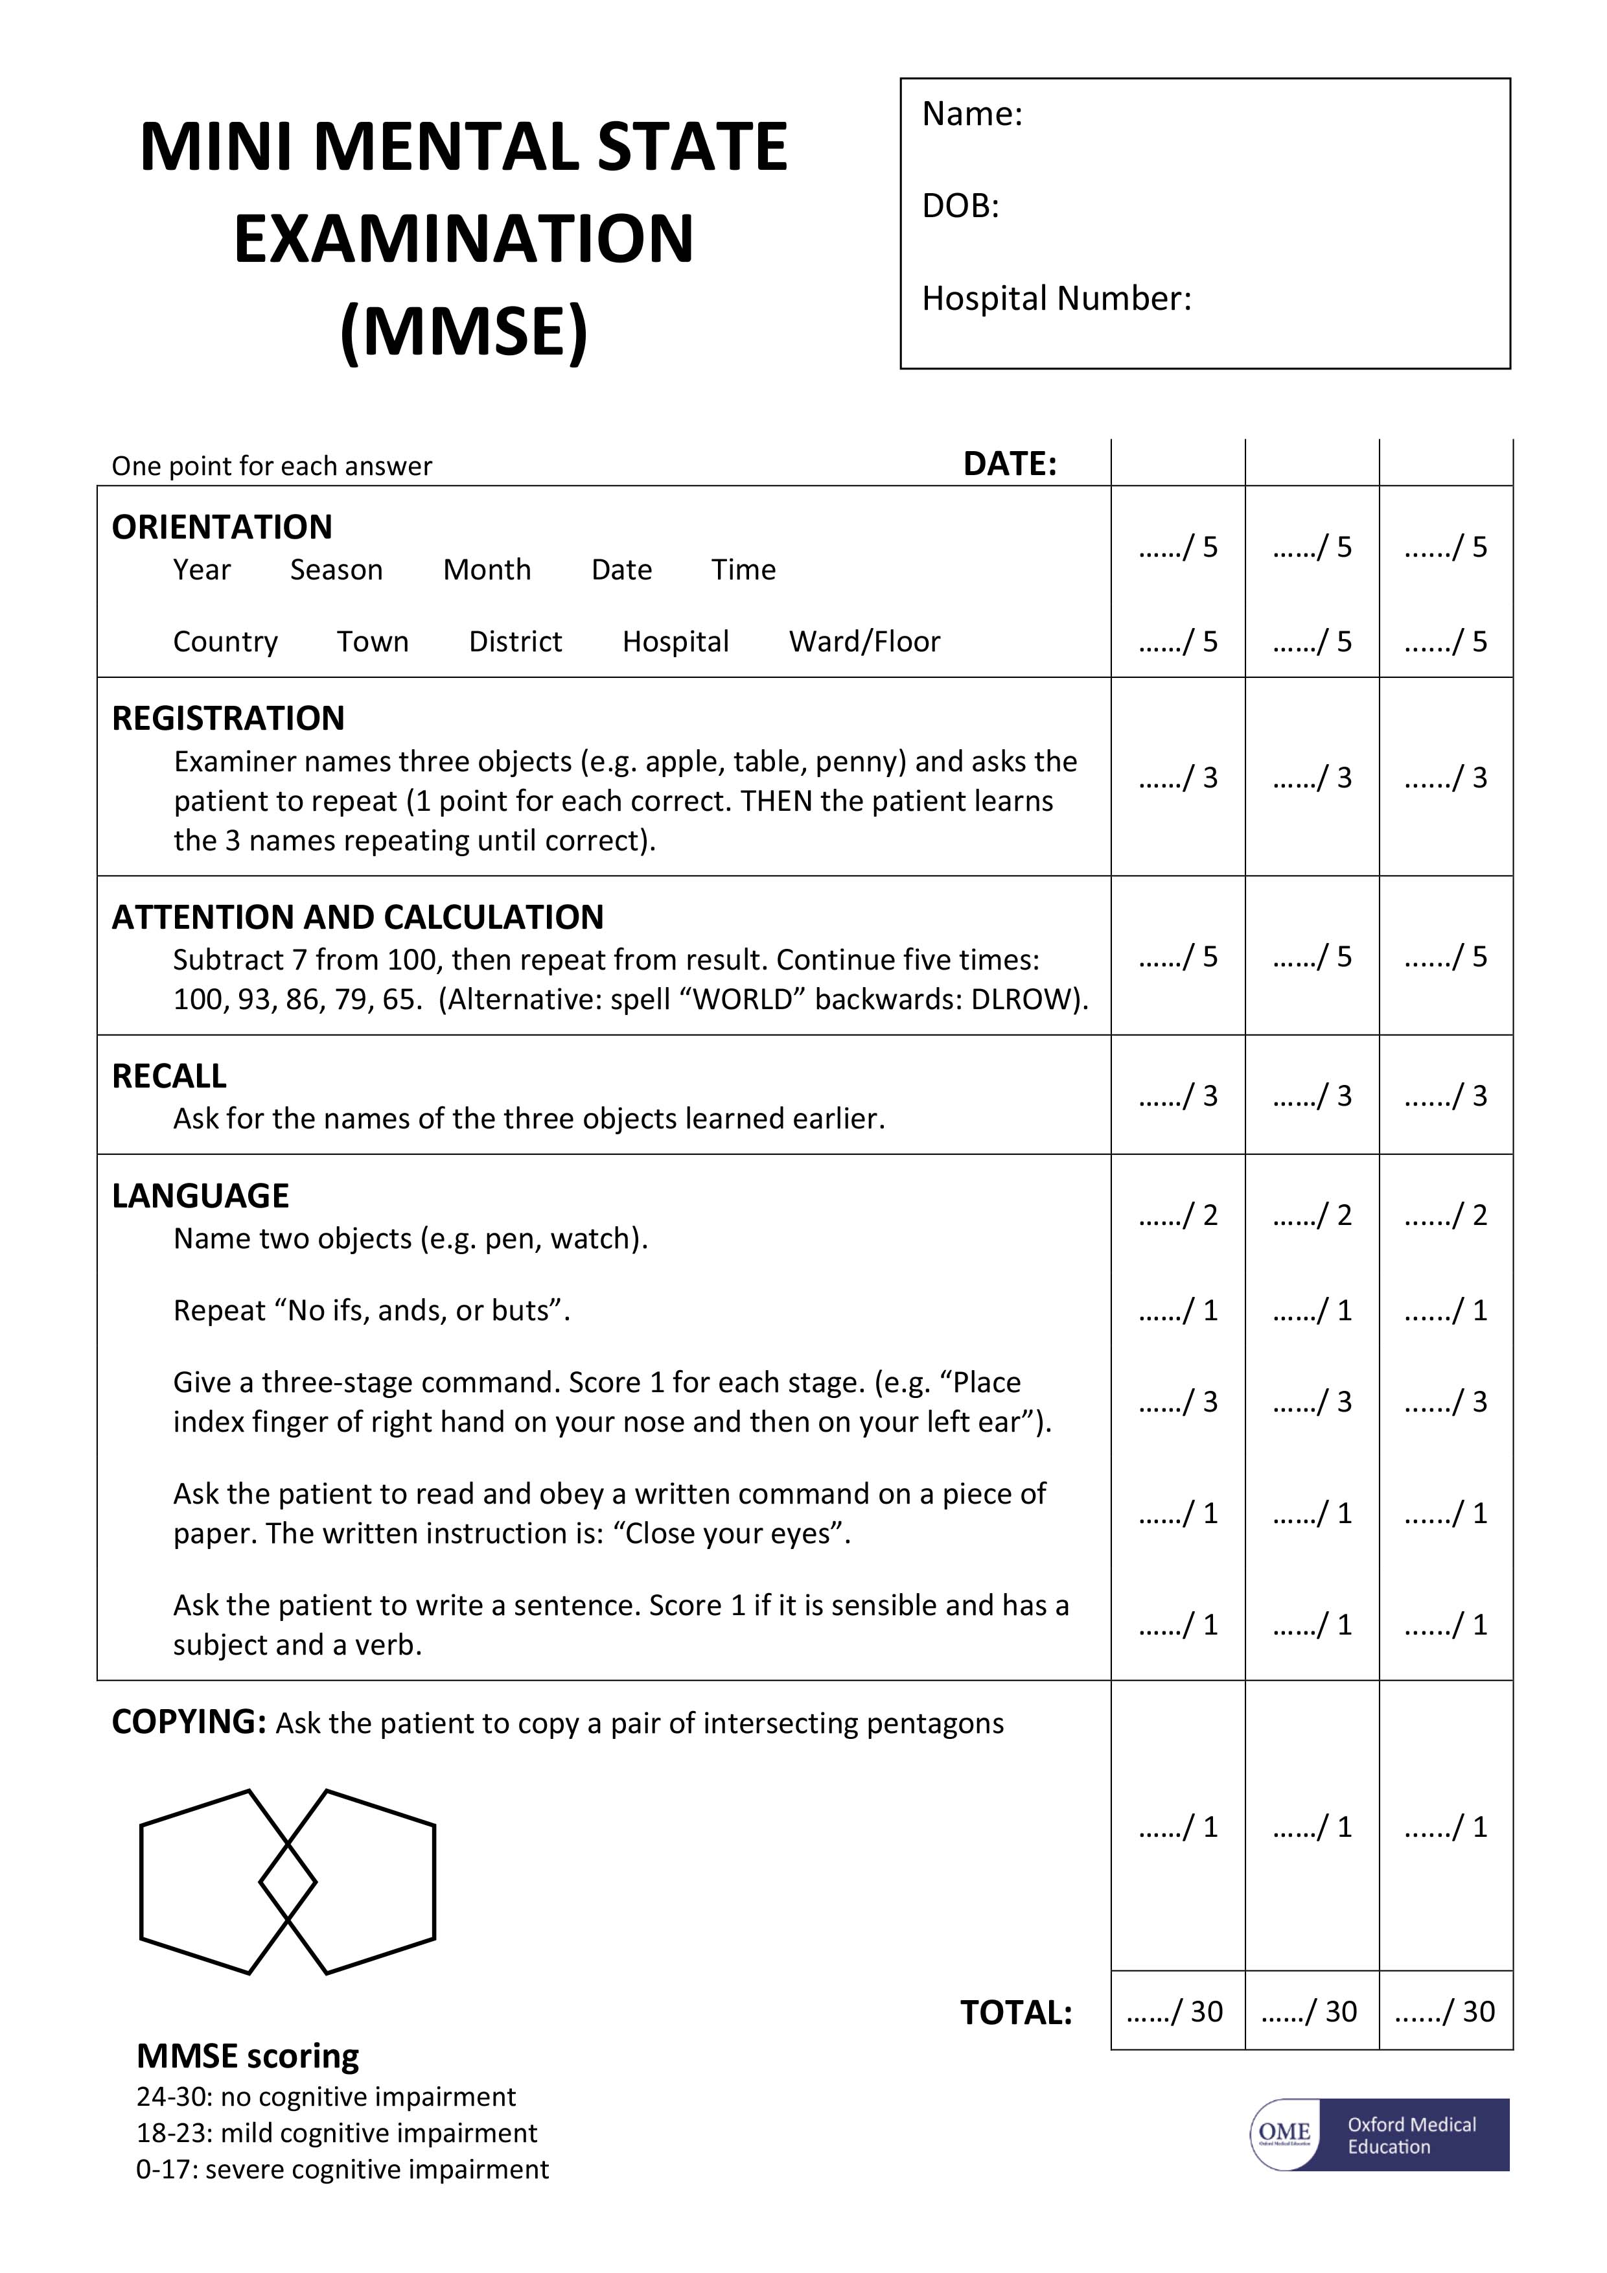

Appendix B: Mental State Exam

OSCE Checklist: Mental State Examination

Opening the consultation
1 | Introduce yourself to the patient including your name and role
2 | Conﬁrm the patient's name and date of birth
3 | Explain that you’d like to have a chat with the patient to see how they’re currently feeling
4 | Gain consent to proceed with a mental state examination
Appearance
5 | Observe the patient’s appearance
Behavior
6 | Note how the patient engages and if there seems to be rapport
7 | Observe the patient's level of eye contact
8 | Observe the patient's facial expressions
9 | Observe the patient's body language
10 | Identify any evidence of abnormal psychomotor activity (e.g. psychomotor retardation or restlessness)
11 | Note any abnormal movements or postures
Speech
12 | Note the rate and quantity of the patient’s speech
13 | Note the tone and volume of the patient’s speech
14 | Note the ﬂuency and rhythm of the patient’s speech
Mood and aﬀect
15 | Explore the patient's current mood by asking appropriate questions
16 | Observe the patient's aﬀect
Thought
17 | Note the speed, ﬂow and coherence of the patient’s thoughts
18 | Explore the content of the patient’s thoughts for abnormalities
19 | Ask about thought possession to screen for abnormalities
Perception
20 | Explore the patient’s current perception
Cognition
21 | Formally assess the patient’s cognition (e.g. AMTS, MMSE, ACE-III)
Insight and judgment
22 | Assess the patient's current insight into their problems

23 | Assess the patient's current judgment skills
Closing the consultation
24 | Ask the patient if they have any questions or concerns that have not been addressed
25 | Thank the patient for their time
Key communication skills
26 | Active listening
27 | Summarizing
28 | Signposting

Appendix C: Physical Examination Form

CATEGORY | Normal  Or Abnormal | IF Abnormal, Describe below | Change from baseline
General Appearance | Normal  Abnormal  Not Examined |  | Yes  No  NA
HEENT | Normal  Abnormal  Not Examined |  | Yes  No  NA
Neck | Normal  Abnormal  Not Examined |  | Yes  No  NA
Chest and Lungs | Normal  Abnormal  Not Examined |  | Yes  No  NA
Cardiovascular | Normal  Abnormal  Not Examined |  | Yes  No  NA
Abdomen | Normal  Abnormal  Not Examined |  | Yes  No  NA
Genitourinary | Normal  Abnormal  Not Examined |  | Yes  No  NA
Rectal | Normal  Abnormal  Not Examined |  | Yes  No  NA
Musculoskeletal | Normal  Abnormal  Not Examined |  | Yes  No  NA
Lymph Nodes | Normal  Abnormal  Not Examined |  | Yes  No  NA
Extremities/Skin | Normal  Abnormal  Not Examined |  | Yes  No  NA
Neurological | Normal  Abnormal  Not Examined |  | Yes  No  NA
Other:__________ | Normal  Abnormal  Not Examined |  | Yes  No  NA

Note: For follow-up PE, if a body system category changes from “Normal” at baseline to “Abnormal” at follow-up due to a new disease/condition, or a preexisting disease/condition worsens from the baseline, an adverse event form should be completed to report the change.

PHYSICIAN SIGNATURE: ___________________________ DATE SIGNED ___ ___ / ___ ___ ___ / 2 0 ___ ___
d d m m m y y y y

