1a)Draw a diagram showing the security market line and use it to help explain the Capital Asset Pricing Model (CAPM) and the concept of Beta in this model.
b)Derive the Capital Market Line using a risk-free security and use it to explain lending and borrowing portfolios.
c)You are given the following information:
(i)A stock with a beta of 0 has an expected return of 4%.
(ii)A portfolio made up of 50% invested at the risk-free rate and 50% invested in the market portfolio has an expected return of 9%
What is the expected return on the market portfolio?
- a.
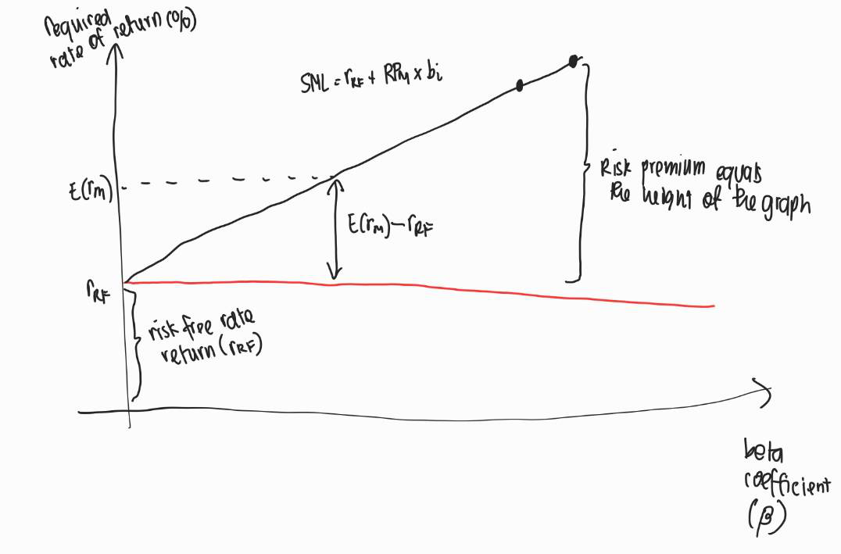
CAPM model is a model that describes the relation between systematic risk (or risk that is inherent to the market or the very basic risk that a completely diversified portfolio will have) and expected return for the investment. Security Market Line or SML is basically the graphical representation of the CAPM model. Here, the required rate of return is related to the beta of the investment, which is a measure of the risk of the investment compared to the overall market – with beta of one referring to the market risk. Therefore, from the graph, we can see that the higher the beta (or risk of the investment), the higher rate of return is required for the investment/stock.

b. Capital market line is a representation of portfolios that combine risk and return efficiently – which is related to the Sharpe Ratio as its slope.

Assuming all the portfolios on CML have same Sharpe Ratio, we can write it as:
$$\frac{r_{s}-r_{RF}}{σ}=\frac{RP_{M}-r_{RF}}{σ_{M}}$$
Rearranging the equation give us the:
$$r_{s}=r_{RF}+\frac{RP_{M}-r_{RF}}{σ_{M}}σ$$
With $r_{s}$ as portfolio return, $r_{RF}$ as risk free rate, $RP_{M}$ as market return, $σ_{M}$ as market’s standard deviation, and $σ$ as portfolio’s standard deviation.

This shows that people will try to borrow or lend at the risk-free rate, since this condition will maximize return for the level of risk.

c. We can use the first information to find the $r_{RF}$
$$r_{s}=r_{RF}+RP_{M}.b_{i}$$
$$b_{i}=0$$
$$r_{s}=r_{RF}=4\%$$

The expected return of the portfolio is the weighted average of all the investments:
$$r_{s}=w_{a}r_{a}+w_{b}+r_{b}$$
$$9=\left(0.5\right)\left(4\right)+\left(0.5\right)\left(RP_{M}\right)$$
$$RP_{M}=14\%$$
2a)Explain the concept of the Efficient Markets Hypothesis (EMH) and explain why prices should reflect all available information.
b)Discuss the implications of the EMH for investors.
c)Discuss the empirical evidence in favour of and against the semi-strong form of market efficiency?
2. a. Efficient market hypothesis is a hypothesis that states the prices of assets reflects all available information in public. Prices should reflect all available information because the prices will adjust on new information on the market that possibly affects the price of share (for example, company expansion, future merger) that is available to investors.
b. This EMH implies that investors will never be able to beat the market efficiently, hence the only way to have higher returns is by buying riskier stocks or assets. This is due to the fact if the information is widely available, there is no way for investors to consistently buy only undervalued stocks because the price will adjust accordingly.
c. An evidence that supports the semi-strong form of market is the fact that fundamental and technical analysis is useless and hence only non-public information (MNPI) matters. For example, if an information is widespread, the price of the stock will quickly adjust and hence the only time for the investor to earn profit is to know the information beforehand. However, on the other hand, the against side argue that such analysis is useful to see the prospect of a company – for example, fundamental analysis is useful to determine whether a certain company is actually expanding or already in a stagnation phase. Therefore, such analysis can still be utilized in earning profit in stock market.

