Probability, Normal Distribution, and Normal Inverse

- The demand forecast is 21,734. No uncertainty (standard deviation 0).
  - How much would you order?
Since according to the problem, there is no uncertainty indicating a zero standard deviation. Therefore, a demand forecast for a product of 21,734:
Number of Orders = 21,734 x 100% = 21,734. The product that I need to order is 21,734 or higher.
  - In addition, you want 500 units of safety stock. How much would you order?
The safety stock of 500 units will be an excess of the required number of products. Assuming I order exactly 21,734 units.
Total number of orders = 21,734 + 500 = 22,234 units

- The demand forecast is 21,734 units with a standard deviation of 3,421. You order 25,000 units.
  - What is the safety stock?
To solve for the safety stock, we will use the formula:
Safety stock = No. of orders – Demand Forecast
Safety stock = 25000 units – 21,734 units
Safety stock = 3266 units
  - What is the probability of a stockout? (Use the Norm. Dist function in Excel)
Before we get the probability of stockout using the Normal Distribution function in excel, we need to find "z" or the safety factor first using the formula:
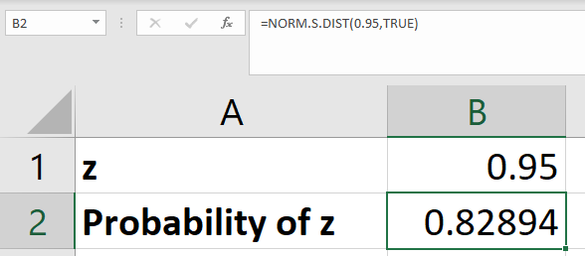
z = $\frac{Safety Stock}{Standard deviation of demand}$
z = $\frac{3266}{3421}$
z = 0.95
The probability of z indicates a service level. To find the probability of stockout"
Stockout (Risk) = 1 – Service Level
Stockout = 1 – 0.83
Stockout = 0.17 or 17%
  - How many units should you order so that the service level is 99%?
The service factor for a 99% service level using a normal distribution chart is 2.33.
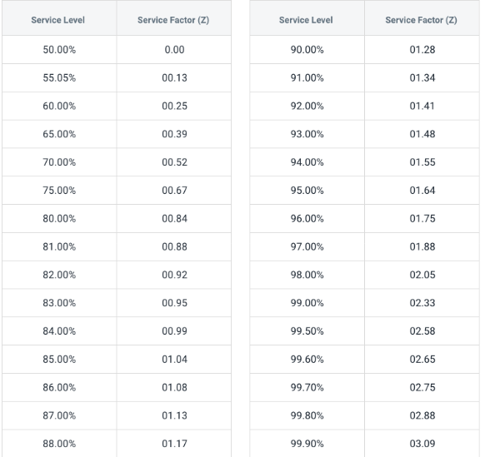

Image from: https://www.primaseller.com

Applying the formula to find the number of units to order:
Number of orders = z (standard deviation of demand) + demand forecast
Number of orders = 2.33(3,241 units) + 21,734 units
Number of orders = 29,285.53 units
  - For c), what is the corresponding safety stock?
The safety stock for 99% service level is:
Safety stock = z (standard deviation)
Safety stock = 2.33(3,241)
Safety stock = 7551.53 units

- A product costs $140. You sell it for $210. Any leftover inventory goes to a liquidator who pays you $120 per unit.
  - The “upside” of ordering more: What is the loss on one unit if we stock out?
If we stock out, there’s no leftover in the inventory. Therefore, the loss on one unit if we stock out is simply:
Loss = (Selling Price – Product Cost)
Loss = $210- $140
Loss = $70 per unit
    - Is this the “underage” or the “overage”?
The answer that we get is underage because the formula for “underage” is Selling Price – Product Cost.
  - The “downside” of ordering less: What is the loss on one unit if we have excess inventory?
If there’s an excess in inventory, I will get $120 per unit excess from the liquidator. So, the loss will be:
Loss = Product Cost – $120
Loss = $140 - $120
Loss = 20$
    - Is this the “underage” or the “overage”?
The answer that we get is “overage” because it describes the number of units that cannot sell due to excess product.
  - What is the service level that balances the upside and the downside (aka “critical fractile”)?
To solve for the service level that will balance the upside and the downside, we will use the formula:
Critical fractile = $\frac{overage cost}{underage cost+overage cost}$
Critical fractile = $\frac{20\$}{70\$+20\$}$
Critical fractile = 0.222
  - The demand forecast has a mean of 10,000 and std dev 2,000.
    - What is the order size?
To solve for the order size (Q), we will use the formula:
Q = mean + (z x standard deviation)
To find the z, Φ(z) = 1 – 0.222 = 0.778. From the z-chart at 77.8% or 78% service level, z = 0.772
Q = 10,000 + (0.772 x 2000)
Q = 11,544
Therefore, the order size is equal to 11,544.
    - What is the safety stock?
The formula to solve for the safety stock is:
Safety stock = z x standard deviation
Safety stock = 0.772 x 2000
Safety stock = 1544 units
Therefore, the safety stock is equal to 1544 units.
- Repeat 3. Expect now you pay the liquidator $5 to take them off your hands.
  - The “upside” of ordering more: What is the loss on one unit if we stock out?
If we stock out, there’s no leftover in the inventory. Therefore, the loss on one unit if we stock out is simply:
Loss = (Selling Price – Product Cost)
Loss = $210- $140
Loss = $70 per unit
    - Is this the “underage” or the “overage”?
The answer that we get is underage because the formula for “underage” is Selling Price – Product Cost.
  - The “downside” of ordering less: What is the loss on one unit if we have excess inventory?
If there’s an excess in inventory, I will no longer get $120, and in exchange, I will pay $5 to the liquidator. So, $120 - $5 = $115 and the loss will be:
Loss = Product Cost – $120
Loss = $140 - $115
Loss = 25$
    - Is this the “underage” or the “overage”?
The answer that we get is “overage” because it describes the number of units that cannot sell due to excess product.
  - What is the service level that balances the upside and the downside (aka “critical fractile”)?
To solve for the service level that will balance the upside and the downside, we will use the formula:
Critical fractile = $\frac{overage cost}{underage cost+overage cost}$
Critical fractile = $\frac{25\$}{70\$+25\$}$
Critical fractile = 0.263
  - The demand forecast has a mean of 10,000 and std dev 2,000.
    - What is the order size?
To solve for the order size (Q), we will use the formula:
Q = mean + (z x standard deviation)
To find the z, Φ(z) = 1 – 0.263 = 0.737. From the z-chart at 73.7% or 74% service level, z = 0.64

Q = 10,000 + (0.64 x 2000)
Q = 11,280
Therefore, the order size is equal to 11,280.
    - What is the safety stock?
The formula to solve for the safety stock is:
Safety stock = z x standard deviation
Safety stock = 0.64 x 2000
Safety stock = 1280 units
Therefore, the safety stock is equal to 1280 units.
- In plain English, without using technical jargon, explain why the safety stock for 3 and 4 are different.

The safety stock for number 3 is different from number 4 because the multiplier for standard deviation is different. This simply means that the safety stock will vary depending on the number of excess units that cannot sell in the market.
- You are the chief buyer for housewares at a large department store. You face stiff competition from specialty retailers and increasingly online retailers that carry imported cooking and dining articles. To meet the specialty store competition, you have reorganized your housewares department to create a “store within a store” that has the same ambiance as your competitors’ stores. To kick off your concept, you plan a one-month promotion that features several special items, including a delightful, imported Riviera Sky cake ware dish. (The Riviera Sky dish leaves a “sun” image on the sides of the cake.) These cake ware dishes must be ordered six months in advance. Any leftover inventory after the promotion will be sold to a discount chain at a reduced price.
You have collected pricing and cost data in the table below, to help you decide how many of the Riviera Sun cake ware dishes to order. You expect total demand will be normally distributed with a mean of 860 and a standard deviation of 320. The promotion price is $40. Any leftover cake ware dishes will be sold to the discount chain for $10.
Riviera Sun Cake ware Dish
Purchase Price $16.00
Shipping cost $3.00
Handling cost* $0.80
Warehouse surcharge** $1.1
Total Cost $20.90
*Estimate of variable cost for the receiving process for one dish (uncrating, cleaning, and staging in the housewares department)
**Allocation of fixed overhead expenses in the shipping and receiving department.
  - Suppose 1100 imported Riviera Sun cake ware dishes are ordered. What is the probability that the department store has enough cake ware dishes to meet all of the demand?
To solve for the probability that the department store has enough cake ware dishes, we need to find the overage and underage cost first.
Overage cost = Total Cost – Discount
Overage cost = $20.9 –$10
Overage cost = $10.9

Underage cost = Promotion Price - Total Cost
Underage cost = $40 - $20.9
Underage cost = $19.1

Next, we will find the critical fractile.
critical fractile = $\frac{overage cost}{underage cost+overage cost}$
critical fractile = $\frac{10.9\$}{19.1\$+10.9\$}$
critical fractile = 0.363
To find the z, Φ(z) = 1 – 0.363 = 0.636. From the z-chart at 63.6% or 64% service level, z = 0.36
Using excel to find the probability,
The formula to be inputted is =NORM.DIST(X, Mean, Standard Deviation, cumulative)
Where:
X = 1100
Mean = 860
Standard Deviation = 320
Cumulative = True

The probability that the department store has enough cake ware dishes to meet all of the demand is 77.33%

  - How many Riviera Sun cake ware dishes should you purchase?
The number of Riviera Sun cake ware I need to purchase using the formula:
No. of orders = Mean + (z x standard deviation)
No. of orders = 860 + (0.36 x 320)
No. of orders = 975.2 or 976 cake ware dishes
  - You are concerned about customer service. In particular, you perceive there is a loss of goodwill of $8 for every customer who travels to the store to purchase the Riviera Sun cake ware dish but is unable to do so because of a stockout. Now, how many Riviera Sun baking dishes should you purchase?
Since there's an $8 loss of goodwill. We will subtract it from the purchase price. So, $40 - $8 = $32. The new underage cost is Underage cost = $32 - $20.9= $11.1
Next, we will find the critical fractile.
critical fractile = $\frac{overage cost}{underage cost+overage cost}$
critical fractile = $\frac{10.9\$}{11.1\$+10.9\$}$
critical fractile = 0.495
To find the z, Φ(z) = 1 – 0.495 = 0.505. From the z-chart at 0.505% or 51% service level, z = 0.013
The number of Riviera Sun cake ware I need to purchase using the formula:
No. of orders = Mean + (z x standard deviation)
No. of orders = 860 + (0.013 x 320)
No. of orders = 864.16 cake ware dishes

