Mechatronics, Design Control system for a pinball launcher
Name
Institution
Date
QUESTION A
Considering the system and writing: electrical equations mechanical equations electromechanical equations
Taking the Laplace transform of all this equations gives the relationship between the input voltage to the motor and the motor power output

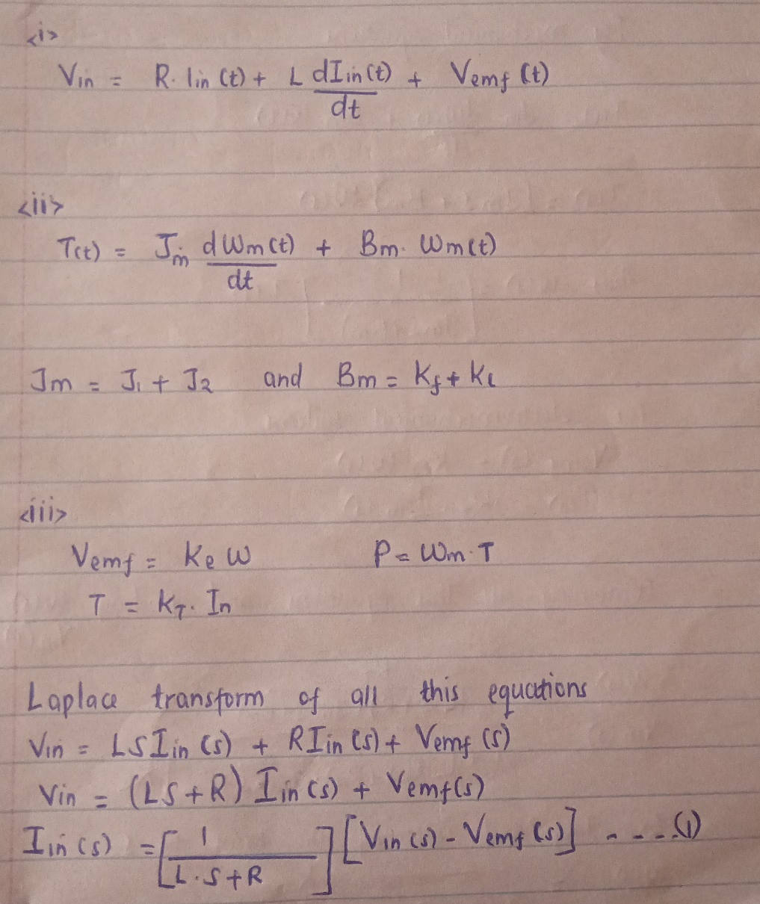
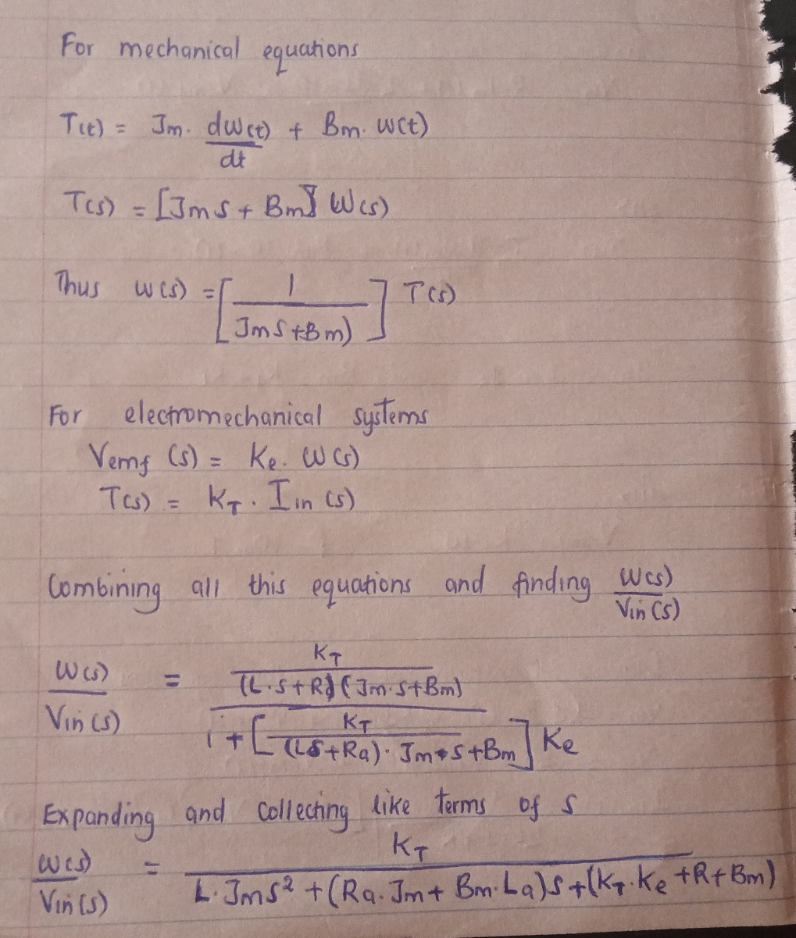

QUESTION B
The relationship between voltage input and the output angle of the motor of the motor shaft can be found by integrating motor velocity with respect to time.

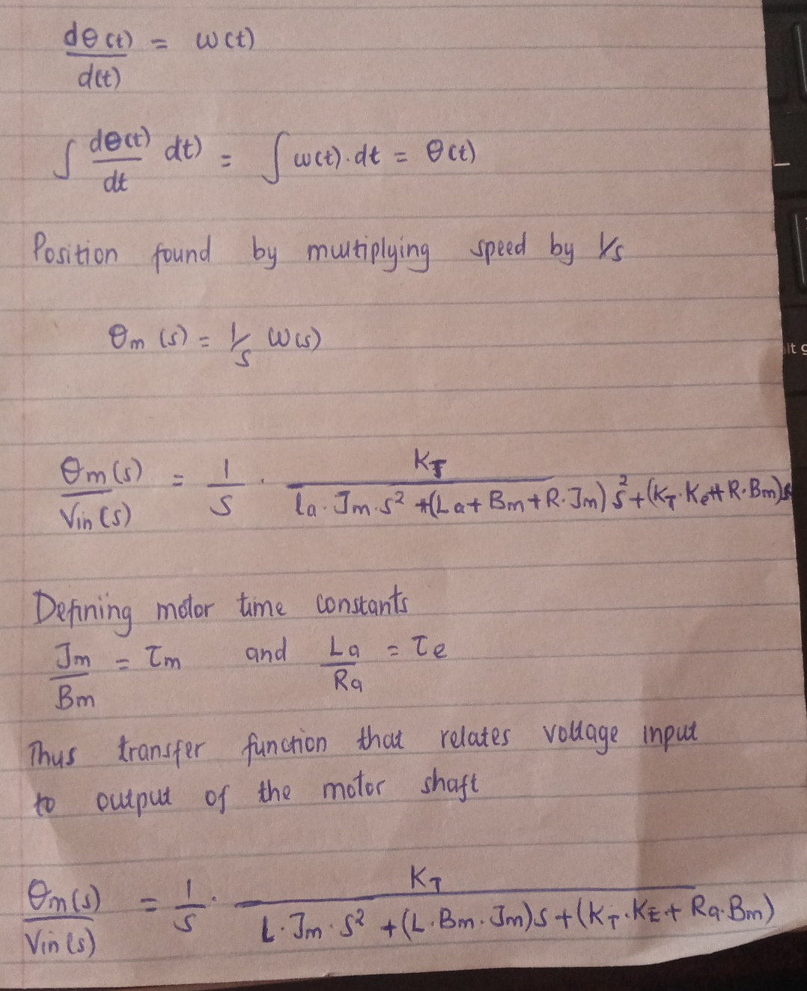
QUESTION C

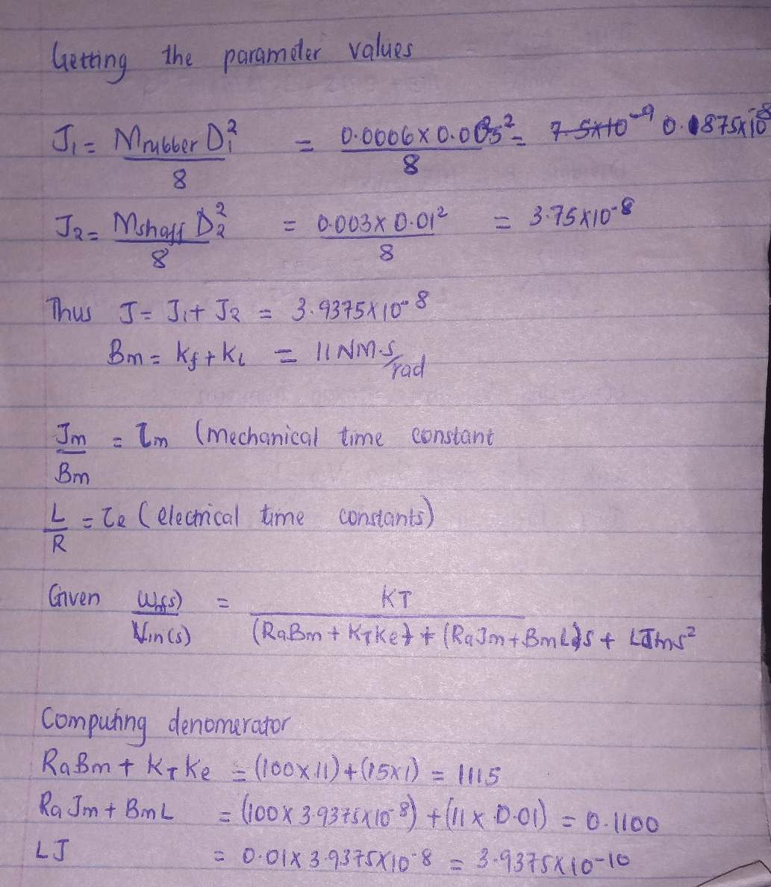
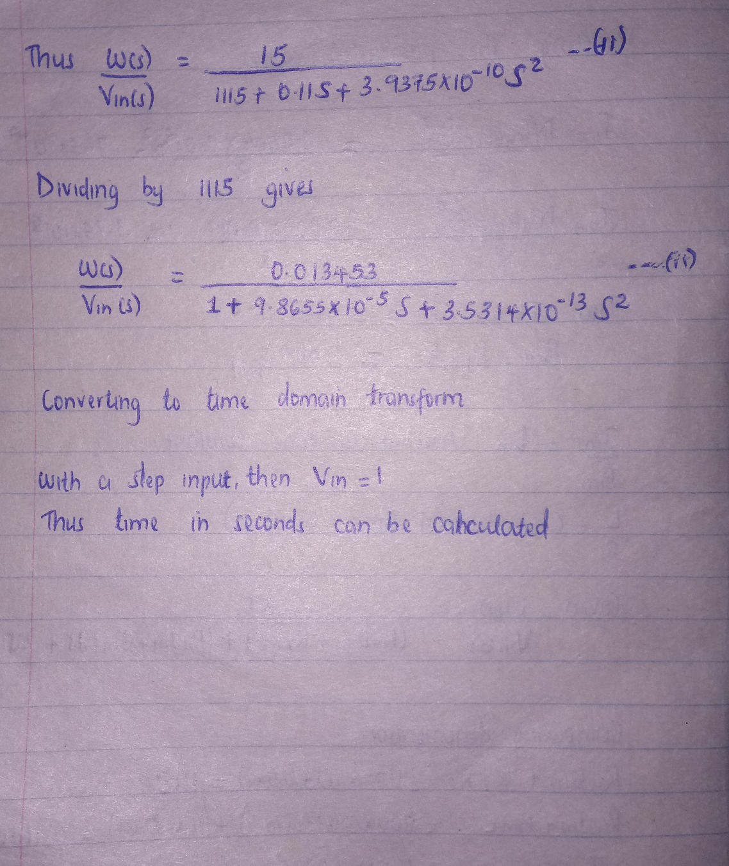

QUESTION D
