Equity Research of Adobe Inc.

Description of the company
Adobe Inc. is a worldwide software company that offers tools and solutions for individual or teams to create, design and promote their digital content. Adobe competes with Microsoft, Alphabet Inc. and many other software companies. At first, the focus of Adobe was content creating and software creativity but over the decades, Adobe started to put its full attention to digital marketing software as well. The former name of the company was Adobe Systems Incorporated and changed its name to Adobe Inc. in October 2018.
The company offers subscription-based on three different segments:
Digital Media: A subscription-based flagship product allows creators, designers, marketing agencies or publishers to have access to the latest version of its creative products. This segment offers Creative Cloud and Document Cloud and Adobe is the leader with Creative Cloud in the market by offering subscription on desktops, and mobile devices. The company is also a leader with Document Cloud in the market that offers flexibility to users. In 2020, the company announced 22% growth in the revenue from this segment.
Digital Experience: Al-driven solutions are offered for marketing, analytics, advertising and media optimization as well as covering the set of customers’ needs that make Adobe the market leader again. The company showed almost 34% growth in this segment as it’s indicated in report of 2020.
Publishing and Advertising: Products and services are provided, such as e-learning solutions, technical document publishing, web conferencing, document and forms platform, as well as publishing needs of technical and business, and original equipment manufacturers (OEMs) printing businesses.

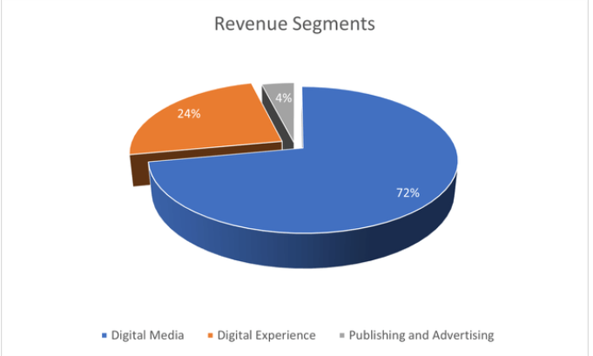
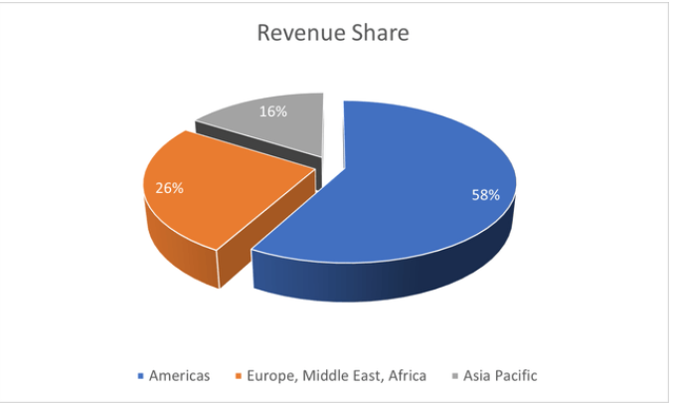

The graphs above show the revenue distribution of Adobe segment by segment. As it announced in the first quarter of 2021, revenue of Digital Media segment was $2.86 billion that shows nearly 32% year-over-year growth, in addition Annualized Recurring Revenue also known as ARR of Digital Media reached $435 million quarter over quarter. Revenue of Document Cloud also showing an upward trend by reaching $480 million with the increase of 37 percent year-over-year growth. Besides, Creative revenue also increased 31 percent and reached $2.86 billion.
Over the last quarter, Digital Experience segment also showed an increase by 24 percent and peaked its revenue $934 million; Subscription of Digital Experience revenue gained $812 million.
GAAP operating income as it is announced in the same report of first quarter was $1.45 billion with net income of $1.26 billion; non-GAAP operating income was $1.38 billion and had $1.52 billion of net income.
Adobe also announced to repurchased almost 1.9 million shares during the first half of the year. CEO of the Adobe Inc. Shantanu Narayen explained that ‘Adobe drove record Q1 revenue and we are raising our annual targets based on the tremendous opportunity across our business and our continued confidence in our global execution. Adobe’s Creative Cloud, Document Cloud, and Experience Cloud have become mission critical to all customer segments, from students to individuals to large enterprises, across the whole world’
John Murphy, vice president and CFO of Adobe made a statement about the performance of the company ‘Our execution in the first quarter was strong, driving accelerated revenue growth and earnings. Adobe is unique in its ability to drive both top-line and bottom-line growth with strong cash flows and margins’
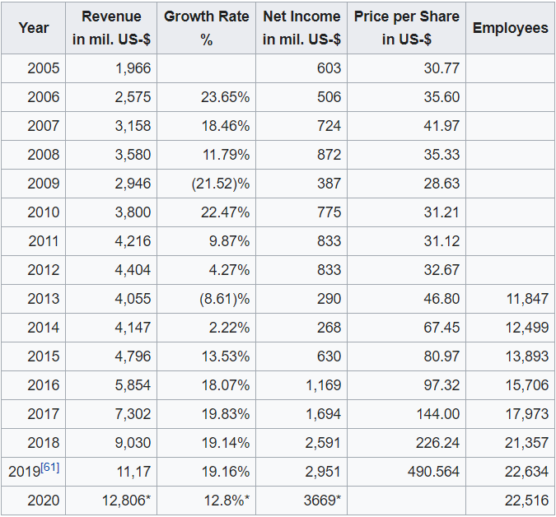

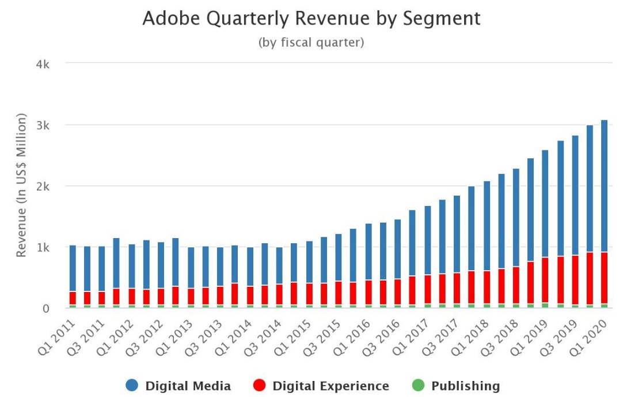

The graph below shows the subscription revenue of Adobe by segment from Q1 2011 to Q1 2020.

Adobe was established in December 1982 by John Warnock and Charles Geschke, few years after Adobe entered the software market by presenting Illustrator and a vector-based drawing program. It is reported, in 1982 Steve Jobs wanted to buy the company for $5 million but he was refused by the cofounders, but later they agreed to sell him 19% of the shares of the company. The purchased made Adobe the first company in Silicon Valley to become profitable in its first year.
In August 1986 Adobe entered the NASDAQ Composite Index
They released digital fonts after the Adobe’s first products PostScript which was the first international standard for computer printing. In 1989, flagship product, known as graphics editing program was introduced with Photoshop 1.0 which resulted the dominance of Adobe in the market. 4 years after that, Adobe introduced PDF with its Adobe Acrobat and Reader software. As it reported in 2019, Adobe has more than 21,000 employees.

Management Team
Shantanu Narayen: Shantanu Narayen is the chairman, and president of Adobe. He joined Adobe in 1998 as vice president and was responsible for the technology management; in 20007 he became CEO, and in 2017 he also received chairman of the board status. Before joining Adobe, he worked as a product developer at Apple, Shantanu is also currently vice chairman of the US-India Strategic Partnership Forum. Shantanu’s strategic moves helped Adobe to became a software leader in the industry by creating standard for digital documents and offering the best experiences to users while maximizing the productivity. As the records show Adobe’s total revenue and industry recognition has drastically level up under the leadership of Shantanu Narayen.

Scott Belsky: Scott Belsky is the chief product officer and executive vice president of Adobe. He joined Adobe in December 2017 and before he was a venture investor at Benchmark in San Francisco. His main focus is to increase the creativity of Creative Cloud platform and offering the best design. He has been an advisor on design and management for many leading companies such as Adidas, Pentagram, Pinterest and more. He was in the list of 100 Most Creative People in Business in 2010.

Anil Chakravarthy: Anil Chakravarthy is the executive vice president and general manager of Adobe, also responsible for the worldwide field operations of the company. He joined Adobe in 2020 and before he worked at Informatica as chief executive officer from 2016 to 2019, with this experiences of product innovation and industry he brings expert solutions for data, customer satisfaction, management and advertising.

Gloria Chen: Gloria Chen is the chief people officer and executive vice president. She leads strategy, operation and talent teams, including human resources functions across 75 locations around the globe. She is working in Adobe over 20 years, and played a vital role during the tough times for the company. She started her career as a software engineer and before Adobe worked at McKinsey & Company as an engagement manager.

Ann Lewnes: Chief marketing officer and executive vice president. Ann Lewnes was working at Adobe CMO for over a decade and she played an important to role in the digital transformation or marketing and design. Before joining Adobe, Ann Lewnes worked for building the Intel inside brand as VP of Marketing. She is named one of the world’s most influential CMOs by Forbes. She received the New York Women in Communication’s Matrix Award in 2020.

Why Adobe is a good investment option
- Adobe Inc. (NASDAQ: ADBE) is one of the leading software companies in the world and already became a standard for image, film editing, or designing. It allows customers to modify their digital documents from multiple devices, as well as storing and electronic signatures.

- Adobe products are designed to be suitable for marketing, commercial activities which offers people to have unique experiences.

- Years of experiences show, Adobe turns its direction to boost productivity and efficiency as much as possible. Adobe helps users to save time while creating, signing or sharing digital documents with Document Cloud.

- Based on the growth in revenue of Adobe over the years, CEO Shantanu Narayen indicated the strong momentum of Adobe Acrobat and Adobe Sing both in desktop and mobile applications. In addition, Adobe announced that value of this segment will reach $2 billion by 2023.

- Experience Cloud is suitable software for marketing and analytics by using Al technology and it is already proved that Adobe is taking the leadership in this area with the segment. Revenue of Experience Cloud reached $934 million in the first quarter of the year which shows 24% growth from the last year. Estimated revenue for this segment by 2023 is $85 billion.

- Adobe’s share price reached $485 now from $175 at the end of December 2017, and gained 55% since year of 2017 compared to the S&P 500. The focus on digitization and cloud technology helped Adobe over the past years as in growth in revenue, market shares, stable momentum and more.

- Adobe Inc. has better profitability which is almost 84.21% than the companies in the application software industry.

- Adobe also has a better record of net margin than almost the all of the companies in the software market.

- Cash Flow growth is essential for any business, growth in cash helps companies to improve and extend their business without a need of any external fund. As the records show, year-over-year cash flow growth of the Adobe is around 23.7% which means way higher than many of its peer in the software industry, yet the rate for the industry is 5.3%. Adobe shows great improvement cash flow growth improvement over the 5 years, growth has been recorded 35.5% while the industry stuck average of 9.1% growth rate.

- Records also show there is upward revisions in earnings estimate for Adobe Inc.; in fact, estimate for the current year is recorded 5.9%.

- Furthermore, when evaluating the worth of companies/stocks, there are factors to consider, such as economic mode, ROIC, debt, growth numbers as in sales, earning per share, equity and cash flow. Based on these criteria, followings show:

  - Adobe revenue has increased 37% from 2020 and reached $480 in the first quarter of 2021.
  - Adobe has profit margin of 40.68% and outperformers its industry peers.
  - Return on Equity of Adobe is 41.09% which is impressive since the industry average return on equity is 13.47%.
  - Return on Assets equals 24.88% while the industry average is -2.79%.
  - In the end of the December 2017, the stock price of ADBE was $174 which grew to $491 in 2021; indicates over 16% potential grow.
  - The estimations show Adobe will have a total addressable market of $147B by 2023 from an estimated TAM of $118B in 2022.

- Usage of Adobe products by the companies has been drastically increased over the years as the shown below:
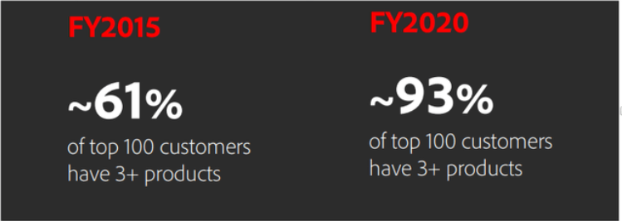

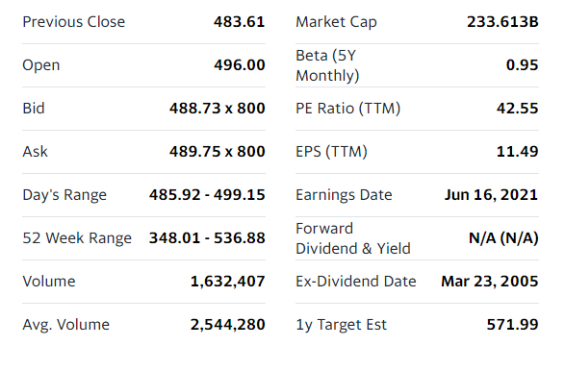
- Highlighted information from the financial data of Adobe:
Price Chart of the Adobe over the 5 years:

About the price chart of Adobe, Rob Lauzon who is the managing director of Middlefield Capital says ‘Adobe has had a good run over the last couple of years and many of these stocks are settling back here so you might get a chance to buy it on a pretty good pullback, near term, and I would have a five-year outlook and I think you’ll be pretty happy with a pretty solid investment on the technology side.’
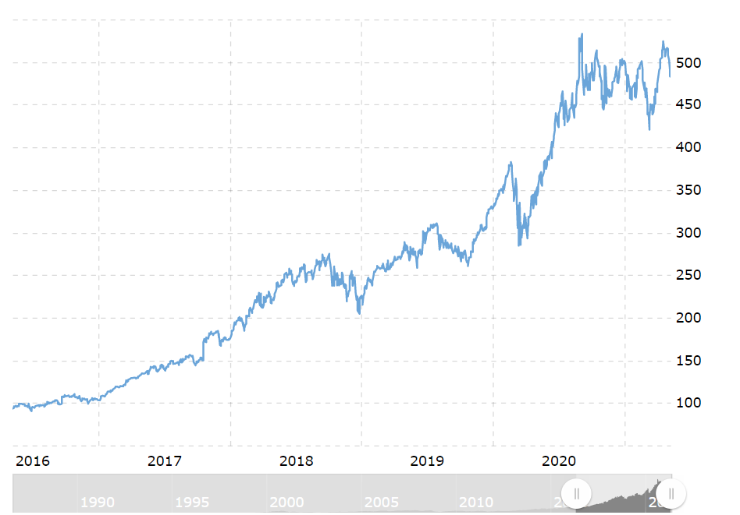
In May 11, 2020 the current price of Adobe stock is $483.740, and as the chart below shows there is an uptrend for stock price for at least past 1 year. Since there is an uptrend tendency of Adobe stock price, it’s likely that market segments were also popular given the period of time. Analysts strongly believe that future stock price will be around $650.00 with a high estimate, and with a low estimate of $511.00 which shows 19.99% growth from the last price, after a year. Since April, there is a buy trend among the investors and has not changed yet.

Market Cap Chart for 5 years:

Market value is an important tool to determine the worth or value of the asset and a measurement of the company size. Adobe market cap is $233.61B for May 7 2021. The annual market of Adobe has been increasing since November 2018 which was $122,350 Mil to $149,298 Mil in November 2019 and to $229,187 Mil in November 2020. The market cap of Adobe $233.61B shows its current price of 488.73 multiplied by its share number which is 478, and as a large cap company, shareholders of Adobe are exposed to really little amount of risk.
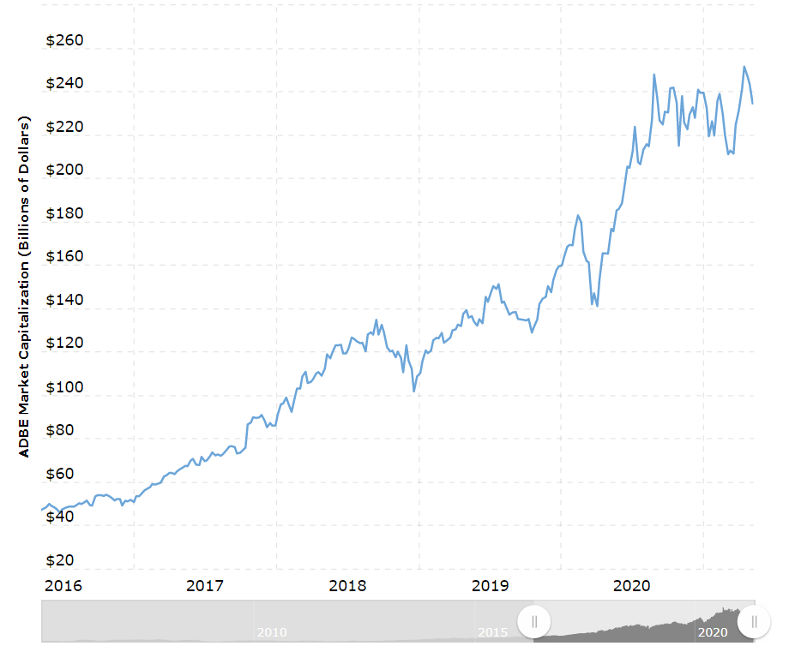

Current and historical return on equity (ROE) of Adobe: ROE shows the total income returned as a percentage to shareholders’ equity which measures how much profit the company makes with the money that shareholders invested. It is an important tool to prove shareholders that company is profitable and investors should buy their stocks. Mathematically it is calculated as Net Income or Profit/Shareholder’s Equity.
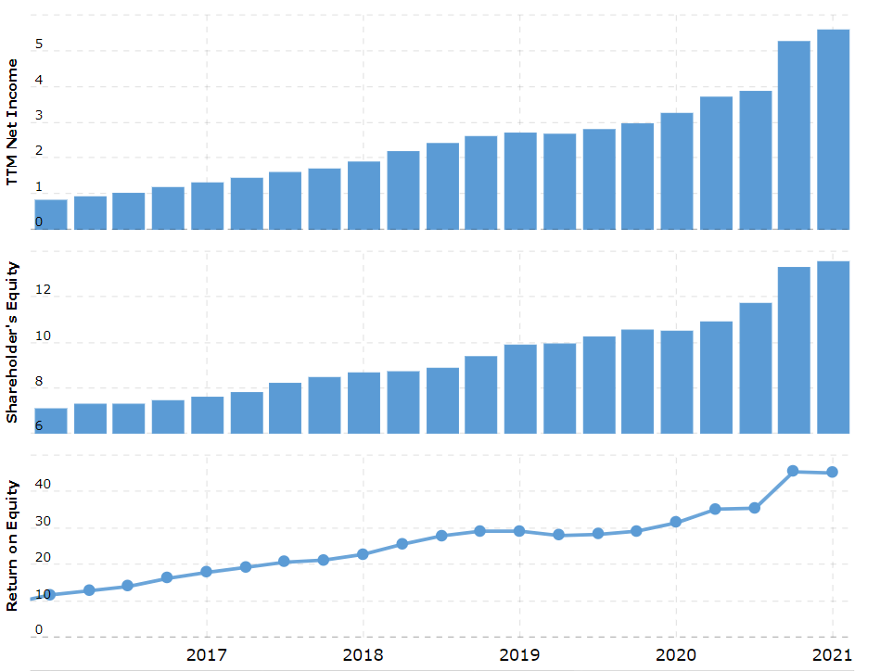
Adobe Inc. had a return of 47.58% on shareholder’s equity in the first quarter of year. Return on equity reports shows Adobe has better profile than 72.73% of the companies in the application software industry which shows it makes good use of its equity and improving the profits.

Return on assets(ROA) data of Adobe: Return on assets measures how profitable the company is and the profits made for each dollar invested in assets; it shows how company uses the total assets to operate profits. It is a helpful tool to evaluate the company’s performance over the years, if ROA increases, it shows that company is squeezing more profits. Mathematically, return on assets is calculated as (Net Profit/Total Assets) * 100.
Adobe Inc. improved ROA compare to the previous quarter and reached 24.88% in the first quarter of 2021. Adobe again leads in the market with having almost 100% better return on assets profile.
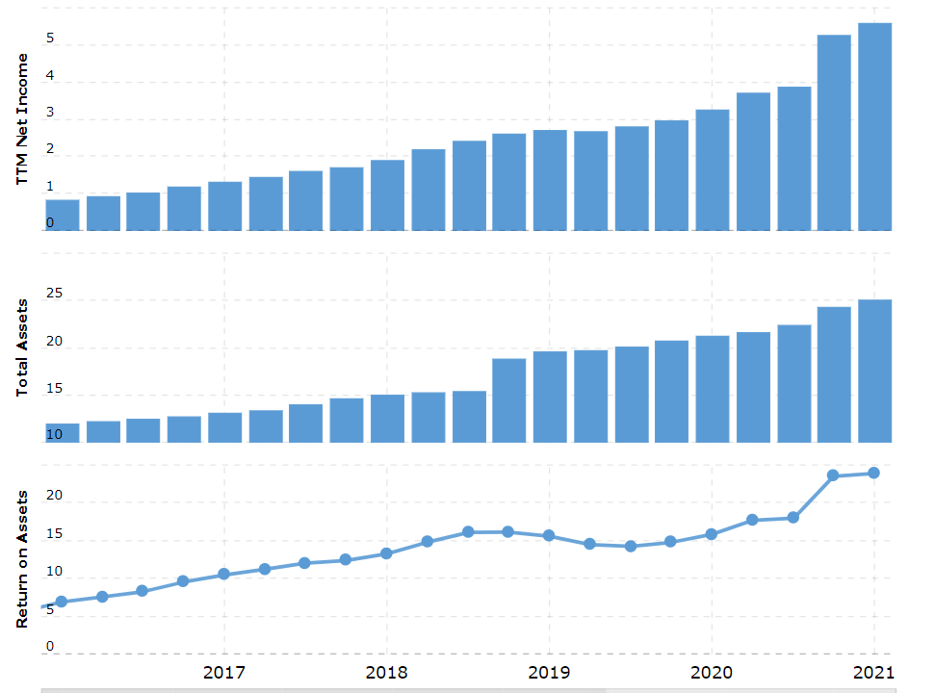

Top Shareholders
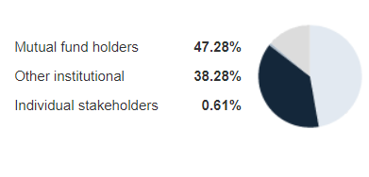

As it’s seen in the figure above, institutional investors have the majority of ADBE stocks. Generally speaking, stocks that have many institutional ownerships seem to be approving and have a good reputation. However, there are consequences of always depending on the reputations of institutional ownership; such as bad business decision might cause a sudden drop in stock price, or on the contrary, influencing other investors or institutions to invest in the particular stock. Institutions have more than half of the company and therefore they operate the power.
The Vanguard Group is the current largest shareholder of the company with 7.54%, Fidelity and BlackRock follow with 5.33% and 5.26% shares and are the second and third largest shareholders. The other insight is hedge funds don’t have a significant in Adobe. The ownership data also shows that 25 top shareholders have less than 50% which means individual investors do not have a majority interest.
Institutional Ownership History of Adobe
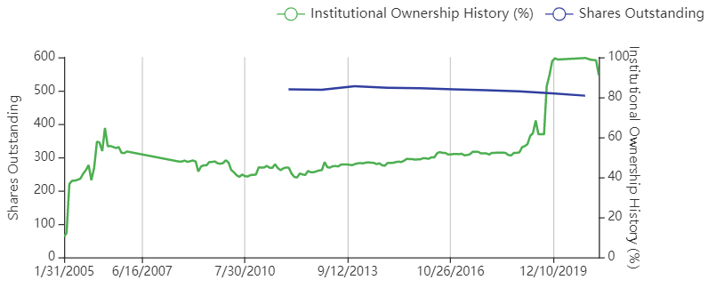

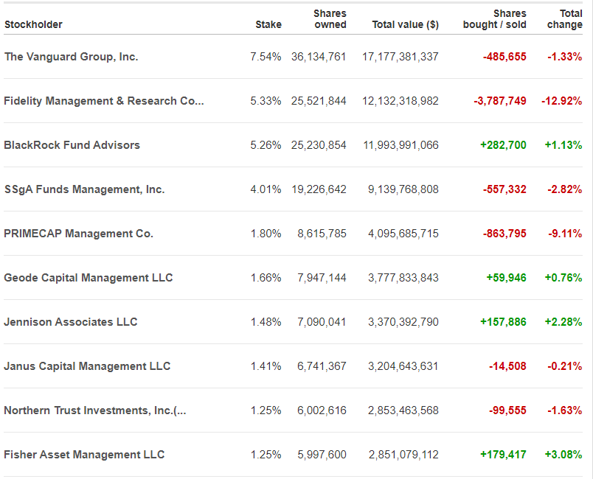
Top 10 owners of Adobe:

Comparable Companies Analysis

 | Adobe Inc.  (ADBE) | Apple Inc.  (AAPL) | Microsoft Corporation  (MSFT) | Dell Technologies Inc. (DELL) | HP Inc.  (HPQ) | Ansys Inc.  (ANSS) | Autodesk Inc.  (ADSK) | Oracle Corporation  (ORCL)
Share Price | $485.08 | $128.42 | $250.88 | $100.33 | $35.64 | $330.65 | $282.05 | $79.81
Market Cap | 233.61B | 2.15T | 1.89T | 76.32B | 44.28B | 28.82B | 61.89B | 230.14B
EV | 233.36B | 2.22T | 1.86T | 118.16B | 47.77B | 28.91B | 63B | 266B
LTM Revenue | 13.6B | 325.41B | 159.97B | 94.22B | 57.67B | 1.74B | 3.79B | 39.69B
LTM EBITDA | 5.33B | 99.82B | 75.58B | 9.65B | 5.03B | 610.11M | 742M | 17.65B
P/E Ratio | 42.41 | 28.91 | 32.90 | 23.66 | 14.99 | 66.34 | 51.57 | 19.02
P/BV | 17.20 | 30.98 | 13.02 | 22.14 | - | 7.69 | 63.10 | 13.66
Total Debt/EBITDA | 0.71 | 1.48 | 1.12 | 4.00 | 1.34 | 1.13 | 2.15 | 4.17
EV/EBITDA | 46.03 | 26.05 | 22.98 | 7.87 | 1.34 | 52.06 | 80.46 | 12.01
Profit Margin | 40.68% | 23.45% | 35.02% | 3.45% | 5.61% | 26.46% | 31.87% | 32.32%
Net Income | 12.83B | 76.31B | 56.01B | 3.25B | 3.23B | 460.22M | 1.21B | 12.83B

The table above shows the comparison of Adobe with its few peers. Generally, Price to Earnings is one of the keys to determining the value of the stock; it is used for comparing the market value of a company with its earnings. Price to Earning of Adobe is significantly higher compared to its competitors, as well as above the market of its sector.
Adobe Inc. reached an Operating Margin of 37.23% in the first quarter of 2021 with the help of an increase in demand and cost control. Net Profit Margin shows, Adobe Inc. is playing the leadership in Software-Programming industry, and ranking 11. in the technology sector as it is recorded in the quarter of 2021.
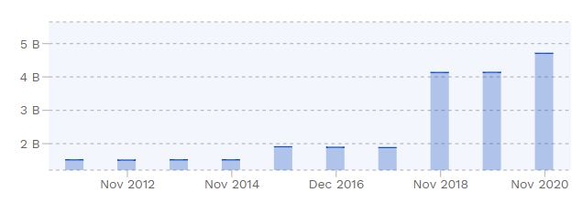
Debt Structure
As recorded in November 2020, the total debt of Adobe is $4.12 billion; between December 2016 to 2020, the total debt was nearly $3.351 billion. Considering the last 5 years, Adobe’s total debt peaked at $4.708 billion in November 2020.
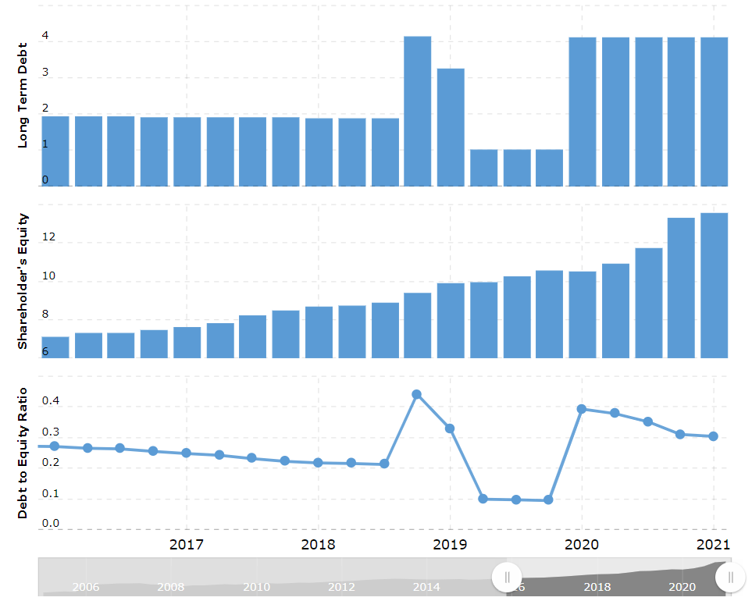
In 2020, 2019 and 2018 the debt increased as in 13.8%, 4.138% and 4.135%. The record shows in 2016 and 2017 there was a decrease in total debt.

Debt is a real problem if the company cannot pay it off and spend more than what it earns. In case of this situation, the company cannot cover its legal obligation and ultimately, the shareholders could leave without having any benefits. Adobe Inc. has liabilities of $5.51B in 12 months. As Adobe Inc. announced to have $4.12B of debt which is almost same as the year before, considering the size of Adobe it is easily understood that liquid assets are well-balanced with its total liabilities. In addition to that, Adobe has more cash than its debt and has been grew its EBIT almost 30 percent over the year and seems confident to handle the situation. Hence, it is okay to say, with considering the healthy profile of the company, that Adobe is using its debt safely and able to offers advantages to shareholders.
Shareholders tend to look at the debt ratio of the companies to understand their leverage. A higher debt ratio usually means that the company is in a high-risk area and likely to hurt its profit, but debt ratios vary across different industries and considering risky debt ratios depend on the industry. On February 28, 2021, the debt/equity report for the Adobe was 0.30.

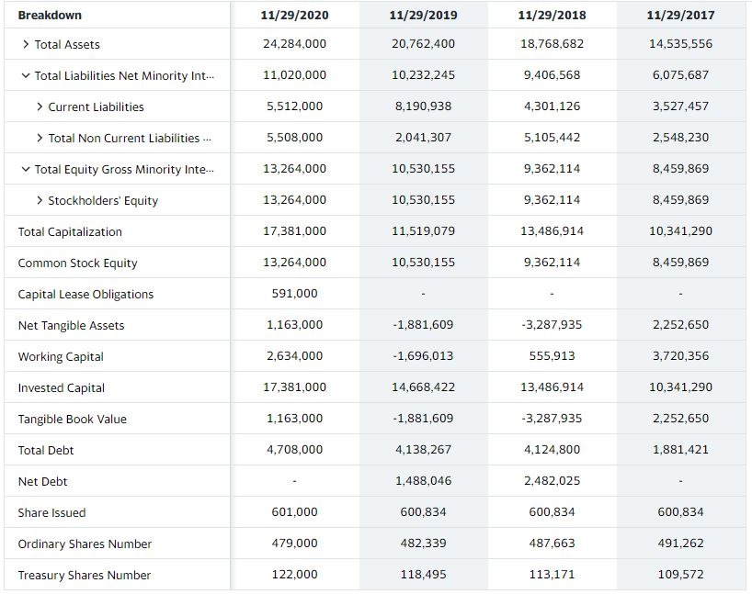
Balance Sheet

Cash Flow Statement
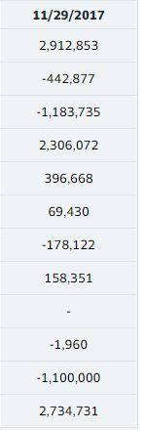
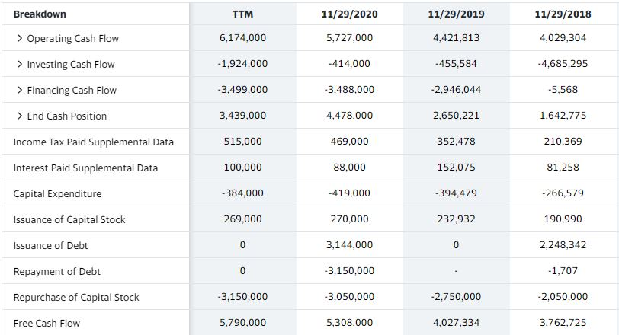

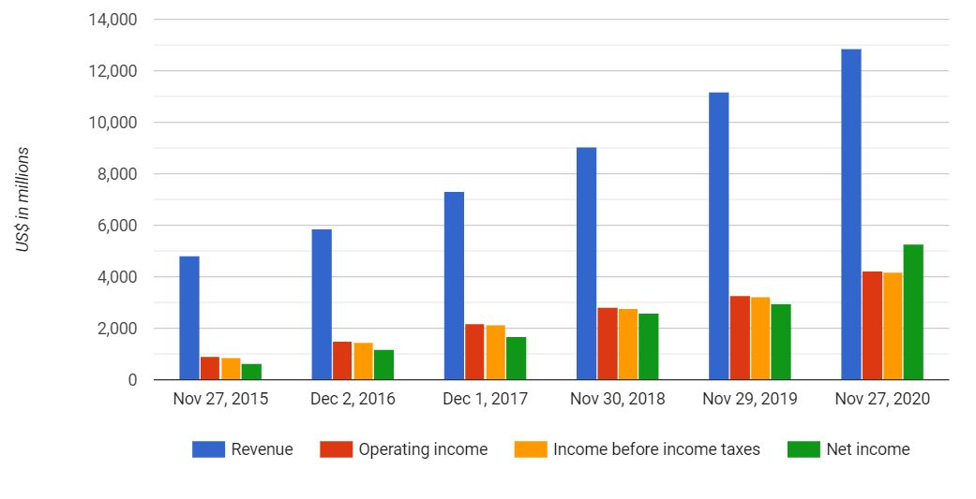
Income Statement

Income statement is a report of 3 months or 12 months that shows how much revenue the company collected how much it went for the expenses and as well as how much was left to claim as a profit over the given time frame. Net income also known as bottom line shows the total profit or loss to shareholders.

Recently, adobe made an announcement of the estimated report earnings for Jun 10 2021. The estimated earnings date is extracted from the company’s historical reporting dates by using algorithms.
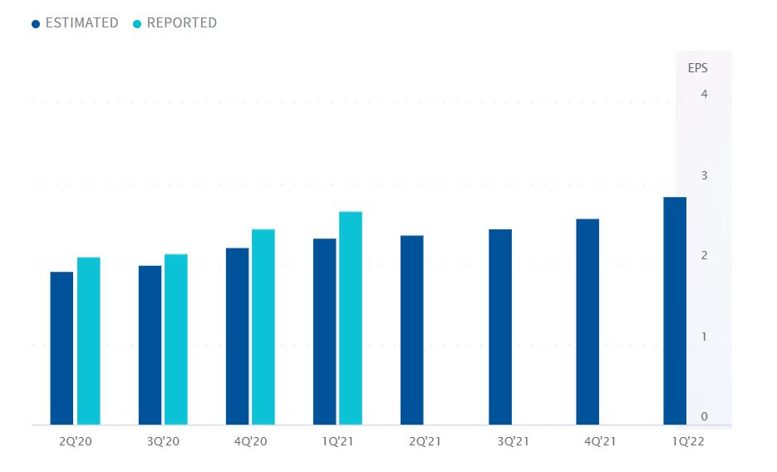
Estimation shows the EPS forecast is 2.35 and it was reported last year as $2.08, but certain analyzes can be done when Adobe announces its earnings date.

