 | Scene/ Image | Script
1 | 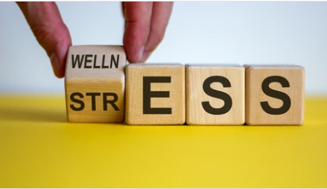  Title Screen: Stress among Grossmont College Students | music
2 |   Image meant to raise the attention | Stress is the leading cause of school dropout; it comes from different students' factors within a student's life.
3 |   Picture illustrating poor time management | It leads to poor time management, financial problems, and poor performance for the affected students.
4 | 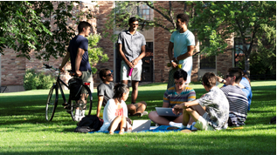  Picture representing students different lives | Different segments of students are affected differently.
5 |   Picture showing various parental responsibilities a single parents has | Single parents have to worry about the safety of their young kids when they attend classes.
6 | 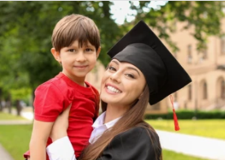  A mother after graduation holding her son representing their journey | Students who have kids have higher financial responsibilities as they are their kid's providers; switching between studying and maintaining a stable financial life can be stressful and demanding.
7 |   Students receiving advice from an expert in the field | Students holding full-time jobs face time management problems, and having a full-time job means having to create time for studies; this is a stressful situation as both options are at high stake.
8 |   Empty pockets representing the financial struggle | Students facing financial struggle are also vulnerable to developing stress-related problems; consistently worrying about finances can negatively affect a student’s performance.
9 |   Image meant to raise the attention of the audience. | The college has a qualified counselor, ready to walk with students from a stressful life to a better scheduled and managed life.
10 |   Student and councillor in a session | Affected students should pay a visit to the counselor. They will have the counselor guide them to adapt better time management strategies and train them on managing stress; career centers also provide suitable solutions for time management.
12 | 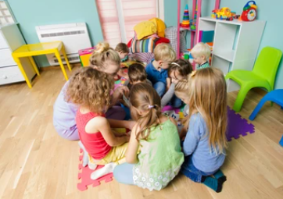  The universities daycare | Students who have a kid can make use of the college daycare for better time management and closer distances to attend to them when they have far apart classes; the college also has an EOPS office where they can access stationaries both for the kids use and their use; they also pay for books a student needs reducing their financial burden.
12 |   Images representing emotional transformation the students should gain | The video should help affected students flip their cards to better time management, better financial stability, and clear information on where to get support for students to live a stress-free life conducive to learning; education is the key to success hard but worthy struggle.
13 |   Picture showing tools that will be used in the production process | The video will be shot using a phone and canvas studio used for all editing and video production activities.

