This will be a group project. Please form a group of maximum 5 persons to complete the project assignment and choose a group name. There is no fixed format for the project report except the submission of a single PDF file as the project report for the entire group via Canvas. Only one of the group members is responsible to upload the report. You have to include the following elements in your project report:

- Your chosen group name and all group members’ info including: First Name, Last Name, Red ID # and Email.

- For each task, you have to present your findings and answers. Attach the computer screenshots of SPICE simulation, component datasheet, Digikey website in your report to prove that you have done the required simulations and component survey.

- In this project, you could earn extra credit points as elaborated in task 1 and task 6. While you may carry forward the extra credit earned in project 1 over to project 2, please note that the maximum total overall projects (project 1 + 2) scores will be capped at 250 points.

- Late submission will NOT be accepted.

- Please show a task distribution rubric of all group members in the cover page. You may nominate one Most-Valuable-team-Player (MVP) in your group. The nominated student will receive extra credit (up to (N−1)% for a N-person team).

Software Preparations:
Please refer to the LTSPICE tutorial uploaded separately on Canvas. You are expected to make use of the abundant online resources regarding LTSPICE simulation.

Project 2: Inverting amplifiers using op-amp, CS-MOSFET and CE-BJT (5+1 Tasks) You are encouraged to read Chapter 7 in the textbook before attempting this project.

Project requirements:
Power supply: 10V
Voltage gain: |40| or greater.
Input signal: 25 mV amplitude, 10 kHz sine wave with 6V DC offset.
Output load: 10 kΩ resistor
Input and output coupling capacitors: 10μF
Biasing and feedback elements: Resistors and capacitors only.
Using op amp calculations:
Gain = -50
Input resistance = 100
Feedback resistance = 5K

Using FET calculations:
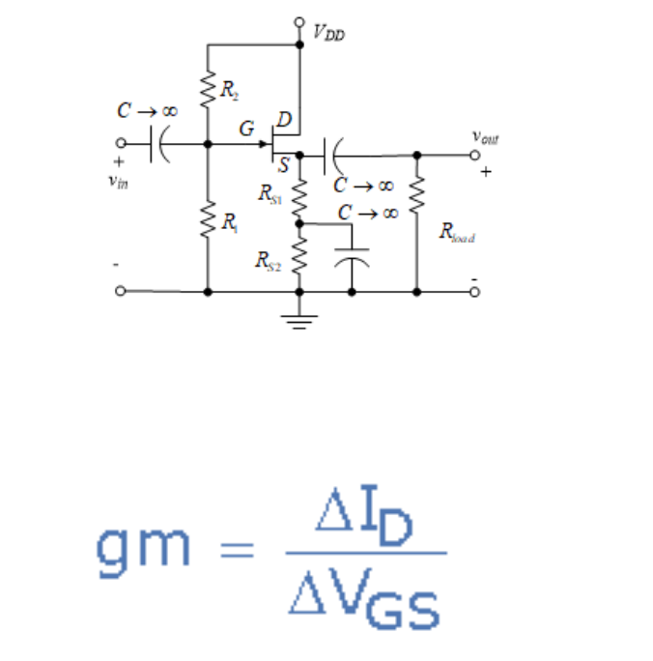
DC Biasing:
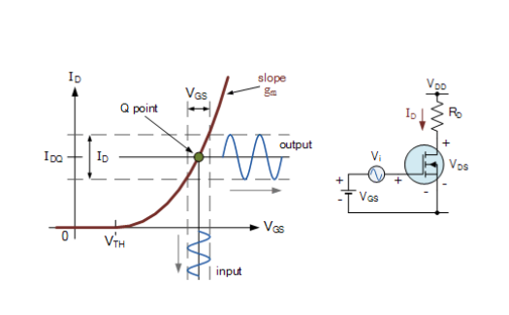

Characteristic curves
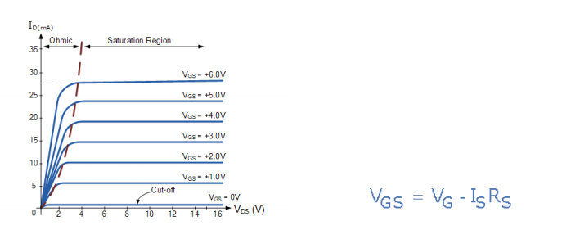
Gate biasing voltages:

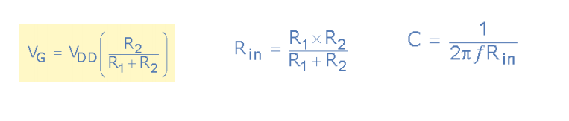
Using BJT calculations:
This is a simple design tool for calculating bias resistor values, small-signal gain and input/output resistances of a common-emitter BJT amplifier. Just fill the input fields below in given order from top to bottom. The ordering of the fields serves as a step-by-step guide for the design process. The base bias resistor values are calculated automatically (using 5% tolerance resistances), but custom values can be given and those will not be overwritten. After iterating any resistance value, always press 'Calculate results' button to update the results. The small-signal values are evaluated in the mid-band, CB (and CE) short-circuited. The small-signal gain is evaluated as VO/VS, and the input/output resistances are evaluated as shown in the pic.
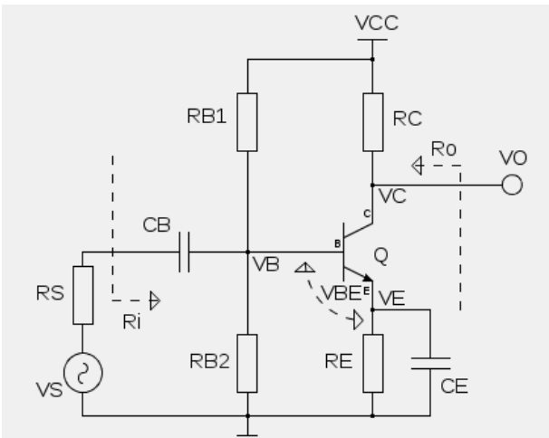

If CE bypass is not used, small-signal gain is about RC/RE.

- Choose an op amp, BJT and MOSFET available in LTSPICE which you think will fulfil all the project requirements. Explain why you think these models will meet the design requirements. State the manufacturer, key device parameters, packaging option and price per unit from the Digikey (https://www.digikey.com/) website. Include a snapshot of the datasheet front page (which shows device key specifications). Verify your device key parameters, i.e. threshold voltage of a MOSFET; H_{FE}/β for a BJT are simulated and verified via DC simulation from LTSPICE, instead of citing directly from datasheet.

We chose
Operational amplifier is ADA4522,
Mosfet is RUF025N02
BJT is 2N2222

The components stated above are what we will be using throughout the schematics to fulfil all the project requirements. We chose those specified models because they are widely available and have consistently shown impressive results in many other schematics. We are confident that these components can be designed to fulfill all of the requirements stated within the project and maintain a reasonable cost at the end.

- Design an op-amp inverting amplifier, meeting the above mentioned requirements. Kindly note that since this is a single power supply system, you will need to properly design the amplifier input and output DC bias. Show amplifier transient simulation (up to 10 ms) of input-output waveforms, peak current consumption with ideal 12V DC source. Show your hand calculation.
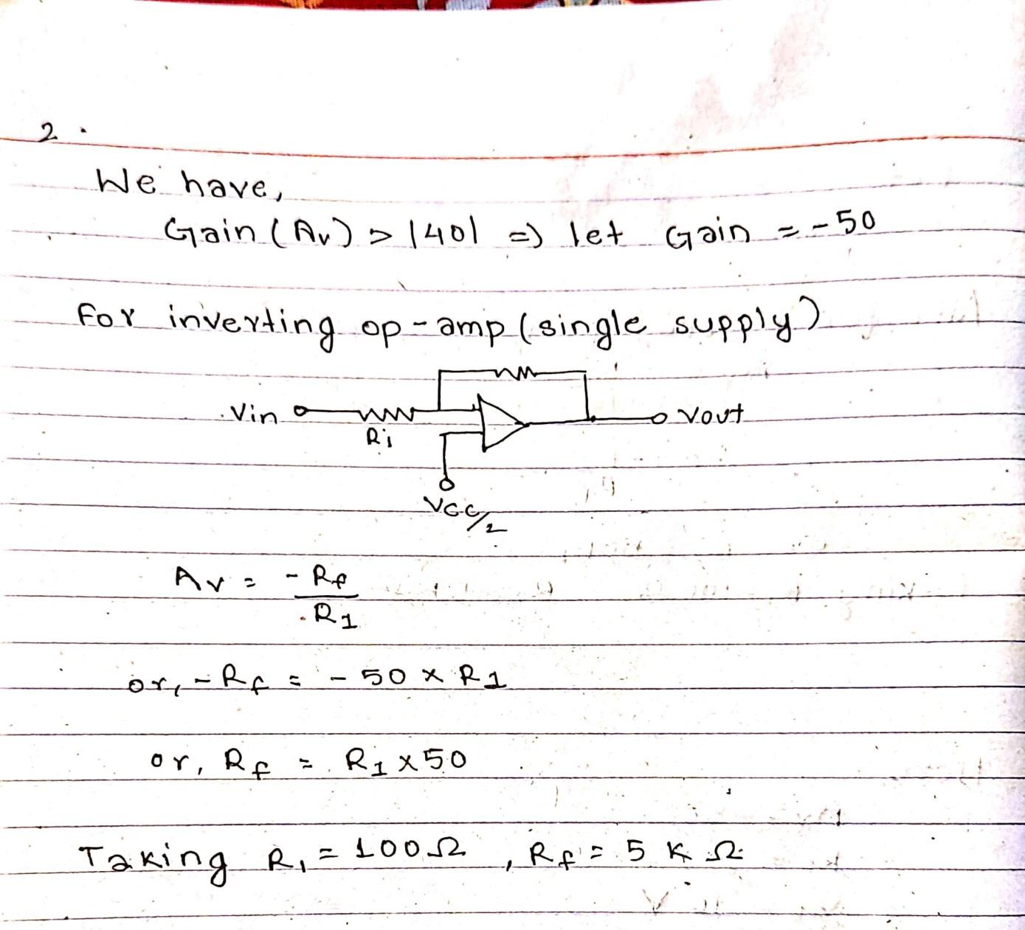
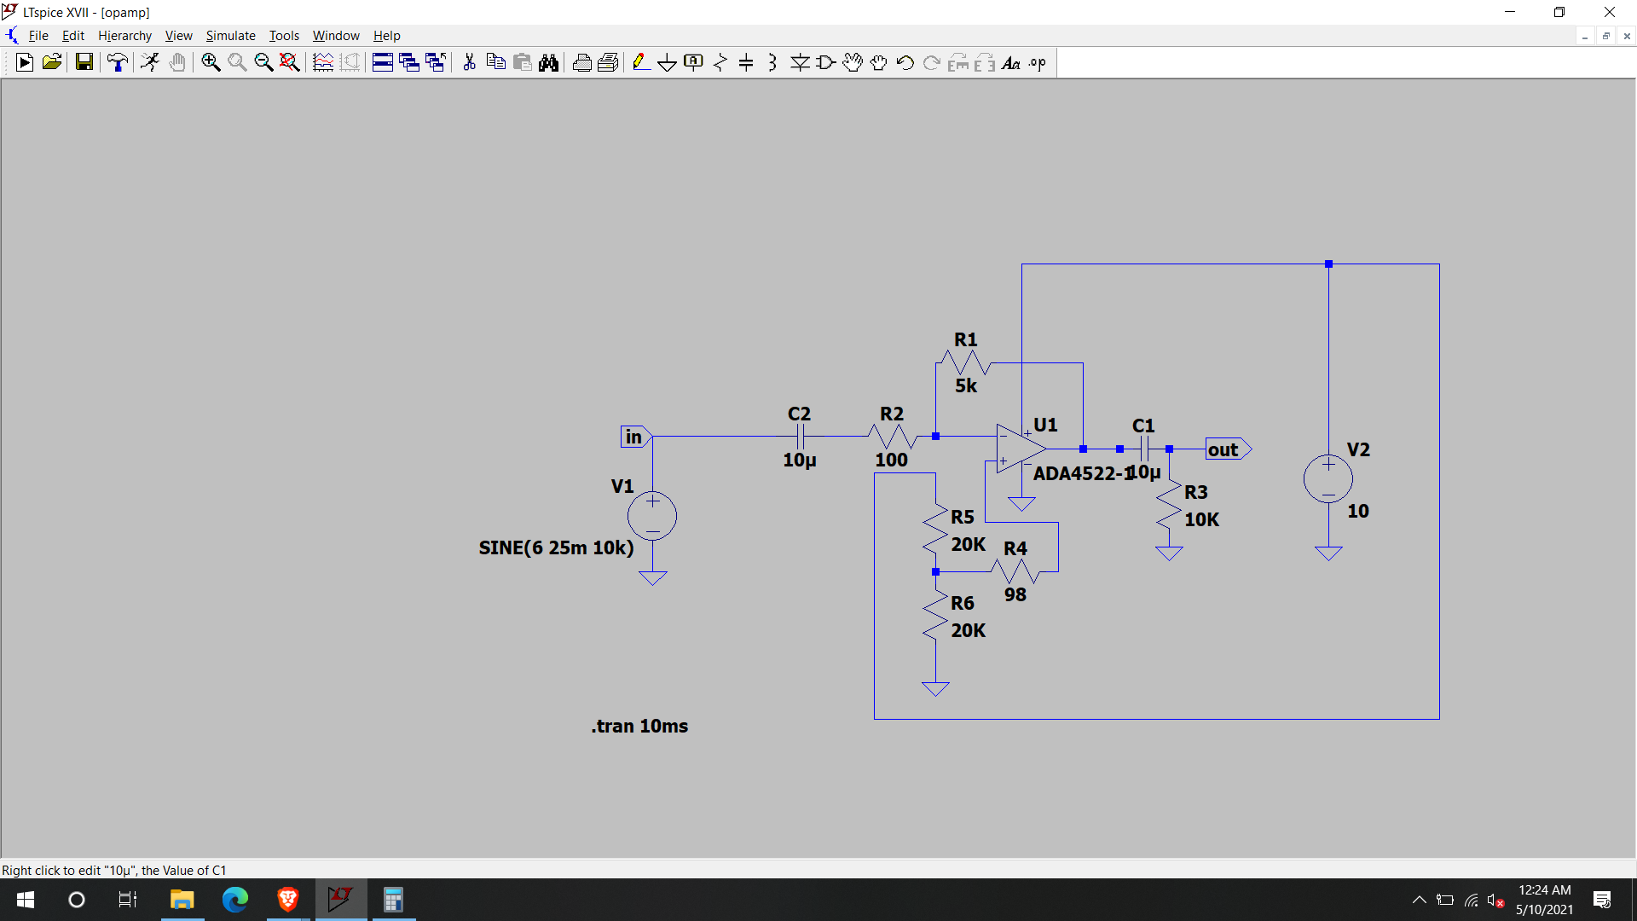
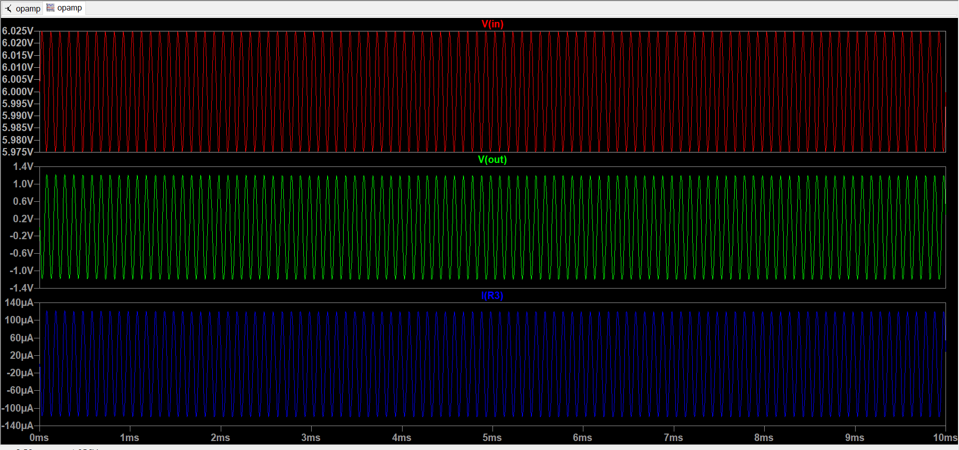
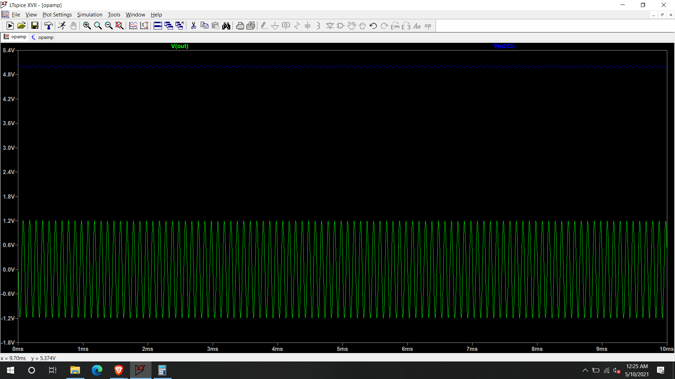
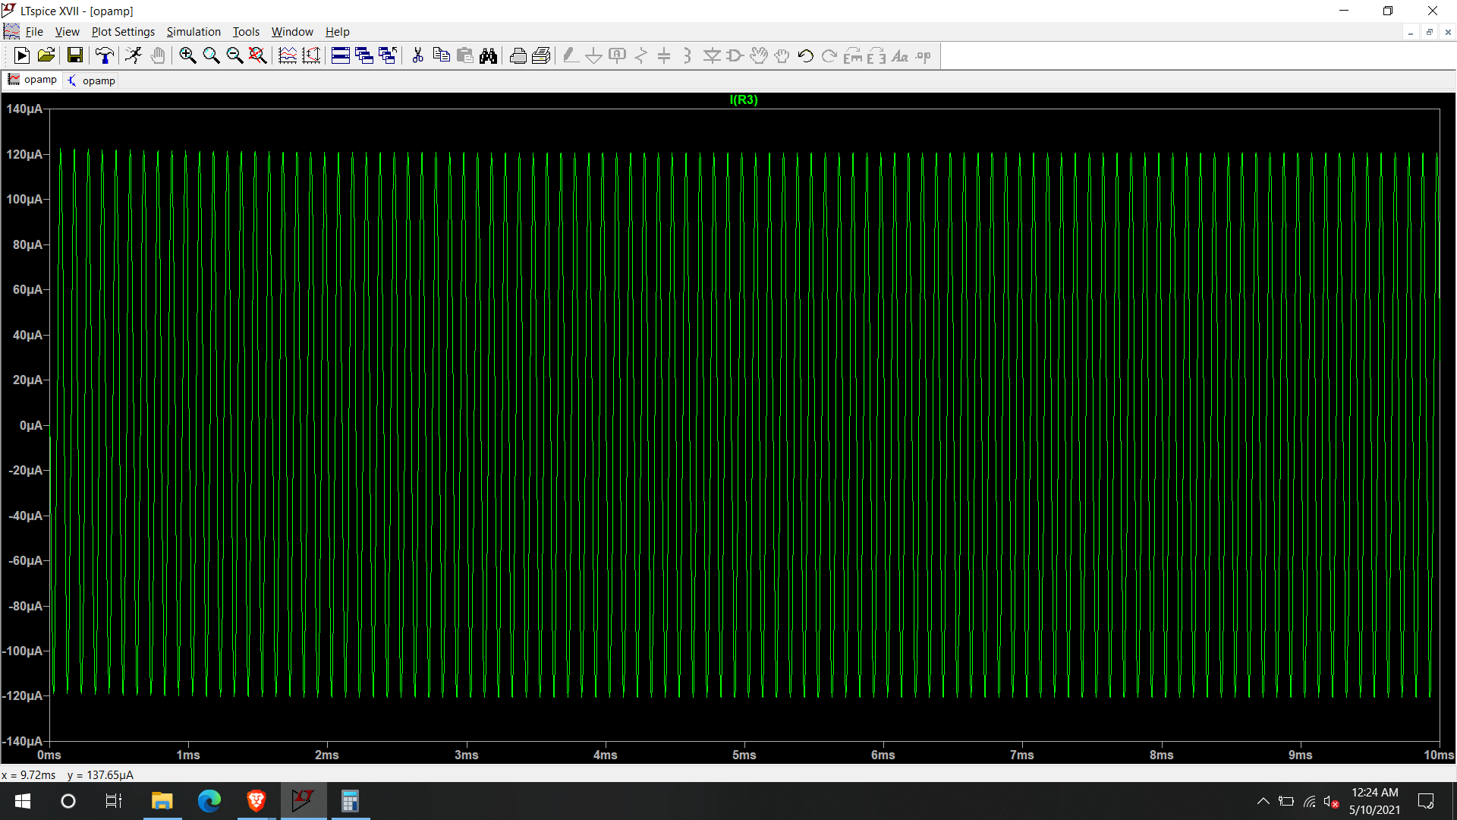

- Design a common source MOSFET amplifier, meeting the above mentioned requirements. Kindly note that since this is a single power supply system, you will need to properly choose the amplifier DC input and output bias. Please note that while you can only use one transistor, but you may use source degeneration, capacitor by-pass technique to improve your amplifier performance. Show amplifier transient simulation (up to 10 ms) of input-output waveforms, peak current consumption with ideal 10V DC source. Show your hand calculation.

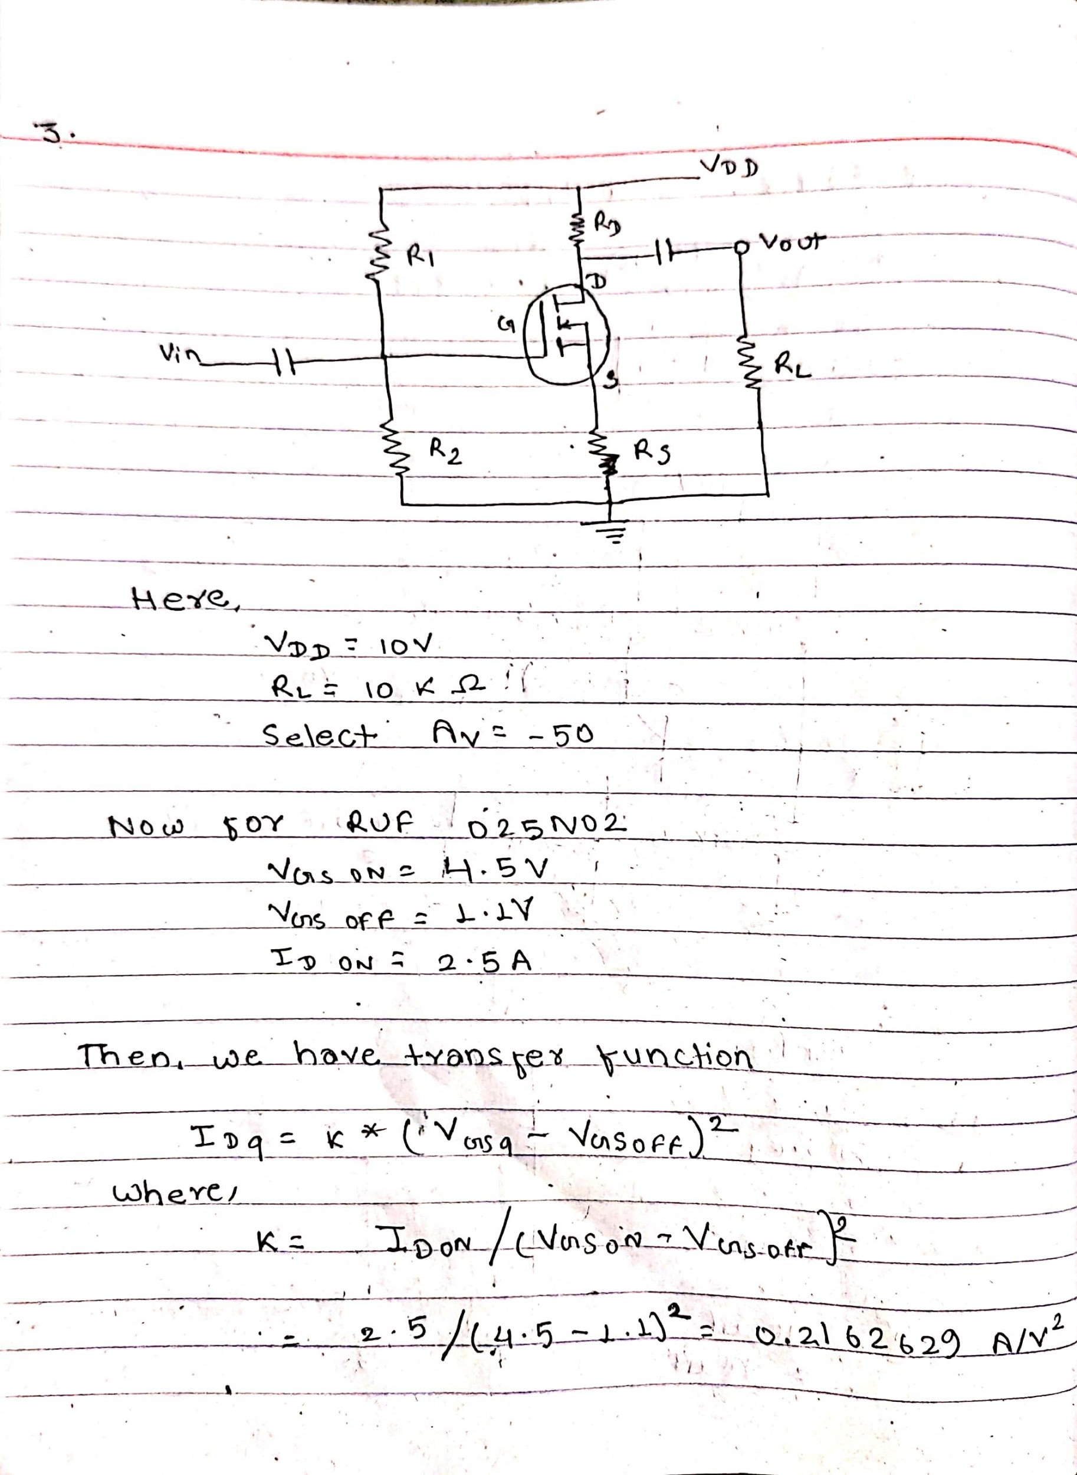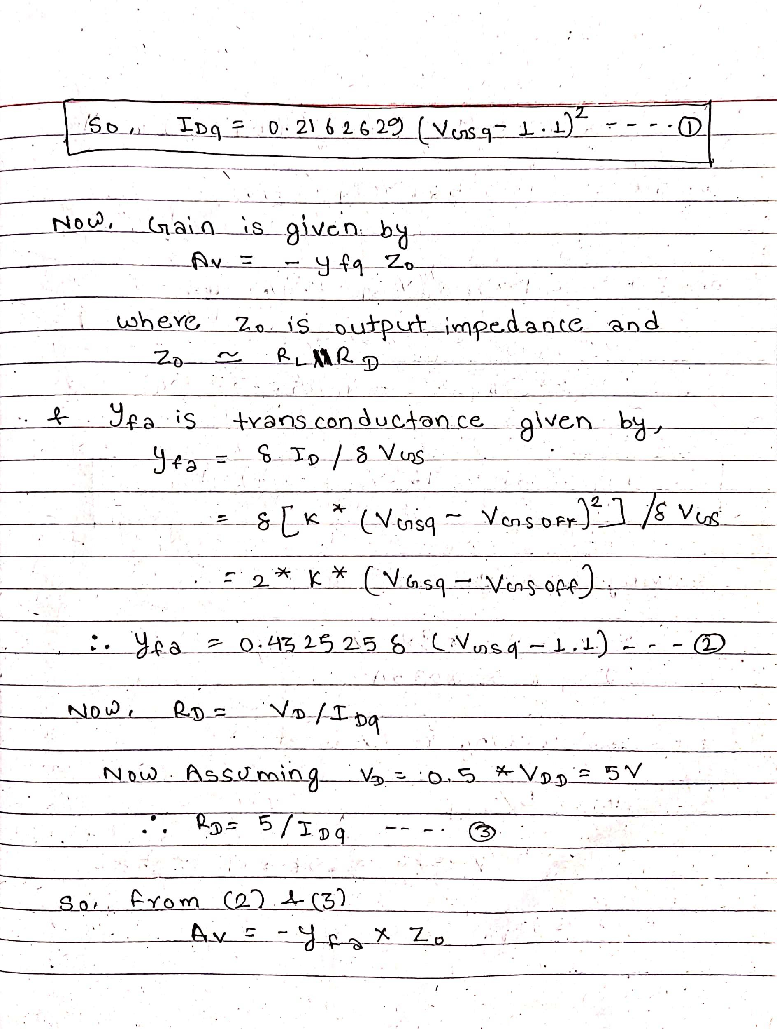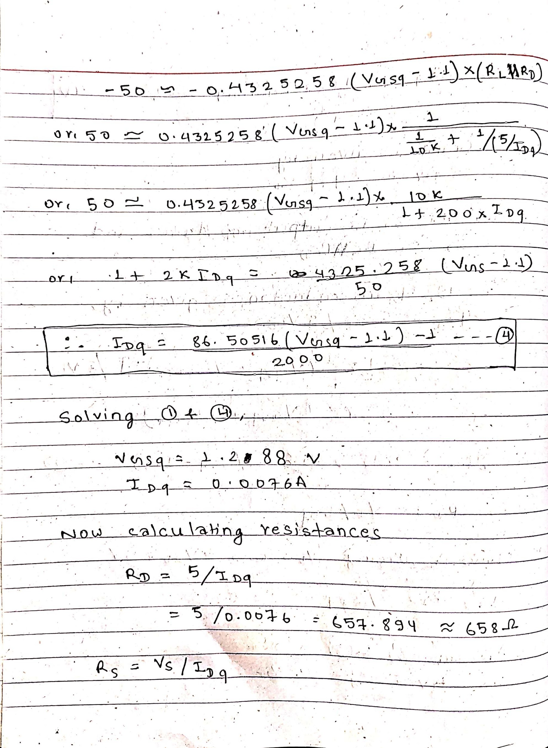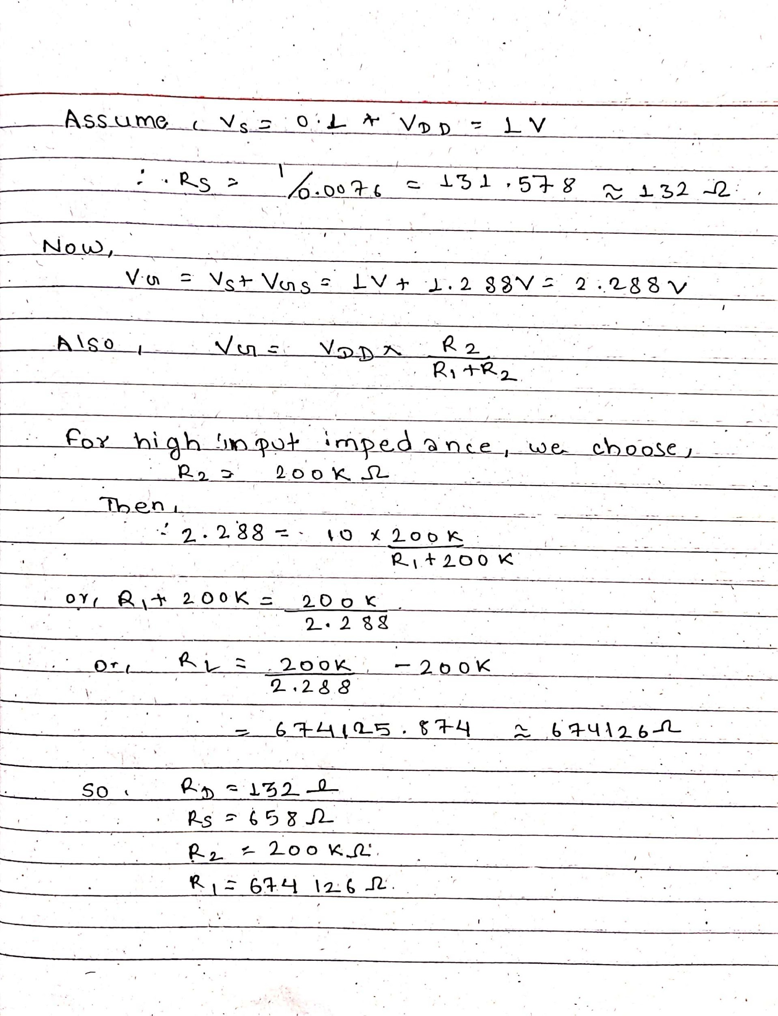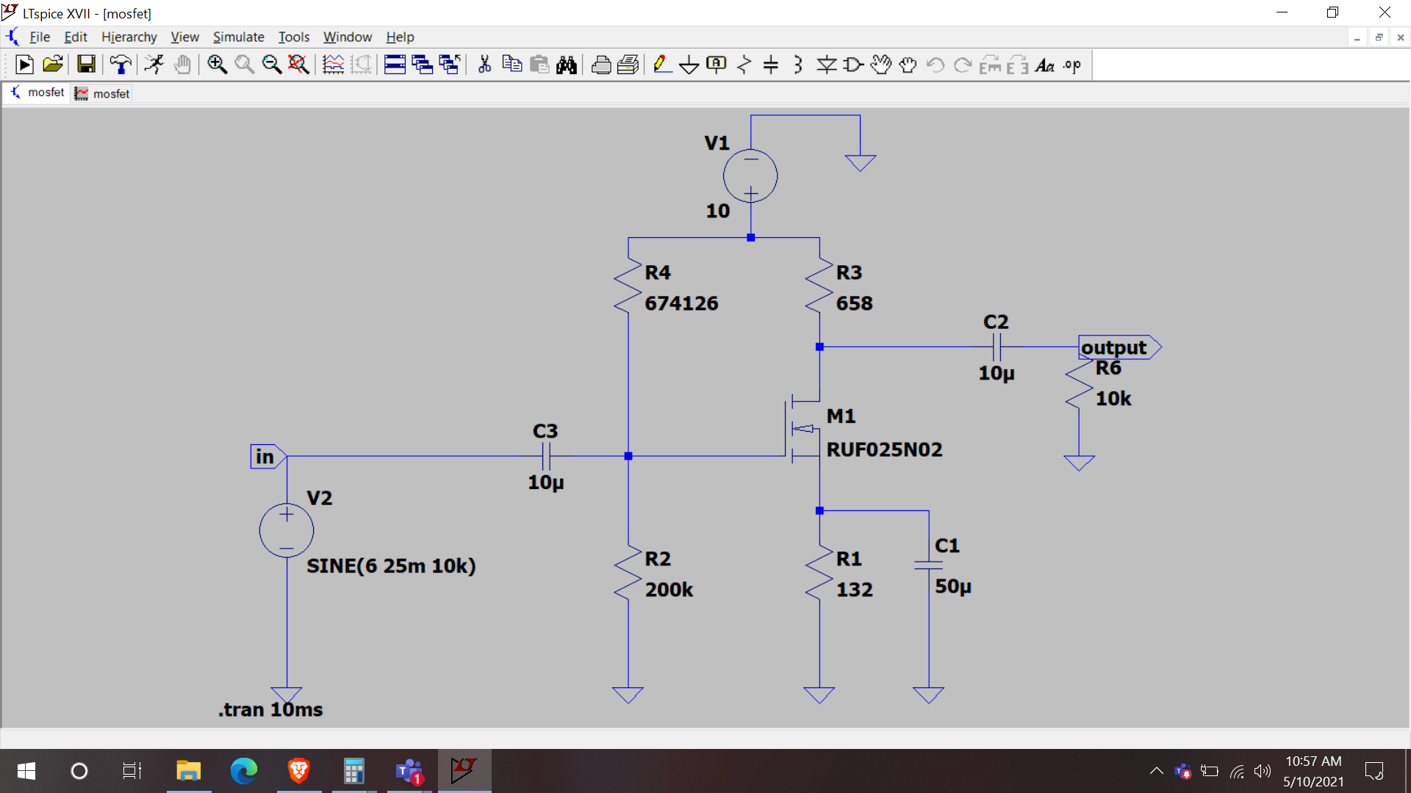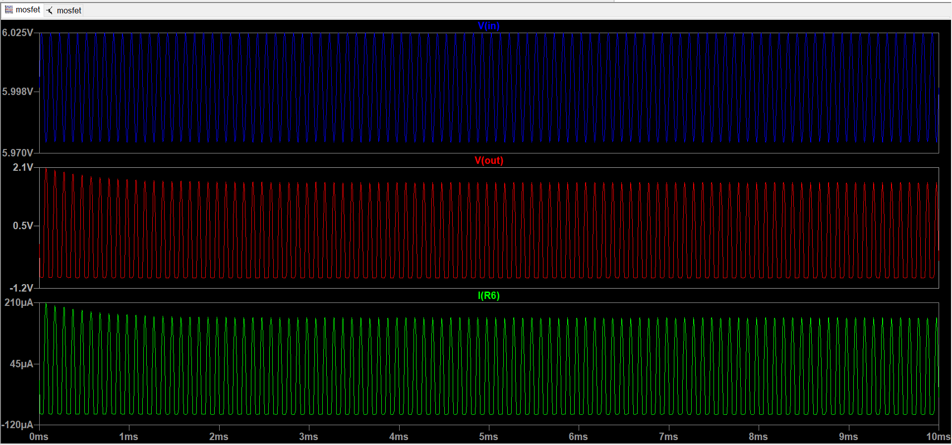
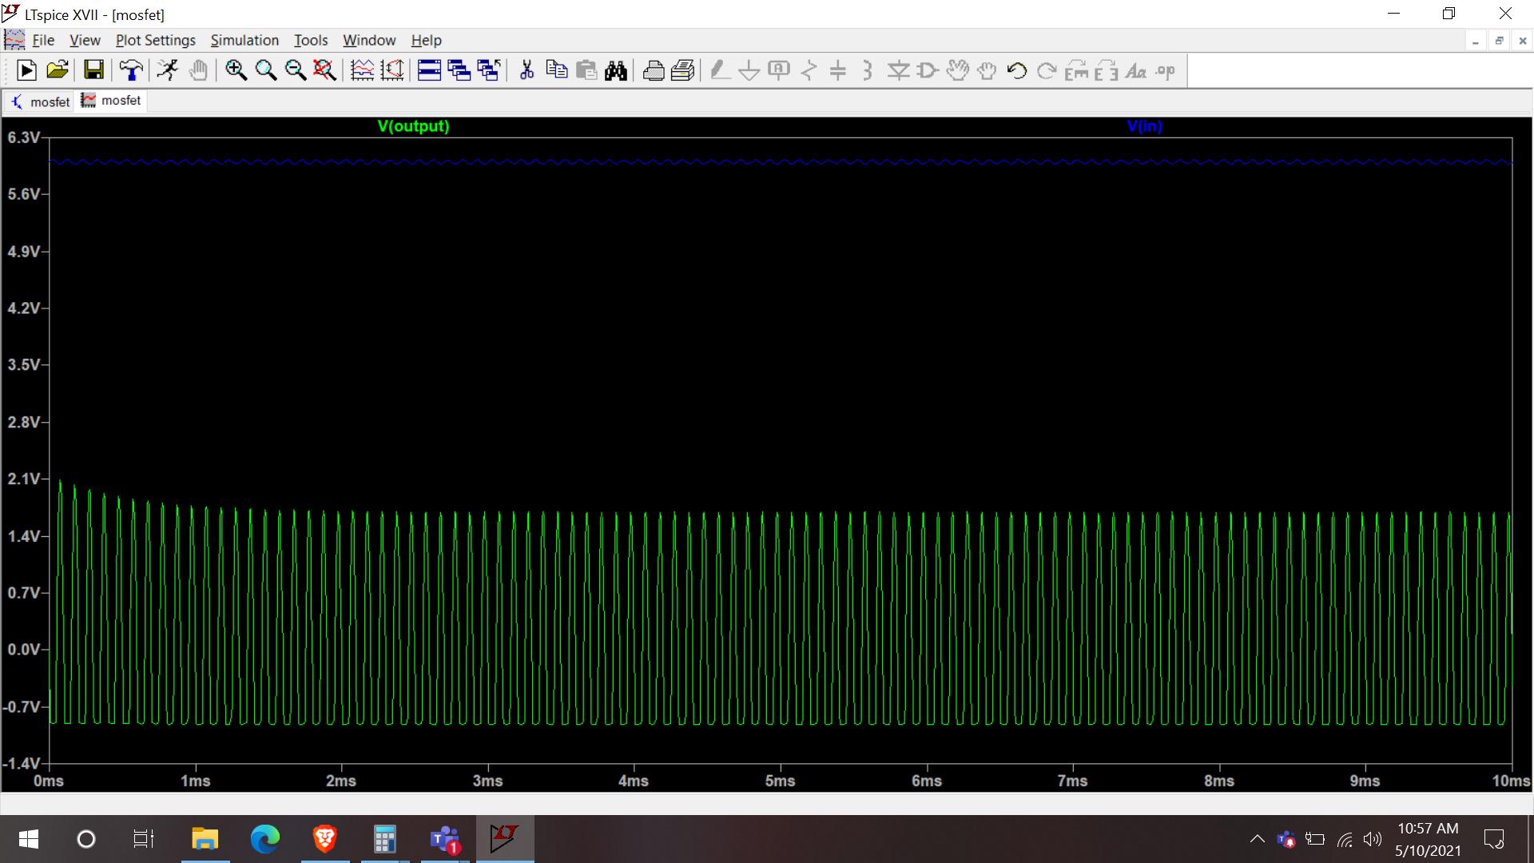
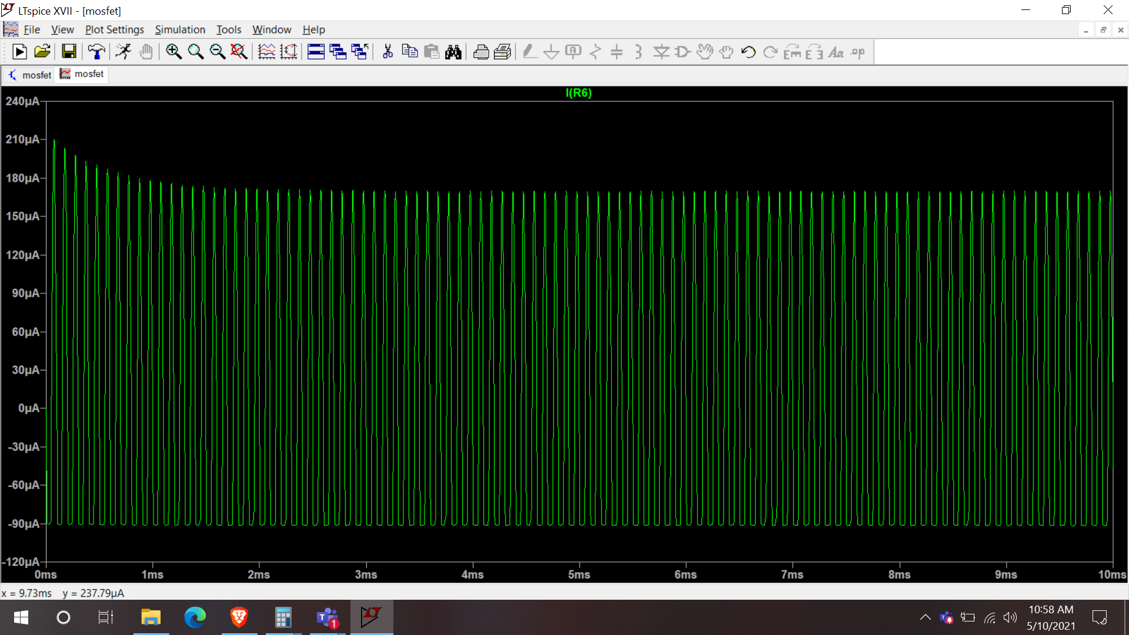

- Design a common emitter BJT amplifier, meeting the above mentioned requirements. Kindly note that since this is a single power supply system, you will need to properly choose the amplifier DC input and output bias. Please note that while you can only use one transistor, but you may use emitter degeneration, capacitor by-pass technique to improve your amplifier performance. Show amplifier transient simulation (up to 10 ms) of input-output waveforms, peak current consumption with ideal 12V DC source. Show your hand calculation.

Hand calculation:
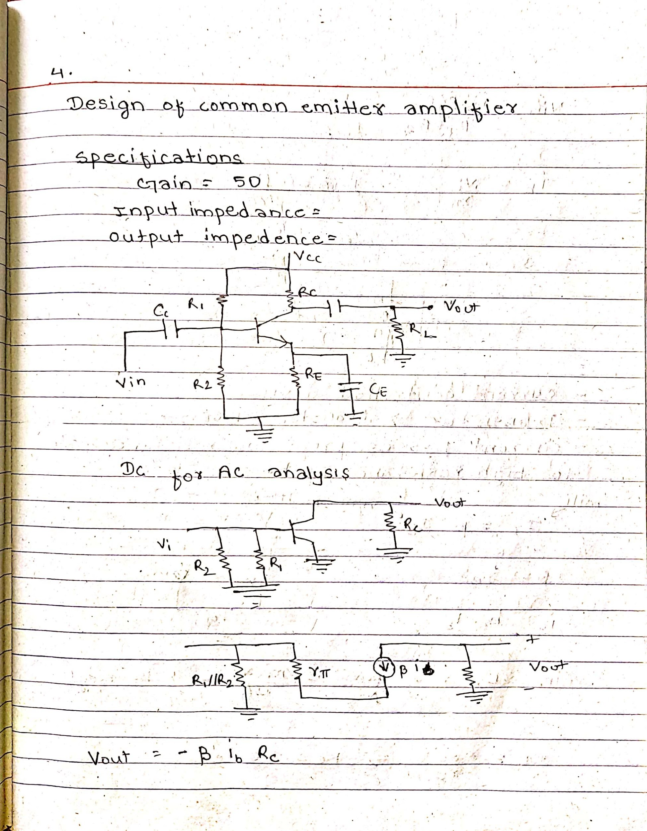
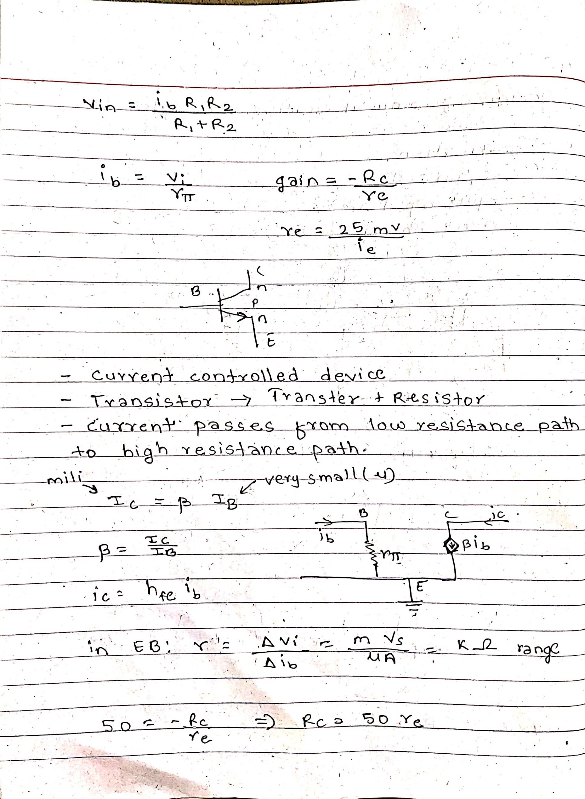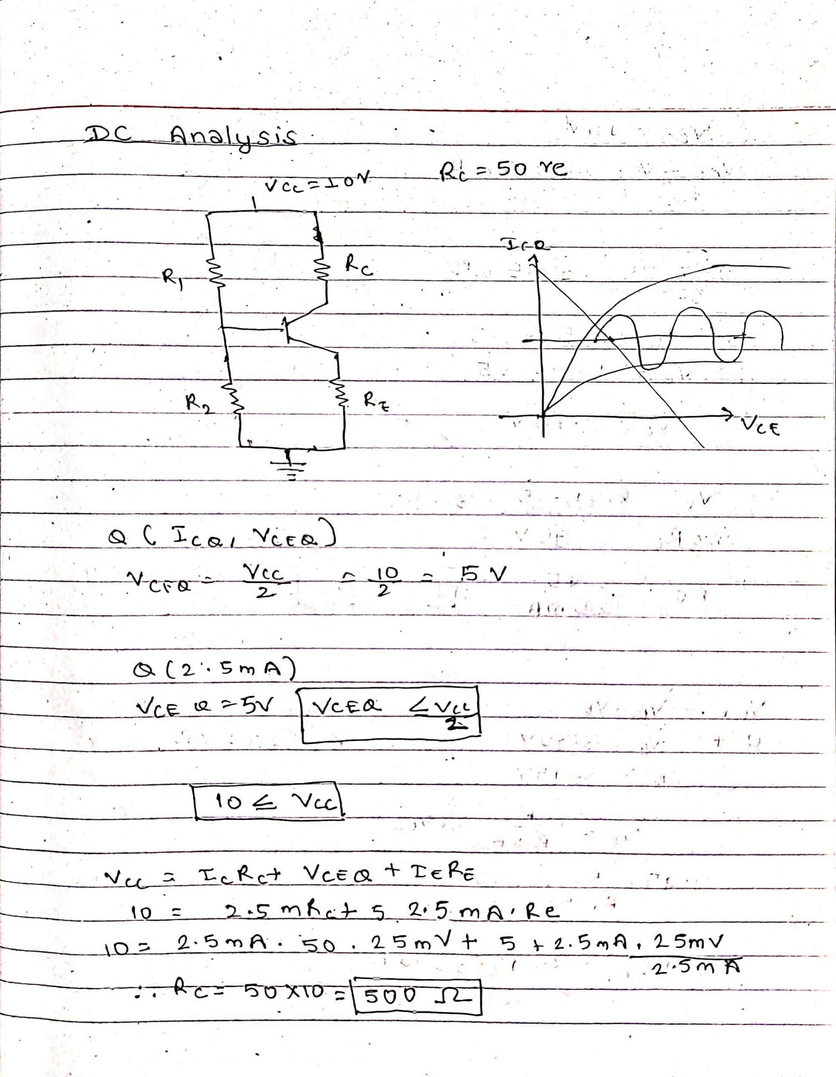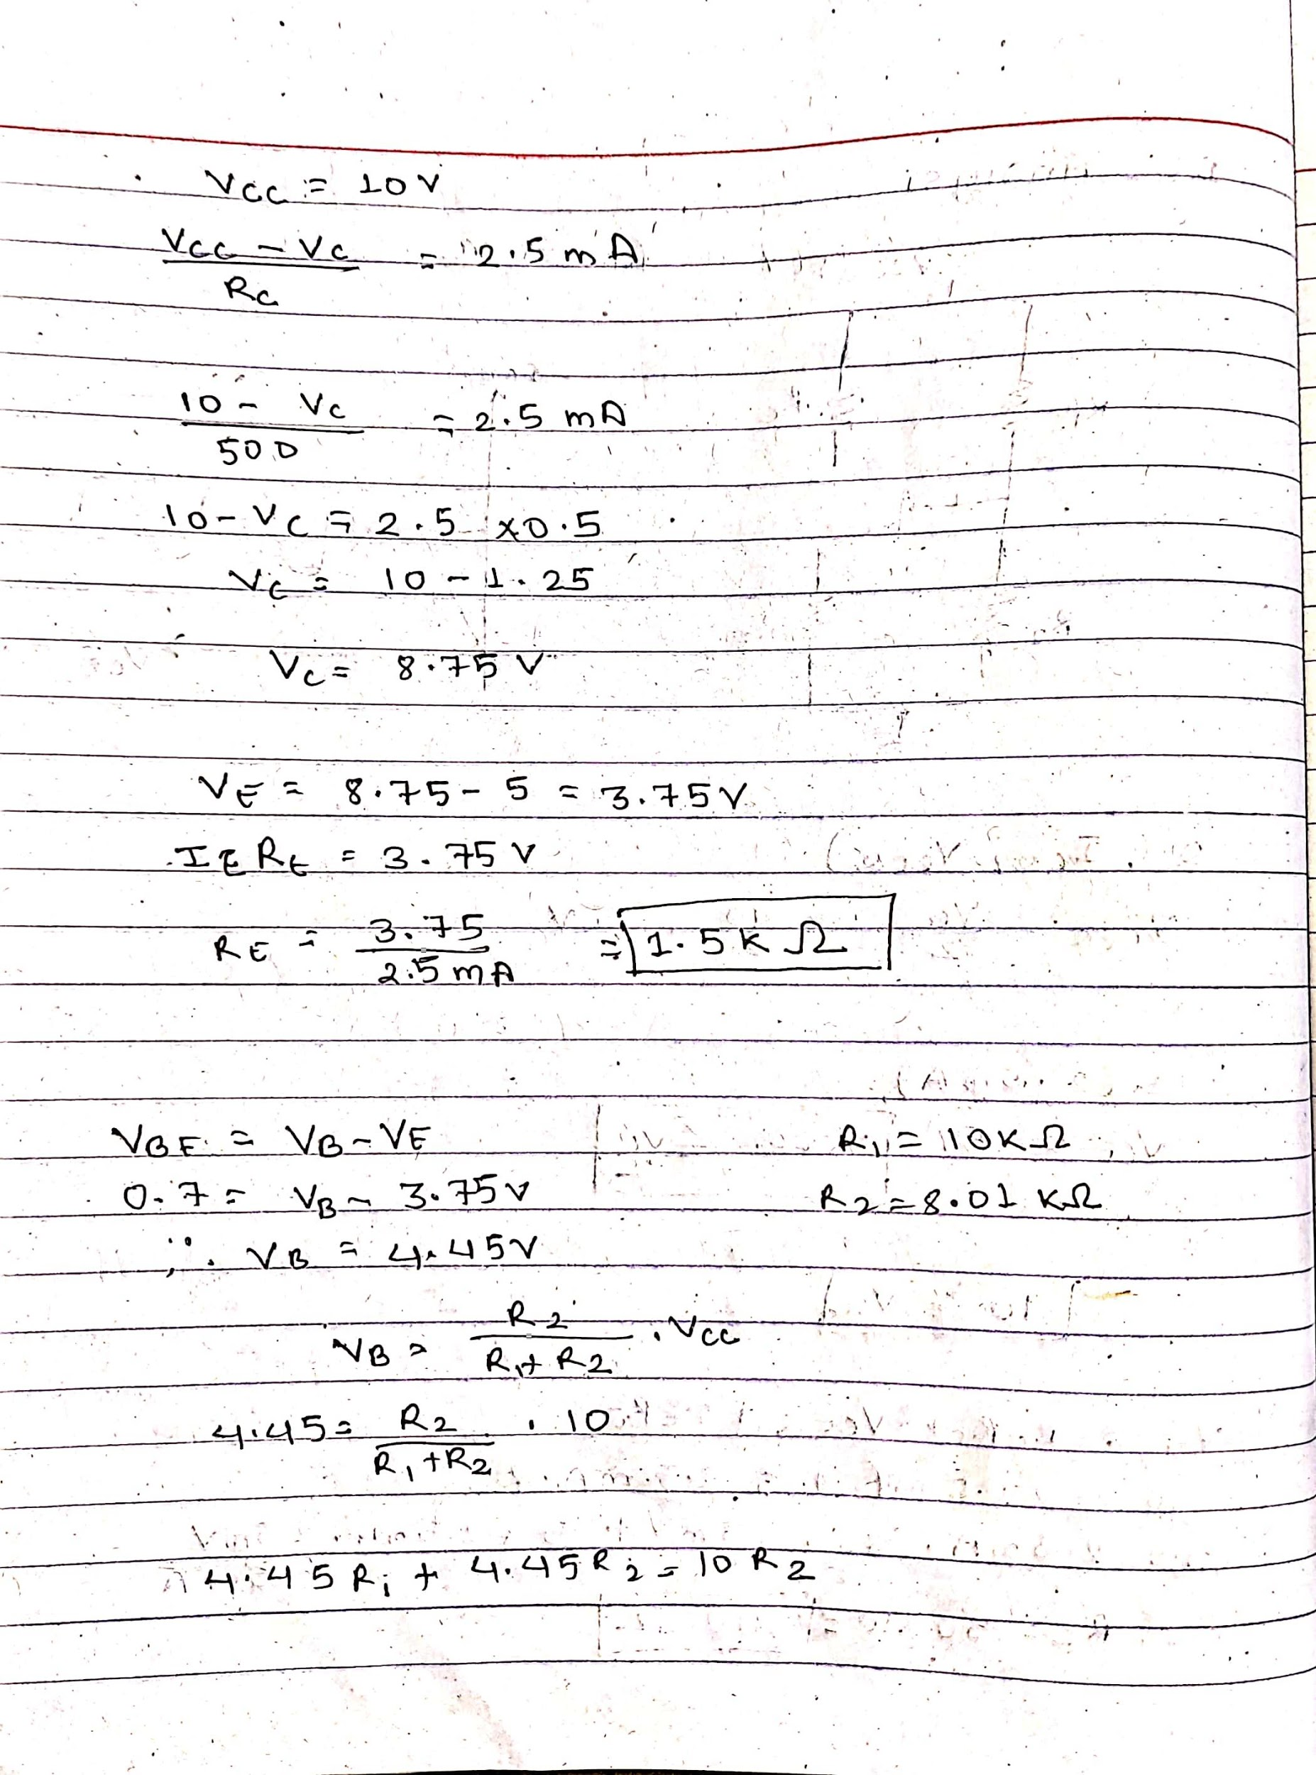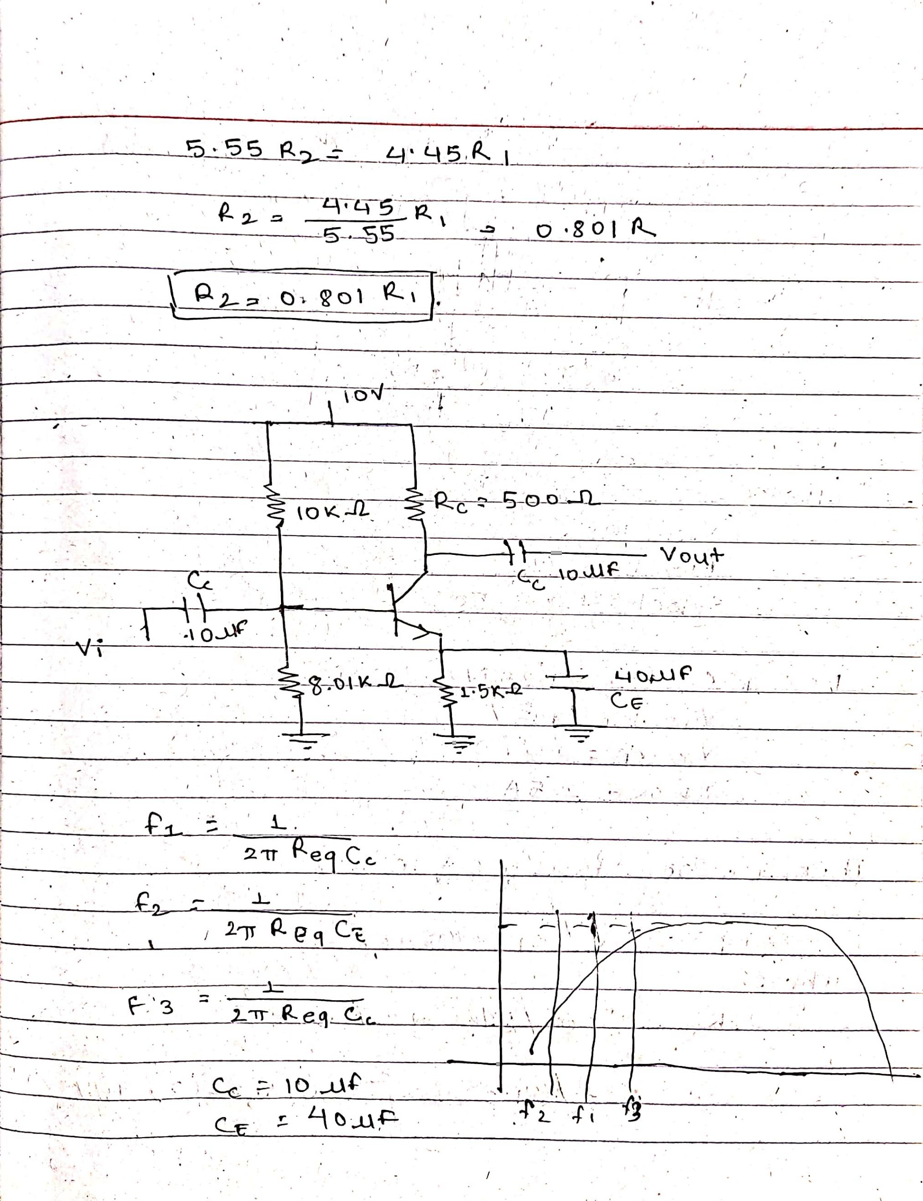

BJT amplifier circuit design:
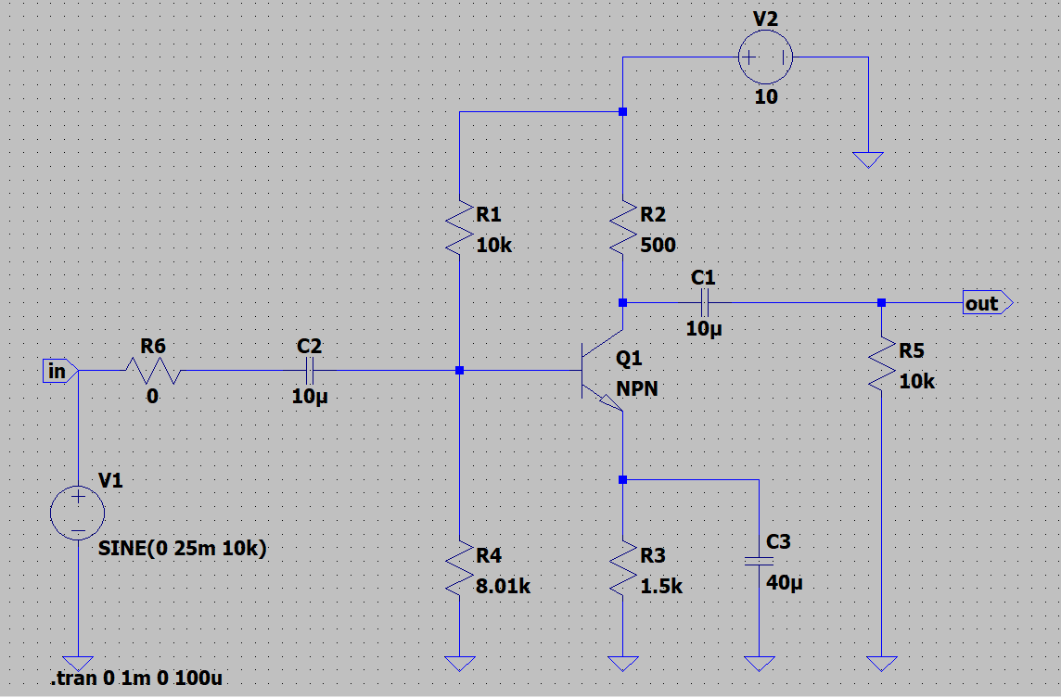

BJT input and output waveform after simulation
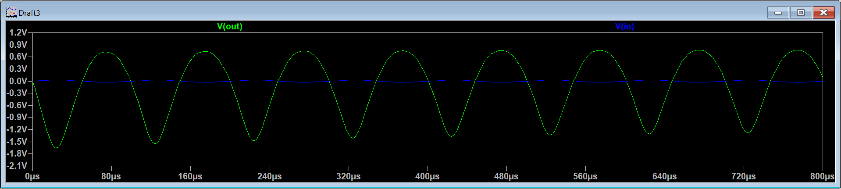
Input:
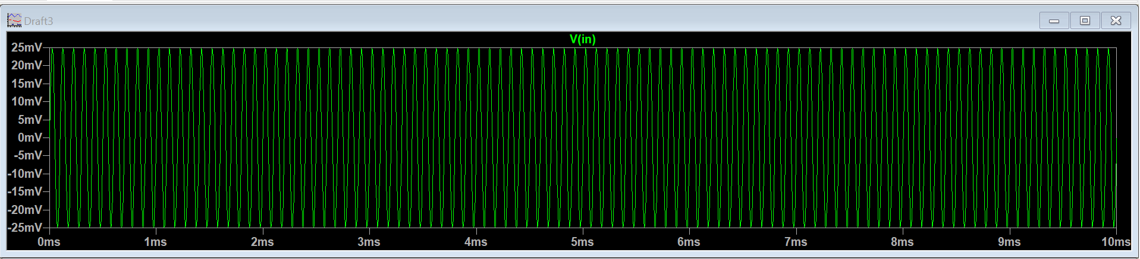

Output:
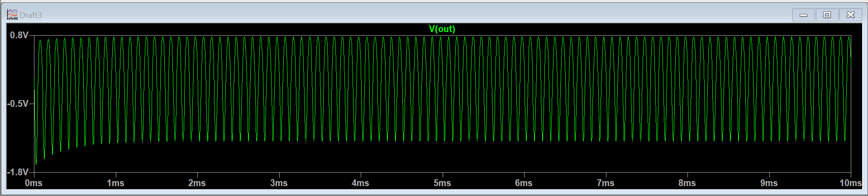
- Re-run transient simulation to show the Total harmonic distortion (THD) performance of the three amplifiers completed in step 2, 3 and 4, using three scenarios:
a) Ideal 10V DC voltage source (clean DC with no ripple voltage),
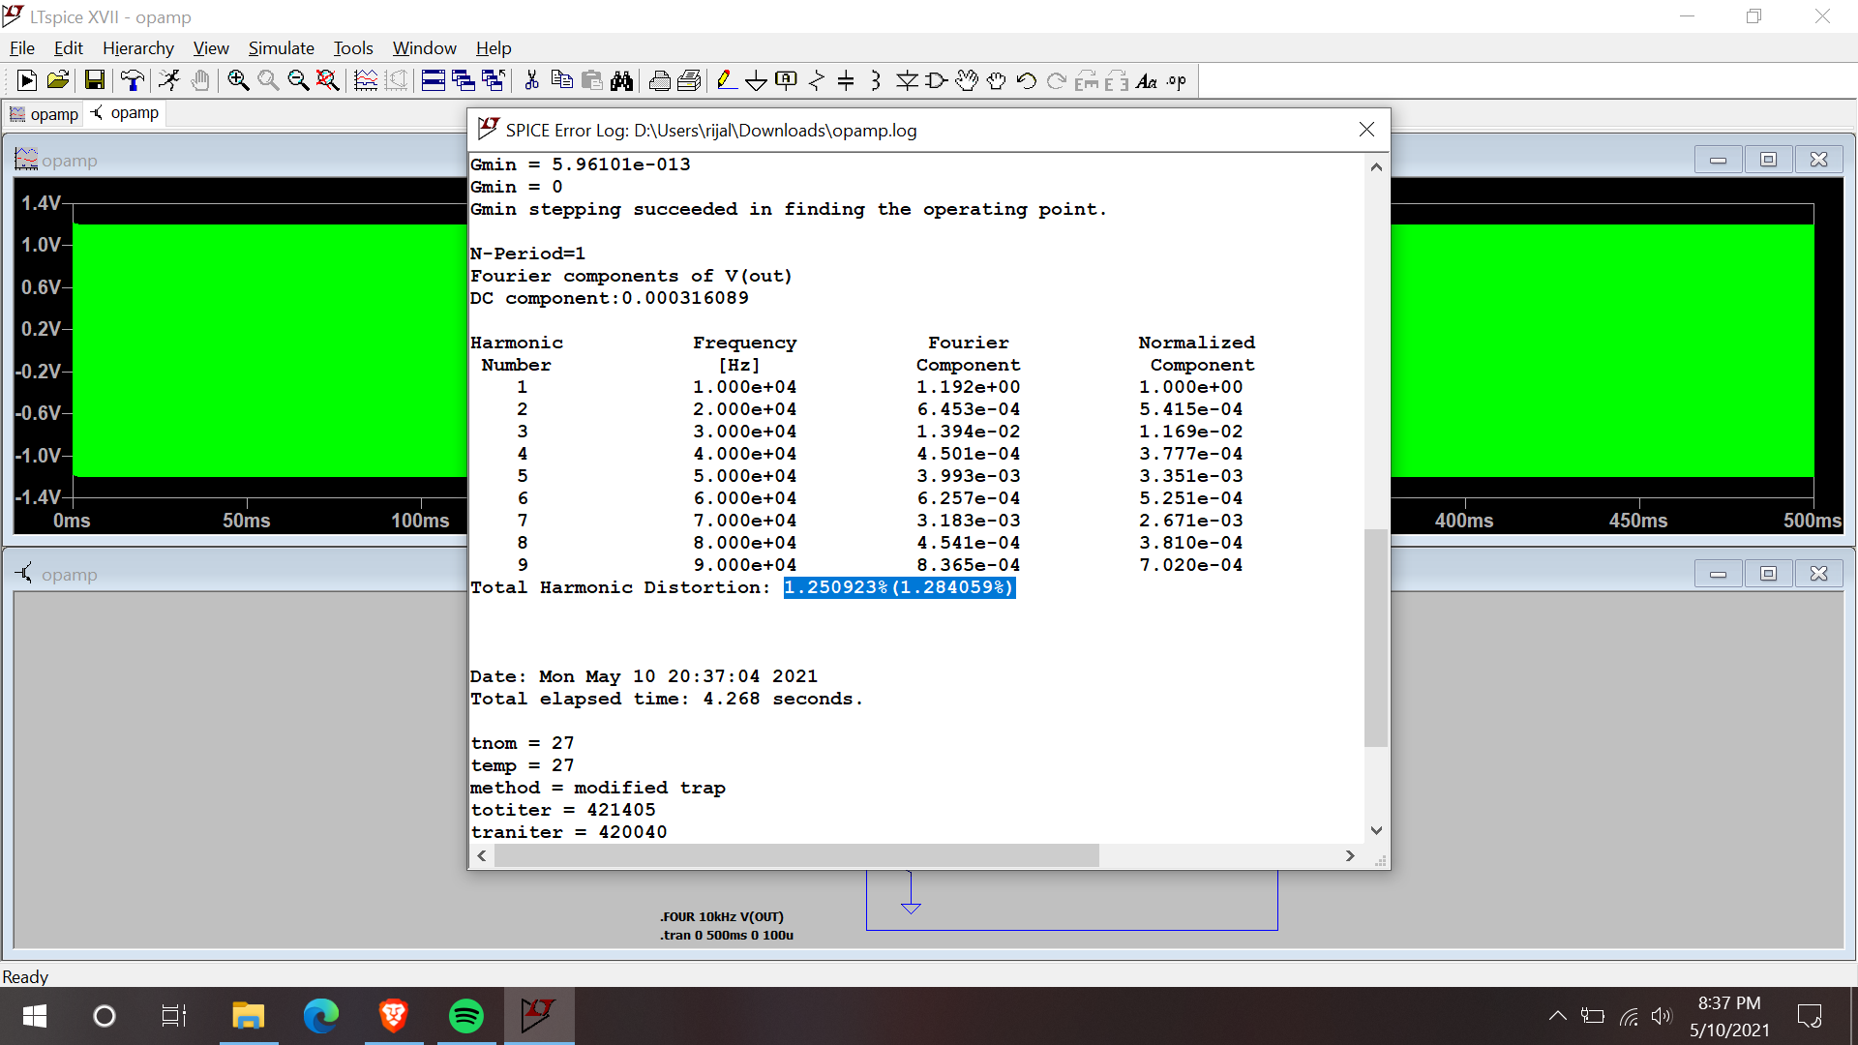
OP-amp Inverting Amplifier

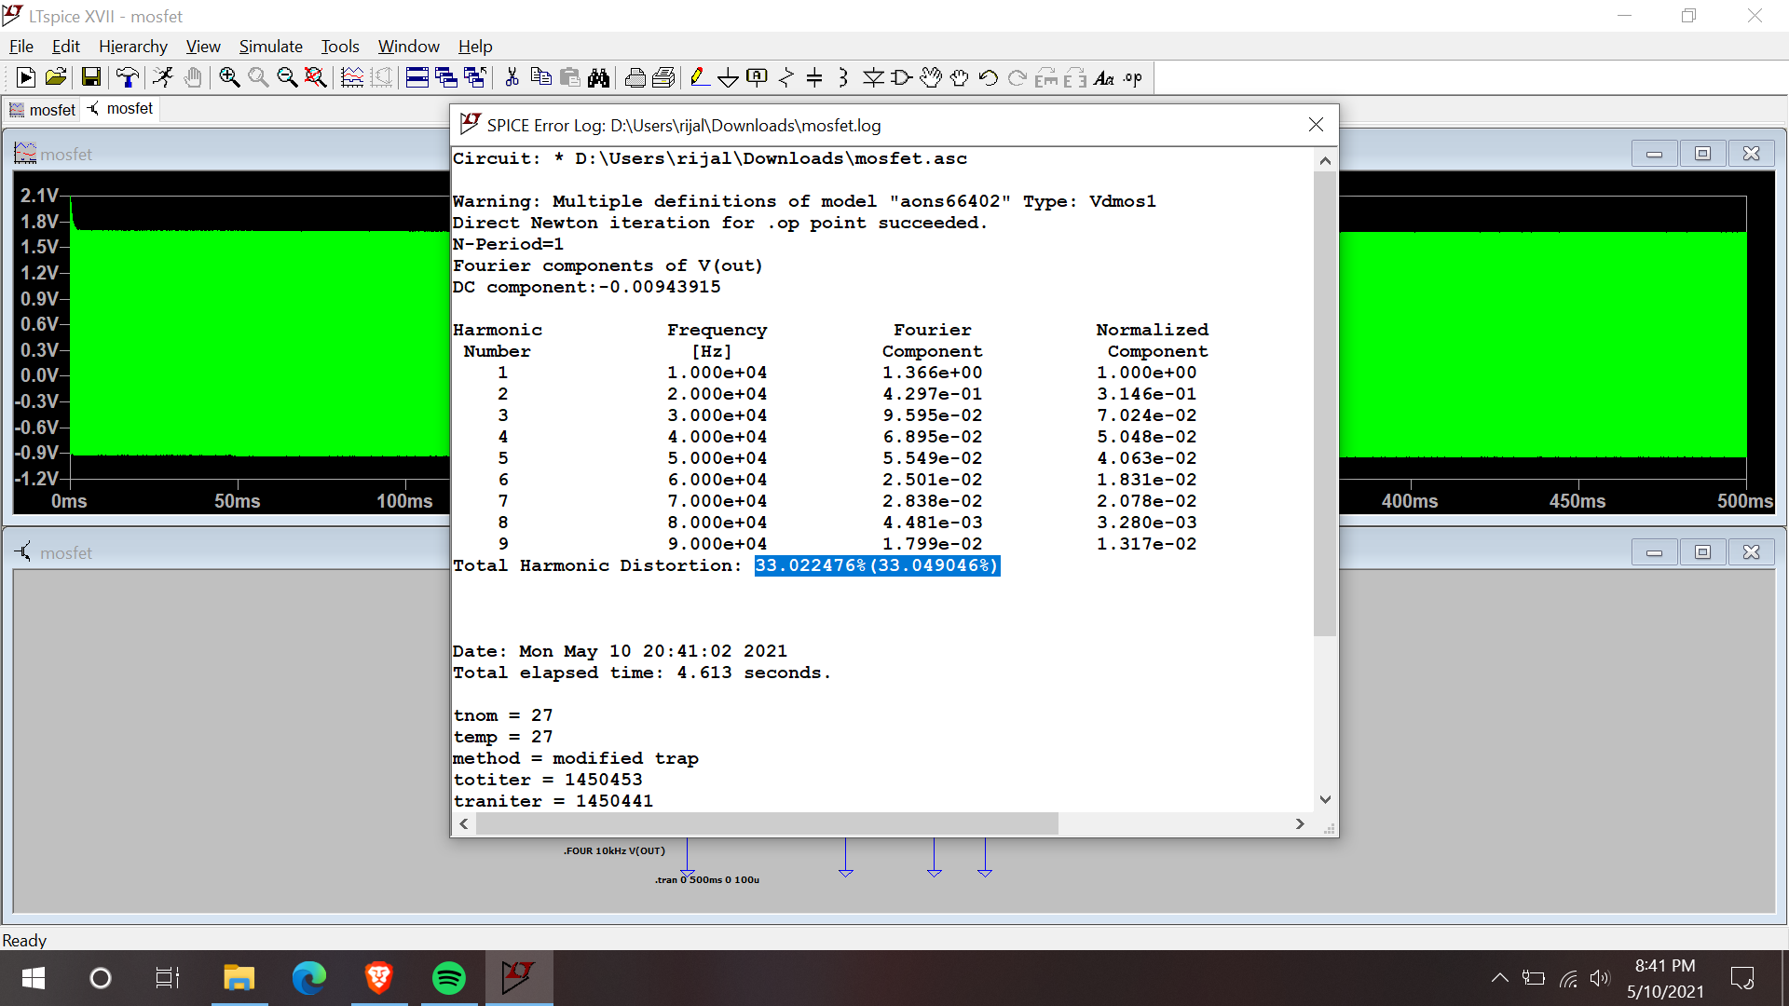
Mosfet Inverting Amplifier
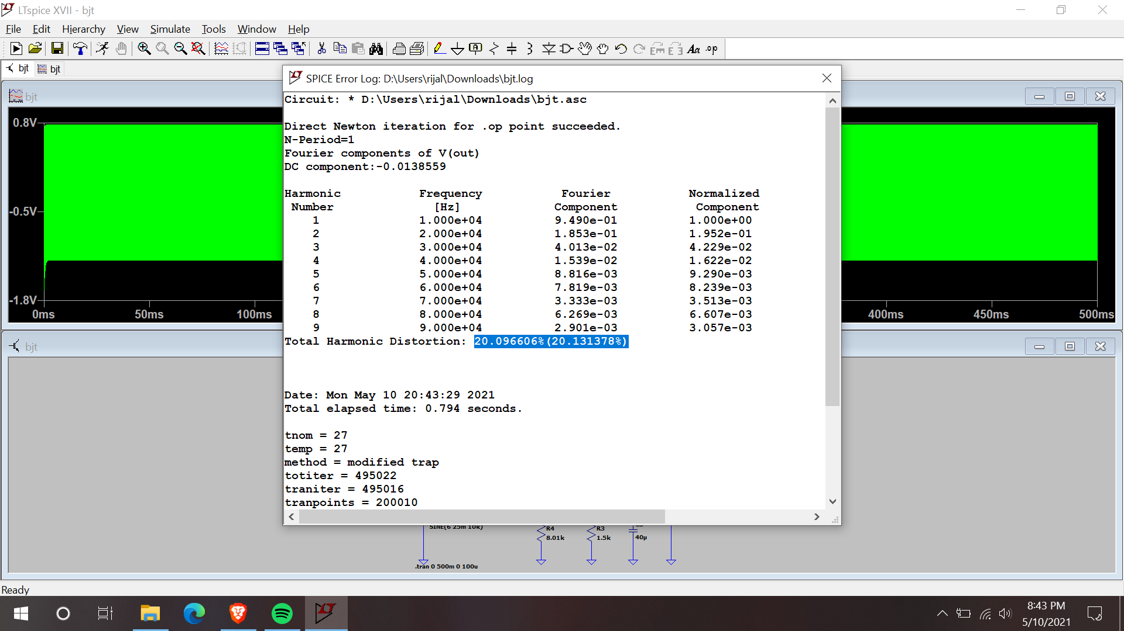
BJT Inverting Amplifier

- 10V DC voltage source with 100 mV amplitude 50 Hz sine wave ripple, After that:
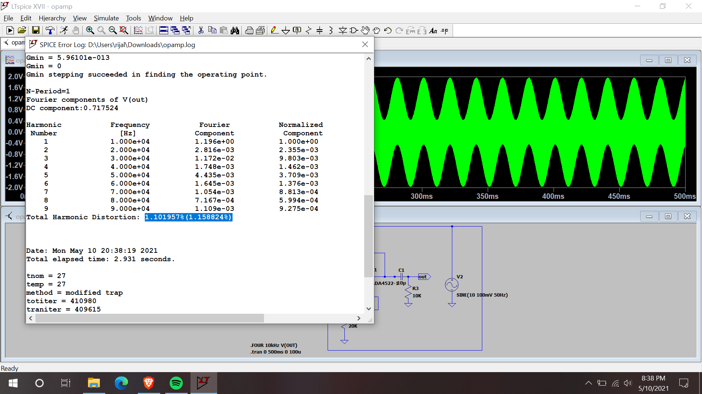
OP-amp Inverting Amplifier
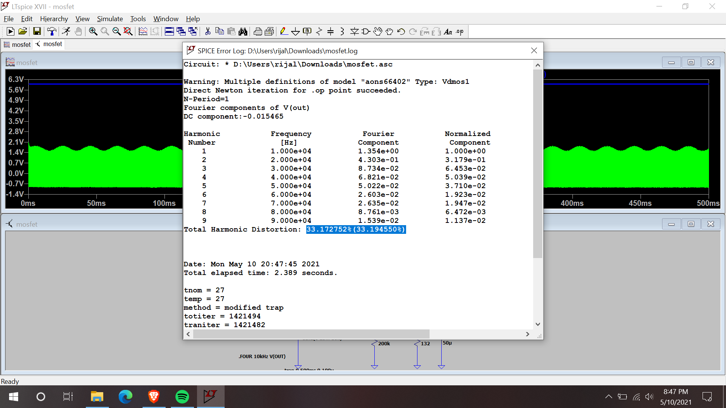
Mosfet Inverting Amplifier

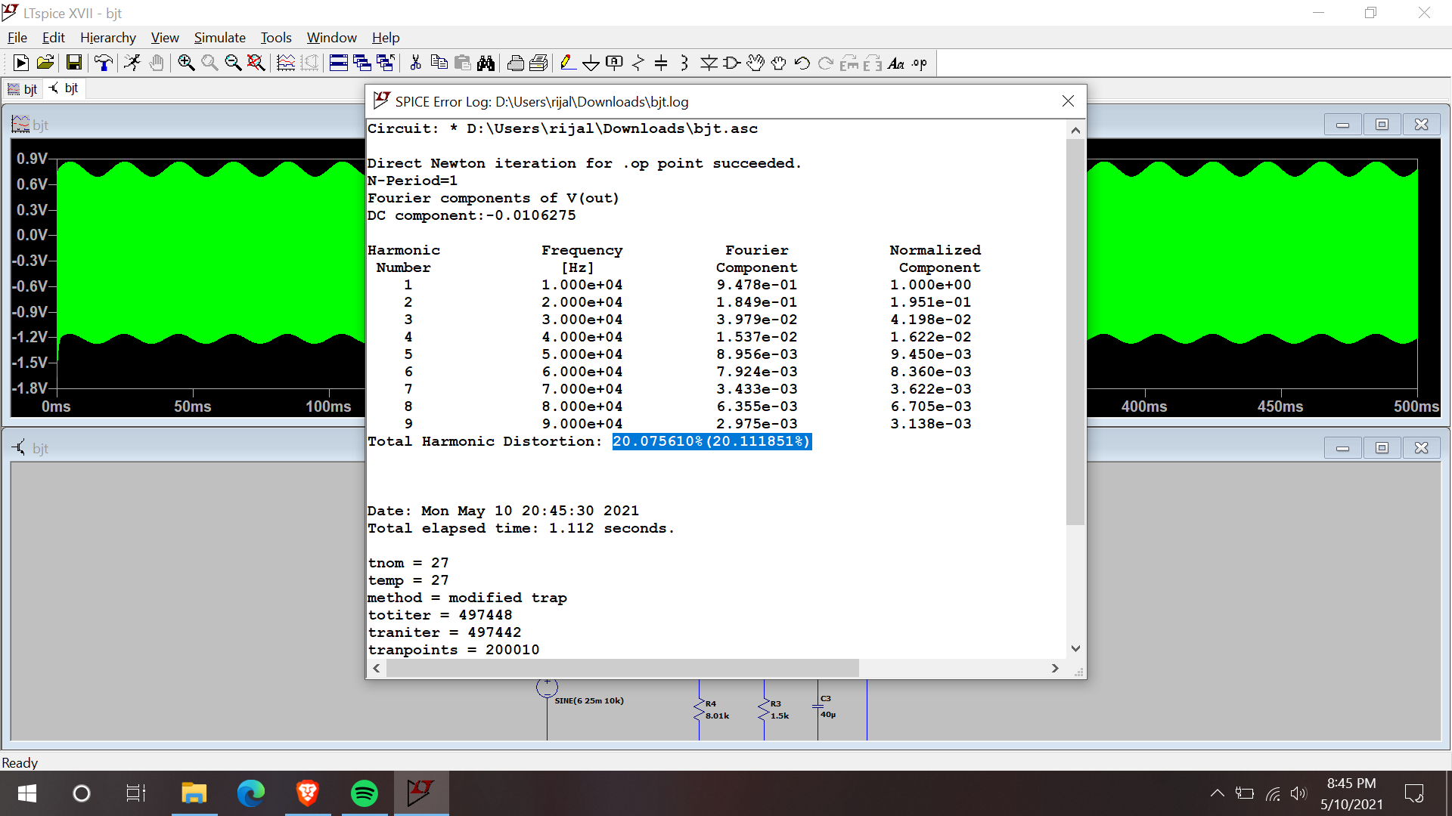
BJT Inverting Amplifier

- Compile a table summarizing the voltage gain, peak power consumption and THD performance of all three amplifiers.

Amplifier | Voltage gain | Peak Power Consumption | THD(%)
Mosfet amp | 68 | 130mW | 33.022
Op-amp | 48.8 | 210mW | 1.250
BJT | 31.06 | 62.2mW | 20.096

- Compare and discuss your findings in step 5-c.
From the table it can be seen that the Op-amp offers the lowest Total Harmonic Distortion with a greater power consumption whereas BJT offers the lowest power consumption.

Note: To measure THD, include SPICE directive: .FOUR 10kHz V(OUT) in your schematic. After running transient simulation, view the SPICE error log to show the THD simulation results. When measuring THD, run transient simulation up to 500 ms to allow sufficient time for the circuit to enter steady state for more accurate results.

Example:
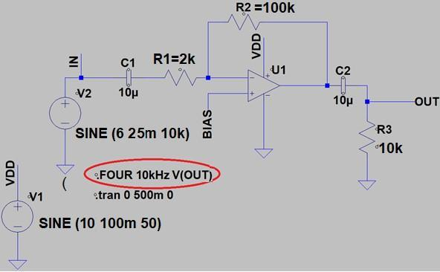

Fig. 1: Example of Op amp circuit to measure THD
(You would need to modify this circuit according to the project specification. For example, you will need to design a resistor divider to generate the BIAS voltage, and change the feedback resistors).

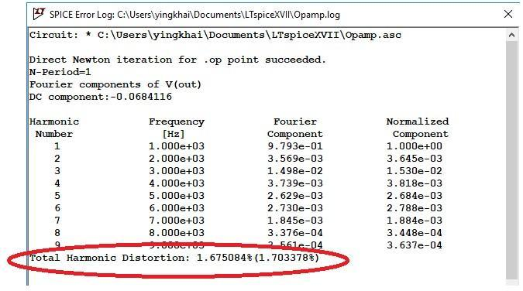

Fig. 2: Sample THD output from LTSPICE

The groups with the best performance in either the lowest Peak Power Consumption (while meeting minimum gain and THD requirements), or the lowest THD in task 6 will be awarded extra credit of 15 points. To ensure fair, apple-to-apple comparisons, you will be benchmarked within your chosen topology (Opamp / BJT / MOSFET) only.

6) Choose one of the amplifiers designed in step 5 as the final amplifier to compete for extra credit in step 6. However, the final amplifier presented in step 6 must meet the following THD specification. Hence you may need to redesign or optimize the selected circuit to meet this specification if none of them meet the THD specification.

*Total harmonic distortion (THD): 7.5% or smaller under 10V DC voltage source with 100 mV 50 Hz sine-wave ripple. When measuring THD, run transient simulation up to
500 ms to allow sufficient time for the circuit to enter steady state for best results.

Present your total bill of material and performance summary of this amplifier, in Table I format as shown below. Explain your choice, rationale and attach related Digikeys pricing snapshots to substantiate your cost claim. When calculating your total cost, you may assume that you are building one unit of such design. Finally, estimate the printed circuit board (PCB) space required by all the components needed to construct the proposed circuit. You may get the component PCB footprint information from the datasheet.

*Please include the following table in the last page of your report.
*Note that power consumption is measured by the total current drawn from power supply, multiplied by the respective voltage, not only the power going to the load resistor.

TABLE I: INVERTING AMPLIFIERS PERFORMANCE SUMMARY
Components required | Manufacturer: | Digikey URL: | Price per unit: | # of units required | Total cost
Your choice of amplifier topology | Op-amp Inverting amplifier
Op amp  model:  ADA4522 | Analog Devices Inc. | https://www.digikey.com/en/products/detail/analog-devices-inc/ADA4522-2ARMZ-R7/5268023 | $4.69 | 1 | $4.69
Biasing Resistor models:  ERA-  3AEB203V  20k | Panasonic Electronic Components | https://www.digikey.com/en/products/detail/panasonic-electronic-components/ERA-3AEB203V/1465885 | $0.31 | 2 | $0.62
Biasing Resistor models:  ERJ-14NF1000U  100 | Panasonic Electronic Components | https://www.digikey.com/en/products/detail/panasonic-electronic-components/ERJ-14NF1000U/283197 | $0.24 | 1 | $0.24
Biasing Resistor models:  ERJ-PB3D1002V  10k | Panasonic Electronic Components | https://www.digikey.com/en/products/detail/panasonic-electronic-components/ERJ-PB3D1002V/6213180 | $0.16 | 2 | $0.32
Biasing Resistor models:  ERJ-8ENF5101V | Panasonic Electronic Components | https://www.digikey.com/en/products/detail/panasonic-electronic-components/ERJ-8ENF5101V/1746058 | $0.10 | 1 | $0.10
Capacitor models: | AVX Corporation | https://www.digikey.com/en/products/detail/avx-corporation/F920J106MPA/4004946 | $0.40 | 2 | $0.80
Total system cost for one unit of  amplifier including all biasing  components | $6.77
Voltage gain | 48.8
Peak Power consumption drawn from power supply (including biasing network, amplifier and load) | 210mW
THD  (Under 10V±100 mV ripple) | 1.101%

Sample transistor amplifier topology for consideration (Note in this project R_{SIG} is 0 ohm) are shown below. The additional R_{S}/R_{E} are there to help tuning better linearity, sacrificing power and gain efficiency. However, if you only care about satisfying gain requirement but do not care about the extra credit THD requirement in step 6, just choose R_{S}=0 or R_{E}=0 ohm. This will simplify the design steps using basic CS or CE amplifier design equations.)

