Objective
Benford's law, also known as the first-digit law, describes the frequency distribution of leading digits in numerical data sets. According to the rule, the leading significant digit in many naturally occurring sets of numbers is likely to be tiny. In sets that follow the rule, for instance, the number 1 emerges as the most important digit about 30% of the time, and the numbers reduces all the way down to a leading number of 9, which happens 4.6 percent of the time.

Procedure
Why Do This Analysis? When fraudsters concoct data, they may not be aware of how to fabricate false data in accordance with Benford's Law. Building a Benford's Law visualization in Tableau will help you decide whether the numerical data is bogus or raise questions about its veracity. To summarize, note that one is not always the loneliest number!
In order to generate a Benford’s Law visualization in Tableau, please follow these steps:
Step 1: Connect to data
Link to Tableau's Superstore sample data in Tableau Desktop.

Step 2: Design the Calculated Fields
- Make use of the Orders datasource.
- Create Calculated Field can be found under Analysis->Create Calculated Field.
- Sales First Digit is the name of the calculated sector.
- LEFT(STR([Sales]),1) is the formula.
- Create Calculated Field can be found under Analysis->Create Calculated Field.
- Benford's Law Sales is the name of the Calculated Sector.
- Make the following formula: LOG(INT([Sales First Digit])+1)-LOG(INT([Sales First Digit]).
- From your Tableau Server, Online, or Desktop gui, right-click Benford's Law Sales and pick Aggregation as Minimum under Default Properties.
- Right-click Benford's Law Sales and use Percentage as the Number Format from the Default Properties menu.
Step 3: Make a Visualization
- Drag the first digit of sales to the columns.
- Exclude can be found by right-clicking 0 and selecting Exclude.
- Drag the number of records to the rows.
- Pick Fast Table Calculation->Percent of Total from the menu that appears when you right-click Number of Records from Rows.
- Rows can be dragged by Benford's Law Sales.
- Using the business analytics Tableau, big data visualisation program, right-click Benford's Law Sales from Rows and pick Dual Axis.
- Pick Synchronize Axis from the context menu as you right-click the second axis.
- Change the Mark Kind and Color to your liking.

The Keys to Adding Totals to the Stacked Column Chart :
- Add a “Grand Total” column to the results
- Highlight the data that does not have the “Grand Total” tab.
- Select a “2-D Stacked Column” map from the “Insert” menu.
- Select “Switch Row/Column” as required to position the first data column on the X axis.
- Choose the map, then extend the data set to include the “Grand Total” column.
- Add "Data Labels" to the chart's Grand Total sequence.
- When you right-click on the Grand Total and choose "Change Series Chart Type," the viz changes to a "Combo" chart.
- Change the “Grand Total” sequence map style to “Line,” but leave the others as “Stacked Column.”
- Align the line's data mark by moving the Label Position to "Above."
- Select the line, format the data sequence, and change the “Line” alternative to “No Line” to leave just the totals and cover the line.
- Highlight the values from the “Grand Total” column in the “Select Data Label Range” pop up window.
- Change the "Label Place" setting to "Inside Base."
- Select the Grand Total Series on the map and right-click so the “Fill” alternative appears.
- Change "Fill" to "No Fill"
- Set the “Spacing” column values to 0.
- Delete the Legend entry for "Grand Total."
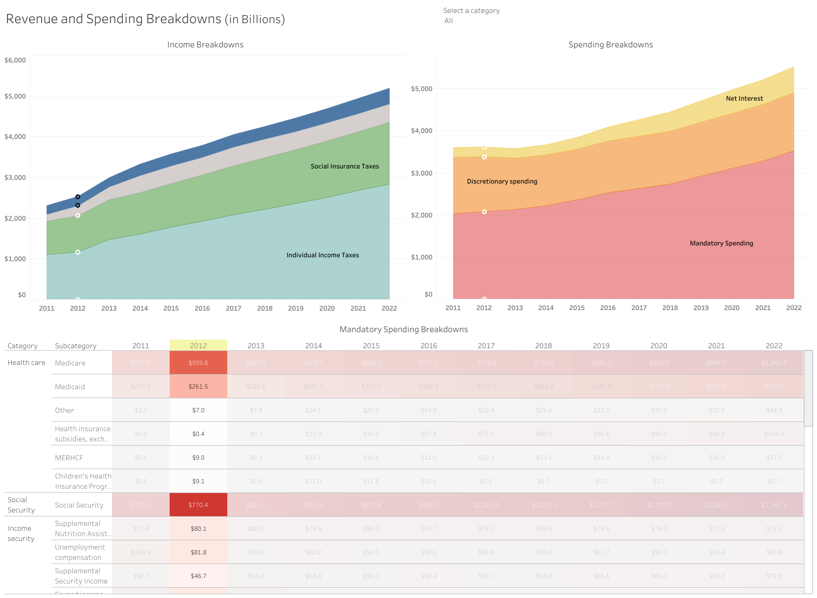

Findings
The financial decision represents a role in the rating on accountability that may or may not be an indication of compliance with Benford's law. Government accounts have also not been analyzed for 2019. Another reason would be the public agent's exacerbated opportunistic conduct attributable to shortcomings in government contracts that do not balance risk/responsibility with monetary rewards.
Benford Law can also serve as one of the factors for measuring the degree of openness of a nation to conduct an earlier review of the budget of the Government and to conduct future audits. The future research should concentrate on the construction of disclosure indices by using the model vector "conformity with Benford law" and an increase in the number of spending areas surveyed. Due to the widespread range of resources that do not allow the export of data to the same medium, the study attempted to evaluate the costs using different data websites as a guideline and found limited data access.

Challenges
The common problems in an assortment are: Unlicensed Server Management, Unlicensed VizQL Server Process Management, Cookie Restriction Error, Confused Authentication, Server troublease processes, License Desktop Troubleshooting, Tableau Nodes Troubleshoot Disk Use, Run As User Troubleshooting, and Cleaning Up Tableau-Server Related Files.

